**CS160: Human Computer Interaction**

**Spring 2022**

**Assignment 3: Heuristic Evaluation**

**李振邦 2019531055**

1. **Heuristic Evaluation**

**Bulleted list of Usability Issues (Severity Order)**

**Subject:** Paper Door: paper exploring tool targeted at boosting research and learning.

**User:** People (especially beginners) who wants to explore the research fields.

**Ten Usability Heuristics:**

**#1: Visibility of system status**

**#2: Match between system and the real world**

**#3: User control and freedom**

**#4: Consistency and standards**

**#5: Error prevention**

**#6: Recognition rather than recall**

**#7: Flexibility and efficiency of use**

**#8: Aesthetic and minimalist design**

**#9: Help users recognize, diagnose, and recover from errors**

**#10: Help and documentation**

**Problems:**

1. **User control and freedom**

**·** Lacking necessary entrances of going backwards, especially in part like ‘文章架构’.

When users make mistake in performing actions, they need a clearly marked "emergency exit" to leave the unwanted action without having to go through an extended process.

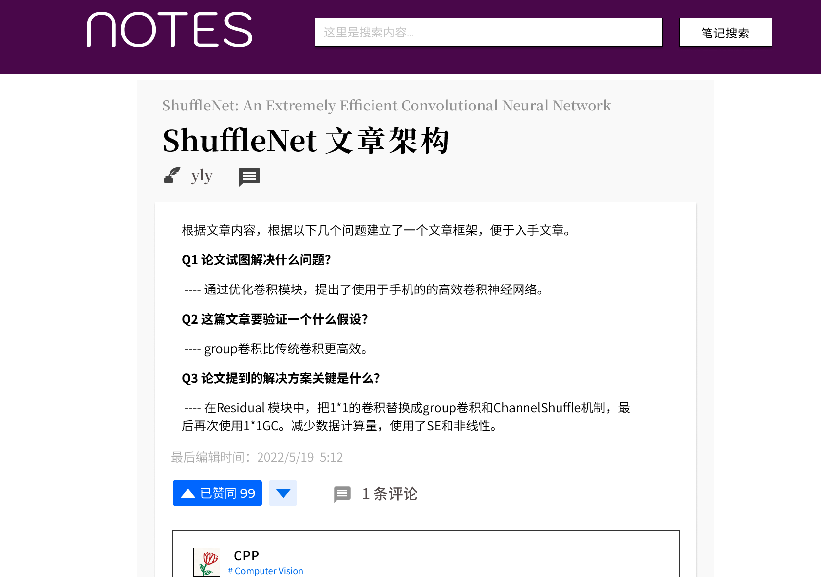

1. **Visibility of system status**

**·** Need to let the user know there exists translate function, missing necessary button. (Visibility of system status)

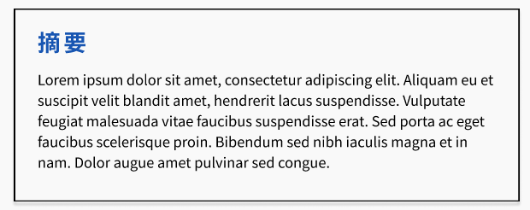

1. **Visibility of system status & User control and freedom**

**·** It is very hard to recognize information from the relation map of the field.

**·** Users do not have any basic ways to interact with the relation map. (like zoom in/out, showing short descriptions when hovering on the nodes.)

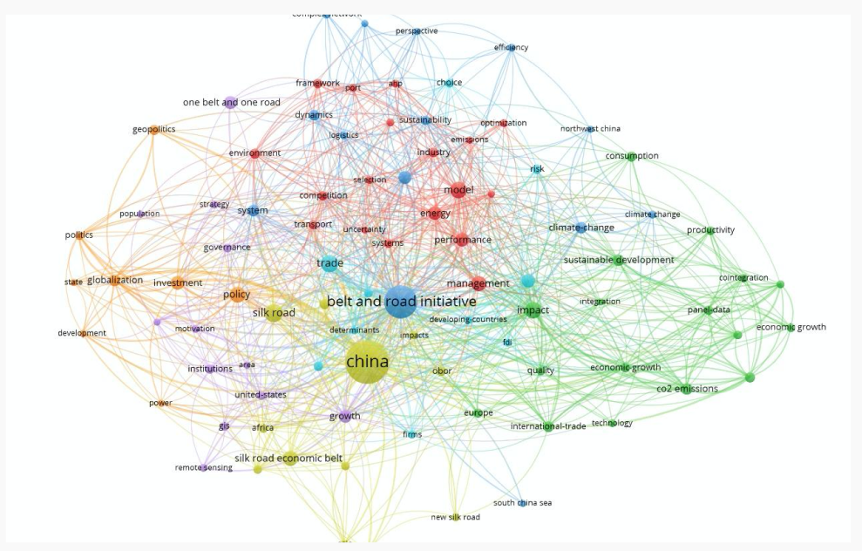

1. **Aesthetic and minimalist design**

**·** The ‘热门文章’ block on the homepage is useless and confusing. Users do not need the information of the hottest papers in all the fields. Besides, hot to decide this ranking is also confusing.

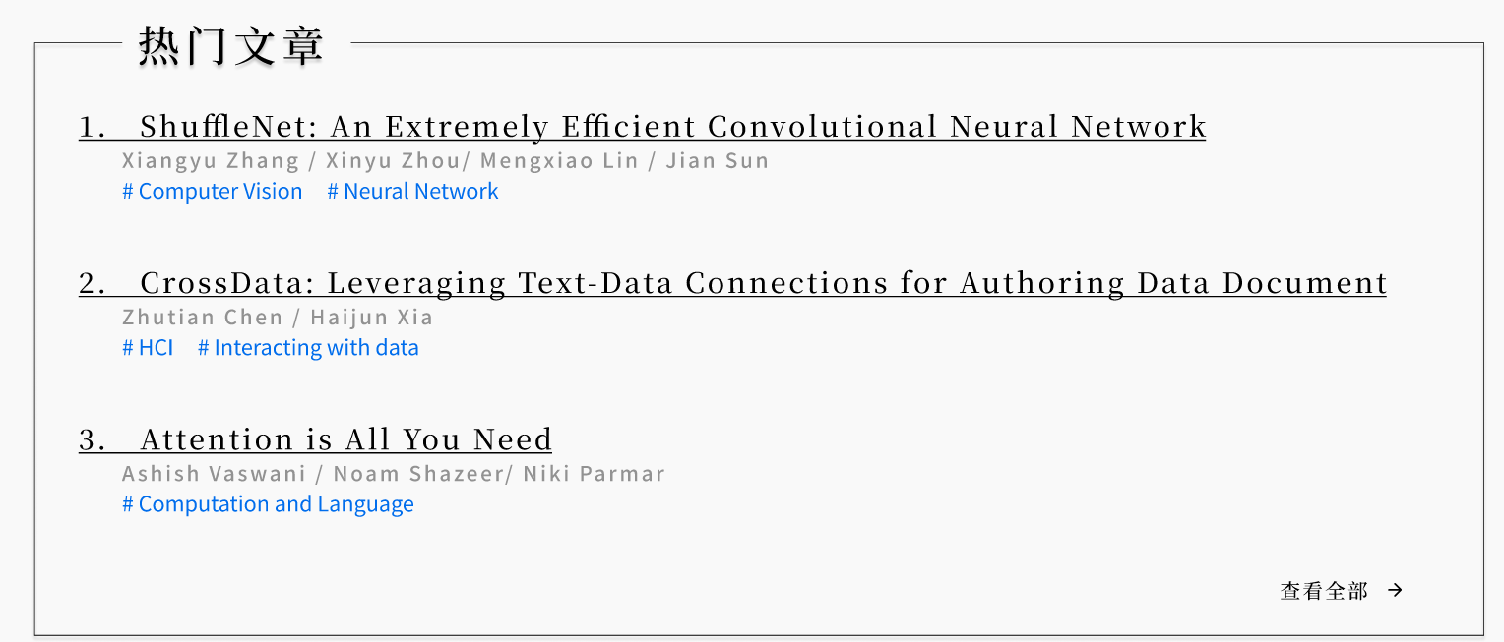

1. **Flexibility and efficiency of use**

**·** The filter of searching are not directly accessed and can not do overlay.

A 4-check-box search filter may be better, allowing users to search papers about distinct topic in distinct field by distinct authors at the same time,

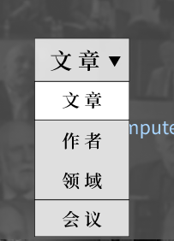

1. **Group Evaluation**

**Major problems & Potential solutions**

**Problem 1: Current way of providing information still lack flexibility and intelligibility for beginners.**

For beginners doing research, they need the website to provide them with a directory of authors and fields. What’s more, some brief introductions about the main topics and the sub fields are also necessary for fast understanding.

However, the current design only providing search for specific content may be ineffective because beginners have limited knowledge of research content. They do not even know what to search or what are the popular sub topics in a distinct field. The deeper relation information provided by the website and the webpage layers may make the understanding problem even worse.

**Our proposed solution:**

Add a directory of authors, fields, and journals to provide users with more comprehensive information.

Add necessary introductions about the basic information like sub fields and main topics.

**Problem 2: Functions of user’s personal creating area are not fully explored.**

This website integrates the functions that are similar to those in the BBS, question, discussion and so on combined with academic papers can achieve very good linkage effect, can bring a lot of information to the user. Such function integration and home page layout have some certain improvements in intelligibility compared with the traditional paper website requirement for personal account.

However, users need a more powerful personal home page. It should be convenient to publish, display and so on, and should not be limited to its own collection function. In addition, it also have to hold certain requirements for identity authority verification and other functions.

**Our proposed solution:**

For the current prototype, we can refer to the user's personal home page of the video website to make certain improvements, enhance the function of the home page, improve the interaction between users, and help optimize the community environment.

**Conclusions about Heuristic Evaluation**

Heuristic evaluation is very effective in exploring users' potential needs and cognitive models. It is capable of getting a range of views and picking up more potential problem areas in the root elements of the product, since it is very powerful in aspect of shooting the distinct basic issues.

However, it can only focus on the internal problems of the product, and it is difficult to conduct linkage tests with the external environment and background information. It may fail to detect certain critical problems not related to some specific function, but the concepts of the whole system.