[1]

Impedance Transformation and Design of Single Port Network with Transmission Line

Zhenbang Li, Zhaoyang Yu

*Abstract*—For RF circuits design, impedance matching at its operating frequency is vital to reaching ideal performance. Using Smith chart and CST simulation, we represent an efficient way to design single port networks such that the input impedance matches the impedance given in advance, which, in our project, is set to be 13+j*27Ω, and the frequency given is 1.9GHz.

# Schematic diagram design and simulation of ideal transmission line and ideal load

T

he first task is based on ideal transmission line, which is divided into two separate part. First, we design a network with two components, as described in A. Then, we design a Π-type-topology component with three components, as described in B.

## Network with Two Components

Considering that the impedance given has a positive imaginary part, we decided to use a resistor and an inductor. The resistor we chose is 12.4Ω and the inductor we chose is 2.07nH, resulting in an impedance of 12.9+j*27.1Ω, which satisfied the demands.

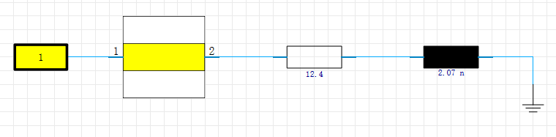

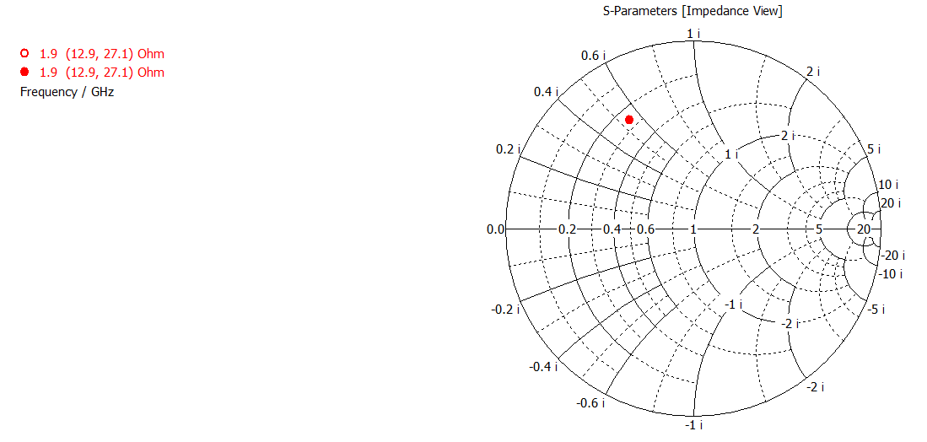

Fig. 1 Design of the circuit network and the corresponding S-parameter simulation result

## Π-type Network with Three Components

We chose to design Π-type network in order to correspond to the model in task 3. Here, we used a resistor and two inductors, whose values are 42.8Ω, 3.79nH and 2.02nH respectively. The impedance we achieved is 13+j*27.2Ω, which satisfied the requirements.

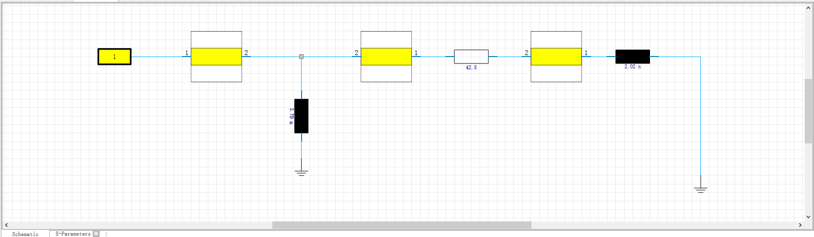

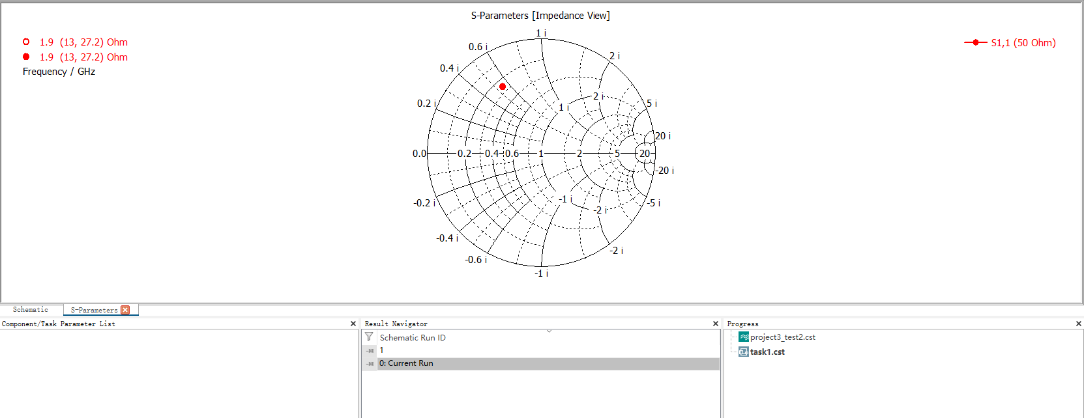

Fig. 2 Design of the Π network and the corresponding S-parameter simulation result

# Schematic diagram design and simulation of thin microstrip line and ideal load

## Network with Two Components

The type of the microstrip line we chose is RO4035B, with epsilon=3.48, and height=0.702mm.

In order to make the characteristic impedance 50Ω, we use the “impedance calculation” in template “antennas” to calculate the width of the microstrip, which is calculated to be 1.606 mm.

Like I.A, we chose to use a resistor and an inductor. By simulation, we found the value of the resistor and inductor has to be 12.2Ω and 1.94nH in order to reach the given impedance. The simulation result is 13+j*27Ω, which satisfied the requirements.

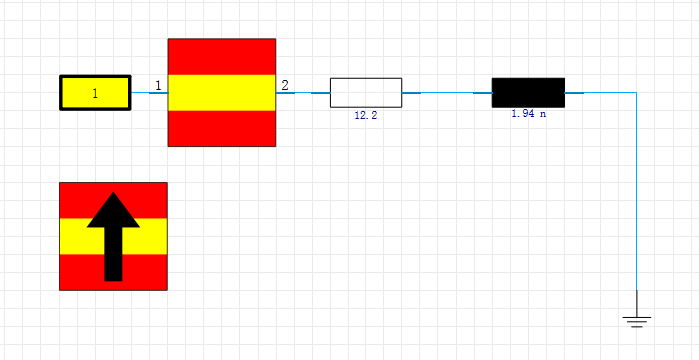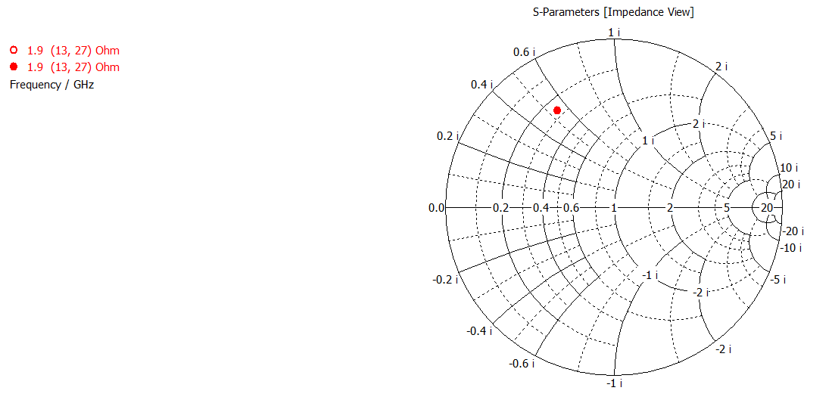

Fig. 3 Design of the circuit network and the corresponding S-parameter simulation result

## Π-type Network with Three Components

The type of the microstrip line we chose is RO4035B, with epsilon=3.48, and height=0.702mm.

In order to make the characteristic impedance 50Ω, we use the “impedance calculation” in template “antennas” to calculate the width of the microstrip, which is calculated to be 1.606 mm. The length of the microstrip was set in order to correspond to the length of the 3D model in task 3. The Π-type was also chosen in order to correspond to the 3D model in task 3.

Like I.B, we chose to use a resistor and two inductors. By simulation, we found the value of the resistor and inductor has to be 8.16Ω, 2.26nH and 1.268nH respectively in order to reach the given impedance. The simulation result is 13+j*27Ω, which satisfied the requirements.

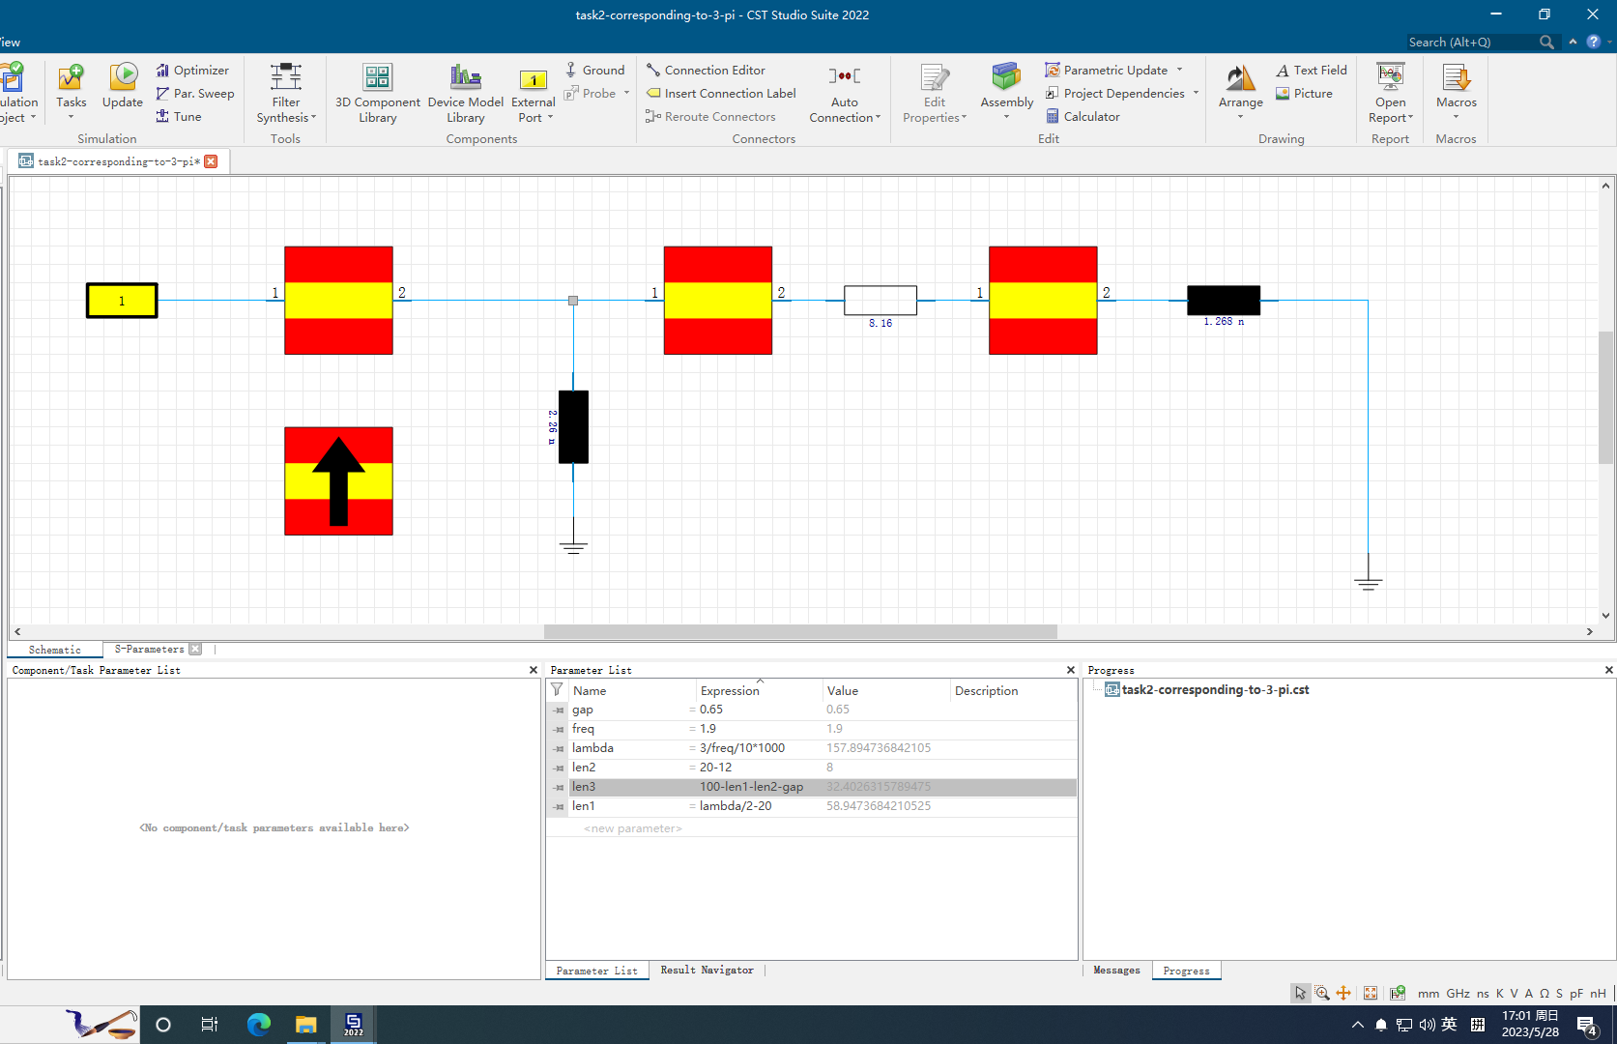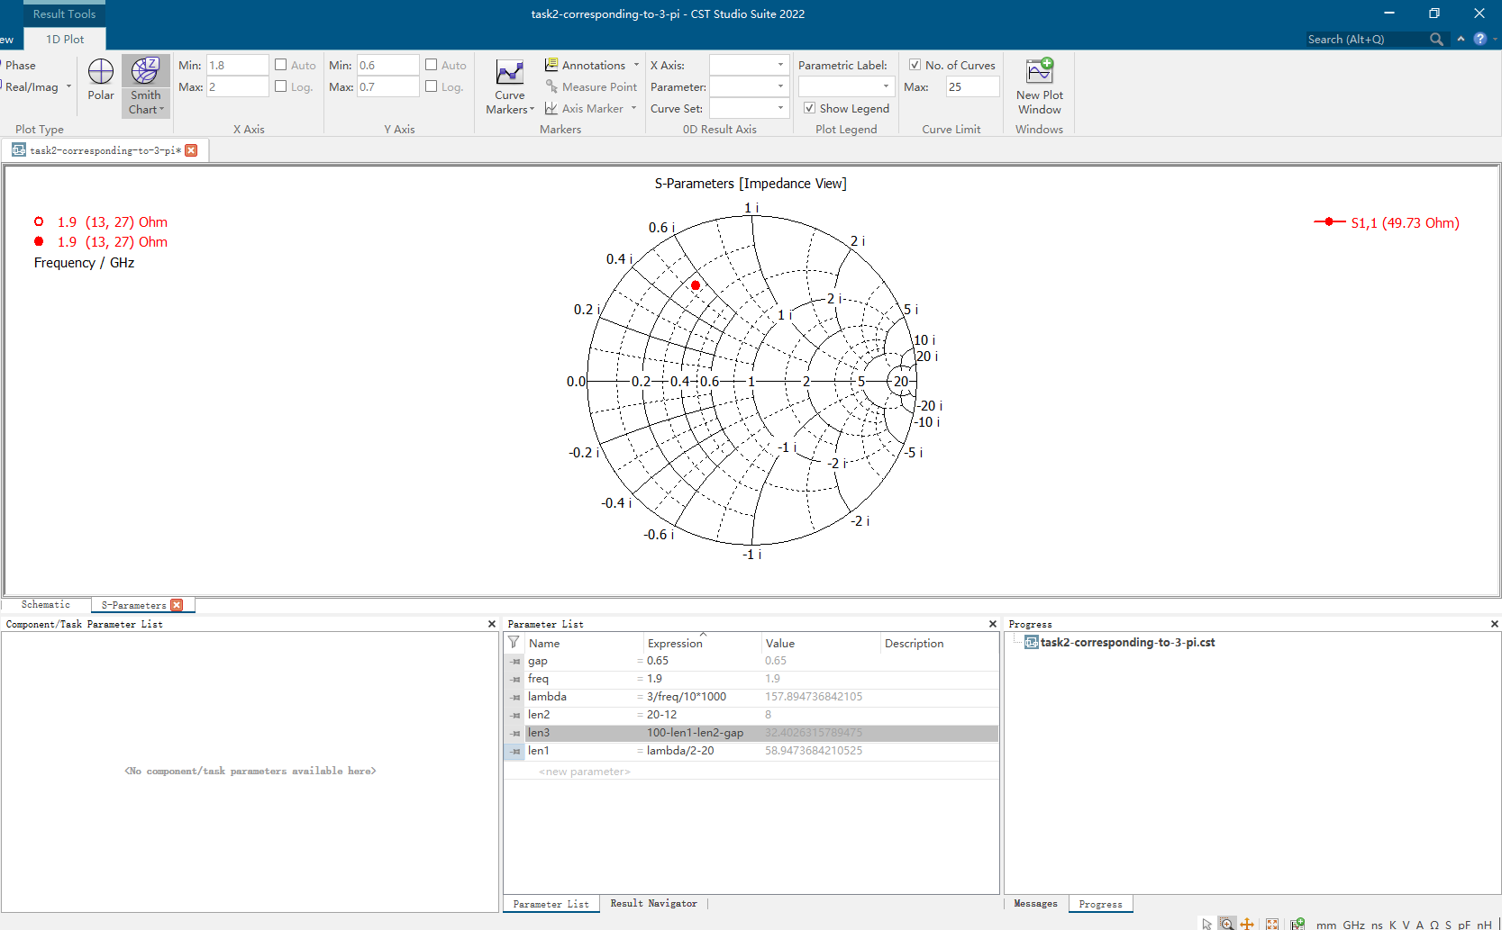

Fig. 4 Design of the Π network and the corresponding S-parameter simulation result

# Schematic diagram design and simulation of thin microstrip line and ideal load

This task can be divided into two parts. First, we create the 3D model for the microstrip transmission line, and the port for connecting elements are also set. Second, we finish the schematic design, and by simulation, we choose the values for the circuit elements.

## 3D Model Setup

The type of the microstrip line we chose is RO4035B, with epsilon=3.48, and height=0.702mm.

Using “impedance calculation” provided by CST, we set the width of the microstrip line to be 1.606 mm. Some parameters such as the width of the gap were set according to the instructions provided by the teaching assistants.

Four ports were set in total, corresponding to three circuit elements, and one excitation port.

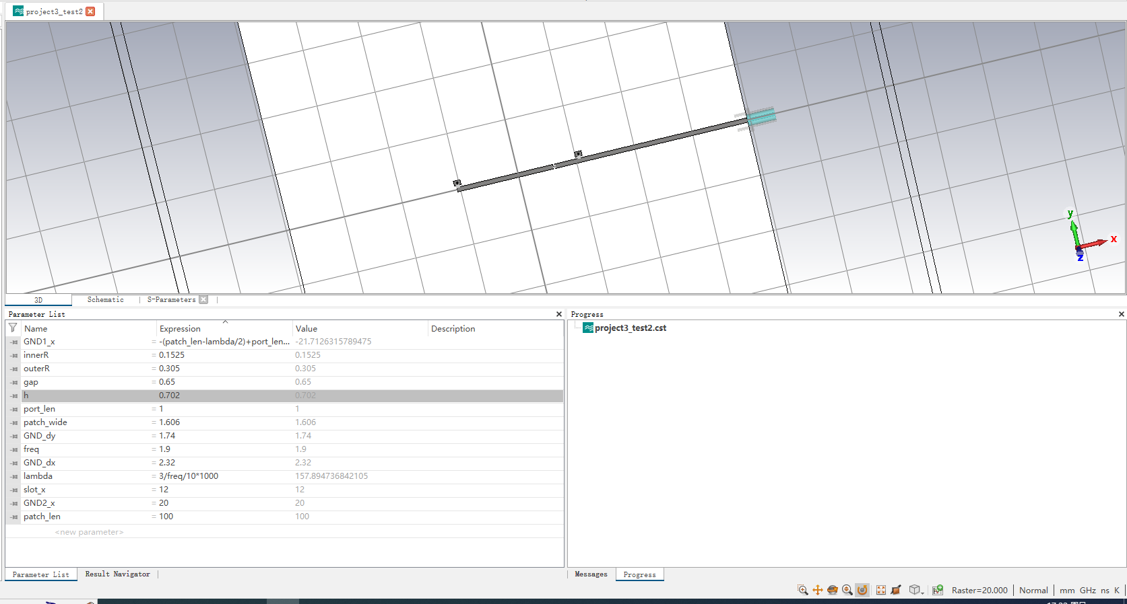

Fig. 5 3D model of the microstrip line and the corresponding parameters

## Π-type Network with Three Components

We connected the elements to the ports according to their relative positions. For instance, the external excitation is connected to port 5 since port 5 is the port connected to the SMA in the 3D model.

The circuit elements we chose were one resistor and two inductors. By simulation, the values of the resistor and the inductors were 0.404Ω, 0.263nH and 0.25nH respectively. The simulation result of the impedance was 13+j*27Ω, which satisfied the demands.

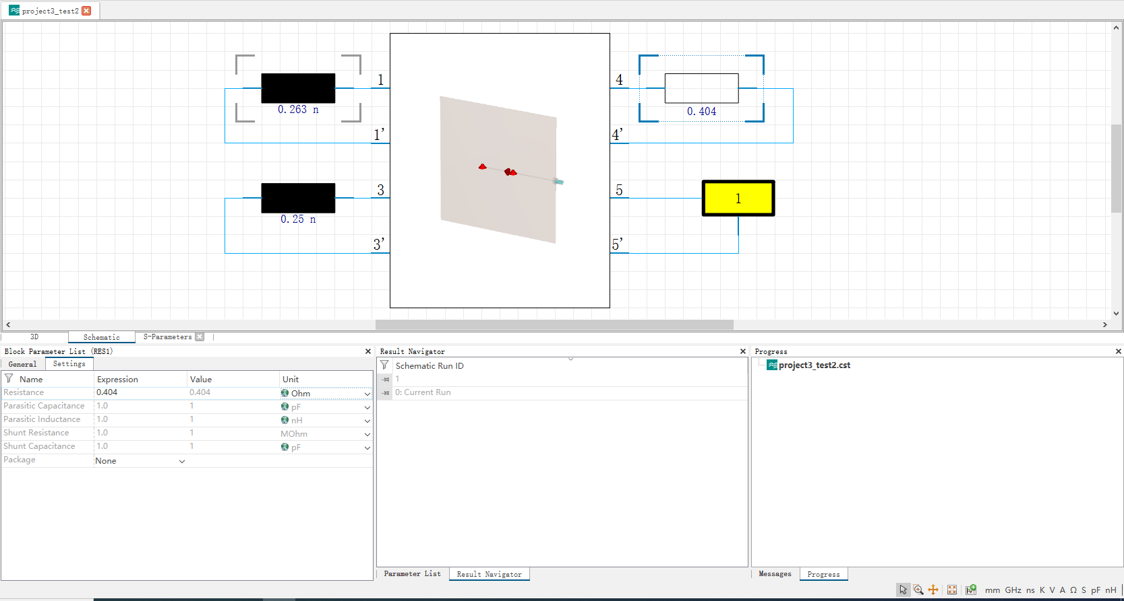

Fig. 6 Circuit schematic of task 3

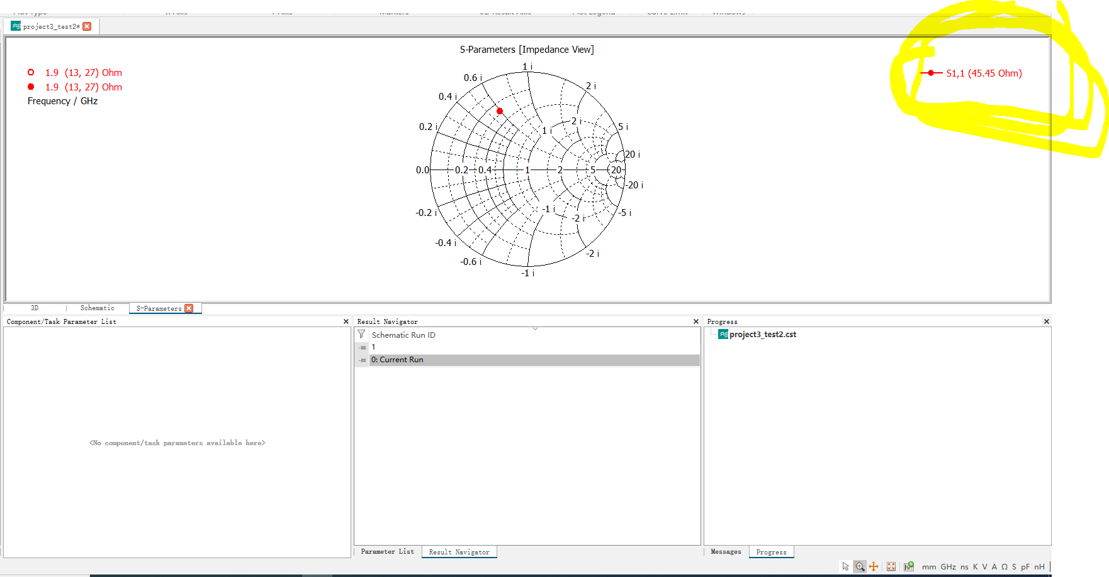

Fig. 7 Simulation result of the network in task 3

## Error Analysis of the Error between the Result of Task 2 and Task 3

Although the impedances we derived in task 2 and task 3 are almost the same, but the values of the circuit elements vary widely.

Some reasons are listed as follows. A major reason is that the SMA port is not ideal. It will add additional impedance. As a result, the values of the circuit elements we chose must be smaller in order to reach the requirements.

Second, in task 2, we didn’t add microstrip lines between ground and the elements, which led to larger value of the inductance in task 2 since extra inductance due to the metal grounding columns in the 3D model in task 3 was not considered in task 2.

# Actual Circuit Fabrication and Measurement

In this part, we should set two sets of load impedance ZL to meet the design target. Then we should simulate them in CST with the real-world S-parameters files form Murata of electronic components to meet the design standard. After the simulation, soldering the circuit board and do measurements of S-parameters and Z-parameters with vector network analyzer. The whole process is conducted under 2.4GHz.

The design target and standard of the simulation are follows:

1) The simulation result of ZL1(dB) and ZL2(dB) should differ in less than 1dB.

2) The simulation result of ZL1(Phase) and ZL2(Phase) should differ 180°(±10°).

The design target and standard of the real-world PCB soldering and measurement are follows:

1) The simulation and real-world measurement result of ZL1(dB) and ZL2(dB) should differ in less than 3dB separately.

## Simulation of target impedance sets

We choose to continually use the 2 inductance π-circuit design in task-2 and task-3 in our design. We start the design with ideal components to make the rough adjustment in order to quickly get down the approximate choice of 2 sets. After the we do the fine adjustment with real-world S-parameters of the circuit components.

First, we get the circuit shown in figure 8, which has two 2.2nH inductances and one 10Ohm resistance (1.8nH, 2.2nH, 10Ohm in the original ideal-component design), we choose it as our starting point, since its degree ZL1(dB) is -0.5750394dB which quite close to 0dB. The corresponding ZL1(Phase) is -147.6027 degrees.

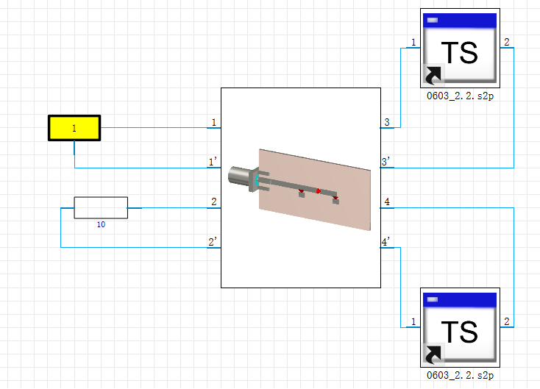

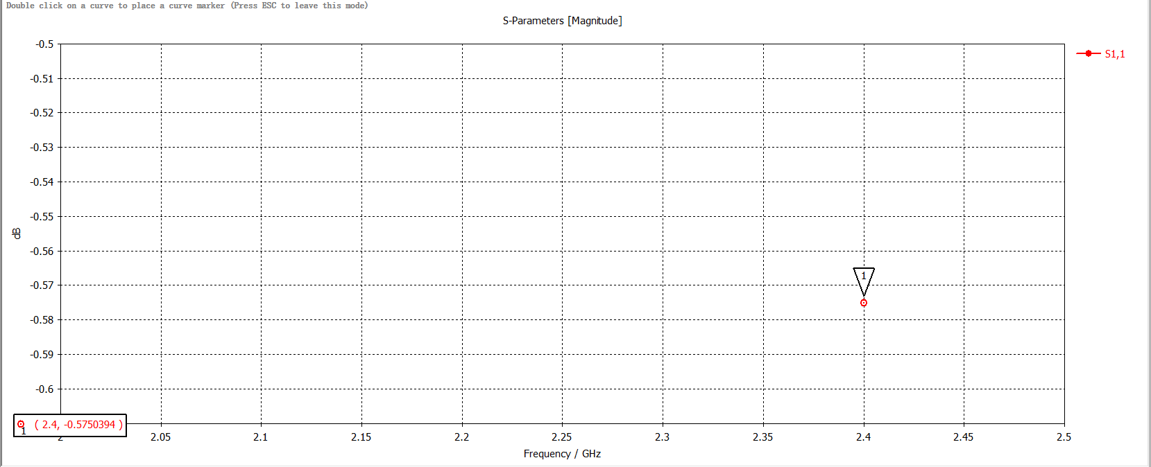

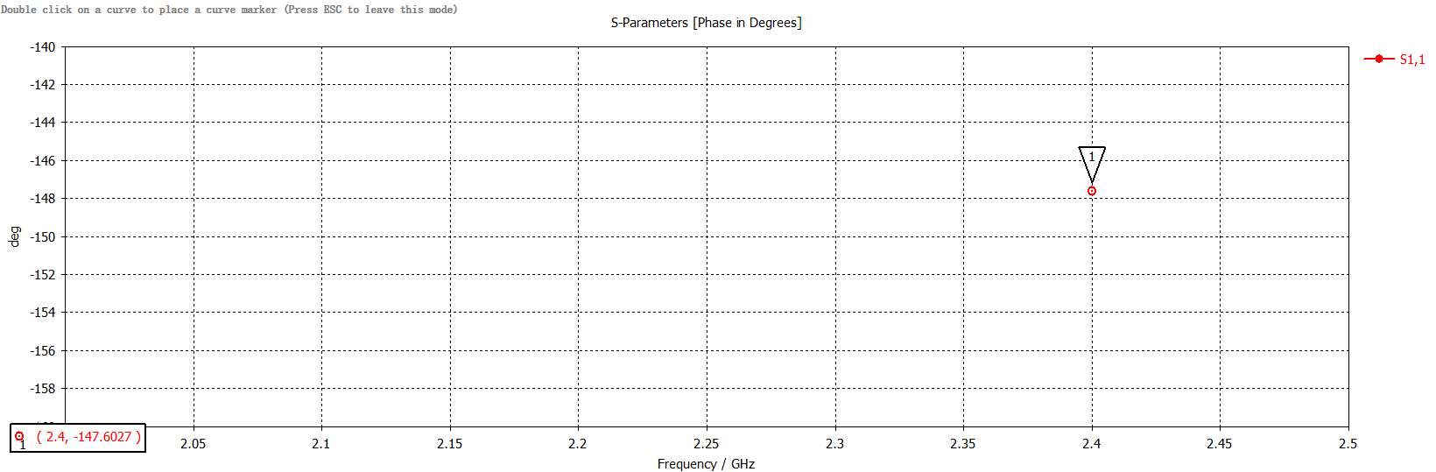

Fig. 8. The circuit elements of impedance set and ZL1(dB), ZL1(Phase).

In the adjustment process, we keep the resistance unchanged to reduce degrees of freedom of the system. After adjustment on the Smith Chart, we can find the closest set which matches our design target. It’s shown in figure 9, with a 15nH inductance, a 6.2nH inductance and a 10 Ohm resistance.

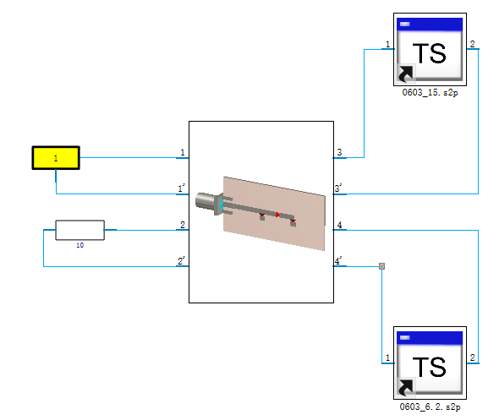

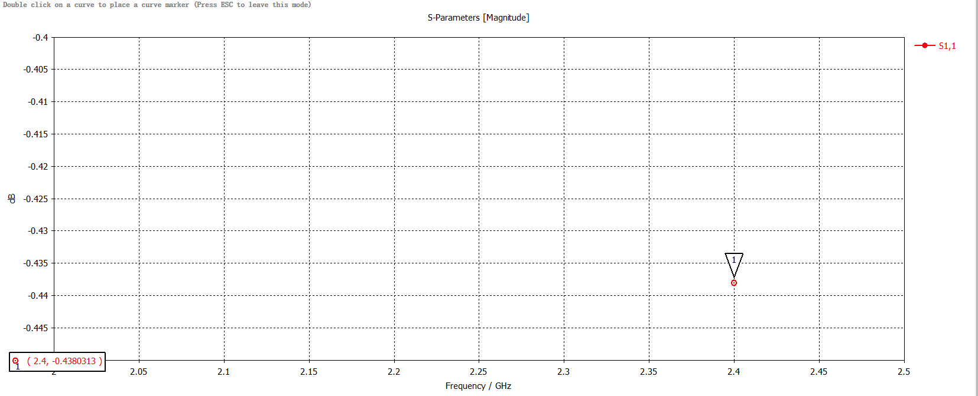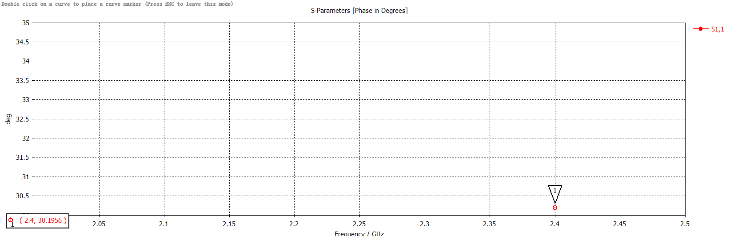Fig. 9. The circuit elements of impedance set and ZL2(dB), ZL2(Phase).

As shown is figure 9, ZL2(dB) is -0.4380313dB, ZL2(Phase) is 30.1956 degrees. Therefore, we can calculate:

Both design targets are satisfied.

In addition, we find that when replacing the ideal components with real-world S-parameters files of the component, the degrees drafting can up to 15 degrees or more, the performance gap between the ideal simulation and real-world circuit is quite large.

## Real-world PCB Soldering and Measurements

In order to reduce the amount of solder used in the soldering process to get more precise measurement result, we choose to use the reflow soldering. Figure 10 is a sample of soldering result.

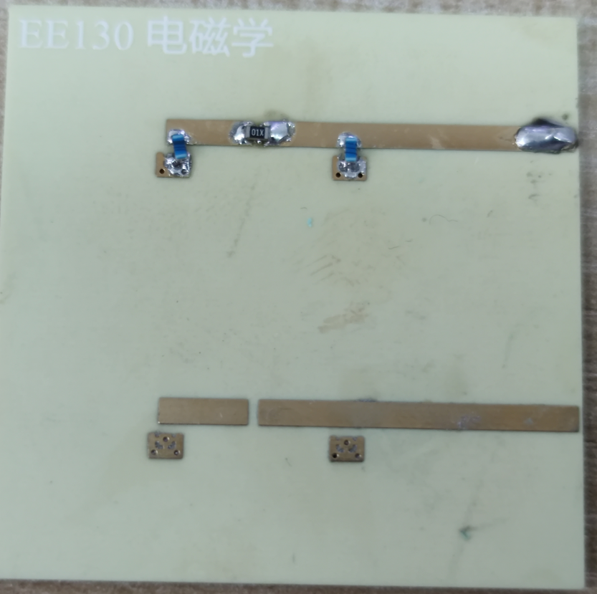

Fig. 10. A soldered component sets with reflow soldering

As shown in the figure 11, with vector network analyzer, we measure the real-world impedances of 2 sets: ZL1(M)(dB) is -1.2295dB, ZL2(M)(dB) is -1.0122dB.

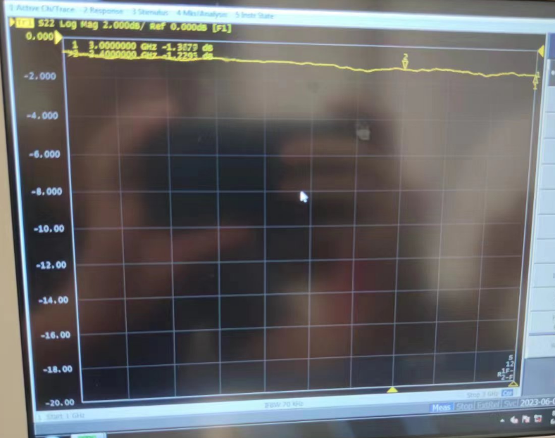

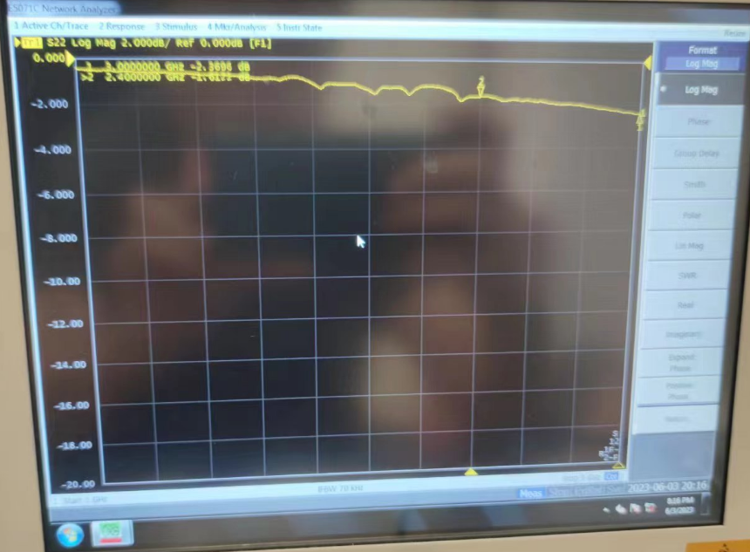

Fig. 11. Measurement results.

Therefore, we can calculate:

Both design targets are satisfied.

It is satisfying to find that with reflow soldering and careful work, we can achieve 1dB accuracy.

## Error Analysis

The source of error in simulation can be:

1) Intrinsic error of simulation software version and solver.

2) The difference between the PCB model and the real situation.

3) Not having real-world S-parameters files of the resistance

for simulation.

The source of error in real-world measurement can be:

1) Solder creates additional parasitic capacitance and parasitic inductance

2) Additional parasitic capacitance and parasitic inductance of the PCB itself.

3) Interference caused by the electromagnetic environment in the laboratory.

4) The difference between the electromagnetic properties of the used electronic components and the S-parameters files form Murata used in the simulation.

5) Not having real-world S-parameters files of the resistance

for simulation.

What’s more, it's worth noting that SMA grounding is vital for the real-world measurement, which is a common mistake to neglect it. Figure 11 show a wrong measurement result without SMA grounding, which is vividly differs from the real result. What’s more, the result of SMA no-grounding case will also fluctuating hugely in the process, since the whole no-grounding PCB function as an antenna.

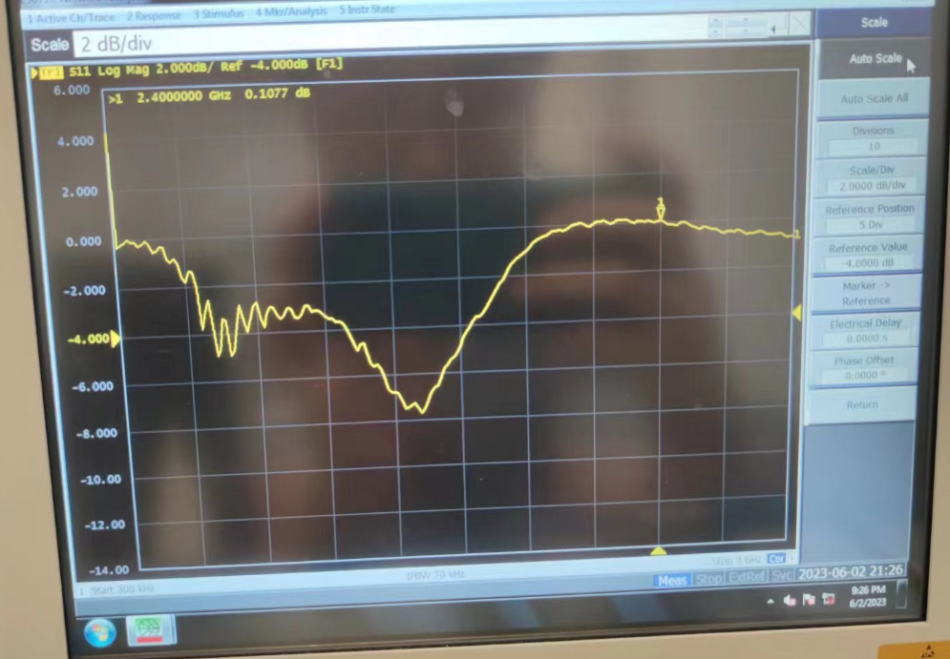

Fig. 11. An example of common mistake: no-grounding SMA.

1.