**Voting Rules Report**

**Name**: LI Zhenbang; 李 振邦

**ID**: 6930350945

**Grade**: M1

**Lab**: Nakamura Lab, Academic Center for Computing and Media Studies (ACCMS)

**Theory**

Answer the following questions while providing the necessary explanation.

1. What are the drawbacks of the Majority rule system? Give real-world examples.

2. Which voting system do you think is the most effective or best in your opinion?

3. Illustrate the steps required to calculate the Copeland scores of the example of slide 33.

Draw the corresponding graph representation.

4. Which voting axioms are the most important in a democratic system?

**Explanation**

Q1

1) In the majority rule systems, the preferences and rights of the minor groups may be neglected or suppressed.

For example, there have been years of minority movements in the United States. In the early majority voting system, various discriminatory systems including racial segregation were enacted. The situation was changed only after the whole Majority rule system was changed.

2) Majority rule systems can result in short-term interest decision making.

For example, the UK’s referendum on leaving the EU was a majority vote. In the short term, the impact of the European debt crisis on the UK has been reduced to a certain extent. However, in the long run, the trade obstruction and domestic conflicts caused by Brexit have caused more and more doubts.

3) Majority rule system may lose efficiency

For example, in a two-party majority system, the formulation and review of bills take a long time.

Q2

I thinking is the proportional representation (PR), where the subgroups of an electorate are reflected proportionately in the elected body. The essence of such systems is that almost all votes cast contribute to the result and are effectively used to help elect someone who can represent all target groups. Therefore, fairness is guaranteed to a certain extent, and the tyranny of the majority is strongly weakened. Since it is a representative system, the efficiency is also guaranteed to a certain extent.

Q3

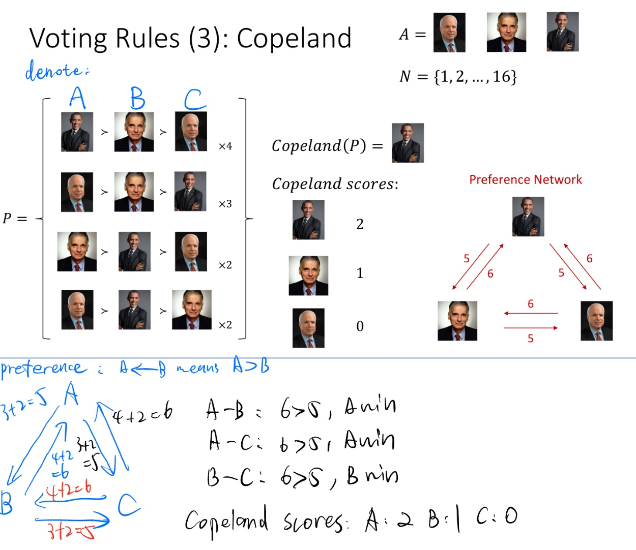

Q4

Anonymity. Neutrality. Non-dictatorship. Consistency. Unanimity.

**Implementation**

1. Go to the GitHub repository of the COMPSOC SDK (https://github.com/raviq/compsoc).

2. Install the SDK. Refer to README for more information on the dependencies.

3. Run some examples using the command described in the usage section of the README.

For instance, try different numbers of candidates and voters given the voting rules Dowdall,

Simpson, Copeland, and Borda implemented in the voting_rules folder.

4. The example in tests/simple_rule contains a rule named borda_alpha. Run the example using the command line. Describe what the rule does.

5. Write your own rule and test it.

6. Write a one-page report where you explain and interpret the logic and results of your rule.

Which axioms does your rule satisfy, and which axioms does it not satisfy?

**Explanation**

Q4

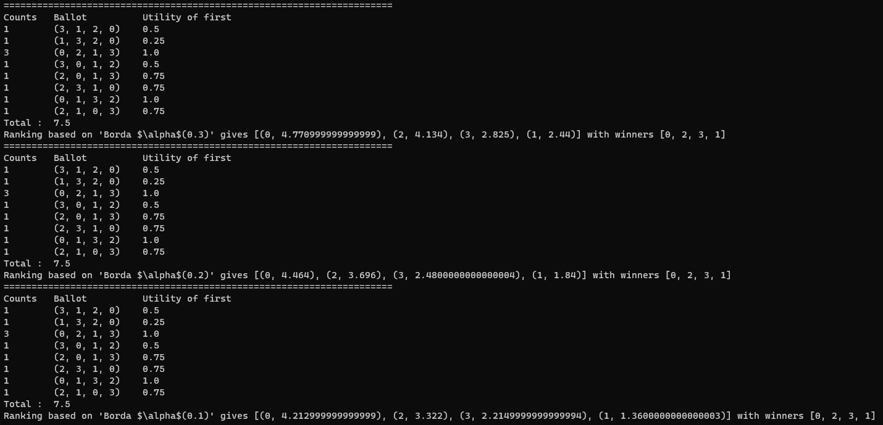

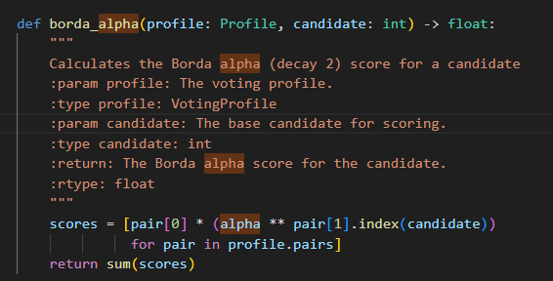

borda_alpha means do a borda voting with a decay factor alpha (0.3, 0.2, 0.1 in the example above). For the computing of the score in profile pairs, power candidate index with alpha as the base, and sum up to get the final borda-alpha score of the candidate.

**Explanation**

Q5

My voting rule in my_rule.py is called the borda_xform. It is also based on borda voting.

The detailed implement is:

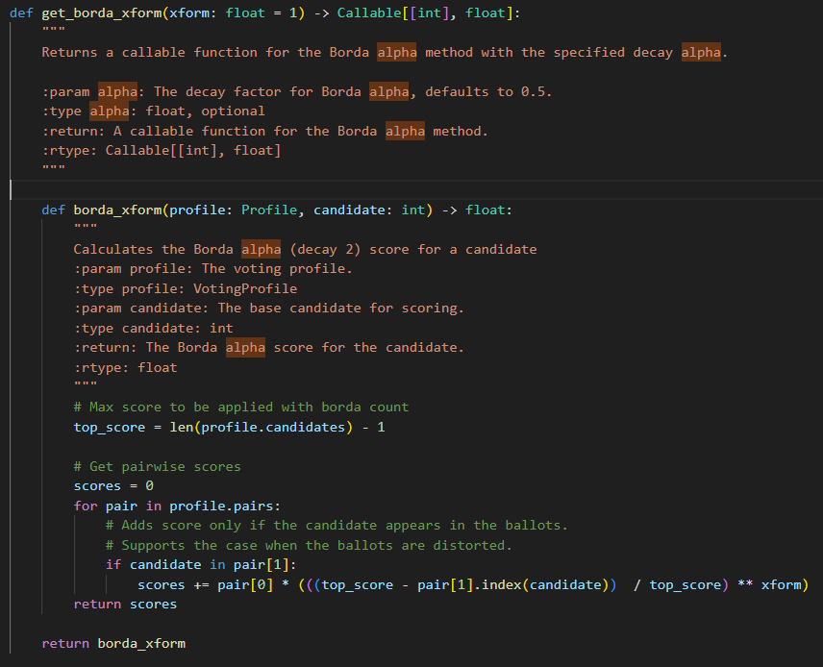

It is like the mixing the idea from traditional borda voting and borda-alpha voting. Here I normalize the relative score level in traditional borda voting and add a xform factor as a power index to allow controlling for the speed of decay process between the layers.

Here is a test result of borda-xform voting

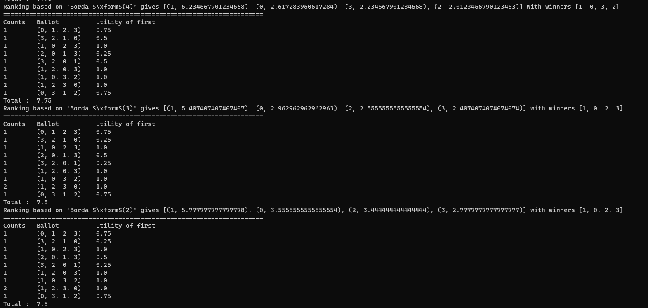

Axioms satisfy: Anonymity, Anonymity, Non-dictatorship

Axioms not satisfy: Non-imposition