Note: I used WSL to run these commands.

Task 1:

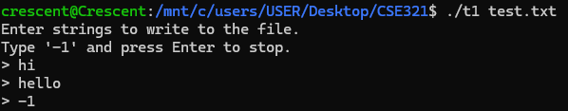

test.txt

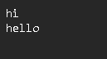

Task 2:

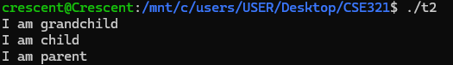

Task 3:



Task 4:

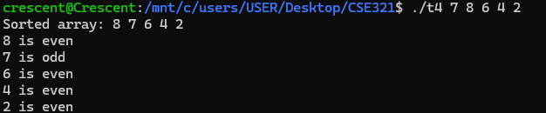

Task 5:

