* 5.6 采用手算、回溯、前向检查、MRV以及Least constraining value策略解密码算术问题：

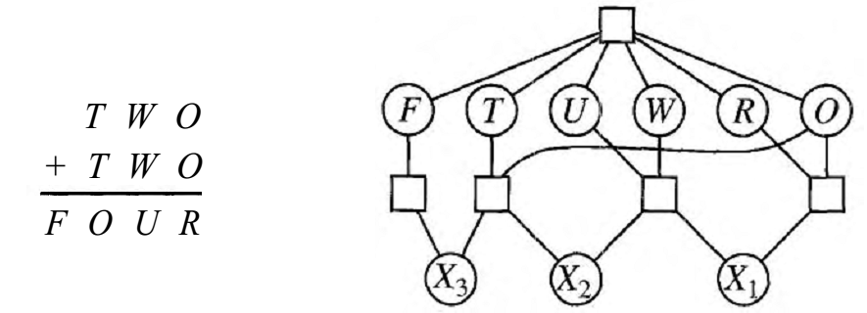

Variables: F T U W R O X1 X2 X3

Domains: {0,1,2,3,4,5,6,7,8,9}

Constraints: Alldiff (F,T,U,W,R,O)

O + O = R + 10 · X1

X1 + W + W = U + 10 · X2

X2 + T + T = O + 10 · X3

X3 = F, T ≠ 0, F ≠ 0

X1、X2、X3的值域为{0，1}。

因为X3 = F ≠ 0, 所以X3 = 1、F=1。T、U、W、R、O的值域为{0,2,3,4,5,6,7,8,9}。T的值域为{2,3,4,5,6,7,8,9}。使用MRV给T赋值。

根据约束X2 + T + T = O + 10 · X3可得：X2 + 2T = O + 10。则O = X2 + 2T – 10

T = 2,3,4时O为负值，不在值域范围。T=5时，O=0,考虑O + O=R+10*X1, R只能为负数矛盾。回溯到T。当T = 6,7,8时, O有2个取值，因此使用最小约束值启发，取T=6。

由X2 + 2T = O + 10得O = X2 + 2, O只有2个取值，根据MRV启发给O赋值。取O=2, 可以得X2=0。根据约束X1 + W + W = U + 10 *X2得X1 + 2W=U, O+O=R+10*X1得R+10*X1=4则R=4-10*X1. R的取值只有4.赋值R=4，X1=0, 此时F=1,T=6,O=2,R=4 想X1+2W=U得2W=U, U的值域为剩余偶数集合{0,8}并且具有比W更小的域。因此，我们为U赋值, U=0，则W=0矛盾，回溯到U

赋值U=2, W=4与R相矛盾，回溯到O.

赋值O=3则X2=1, X1 + W + W = U + 10 * X2得X1 + 2W = U+ 10, O + O=R+10 * R1

得R + 10*X1=6与上述差不多，R=-6矛盾，回溯到T

T=7， X2 + T + T= O + 10 * X3得X2 + 14 = O + 10 O = X2 + 4, O只有2个取值{4,5}。因此根据MRV选择为O赋值，赋O=4得X2=0, X1 + W + W=U + 10 *X2得X1+2W=U, O+O=R+10*X1得R + 10*X1 = 8，此时X1只能为8.因此赋值R=8。可以推出X1=0, X1+2W=U得2W=U,U的可能取值为{0,2,6}，小于W的取值数。为U赋值6，此时F=1,T=7,O=4,R=8,U=6,此时W=3才能满足所有约束，则最终的解为：F=1,T=7,O=4,R=8,U=6,W=3.

* Consider the following logic puzzle: In five houses, each with a different color, live 5 persons of different nationalities, each of whom prefer a different brand of cigarette, a different drink, and a different pet. Given the following facts, the question to answer is ''Where does the zebra live, and in which house do they drink water?"
  + The Englishman lives in the red house.
  + The Spaniard owns the dog.
  + The Norwegian lives in the first house on the left.
  + Kools are smoked in the yellow house.
  + The man who smokes Chesterfields lives in the house next to the man with the fox.
  + The Norwegian lives next to the blue house.
  + The Winston smoker owns snails.
  + The Lucky Strike smoker drinks orange juice.
  + The Ukrainian drinks tea.
  + The Japanese smokes Parliaments.
  + Kools are smoked in the house next to the house where the horse is kept.
  + Coffee is drunk in the green house.
  + The Green house is immediately to the right (your right) of the ivory house.
  + Milk is drunk in the middle house.
* Discuss different representations of this problem as a CSP. Why would one prefer one representation over another?

想想下面的逻辑难题：在五户人家里，每户人家的颜色不同，住着5个不同民族的人，每个都喜欢不同牌子的香烟、不同的饮料和不同的宠物。鉴于以下事实，要回答的问题是“斑马在哪里生活，他们在哪个房子喝水？”

英国人住在红房子里。

西班牙人拥有这条狗。

挪威人住在左边的第一栋房子里。

库尔人在黄色房子里抽烟。

吸食切斯特菲尔德的人住在狐狸旁边的房子里。

挪威人住在蓝色房子旁边。

温斯顿吸烟者拥有蜗牛。

幸运的吸烟者喝橙汁。

乌克兰人喝茶。

日本人吸烟议会。

库尔是在房子旁边的房子里熏蒸的。

咖啡是在温室里喝的。

绿色房子就在象牙房子的右边（右边）。

牛奶在中间的房子里喝醉了。

讨论这个问题的不同表示作为CSP。为什么一个人喜欢一个代表胜过另一个？

Assuming that one person drinks water and one owns a zebra, then it is possible not only to deduce the answers to the two questions, but to figure out a complete solution of who lives where, in what color house, keeping what pet, drinking what drink, and smoking what brand of cigarettes. By considering the clues a few at a time, it is possible to slowly build inferences that incrementally complete the puzzle's unique correct solution. For example, by clue 10, the Norwegian lives in house #1, and by clue 15, house #2 must be blue. The Norwegian's house therefore cannot be blue, nor can it be red, where the Englishman lives (clue 2), or green or ivory, which are next to each other (clue 6). It must therefore be yellow, which means the Norwegian also smokes Kools (clue 8).

Note that clue 10 mentions the "first" house, without specifying whether it is the house on the extreme left or extreme right if standing in front of them. However, selecting either side as the first house does not change the outcome as to who drinks the water and who has the zebra.

The March 25, 1963 issue of *Life International* contained the following solution, and the names of several hundred solvers from around the world.

|  |  |  |  |  |  |
| --- | --- | --- | --- | --- | --- |
| **House** | **1** | **2** | **3** | **4** | **5** |
| **Color** | Yellow | Blue | Red | Ivory | Green |
| **Nationality** | Norwegian | Ukrainian | Englishman | Spaniard | Japanese |
| **Drink** | **Water** | Tea | Milk | Orange juice | Coffee |
| **Smoke** | Kools | Chesterfield | Old Gold | Lucky Strike | Parliament |
| **Pet** | Fox | Horse | Snails | Dog | **Zebra** |