**Component 1: Checklist**

**Student Name/ID: Niraj Shrestha / 77229162**

**Development Choice: Visual Studio Code / XAMPP**

**1. IDE – Visual Studio Code**

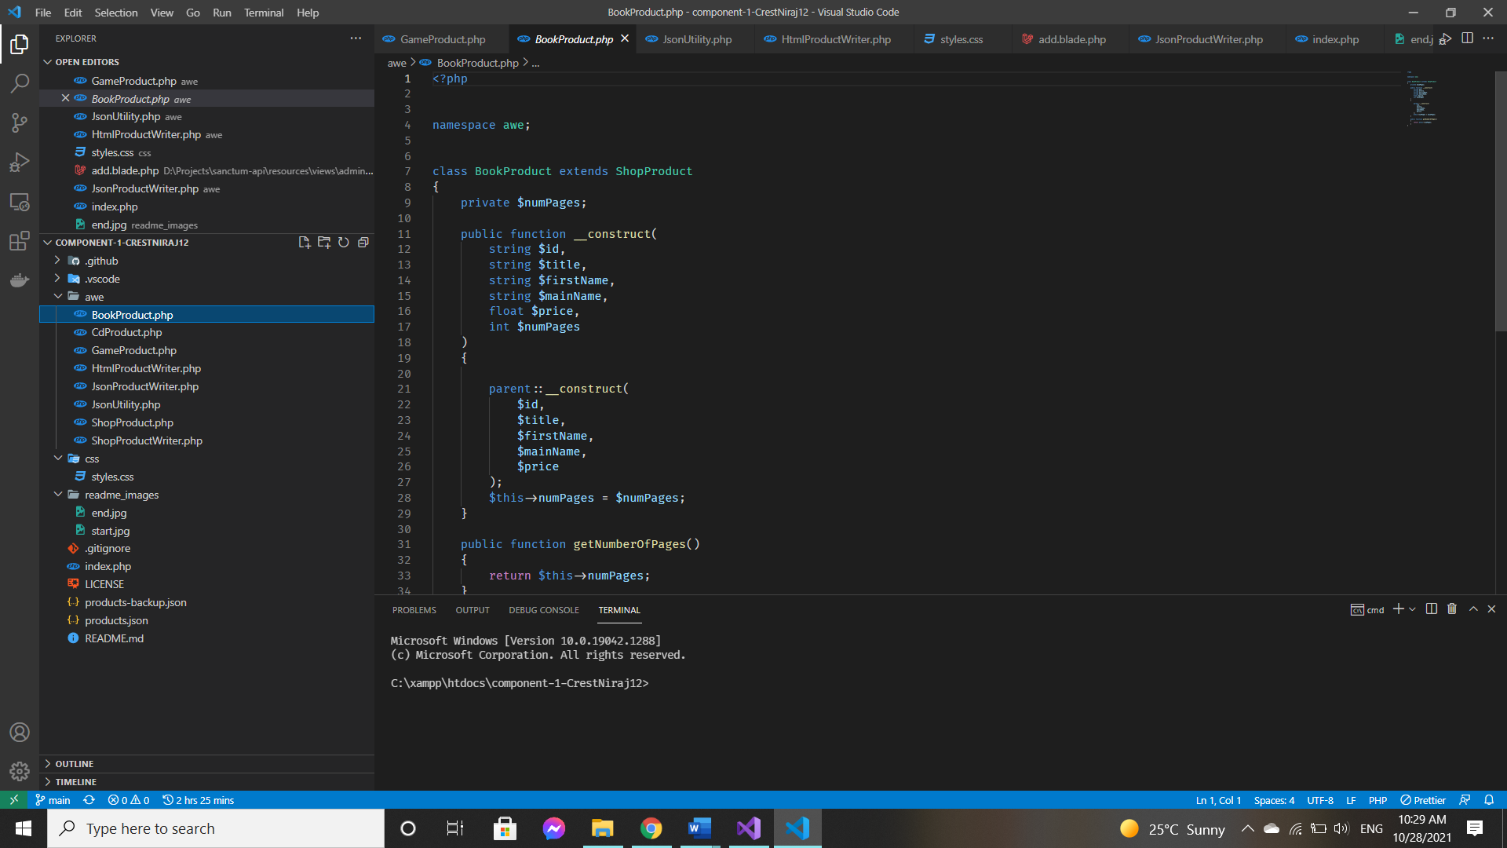

**2. VS Code’s Xdebug extension**

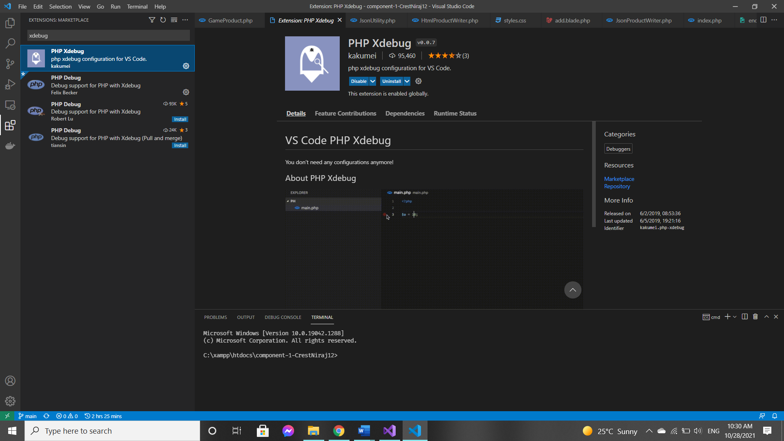

**3. Project Screenshots**

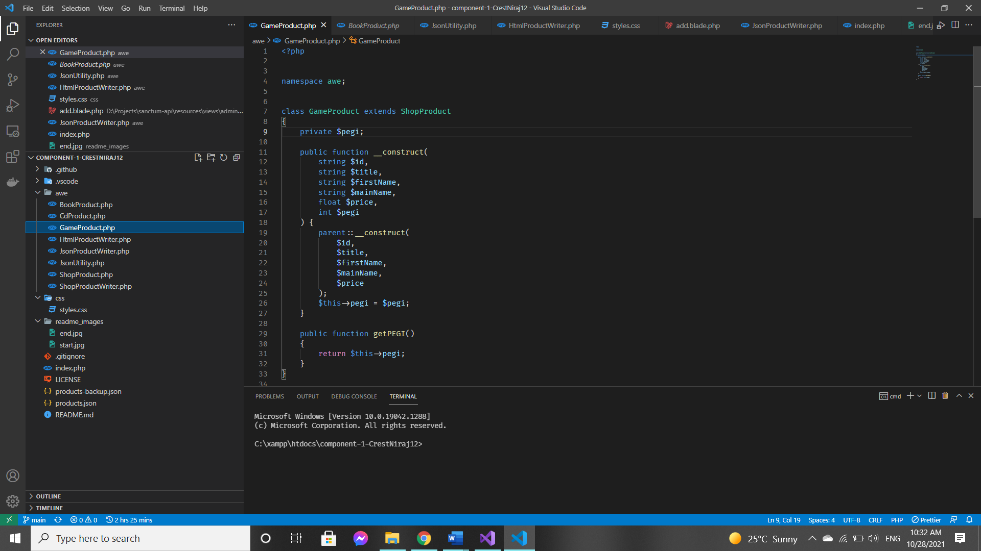

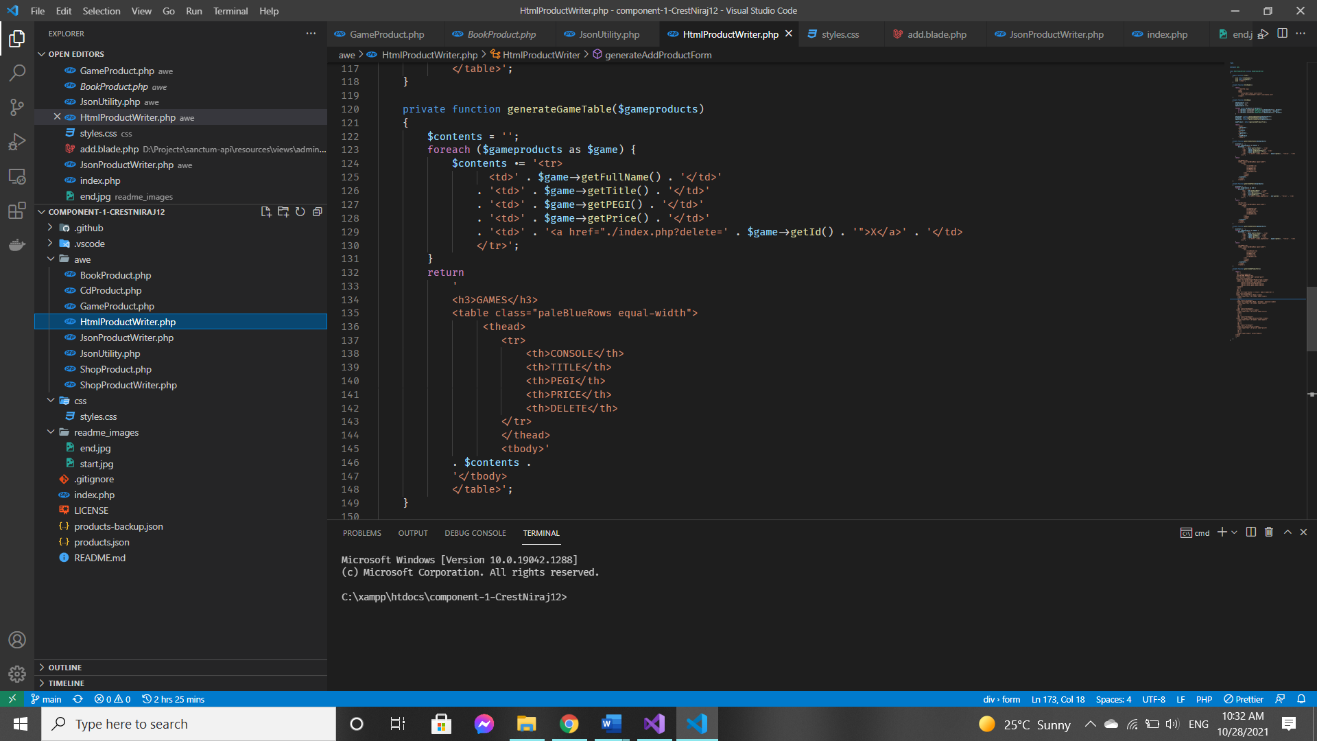

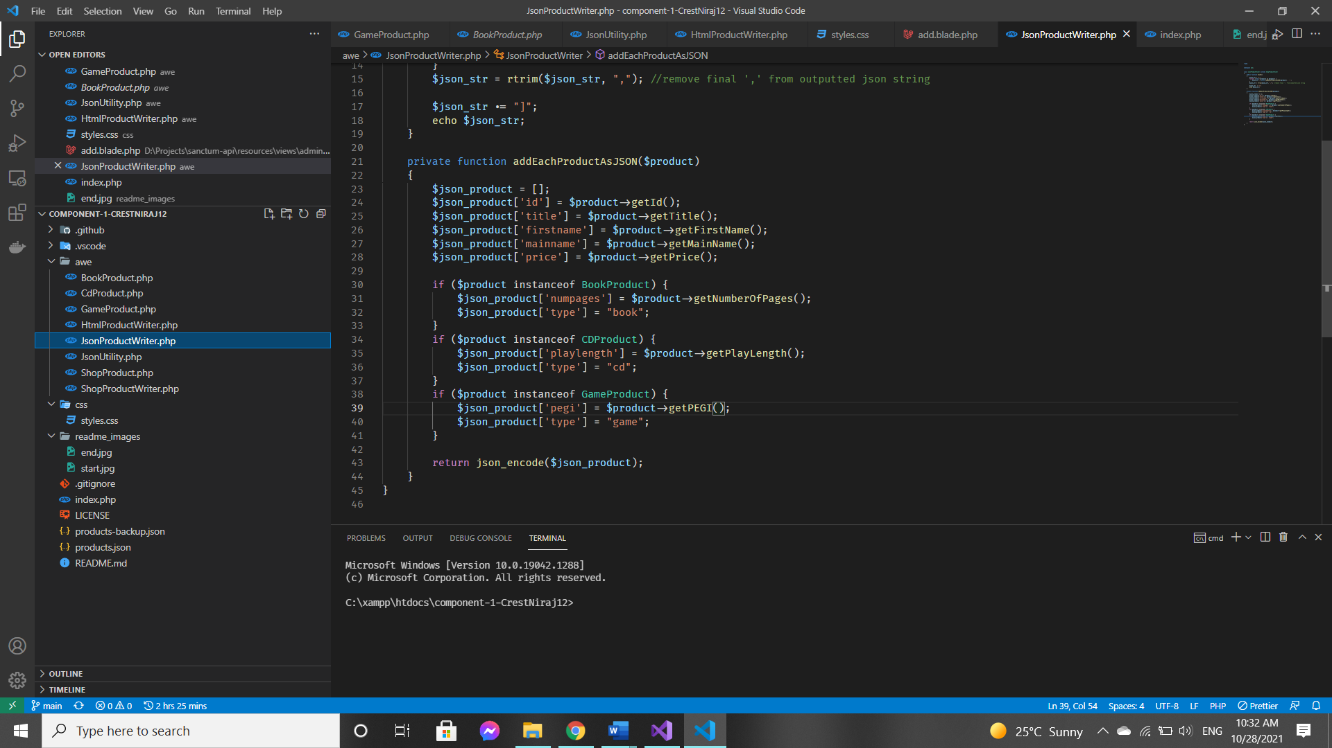

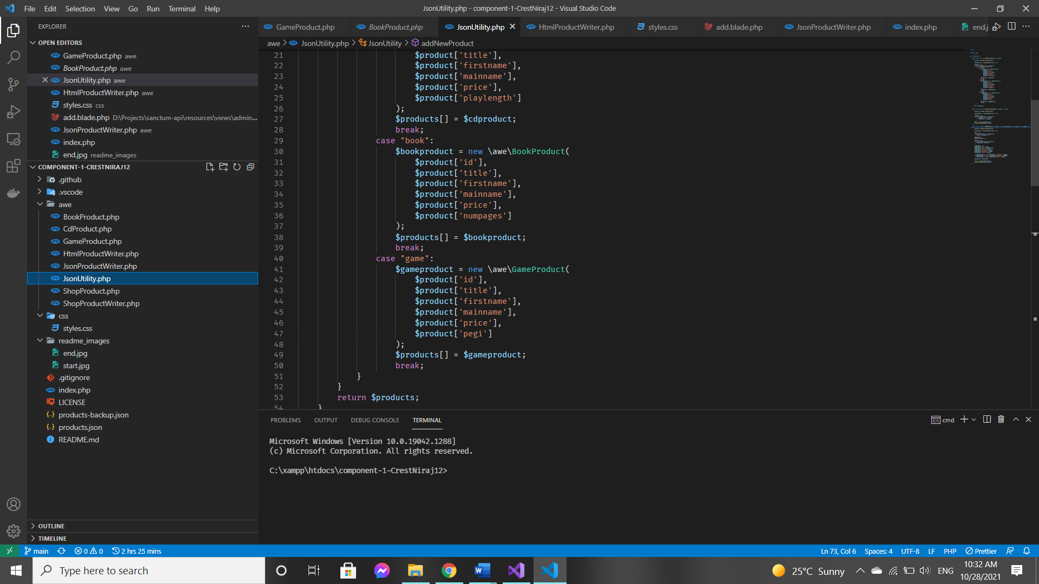

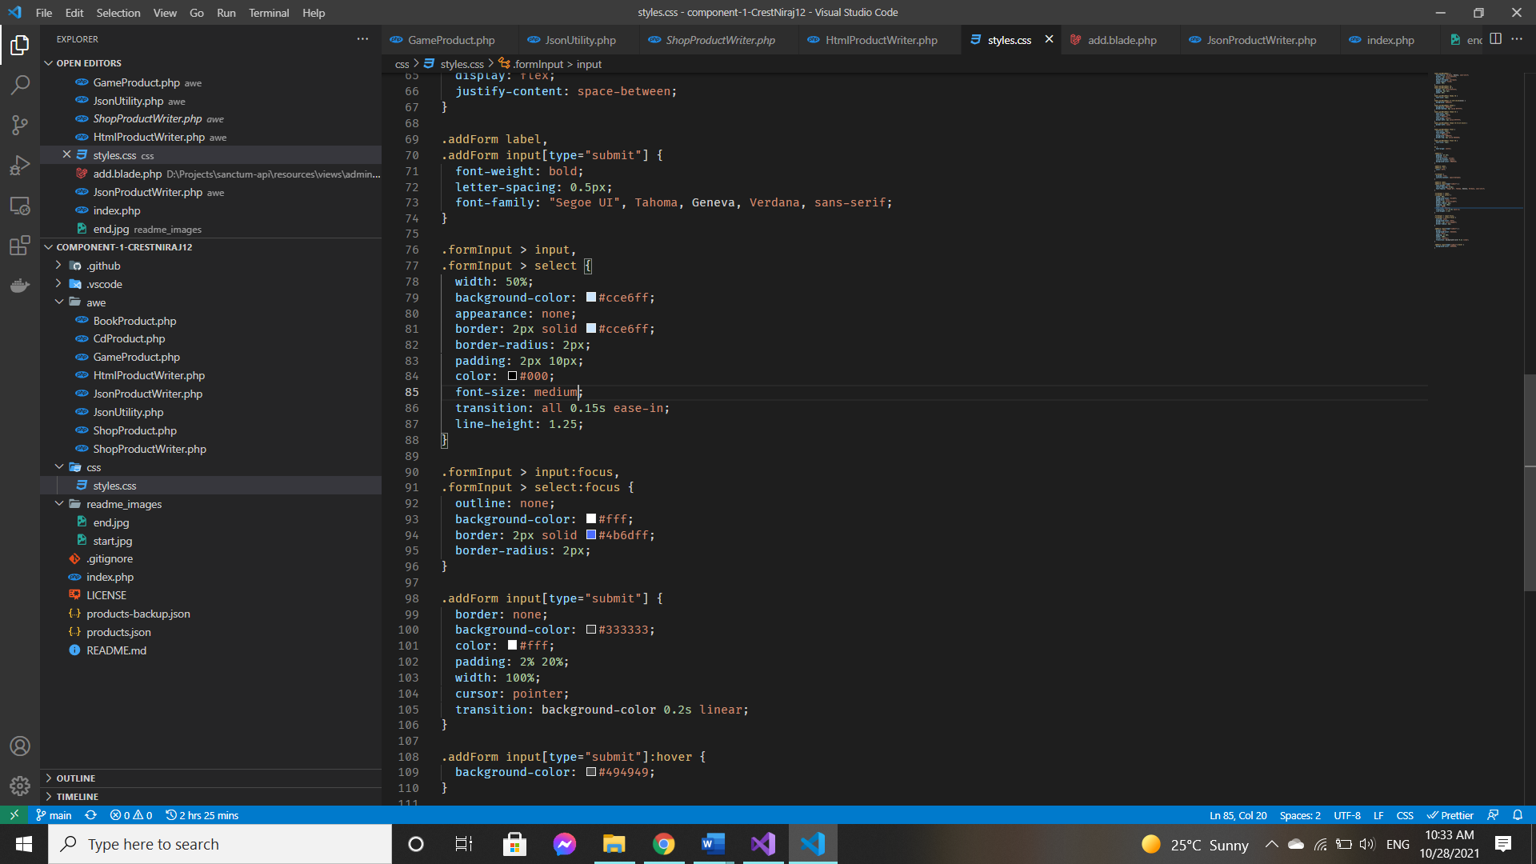

**PHP Version being used: 8.0.0 with Xdebug 3.0.0**

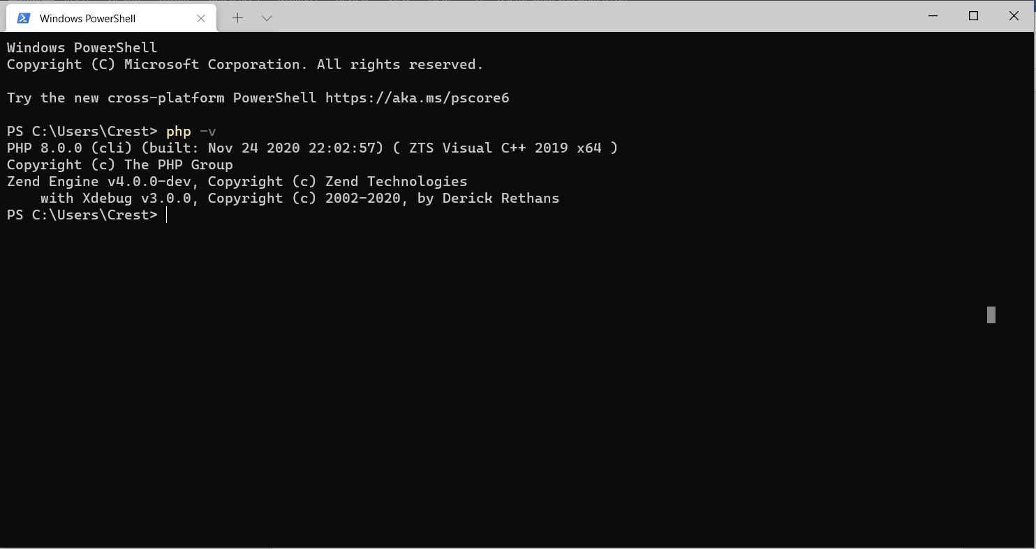

**Git account created and used:** [**https://github.com/CrestNiraj12/AWE-Component-1**](https://github.com/CrestNiraj12/AWE-Component-1)

**Frontend / UI**

