CAR RENTAL APP
SPRINT: 2 --- USER-CENTRIC DESIGN & REQUIREMENTS ENGINEERING
TEAM NAME: OG Group

Group Members:
PRANAY KUMAR YADAV ALLURI : A00044629
RAJU SHRESTHA : A00048083
NAGENDRA BABU KAYAKOKILA : A00051053
BABA RAKESH PUSALA : A00049485
DILEEP THIMMIREDDYGARI NARAYANA REDDY : A00036749

Table of Contents

1. Introduction & Sprint Goal 3
2. Elaboration of User Stories & Backlog Refinement 3
3. Design Artefacts & Software Blueprinting 4
A. Use Case Diagram 4
B. User Flow / Activity Diagram 4
C. Wireframes 6
4. Conclusion & Preparedness for Sprint 3 6

1. Introduction & Sprint Goal
Continuing the consistent project foundation in Sprint 1, Velocity Devs embarked on Sprint 2 with one apparent goal, and that was to achieve the high-level business context into detailed, actionable, and user-approved software design. The aim of the sprint was to get to know the needs of our users in an in-depth manner, elaborate on a fully functional requirement set, and develop the rough-cut specifications of our application. This makes sure that our development processes in further sprints are in line with addressing actual user problems effectively and efficiently.

2. Elaboration of User Stories & Backlog Refinement
In Sprint 1, we determined our major personas, which were Oliver Thompson (the Business Owner) and Amelia Green (the Customer). Sprint 2 targeted breaking their requirements into a fine product backlog. We patented a complete execution of user stories, which were formatted with lucid as a... I want to... so that..." structure, with elaborate Acceptance Criteria (AC). This served to convert the general objectives into development tasks that are specific and testable.
The example is the problem of the occurrence of double-bookings as a problem statement in our initial problem statement has been addressed by User Story 4: Duplicate Booking Prevention explicitly. The acceptance criteria clearly stipulates that the system should not allow a client to book the same car on the same day within the same time and the system should verify at both application and database level to confirm that the data is received in a correct format. On the same note, User Story 7: System Integrity and Validation can satisfy Oliver in his need of having an efficient management system as it aims at the rules involving whether the back-end of the system to ensure good and error-free bookings (Soehnchen et al. 2023).
We have officially added and managed these user stories on our Github Projects board which is our official Sprint Backlog and Task Board. Owners, priorities, and other appropriate labels are attached to each story (e.g., front-end, back-end, database) and give complete visibility into the working process and advance of the team.

3. Design Artefacts & Software Blueprinting
We prepared a set of design diagrams in order to visualize functionality of the application and user interaction. These artefacts will be critical communication tool, to make sure that they have a common understanding between all the team members before the writing of a single line of code (Habiba, Bogner and Wagner, 2022).

A. Use Case Diagram
Use Case Diagram gives a general outline of how the system works as seen by an external actor of the system. It explicitly outlined the interactions between two key actors Customer and Administrator, and the fundamental system activity.
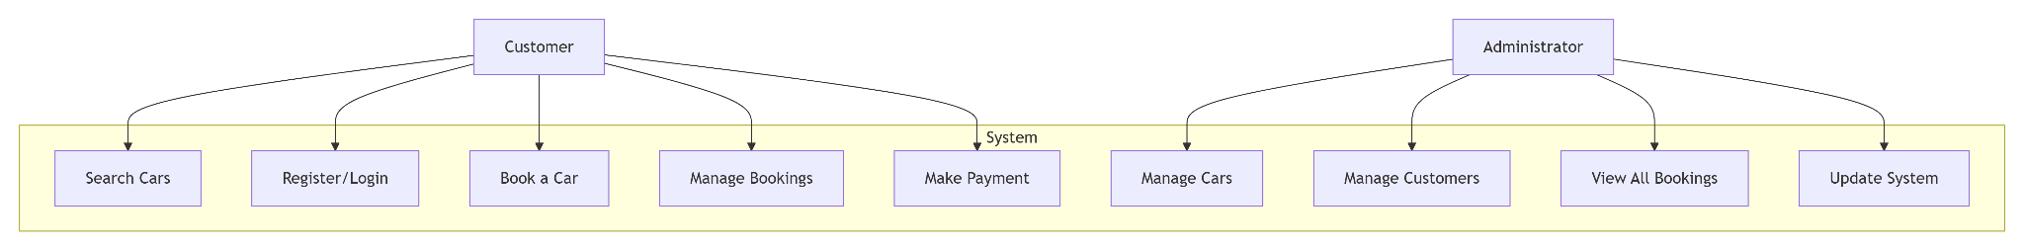
Figure 1: Use Case Diagram showing actor interactions with the Car Rental System
(Source: Self-Created)

B. User Flow / Activity Diagram
The process of mapping the users experience is important in ensuring a user-friendly experience. The diagrams provided below visualize the points where a customer makes essential steps to search and reserve a car by specifying decision points and business logic.
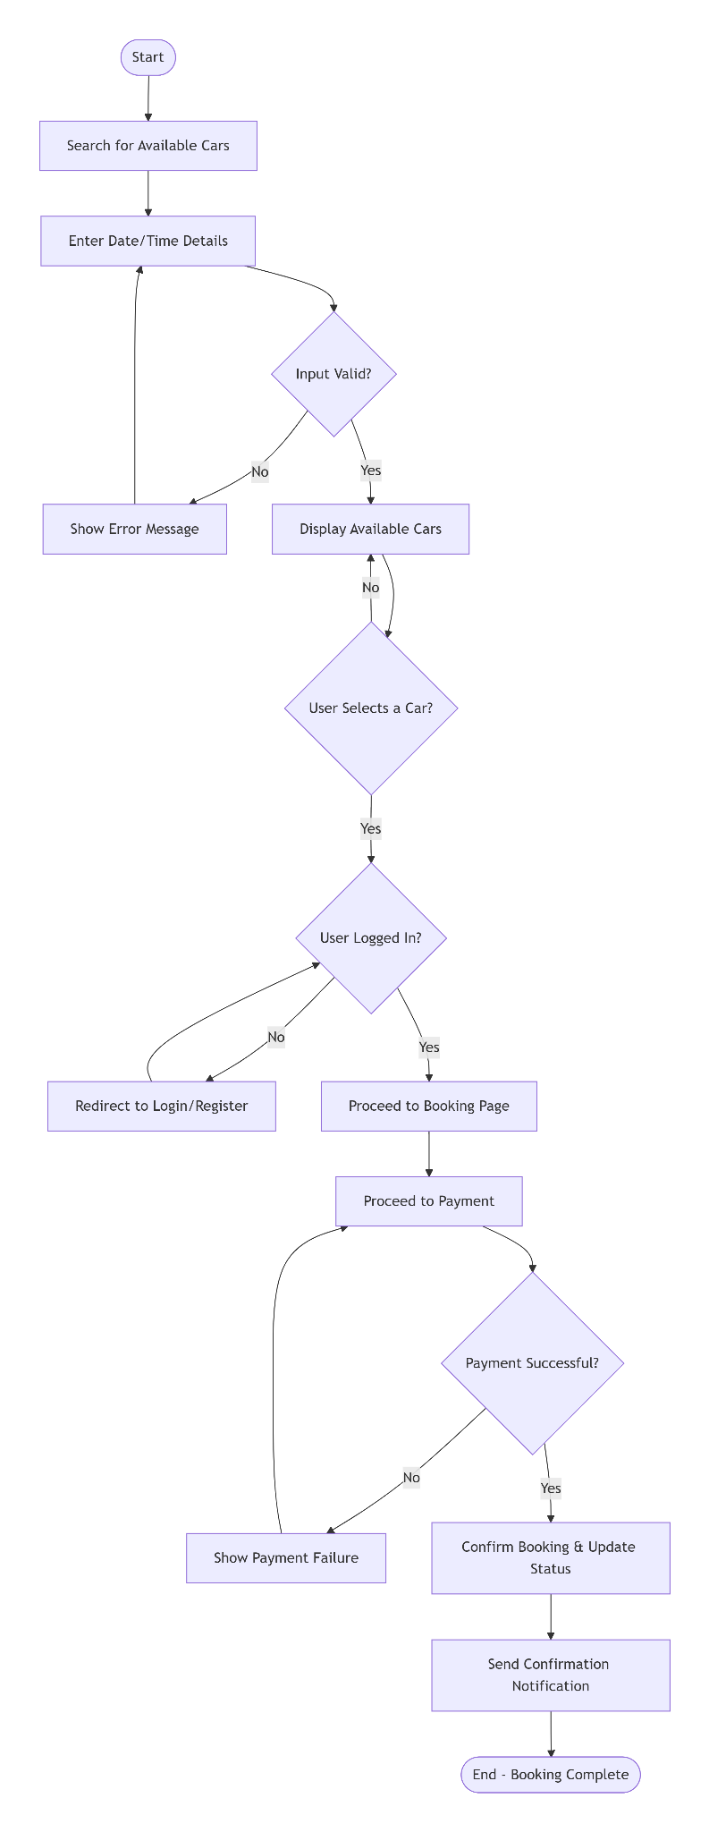
Figure 2: User Activity Diagram for the car search and booking process
(Source: Self-Created)

C. Wireframes
The major user stories were sketched in low-fidelity wireframes to determine the layout and essential elements of the main pages without being distracted with visual design. These include:
Car Search Page: It includes a date/time pickers and a search button as well as a car results grid that displays images, details and prices of the cars.
Booking Summary Page: It shows the information of the choice of car, the rent period, the total price clearly and a big proceed to payment button.
User Dashboard: There will be some tabs with the user being able to see their future, previous, and cancelled bookings with the option of their being able to cancel their active bookings (Snoeck and Wautelet, 2022).

4. Conclusion & Preparedness for Sprint 3
Sprint 2 was very fruitful as it has been effective in bridging the concept, and the concrete design. We have developed a strong and ordered product backlog, confirmed our comprehension of the user requirements by developing detailed user stories and acceptance criteria, and drew up necessary design blueprints. The Use Case and Activity diagrams will provide the entire team and stakeholders with a single picture of the scope and flow of the system.
Having a refined backlog and a well-defined design guide in place, Velocity Devs is now in the ideal position to start working on Sprint 3 development. We will switch to the implementation of the back-end infrastructure, which consists of a database schema, a Node.js/express server, and API endpoints, and develop the beginning of the back-end templates with a PUG, first in the form of the most important user story, e.g., User Story 1 (Car Search) and User Story 2 (Car Booking).

