**A**

**Project Report**

**On**

**ACPLAY**

**Submitted by**

***Arth Vala [210510312010]***

***Chetan Patil [210510311003]***

***Prince Jasani [210510314006]***

**as**

**Partial fulfilment of Semester V**

**of Bachelor of Computer Applications/ Bachelor of Science in Information Technology/ Integrated Master of Computer Applications**

**for A.Y. 2023-2024**

**Under the Guidance of**

**Dr. Mukesh Choudhary**

**Submitted To**

**Parul Institute of Computer Application,**

**Faculty of IT & Computer Science**

**Parul University**



**PARUL INSTITUTE OF COMPUTER APPLICATION**

**CERTIFICATE**

This is to certify that ***Arth Vala, Chetan Patil, Prince Jasani*** the student(s) of Parul Institute of Computer Application, has/have satisfactorily completed the project entitled “***ACPlay”*** as a part of course curriculum in BCA / BSCIT/ IMCA semester-V for the academic year 2023-2024 under guidance of ***Dr. Mukesh Choudhary.***

Enrolment Number: 210510312010

Enrolment Number: 210510311003

Enrolment Number: 210510314006

|  |  |  |
| --- | --- | --- |
| **Quality of work** | **Grade** | **Sign of Internal guide** |
| **Poor / Average / Good /Excellent** | **B /B+ / A / A+** |  |

Date of submission:

HOD, Principal,

Prof. Dr Hina Chokshi Dr. Priya Swaminarayan

**Acknowledgement**

*The success and final outcome of this project required a lot of guidance and assistance from many people and we are extremely privileged to have got this all along the completion of our project. All that we have done is only due to such supervision and assistance and we would not forget to thank them.*

*We respect and thank Dr Priya Swaminarayan, Dean, FITCS for providing us an opportunity to do the project work in BCA and giving us all support and guidance, which made us complete the project duly. We are extremely thankful to Mam for providing her support and guidance, although she had busy schedule managing the academic affairs.*

*We would not forget to remember Prof. Hina Chokshi, HOD, BCA department for her encouragement and more over for her timely support and guidance till the completion of our project work.*

*We owe our deep gratitude to our project guide Dr. Mukesh Choudhary, who took keen interest on our project work and guided us all along, till the completion of our project work by providing all the necessary information for developing a good system.*

*We are thankful to and fortunate enough to get constant encouragement, support and guidance from our Parents, all Teaching staffs of BCA Department which helped us in successfully completing our project work. Also, we would like to extend our sincere esteems to all staff in laboratory for their timely support.*

***Arth Vala [2105103120010]***

***Chetan Patil [210510311003]***

***Prince Jasani [210510314006]***

**Abstract**

ACPlay is an online video-sharing platform that allows users to upload, view, and share videos. On ACPlay, individuals and organizations can create their own channels and upload videos in various formats, such as music videos, vlogs, tutorials, documentaries, comedy sketches, and more. Users can Recognize to channels they like. They can also leave comments, like or dislike videos, and share them with others via social media platforms or embedded links.

ACPlay influence extends beyond the platform itself, as videos hosted on YouTube are embedded and shared on other websites and social media platforms, contributing to its widespread reach and impact on popular culture. Many video sharing platforms have monetization options for content creators. These can include advertisements displayed before, during, or after videos, as well as opportunities for creators to earn revenue through sponsorships, brand partnerships, merchandise sales, and premium content offerings. Some platforms also offer revenue-sharing programs, where creators receive a percentage of the advertising revenue generated by their videos.

**Table of Contents**

1. **Research2**
2. **Feasibility Study3**
3. **Requirement Gathering Analysis5**

**3.2 Functional Requirement…………………………………………………………………………………………………………………………………..5**

**3.3 Non Functional Requirement…………………………………………………………………………………………………………………………...5**

**4. System Requirement Specification7**

**4.1 Software Requirement…………………………………………………………………………………………………………………………………….7**

**4.2 Hardware Requirement…………………………………………………………………………………………………………..……………………….8**

**4.5 Flowchart………………………………………………………………………………………………………………………………..……………………….9**

**4.6 Timeline Chart……………………………………………………………………………………………………………………….……………………….10**

**4.7 Data Flow Diagram……………………………………………………………………………………………………………….………..……………………….11**

**4.8 Sequence Diagram……………………………………………………………………………………………………..…………………………………………….14**

**4.9 Activity Diagram………………………………………………………………………………………………………………………………….15**

**4.10 Entity Relationship Diagram………………………………………………………………………………………………..……………………….16**

**4.11 Use Case Diagram………………………………………………………………………………………………………………..……………………….17**

**4.12 Class Diagram……………………………………………………………………………………………………………………………………………….18**

**5. Data Dictionary19**

**6. Development Phase 1…………………………………………………………………………………………….………………………………………..22**

**7. Development Phase 2…………………………………………………………………………………………………………….……………………….25**

**8. Future Enhancement……………………………………………………………………………………………………………….……………………….26**

**9. References……………………………………………………………………………………………………………………………………………………….27**

1. **Research**
   1. **Project Research**

When the Project was announced by the University Department, We started to do research on what we can make in this project. Then In sometime, We came up with this Project Idea:

ACPlay which is a online video sharing platform that allows users to upload, view, search and share videos.

* 1. **Software Research**

To create ACPlay web application, e had 2 ways to make this web application. Firstly, By using HTML, CSS & JS. Other way was to make it by using some well-known framework called React. We conducted a research where we discovered that we’ll need REACT as Framework, TAILWIND for Styling, MONGODB for Database and VSCODE as a Text Editor.

* 1. **Hardware Research**

We Organized a research for ACPlay, where we discovered that which basic hardware will be required to run this web application.

|  |  |
| --- | --- |
| **Name of Components** | **Specification** |
| Processor | Minimum Intel i3 or Ryzen 3 |
| RAM | Minimum 2GB Ram |
| Hard Disk | Minimum 1GB Storage |

**­­­­**

**2. Feasibility Study**

**2.1 What is Feasibility?**

Feasibility refers to the evaluation and analysis of whether a project is technically, economically, and operationally viable. It involves assessing the project's potential to be successfully completed within the specified constraints, such as time, budget, resources, and desired outcomes.

A well-designed study should offer a historical background of the business or project, such as a description of the product or service, accounting statements, details of operations and management marketing research and policies, financial data, legal requirements, and tax obligations. Such studies precede technical development and project implementation.

There are three types of Feasibility:

**2.2.Technical Feasibility**

This assessment focuses on the technical resources available to the organization. It helps organizations determine whether the technical resources meet capacity and whether the technical team is capable of converting the ideas into working systems. Technical feasibility also involves the evaluation of the hardware, software, and other technical requirements of the proposed system. As an exaggerated example, an organization wouldn't want to try to put Star Trek's transporters in their building- currently, this project is not technically feasible.

**2.3 Economic Feasibility**

This assessment typically involves a cost/ benefits analysis of the project, helping organizations determine the viability, cost, and benefits associated with a project before financial resources are allocated. It also serves as an independent project assessment and enhances project credibility-helping decision-makers determine the positive economic benefits to the organization that the proposed project will provide.

**2.4 Operational Feasibility**

Determine the viability, cost, and benefits associated with a project before financial resources are allocated. It also serves as an independent project assessment and enhances project credibility-helping decision-makers determine the positive economic benefits to the organization that the proposed project will provide.

1. **Requirement Gathering & Analysis**

Requirement gathering and analysis are essential steps in project documentation that involve identifying, collecting, and analyzing the needs and expectations of stakeholders for a particular project. This process helps in defining the project scope, objectives, and deliverables accurately.

There are four types of Requirements Gathering:

**3.1. Functional Requirements**

Functional requirements define what the system or product should do in terms of specific actions, behaviors, and features. They describe the desired functionality, operations, and interactions with the system.

**3.2. Non-Functional Requirements**

Non-functional requirements specify the qualities and characteristics of the system rather than its specific functionalities. These requirements address aspects such as performance, usability, reliability, security, scalability, and maintainability.

**3.3. User Requirements**

User requirements capture the needs and expectations of the end users or stakeholders who will interact with the system or product. These requirements take into account user preferences, workflows, tasks, and user experience considerations.

**3.4. System Requirements**

System requirements define the technical specifications and constraints of the system or product. These requirements may include hardware and software specifications, compatibility with other systems, technical interfaces, data storage requirements, and performance criteria.

**3.5 Existing system and New System**

|  |  |
| --- | --- |
| Existing System | New System |
| Django Framework | React Framework |
| Query Search | Realtime Search |
| Less Flexible | More Flexible |

1. **System Requirement Specification**

**4.1 What is SRS?**

A software requirements specification (SRS) is a description of a software system to be developed. It lays out functional and non-functional requirements and may include a set of use cases that describe user interactions that the software must provide.

**4.2 Need of SRS**

In order to fully understand one’s project, it is very important that they come up with a SRS listing out their requirements, how are they going to meet it and how will they complete the project. It helps the team to save upon their time as they are able to comprehend how are going to go about the project. Doing this also enables the team to find out about the limitations and risks early on.

**4.3 Hardware Requirements**

|  |  |
| --- | --- |
| **Name of Components** | **Specification** |
| Processor | Minimum Intel i3 or Ryzen 3 |
| RAM | Minimum 2GB Ram |
| Hard Disk | Minimum 1GB Storage |

**4.4 Software Requirements**

|  |  |
| --- | --- |
| **Name of Components** | **Specification** |
| Operating System | Windows7,8,10,11 |
| Software development Kit | Any browser, NodeJS |
| Tools & languages | JAVASCRIPT, REACT, NODEJS,  MONGODB, FIREBASE, |

* 1. **Flow Chart**

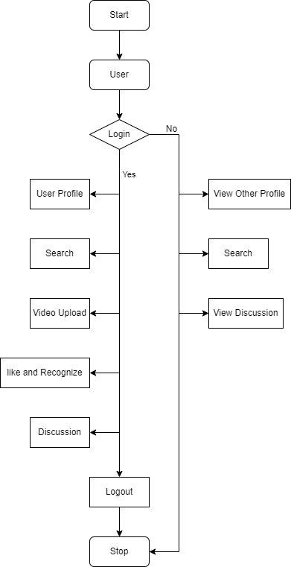

Figure 4.5 Flow diagram

* 1. **Timeline Chart**

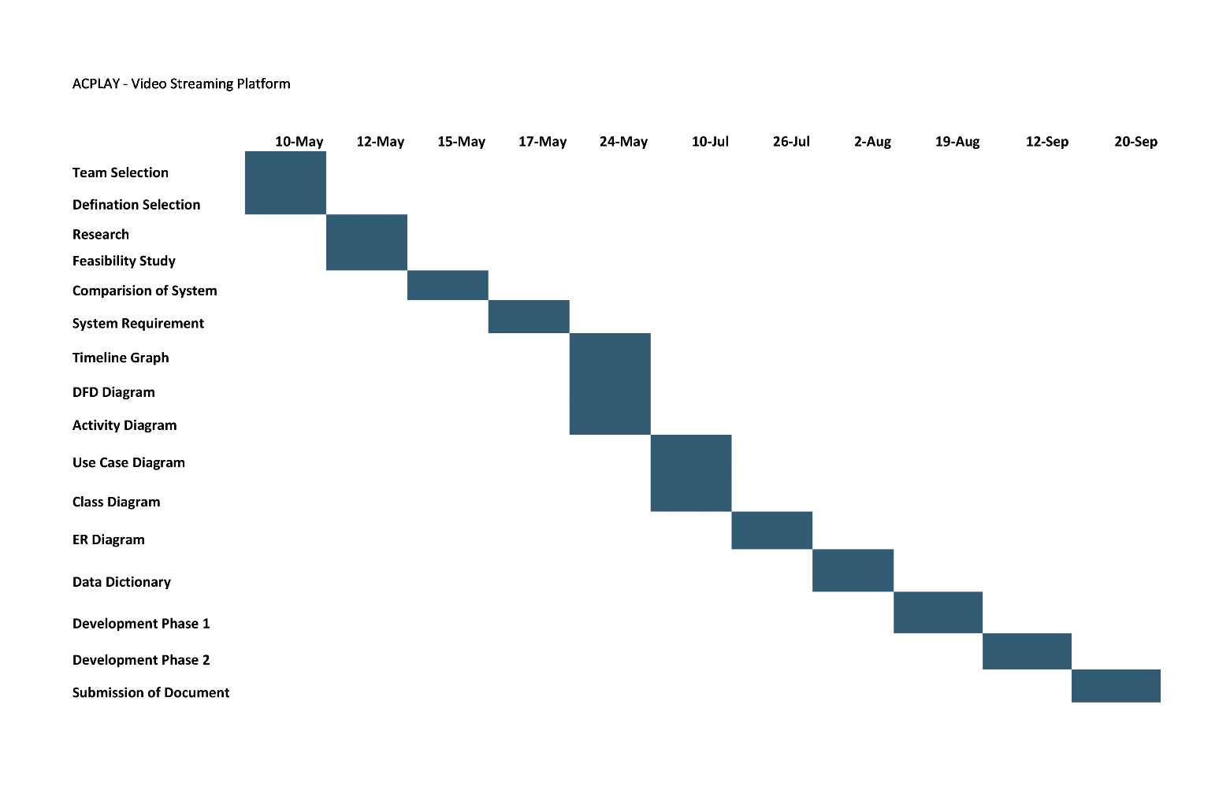

Figure 4.6 Timeline Chart

**4.7 Data Flow Diagram**

* + 1. **Context Level DFD**

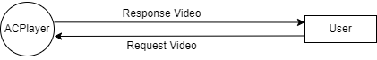

Figure 4.7.1 Context Level DFD Diagram

**4.7.2 Level 1 DFD**

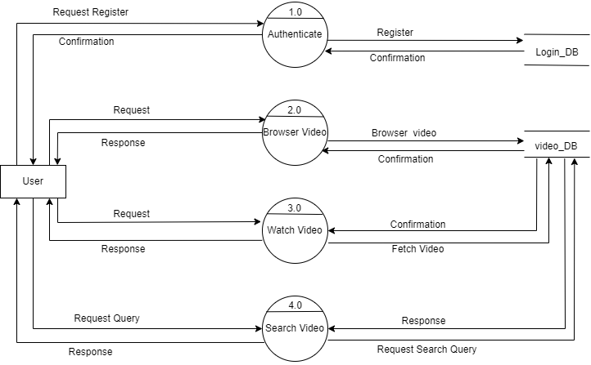

Figure 4.7.2 Level 1 DFD Diagram

**4.7.3 Level 2 DFD**

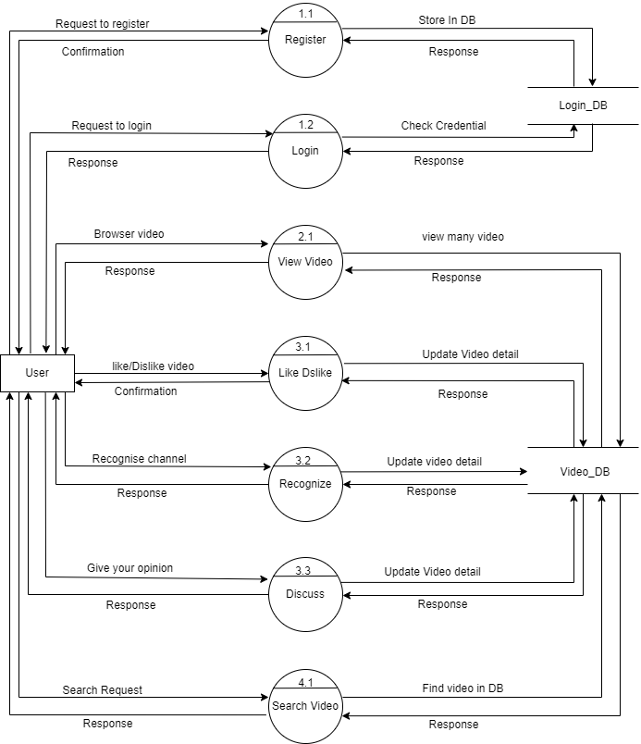

Figure 4.7.3 Level 2 DFD Diagram

**4.8 Sequence Diagram**

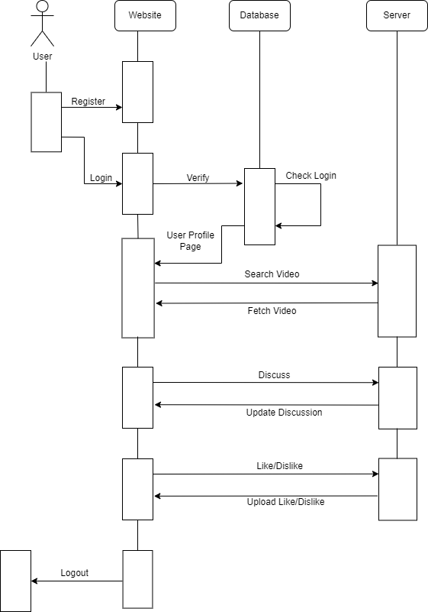

Figure 4.8 Sequence Diagram

**4.9 Activity Diagram**

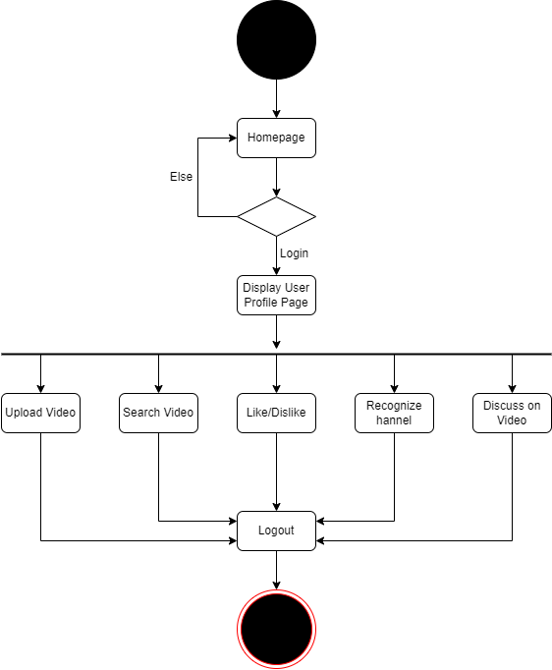 Figure 4.9 Activity Diagram

**4.10 ER Diagram**

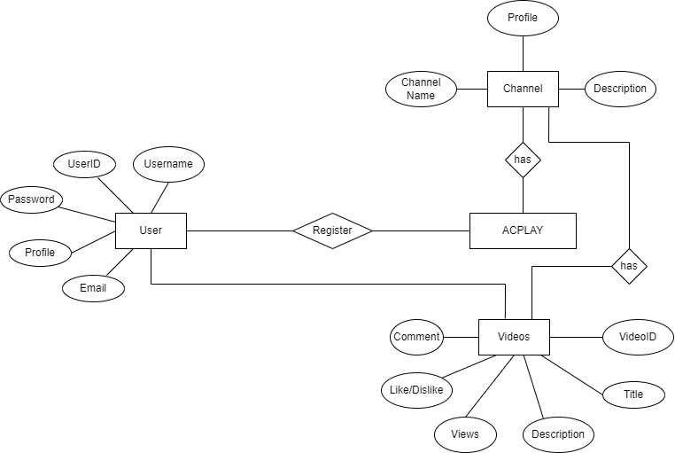

Figure 4.10 ER Diagram

**4.11 Use Case Diagram**

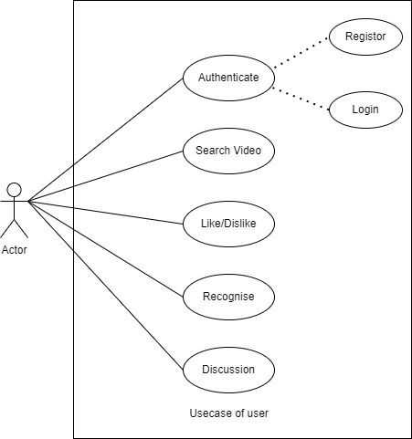

Figure 4.11 Use Case Diagram

**4.12 Class Diagram**

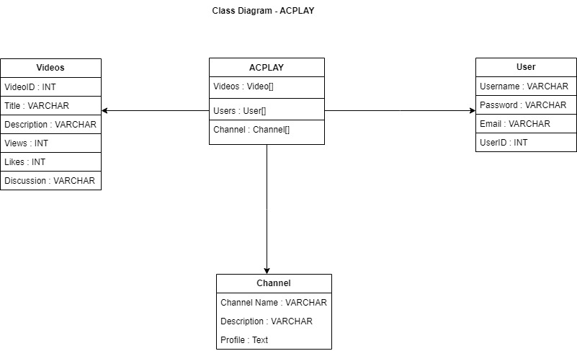

Figure 4.12 Class Diagram

1. **Data Dictionary**

**5.1. Data Dictionary- User Registration**

|  |  |  |  |  |  |  |
| --- | --- | --- | --- | --- | --- | --- |
| **Sr. No** | **Field Name** | **Datatype** | **Size** | **Description** | **Constraint** | **Example** |
| 1 | User ID | INT | 10 | Unique ID of the User. | PRIMARY KEY | 239801 |
| 2 | Username | VARCHAR | 16 | Username of the user. | NOT NULL | ACP |
| 3 | Email | VARCHAR | 50 | Email of the user | NOT NULL | [acp@gmail.com](mailto:acp@gmail.com) |
| 4 | Password | VARCHAR | 50 | Password of User | NOT NULL | ******* |

**5.2 Data Dictionary - Channel**

|  |  |  |  |  |  |  |
| --- | --- | --- | --- | --- | --- | --- |
| **Sr. No** | **Field Name** | **Datatype** | **Size** | **Description** | **Constraint** | **Example** |
| 1 | Channel ID | INT | 10 | Unique ID of the Channel | PRIMARY KEY | 879513 |
| 2 | Channel Name | VARCHAR | 30 | Name of Channel. | NOT NULL | MrBeast |
| 3 | Description | VARCHAR | 500 | Description about Channel | NOT NULL | US Youtuber |
| 4 | Profile |  |  | Profile logo Of Channel |  |  |

**5.3 Data Dictionary - Video**

|  |  |  |  |  |  |  |
| --- | --- | --- | --- | --- | --- | --- |
| **Sr. No** | **Field Name** | **Datatype** | **Size** | **Description** | **Constraint** | **Example** |
| 1 | Video ID | INT | 10 | Unique ID of the User. | PRIMARY KEY | 121623 |
| 2 | Title | VARCHAR | 50 | Title of the Video | NOT NULL | Welcome to Vlog |
| 3 | Description | VARCHAR | 500 | Description of the User. | NOT NULL | Xyz… |
| 4 | Thumbnail |  |  | Show Picture of the Video. | NOT NULL |  |
| 5 | View Count | Int | 10 | Views on the Video |  | 100Views |
| 6 | Discussion | Varchar | 200 | Comments on the Video. |  | Heyy! |

**6. Screenshot of Development Phase 1**

**6.1 Screenshot of Homepage UI**

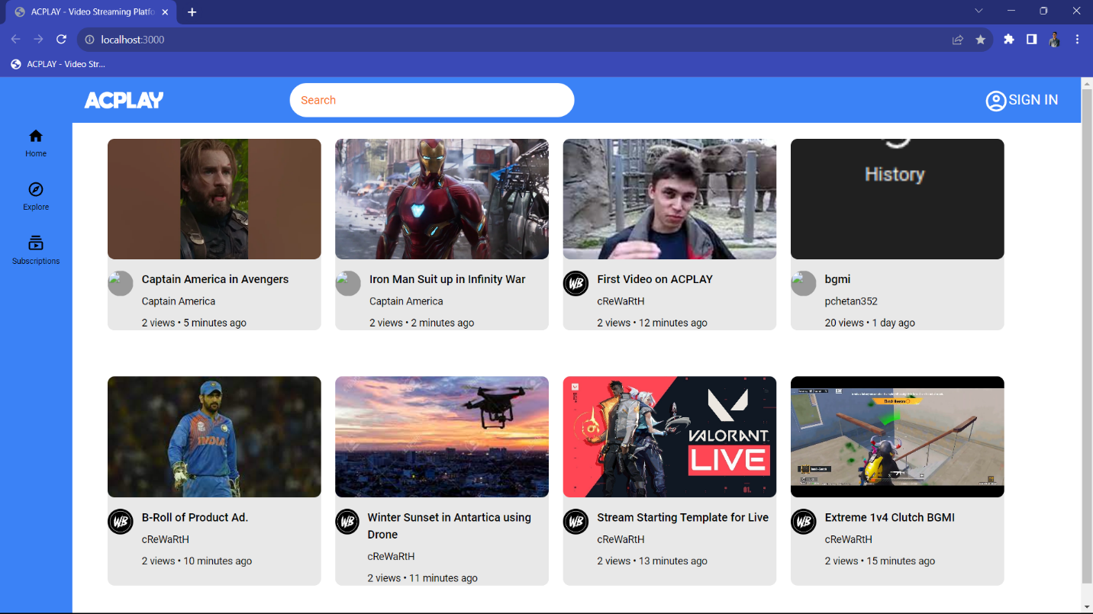

**6.2 Code for Homepage UI**

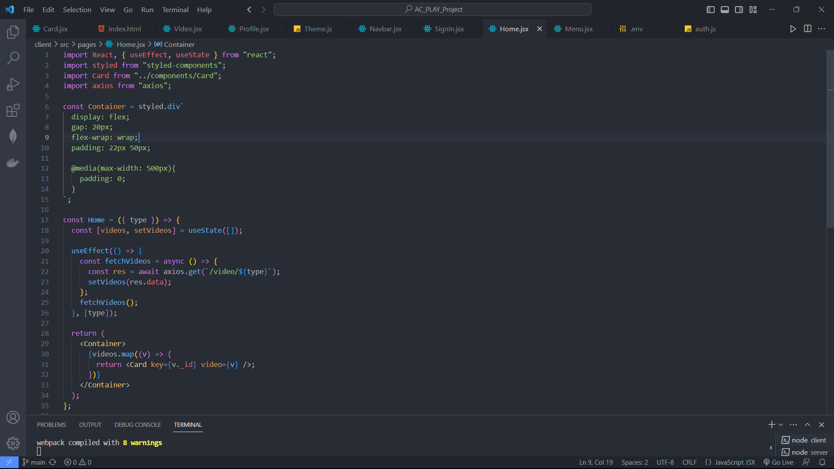

1. **Screenshot of Development Phase 2**

**7.1 Screenshot of Sign-up & Sign-in Page**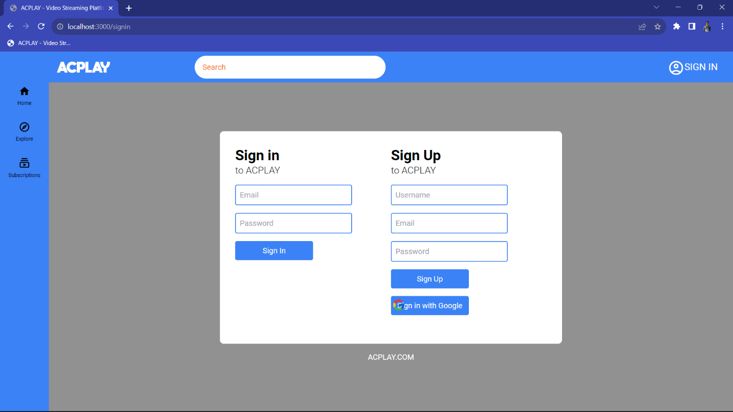

* 1. **Code for Sign Up UI**

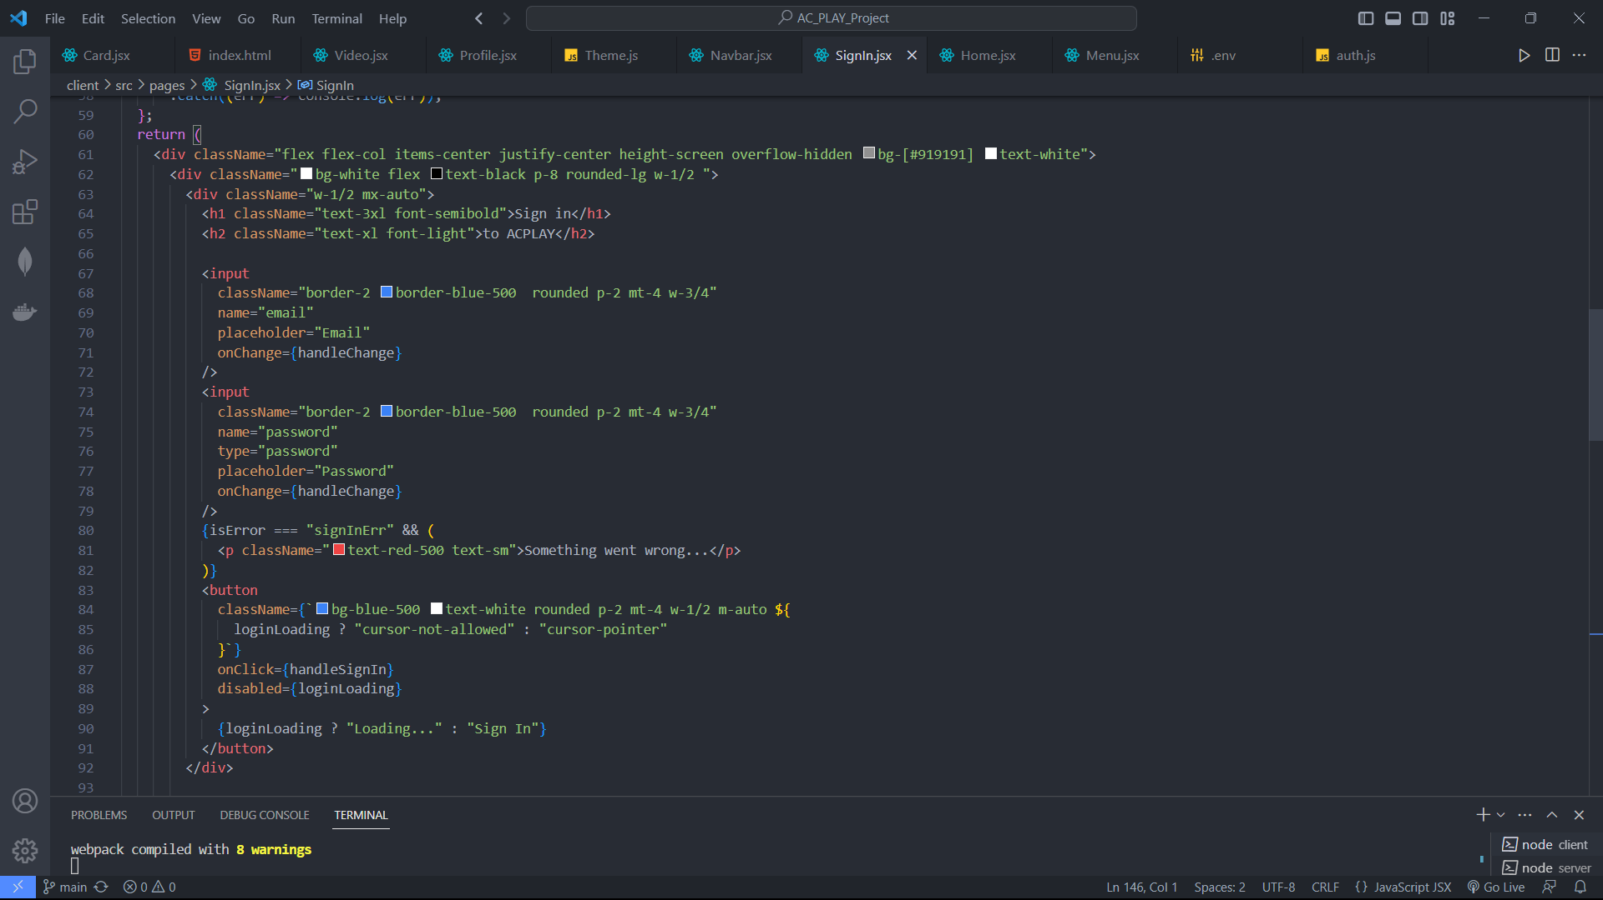

**8. Future Enhancements**

* Create Customized Playlist
* Customized Resolution
* Watch later Module
* Share Video to other Platforms

**9. References**

* <https://www.w3schools.com/js/>
* <https://www.youtube.com/@CodeWithHarry>
* <https://www.mongodb.com/docs/>
* <https://nodejs.org/en/docs>
* <https://devdocs.io/react/>