Adding Interactivity

Crayson Richardson

Rasmussen College

W110/COP1801: JavaScript

Kimberly Powell

November 30, 2019

Adding Interactivity

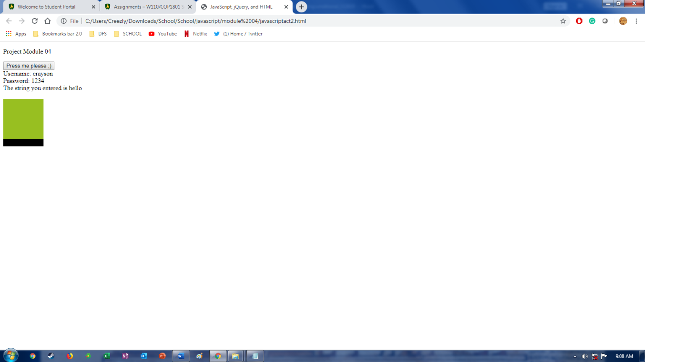

<http://sotd.us/craysonrichardson/Javaclass/COP1801_Javascript/Module_04/javascriptact2.html>

<https://github.com/Crich83/COP1801_Javascript/blob/master/javascriptact2.html>

References

HGaur (2018, January 27). JavaScript: Array sort(). Retrieved from <https://www.geeksforgeeks.org/javascript-array-sort/>.