Thermosensation Assay

Lauren Miner/Ofer Mazor – September 22, 2020

⚠**Once plugged in, do not leave assay unattended**

## Reagents/Materials

*Amounts listed per [BLANK]*

### Day 1

* Thermosensation Assay
* 30 flies

# Protocol

## Day 1

Start to Finish: 20 mins

1. Attach the desired assay shape and secure with the nuts
2. Plug in both plugs of the thermosensation assay
3. Set the hot side to the desired temperature using the up and down arrow keys, then press the gear button to confirm

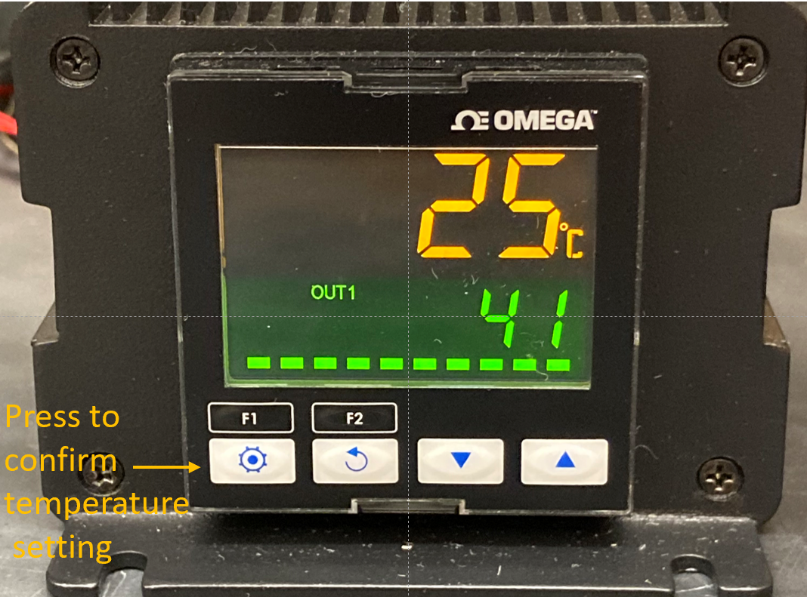

* + The top yellow number is the current temperature of the hot side
  + The bottom green number is the desired temperature setting

1. Wait for the hot side to come to the desired temperature
2. Load 10 flies into the assay, set a time for 5 minutes, and use the accompanying thermocouple to record the temperature of the cold side at the start of the assay
3. When the timer goes off, record the following:
   * Number on the hot side
   * Number on the cold side
   * Number in the middle
   * Number dead or passed out
   * The temperature of the cold side
4. Remove the flies from the assay
5. Calculate the avoidance index:

* By this calculation, an avoidance index of 1 indicates all the flies avoided the heat while an avoidance index of -1 indicates all the flies preferred the heat

1. Repeat twice more
   * At least three replicates consisting of ~10 flies is recommended, more may be necessary
   * We expect the cold side to be somewhere between 23 and 25°C, however if you are repeating this assay multiple times in sequence the cold side may start to climb in temperature which could affect your results. If you notice this happening, you may want to either unplug and let the assay cool off for a bit or keep an ice pack adjacent to the cold side to keep the temperature down.
     1. Never put ice or an ice pack on the assay during an experiment as the aluminum will become too cold and the flies will stop moving
2. **Unplug the assay when you are done**