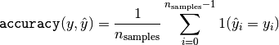

Trial 1:
Only for T20 Matches
Based on Toss Outcome, Toss Decisions and Venue,
1. India vs Aus
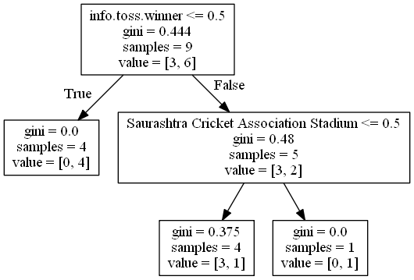
Accuracy = 0.75
Confusion Matrix = True_Positive= 1 , False_Positive= 1,False_Negative= 0,True_Positive=2'

