**Kahler Hospitality Group, MN**

• Rochester Marriott Mayo Clinic

• Kahler Grand Hotel

• Kahler Apache

• Kahler Inn and Suites

• Residence Inn by Marriott

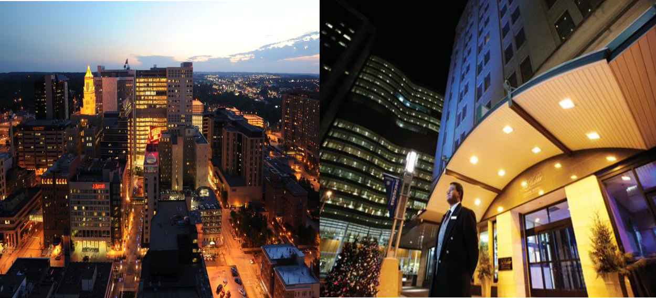

**Address:** [20 2nd Ave S, Rochester, MN 55902](http://www.reservations.com/hotel/kahler-grand-hotel?gclid=CNeK65Ski8UCFYeEfgodCVgAjg&amp;location)

**Website:** [www.kahler.com/lodging](http://www.kahler.com/lodging)

Kahler represents complete commitment to exceptional service. Decades of uncompromising service have left their mark on Kahler, a brand that combines the grace and elegance of the past with an exciting new vision for the future. Rochester is a city in the state of Minnesota. It has consistently been ranked the #1 best places to live in the United States in 2016 by Livability Magazine.

**Open Positions – Work and Travel (March – July)**

Housekeeping: 40 students

Pay Rate: $11.21 per hour plus tips

**Housing Information:**

**Your student room will include:**

• 1 Twin bed and a small refrigerator

• 1 student per room

• Fully Furnished

• Internet is included.

**Also available to you is:**

• Full gym

• Roof top pool and Jacuzzi

• Business center access (computer/printer0)

• Free shuttle service to/from Apache Mall and Walmart

• Walking distance to area banks and local entertainment

• Kitchen facilities in student lounge include a stove, microwave and refrigerator/freezer.

**Housing Cost:** $450 per month and is located with the Kahler Grand Hotel.

**Additional Costs:** Laundry facilities are available at $1.50 per load. Student must bring quarters and their own detergent.

**Dress Code:** Participants should bring black dress pants, a black belt, black socks and a comfortable pair of black no-slip shoes.

**Meal Discounts:** 50% off while working. Not to be used during peak hours.

**Payroll:** Paychecks are given on a bi-weekly basis. Holidays are not paid until after 90 days of employment.

**International Airports near Rochester, MN**

[12 miles](http://www.travelmath.com/drive-distance/from/RST/to/Rochester%2C%2BMN): Rochester, MN (RST / KRST) [**Rochester International Airport**](http://www.travelmath.com/airport/RST)

**Employer will NOT provide transportation from Airport to employer’s location**: Students will have to provide transportation from the airport via the shuttle (Go Direct, or Rochester Shuttle).

Price is around $35.00

[http://www.rochestershuttleservice.com](http://www.rochestershuttleservice.com/); [http://gorochesterdirect.com](http://gorochesterdirect.com/)

**Employer will provide transportation to Social Security Administration:** YES