**软件测试上机报告**



第一次上机作业

**学 院___软件学院___**

**专 业___软件工程___**

**姓 名___李科润_____**

**学 号_ 3017218128_**

**年 级___2017___ __**

**班 级___3______ _**

# 一、实验要求

1. **Install Junit(4.12), Hamcrest(1.3) with Eclipse/IDEA**
2. **Install Eclemma with Eclipse**

In my project, I install Jacoco instead of Eclemma in IDEA.

1. **Write a java program for the given problem and test the program with Junit.** 
   1. **Description of the problem:**

**There is one 50 yuan, one 20 yuan, one 10 yuan, two 5 yuan bills and three 1 yuan coins in your pocket. Write a program to find out whether you can take out a given number (x) yuan.**

# 二、源代码

**public class** FindBills {  
 **public boolean** findOrNot(**int** aquire)  
 {  
 **if**(aquire > 93){  
 **return false**;  
 }  
 **if**(aquire >= 50)  
 {  
 aquire-=50;  
 }  
 **if**(aquire >=20)  
 {  
 aquire-=20;  
 }  
 **if**(aquire >=10){  
 aquire -=10;  
 }  
 **if**(aquire >=5){  
 aquire -=5;  
 }  
 **if**(aquire >=5){  
 aquire -=5;  
 }  
 **for** (**int** i=0; i<3; ++i){  
 **if** (aquire>=1){  
 aquire -=1;  
 }  
 }  
 **if**(aquire==0) {  
 **return true**;  
 }**else**{  
 **return false**;  
 }  
 }  
}

**import** org.junit.Before;  
**import** org.junit.Test;  
  
**import static** org.junit.Assert.*;  
  
**public class** FindBillsTest {  
 FindBills **judge**;  
 @Before  
 **public void** setUp(){  
 **judge** = **new** FindBills();  
 }  
 @Test  
 **public void** findOrNot() {  
 *assertEquals*( **true**,**judge**.findOrNot(55));  
 *assertEquals*( **false**,**judge**.findOrNot(54));  
 *assertEquals*( **true**,**judge**.findOrNot(93));  
 *assertEquals*( **true**,**judge**.findOrNot(83));  
 *assertEquals*( **true**,**judge**.findOrNot(88));  
 *assertEquals*( **false**,**judge**.findOrNot(94));  
 }  
}

use runwith：

@RunWith(Parameterized.**class**)

# 

三、运行结果 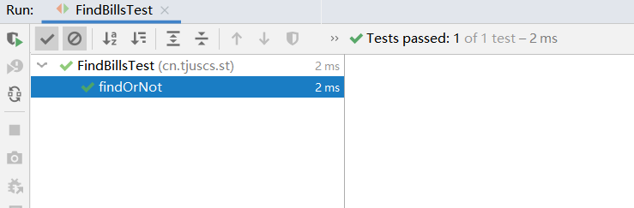

use runwith：

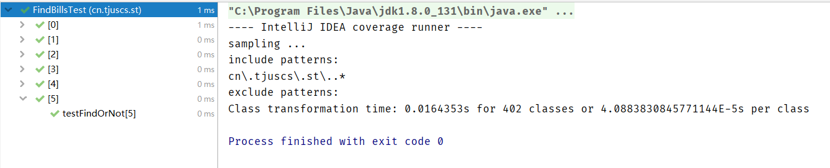

coverage：

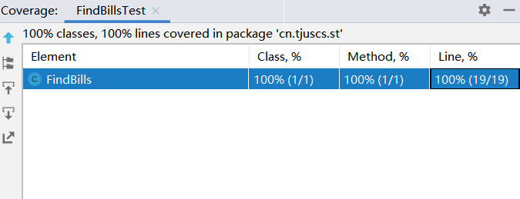

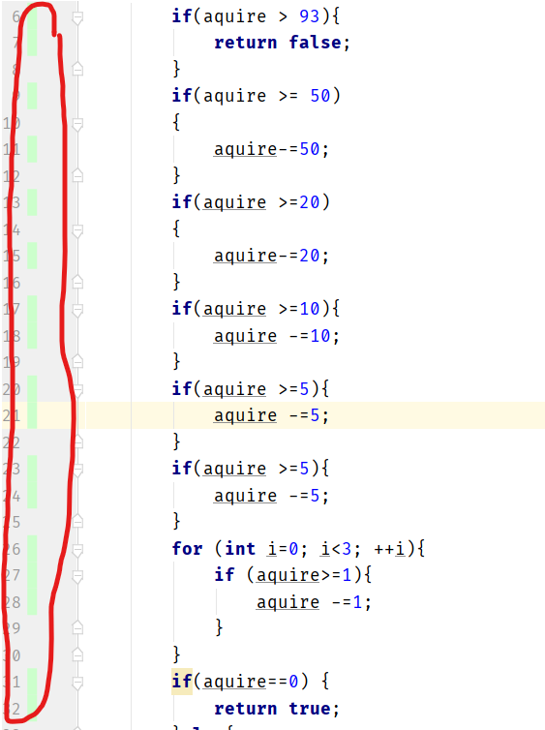

we can see that all the line have been covered by the test case.