**软件测试上机报告**



第一次上机作业

**学 院___软件学院___**

**专 业___软件工程___**

**姓 名___李科润_____**

**学 号_ 3017218128_**

**年 级___2017___ __**

**班 级___3______ _**

# 一、实验要求

**Tasks:**

1. Install Selenium with Eclipse.
2. Install Firefox and SeleniumIDE plugin.
3. Try to record and export scripts using SeleniumIDE.
4. Please complete the following task using Selenium Webdriver:

“Selenium Lab.xlsx” contains information about the students, and http://103.120.226.190/selenium-demo/git-repo can view someone’s information after logging in (student id as username, git address as password). Please check each record in the excel to make sure that each student’s information is consistent with the information on the website.

**Requirements for the experiment:**

1. Finish the tasks above individually.
2. Check in your java code to github or gitee
3. Please send your experiment report to 智慧树, the following information should be included in your report:
   1. The brief description that you install Selenium, Firefox and SeleniumIDE.
   2. Steps for recording and exporting scripts.
   3. Steps for testing the website using Selenium.

# 二、源代码

**public** **static** **void** main(String args[]) {

String firefoxdriver = "geckodriver.exe";

System.*setProperty*("webdriver.gecko.driver", firefoxdriver);

WebDriver driver = **new** FirefoxDriver();

String baseUrl = "http://103.120.226.190/selenium-demo/git-repo";

driver.get(baseUrl);

//使用POI读取xlsx

ExcelPoiReaderUtils POI = **new** ExcelPoiReaderUtils();

String filePath = System.*getProperty*("user.dir") + "/data/Selenium+Lab2020.xlsx";

String[] columns = {"user","passward"};

List data = POI.readExcel(filePath, columns);

**for**(**int** i=0; i<data.size(); ++i) {

Map dataRow = (Map)data.get(i);

WebElement userName = driver.findElement(By.*name*("user_number"));

userName.sendKeys(dataRow.get("user").toString());

WebElement passName = driver.findElement(By.*name*("password"));

passName.sendKeys(dataRow.get("passward").toString());

WebElement submitName = driver.findElement(By.*xpath*("/html/body/div/div/div/div/div/div/div[2]/div/form/div[3]/input"));

submitName.click();

WebElement address = driver.findElement(By.*xpath*("/html/body/div/div/div/div/div/div/div[2]/div/form/div[5]/code"));

**if**(address.getText().equals(dataRow.get("passward").toString())) {

System.***out***.println("Success!");

}**else** {

System.***out***.println("Failed!");

System.***out***.println(address.getText());

}

}

**读取excel部分：**

**public** List<Map<String, String>> readExcel(String filePath, String columns[]) {

Sheet sheet = **null**;

Row row = **null**;

Row rowHeader = **null**;

List<Map<String, String>> list = **null**;

String cellData = **null**;

Workbook wb = **null**;

**if** (filePath == **null**) {

**return** **null**;

}

String extString = filePath.substring(filePath.lastIndexOf("."));

InputStream is = **null**;

**try** {

is = **new** FileInputStream(filePath);

**if** (".xls".equals(extString)) {

wb = **new** HSSFWorkbook(is);

} **else** **if** (".xlsx".equals(extString)) {

wb = **new** XSSFWorkbook(is);

} **else** {

wb = **null**;

}

**if** (wb != **null**) {

// 用来存放表中数据

list = **new** ArrayList<Map<String, String>>();

// 获取第一个sheet

sheet = wb.getSheetAt(0);

// 获取最大行数

// int rownum = sheet.getPhysicalNumberOfRows();

**int** rownum = 20;

// 获取第一行

rowHeader = sheet.getRow(0);

row = sheet.getRow(0);

// 获取最大列数

**int** colnum = row.getPhysicalNumberOfCells();

**for** (**int** i = 1; i < rownum; i++) {

Map<String, String> map = **new** LinkedHashMap<String, String>();

row = sheet.getRow(i);

**if** (row != **null**) {

**for** (**int** j = 1; j < 3; j++) {

cellData = (String) getCellFormatValue(row

.getCell(j));

map.put(columns[j-1], cellData);

}

} **else** {

**break**;

}

list.add(map);

}

}

} **catch** (FileNotFoundException e) {

e.printStackTrace();

} **catch** (IOException e) {

e.printStackTrace();

}

**return** list;

}

**三、运行结果**

Install Selenium with Eclipse.

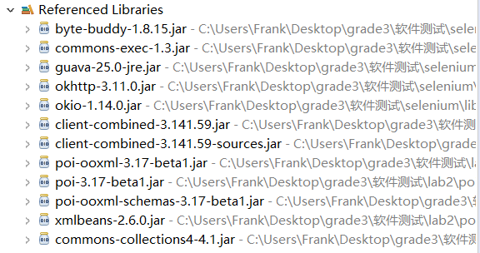

Install Firefox and SeleniumIDE plugin.

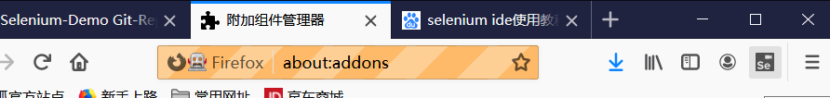

Try to record and export scripts using SeleniumIDE.

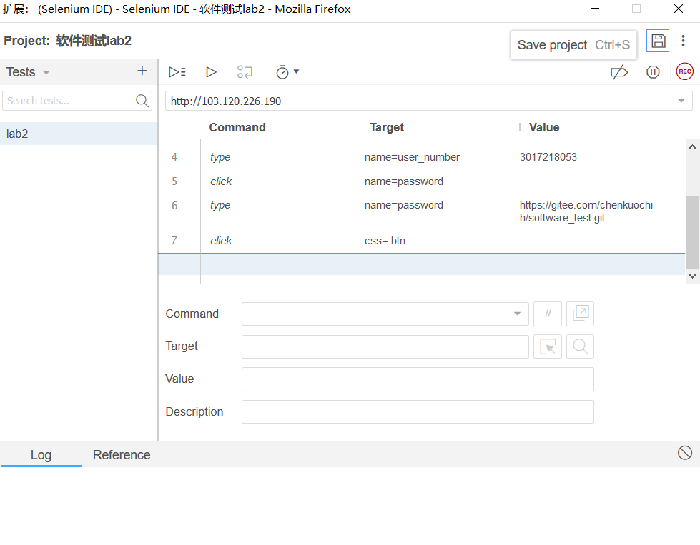

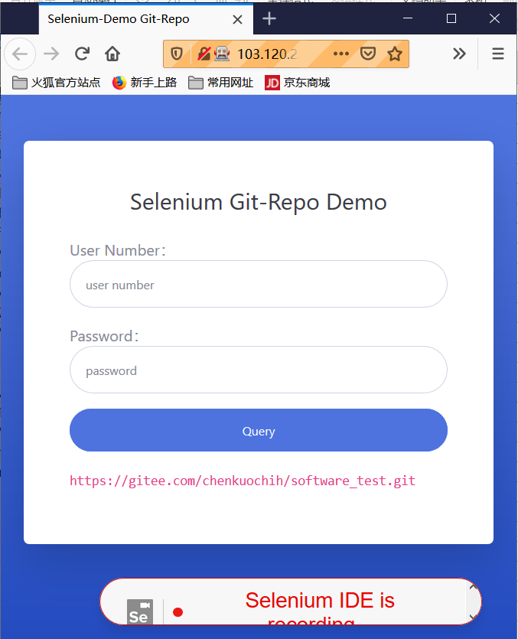

when the program has been run.

