**软件测试上机报告**



第四次上机作业

**学 院___软件学院___**

**专 业___软件工程___**

**姓 名___李科润_____**

**学 号_ 3017218128_**

**年 级___2017___ __**

**班 级___3______ _**

### 一、实验要求

**Tasks:**

1. Install MuJava. The instruction of how to install and use Mujava can be seen in <https://cs.gmu.edu/~offutt/mujava/> .
2. Two small programs are given for your task. BubbleSort.java is an implementation of bubble sort algorithm and BackPack.java is a solution of 01 backpack problem. Try to generate Mutants of 2 given programs with MuJava.
3. Write testing sets for 2 programs with Junit, and run mutants on the test sets with MuJava.

**Requirements for the experiment:**

1. Finish the tasks above individually.
2. Check in your java code to github or gitee.
3. Post your experiment report to “智慧树” , the following information should be included in your report:
   1. The brief description that you install MuJava
   2. Steps for generating Mutants
   3. Steps for making test sets and running mutants.
   4. Your mutants result (The number of live mutants, killed mutants, etc.)

### 二、实验步骤及源代码

1）The brief description that you install MuJava

unzip the file and new a mujava home in C:/

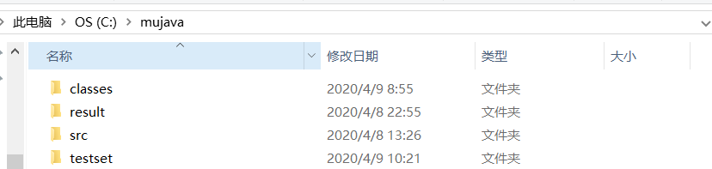

put 3 files in it:

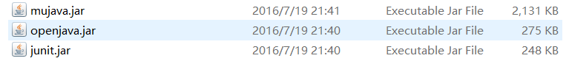

and set up a file named mujava.config



Modify system environment variables



add these paths in CLASSPATH:

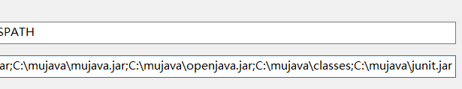

**the most important:**

Put the source files to test to *MuJava_HOME*\src directory.

Compile all the Java files in *MuJava_HOME*\src and copy the .class files into the *MuJava_HOME*\classes\ directory.

then open the cmd and cd C:\mujava :

use this instruction to open the GUI



2）Steps for generating Mutants

then we open the GUI:

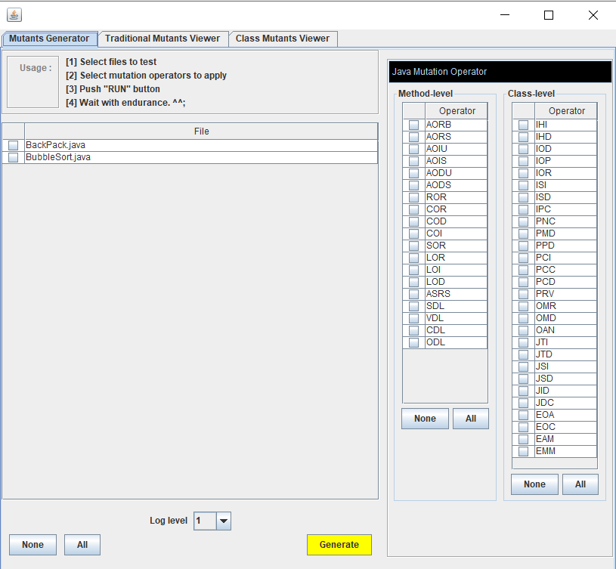

tick these boxes:

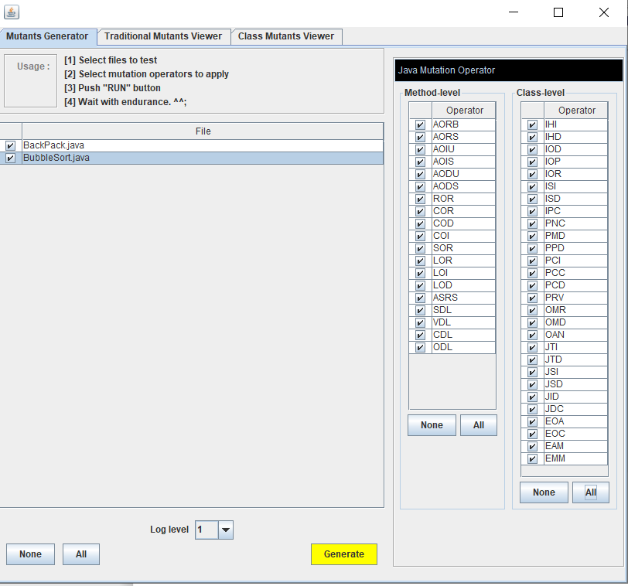

click the yellow Button

then we will find in next windows:

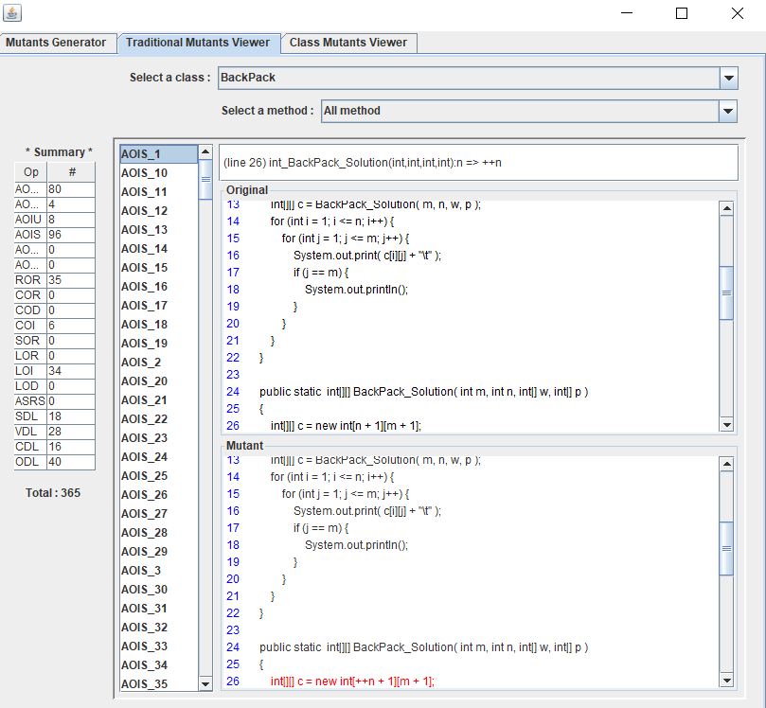

3）Steps for making test sets and running mutants.

use Eclipse edit the testcase:

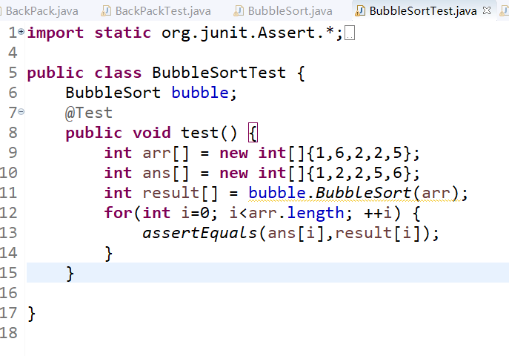

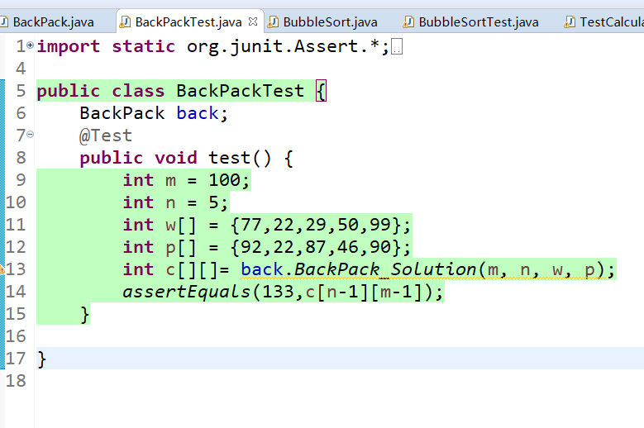

find the testcase class files in the folder:

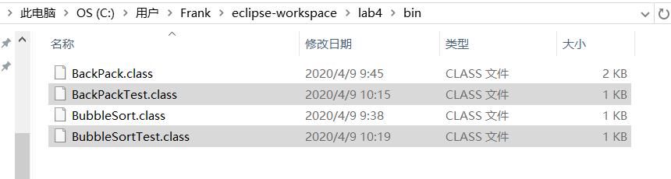

copy it and put it into

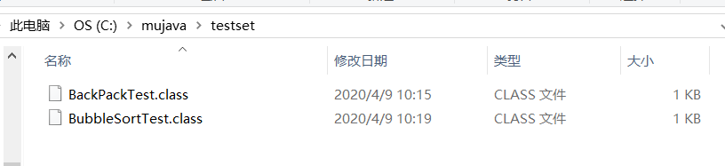

input this instruction in cmd:



then the GUI will open

4）Your mutants result (The number of live mutants, killed mutants, etc.)

the BubbleSort:

total124

live124

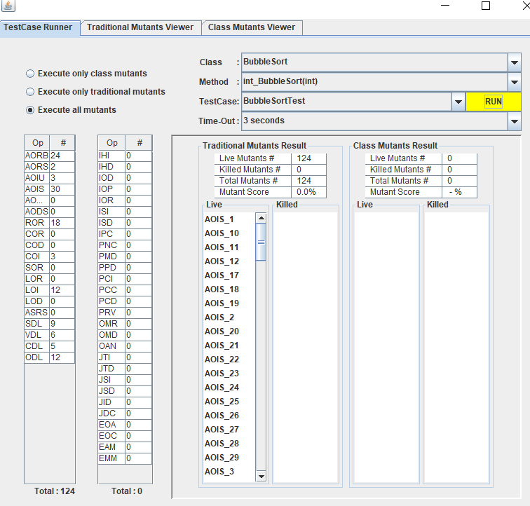

the BackPack:

total 365

live 365

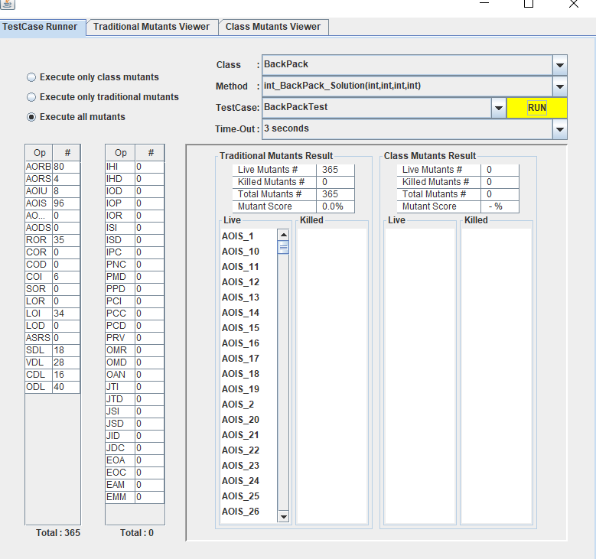

### 三、运行结果

BackPack:

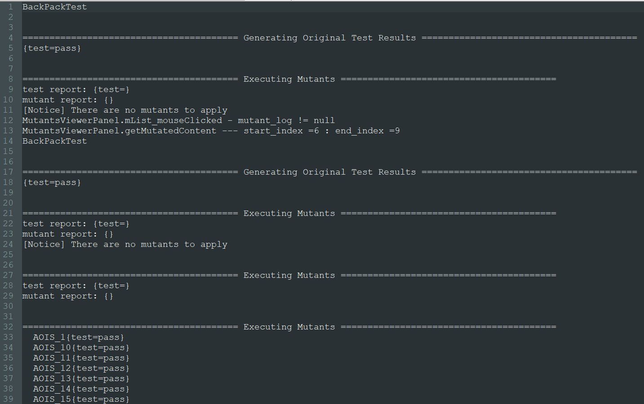

test report: {test=}

mutant report: {VDL_12=, COI_6=, VDL_11=, AORB_78=, COI_3=, AORB_79=, COI_2=, AORB_76=, COI_5=, VDL_14=, AORB_77=, COI_4=, VDL_15=, VDL_18=, VDL_19=, ODL_40=, ODL_43=, ODL_45=, ODL_44=, COI_1=, ODL_47=, ODL_46=, ODL_49=, ODL_48=, VDL_20=, AORB_80=, AORB_69=, AORB_67=, AORB_68=, AORB_65=, AORB_66=, LOI_29=, LOI_36=, LOI_37=, LOI_38=, LOI_32=, ODL_30=, LOI_33=, LOI_34=, ODL_32=, LOI_35=, ODL_31=, AORB_74=, ODL_34=, AORB_75=, ODL_33=, AORB_72=, LOI_30=, ODL_36=, AORB_73=, LOI_31=, ODL_35=, AORB_70=, ODL_38=, AORB_71=, ODL_37=, ODL_39=, VDL_34=, VDL_35=, AORB_58=, VDL_32=, AORB_59=, VDL_33=, AORB_56=, AORB_57=, AORB_54=, AORB_55=, AORB_63=, AORB_64=, AORB_61=, AORB_62=, AORB_60=, AORB_49=, VDL_23=, VDL_24=, AORB_47=, VDL_21=, AORB_48=, VDL_22=, AORB_45=, VDL_27=, AORB_46=, VDL_28=, AORB_43=, VDL_25=, AORB_44=, AOIU_3=, AOIU_4=, AOIU_1=, VDL_29=, AOIU_2=, AORB_9=, ODL_50=, AOIU_7=, ODL_52=, AOIU_8=, ODL_51=, AOIU_5=, ODL_54=, AOIU_6=, ODL_53=, AORB_3=, AORB_52=, ODL_56=, AORB_4=, AORB_53=, ODL_55=, AORB_1=, AORB_50=, AORB_2=, AORB_51=, AORB_7=, VDL_30=, AORB_8=, VDL_31=, AORB_5=, AORB_6=, AOIS_19=, AORB_38=, ROR_2=, AOIS_18=, AORB_39=, ROR_3=, AOIS_17=, AORB_36=, ROR_16=, ROR_4=, AOIS_16=, AORB_37=, ROR_15=, ROR_5=, AOIS_15=, AORB_34=, ROR_10=, AOIS_14=, AORB_35=, AOIS_13=, AORB_32=, ROR_12=, ROR_8=, AOIS_12=, AORB_33=, ROR_11=, ROR_9=, AOIS_11=, AOIS_10=, ROR_1=, AORB_41=, AORB_42=, AORB_40=, ROR_18=, ROR_17=, ROR_19=, AORB_27=, AORB_28=, AORB_25=, AORB_26=, AORB_23=, AORB_24=, AORB_21=, AORB_22=, AORB_29=, AORB_30=, AORB_31=, AORB_16=, AORB_17=, AORB_14=, AORB_15=, AORB_12=, AORB_13=, AORB_10=, AORB_11=, AORB_18=, AORB_19=, CDL_4=, CDL_5=, CDL_6=, CDL_7=, CDL_8=, CDL_9=, ODL_21=, ODL_20=, AORB_20=, ODL_25=, ODL_26=, ODL_29=, CDL_13=, CDL_14=, CDL_11=, CDL_12=, CDL_10=, AOIS_5=, AOIS_6=, AOIS_3=, AOIS_4=, AOIS_1=, AOIS_2=, CDL_15=, CDL_16=, AOIS_9=, AOIS_7=, ODL_10=, AOIS_8=, ODL_11=, ODL_16=, ODL_15=, AOIS_59=, AOIS_58=, AOIS_57=, AOIS_56=, AOIS_55=, AOIS_54=, LOI_6=, AOIS_53=, LOI_7=, AOIS_52=, LOI_8=, AOIS_51=, LOI_1=, AOIS_50=, LOI_2=, LOI_3=, LOI_4=, AOIS_49=, AOIS_48=, AOIS_47=, ROR_42=, AOIS_46=, AOIS_45=, AOIS_44=, AOIS_43=, AOIS_42=, ROR_41=, AOIS_41=, ROR_40=, AOIS_40=, CDL_1=, CDL_2=, CDL_3=, ROR_36=, ROR_35=, SDL_12=, AOIS_39=, ROR_38=, SDL_13=, AOIS_38=, ROR_37=, SDL_14=, VDL_9=, AOIS_37=, ROR_32=, AOIS_36=, ROR_31=, AOIS_35=, ROR_34=, AOIS_34=, ROR_33=, SDL_10=, AOIS_33=, SDL_19=, AOIS_32=, VDL_3=, AOIS_31=, ROR_30=, VDL_2=, AOIS_30=, VDL_1=, SDL_15=, VDL_8=, SDL_16=, SDL_17=, VDL_6=, SDL_18=, VDL_5=, ROR_39=, ROR_25=, AOIS_29=, ROR_24=, AOIS_28=, ROR_27=, AOIS_27=, ROR_26=, AOIS_26=, AOIS_25=, AOIS_24=, ROR_23=, SDL_20=, AOIS_23=, ROR_22=, SDL_21=, AOIS_22=, AOIS_21=, AOIS_20=, ODL_1=, ODL_3=, ODL_2=, ODL_5=, ODL_4=, ODL_6=, ROR_29=, AORS_2=, AORS_3=, AOIS_96=, AORS_1=, AOIS_95=, AOIS_94=, AOIS_93=, AORS_4=, AOIS_92=, SDL_4=, SDL_7=, SDL_6=, SDL_9=, AOIS_89=, AOIS_88=, AOIS_87=, AOIS_86=, AOIS_85=, AOIS_84=, AOIS_83=, AOIS_82=, AOIS_81=, AOIS_91=, AOIS_90=, SDL_1=, SDL_3=, SDL_2=, AOIS_79=, AOIS_78=, AOIS_77=, AOIS_76=, AOIS_75=, AOIS_74=, AOIS_73=, LOI_18=, AOIS_72=, LOI_19=, AOIS_71=, AOIS_70=, AOIS_80=, LOI_25=, LOI_26=, LOI_27=, LOI_28=, LOI_21=, LOI_22=, LOI_23=, LOI_24=, LOI_20=, AOIS_69=, AOIS_68=, AOIS_67=, AOIS_66=, AOIS_65=, AOIS_64=, AOIS_63=, AOIS_62=, AOIS_61=, AOIS_60=, LOI_14=, LOI_15=, LOI_17=, LOI_10=, LOI_11=, LOI_12=}

BubbleSort

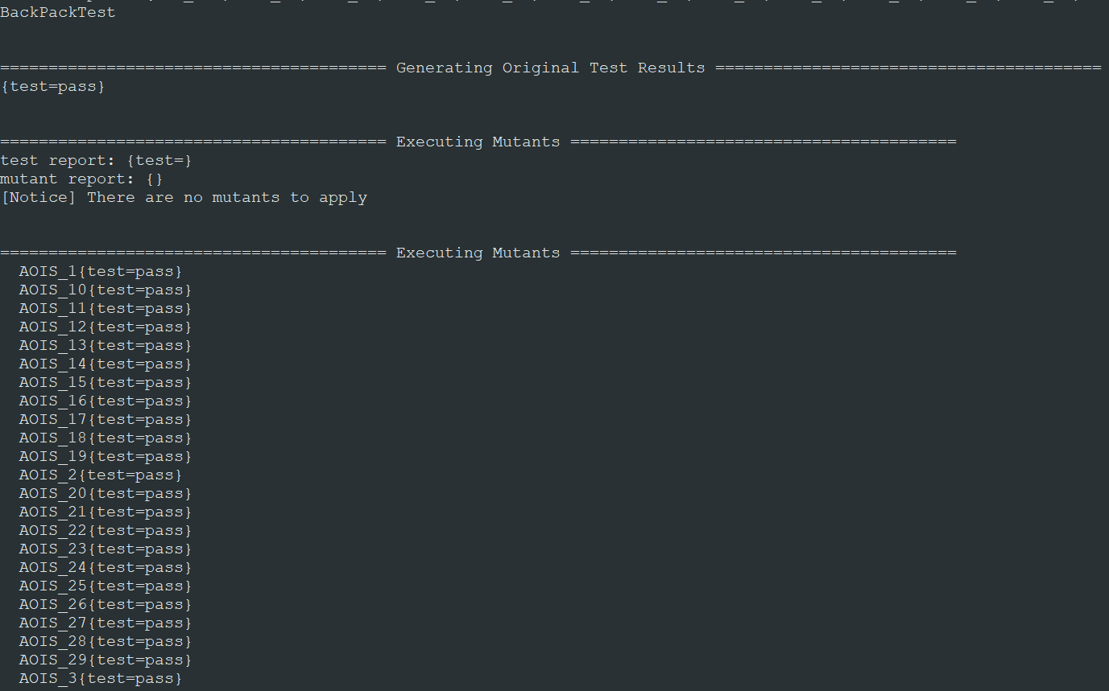

test report: {test=}

mutant report: {VDL_12=, COI_6=, VDL_11=, AORB_78=, COI_3=, AORB_79=, COI_2=, AORB_76=, COI_5=, VDL_14=, AORB_77=, COI_4=, VDL_15=, VDL_18=, VDL_19=, ODL_40=, ODL_43=, ODL_45=, ODL_44=, COI_1=, ODL_47=, ODL_46=, ODL_49=, ODL_48=, VDL_20=, AORB_80=, AORB_69=, AORB_67=, AORB_68=, AORB_65=, AORB_66=, LOI_29=, LOI_36=, LOI_37=, LOI_38=, LOI_32=, ODL_30=, LOI_33=, LOI_34=, ODL_32=, LOI_35=, ODL_31=, AORB_74=, ODL_34=, AORB_75=, ODL_33=, AORB_72=, LOI_30=, ODL_36=, AORB_73=, LOI_31=, ODL_35=, AORB_70=, ODL_38=, AORB_71=, ODL_37=, ODL_39=, VDL_34=, VDL_35=, AORB_58=, VDL_32=, AORB_59=, VDL_33=, AORB_56=, AORB_57=, AORB_54=, AORB_55=, AORB_63=, AORB_64=, AORB_61=, AORB_62=, AORB_60=, AORB_49=, VDL_23=, VDL_24=, AORB_47=, VDL_21=, AORB_48=, VDL_22=, AORB_45=, VDL_27=, AORB_46=, VDL_28=, AORB_43=, VDL_25=, AORB_44=, AOIU_3=, AOIU_4=, AOIU_1=, VDL_29=, AOIU_2=, AORB_9=, ODL_50=, AOIU_7=, ODL_52=, AOIU_8=, ODL_51=, AOIU_5=, ODL_54=, AOIU_6=, ODL_53=, AORB_3=, AORB_52=, ODL_56=, AORB_4=, AORB_53=, ODL_55=, AORB_1=, AORB_50=, AORB_2=, AORB_51=, AORB_7=, VDL_30=, AORB_8=, VDL_31=, AORB_5=, AORB_6=, AOIS_19=, AORB_38=, ROR_2=, AOIS_18=, AORB_39=, ROR_3=, AOIS_17=, AORB_36=, ROR_16=, ROR_4=, AOIS_16=, AORB_37=, ROR_15=, ROR_5=, AOIS_15=, AORB_34=, ROR_10=, AOIS_14=, AORB_35=, AOIS_13=, AORB_32=, ROR_12=, ROR_8=, AOIS_12=, AORB_33=, ROR_11=, ROR_9=, AOIS_11=, AOIS_10=, ROR_1=, AORB_41=, AORB_42=, AORB_40=, ROR_18=, ROR_17=, ROR_19=, AORB_27=, AORB_28=, AORB_25=, AORB_26=, AORB_23=, AORB_24=, AORB_21=, AORB_22=, AORB_29=, AORB_30=, AORB_31=, AORB_16=, AORB_17=, AORB_14=, AORB_15=, AORB_12=, AORB_13=, AORB_10=, AORB_11=, AORB_18=, AORB_19=, CDL_4=, CDL_5=, CDL_6=, CDL_7=, CDL_8=, CDL_9=, ODL_21=, ODL_20=, AORB_20=, ODL_25=, ODL_26=, ODL_29=, CDL_13=, CDL_14=, CDL_11=, CDL_12=, CDL_10=, AOIS_5=, AOIS_6=, AOIS_3=, AOIS_4=, AOIS_1=, AOIS_2=, CDL_15=, CDL_16=, AOIS_9=, AOIS_7=, ODL_10=, AOIS_8=, ODL_11=, ODL_16=, ODL_15=, AOIS_59=, AOIS_58=, AOIS_57=, AOIS_56=, AOIS_55=, AOIS_54=, LOI_6=, AOIS_53=, LOI_7=, AOIS_52=, LOI_8=, AOIS_51=, LOI_1=, AOIS_50=, LOI_2=, LOI_3=, LOI_4=, AOIS_49=, AOIS_48=, AOIS_47=, ROR_42=, AOIS_46=, AOIS_45=, AOIS_44=, AOIS_43=, AOIS_42=, ROR_41=, AOIS_41=, ROR_40=, AOIS_40=, CDL_1=, CDL_2=, CDL_3=, ROR_36=, ROR_35=, SDL_12=, AOIS_39=, ROR_38=, SDL_13=, AOIS_38=, ROR_37=, SDL_14=, VDL_9=, AOIS_37=, ROR_32=, AOIS_36=, ROR_31=, AOIS_35=, ROR_34=, AOIS_34=, ROR_33=, SDL_10=, AOIS_33=, SDL_19=, AOIS_32=, VDL_3=, AOIS_31=, ROR_30=, VDL_2=, AOIS_30=, VDL_1=, SDL_15=, VDL_8=, SDL_16=, SDL_17=, VDL_6=, SDL_18=, VDL_5=, ROR_39=, ROR_25=, AOIS_29=, ROR_24=, AOIS_28=, ROR_27=, AOIS_27=, ROR_26=, AOIS_26=, AOIS_25=, AOIS_24=, ROR_23=, SDL_20=, AOIS_23=, ROR_22=, SDL_21=, AOIS_22=, AOIS_21=, AOIS_20=, ODL_1=, ODL_3=, ODL_2=, ODL_5=, ODL_4=, ODL_6=, ROR_29=, AORS_2=, AORS_3=, AOIS_96=, AORS_1=, AOIS_95=, AOIS_94=, AOIS_93=, AORS_4=, AOIS_92=, SDL_4=, SDL_7=, SDL_6=, SDL_9=, AOIS_89=, AOIS_88=, AOIS_87=, AOIS_86=, AOIS_85=, AOIS_84=, AOIS_83=, AOIS_82=, AOIS_81=, AOIS_91=, AOIS_90=, SDL_1=, SDL_3=, SDL_2=, AOIS_79=, AOIS_78=, AOIS_77=, AOIS_76=, AOIS_75=, AOIS_74=, AOIS_73=, LOI_18=, AOIS_72=, LOI_19=, AOIS_71=, AOIS_70=, AOIS_80=, LOI_25=, LOI_26=, LOI_27=, LOI_28=, LOI_21=, LOI_22=, LOI_23=, LOI_24=, LOI_20=, AOIS_69=, AOIS_68=, AOIS_67=, AOIS_66=, AOIS_65=, AOIS_64=, AOIS_63=, AOIS_62=, AOIS_61=, AOIS_60=, LOI_14=, LOI_15=, LOI_17=, LOI_10=, LOI_11=, LOI_12=}