* **ODUSOLA** Moyosoreoluwa Emmanuel
* **222489**
* **CSC 235**

1. Unix was derived from AT & T Unix whose development was started in 1969 by Ken Thompson, Dennis Ritchie in Bells Labs research center whose primary goal to be a convenient platform for programmers to run their software on. It was initially written in assembly language but written with C in 1973.

Linux however, is a free and open source operating system built like Unix but on the Linux kernel which was originally based on the Intel x86 architecture. It is also runs on embedded system which means that it runs on devices with their OS built into the firmware and is tailored to suit the system.

1. Software functional requirements, otherwise known as Functional specifications, are features or capabilities that describe system behaviour under specific scenarios which software developers must implement to allow users to execute their tasks. An example is a program that validates a user’s pin at the point of withdrawal at either an ATM or POS Terminal.
2. Compared to an operating system like Windows, Unix is more stable.

It has a higher level of security access, making it suitable for private programs.

Since Unix is Open Source, programmers have greater access to libraries and drivers compared to Windows and Mac.

It powers a huge percentage of web servers due to its higher processing capacity.

1. Unix is often referred to as a Scientist OS because there are certain distributions that are targeted towards Scientists like CAELinux, Fedora Robotic, Scientific and Astronomy Suite which contain tools used in the field of Neuroimaging Analysis, Astronomy and Robotics. In addition to this, the high level of security provided makes it a suitable OS for scientists carrying out private research plus the ability to maximise the efficiency of the processor.
2. C is a procedural-oriented, high level language. This means that C follows a step-by-step approach to simplify a responsibility into an array of variables through an ordered set of instructions.
3. **Details Structure of C Programming Language**
4. **Documentation section**

This comprises statements included at the start of a program which is executed before the actual compilation of the program. It is represented as

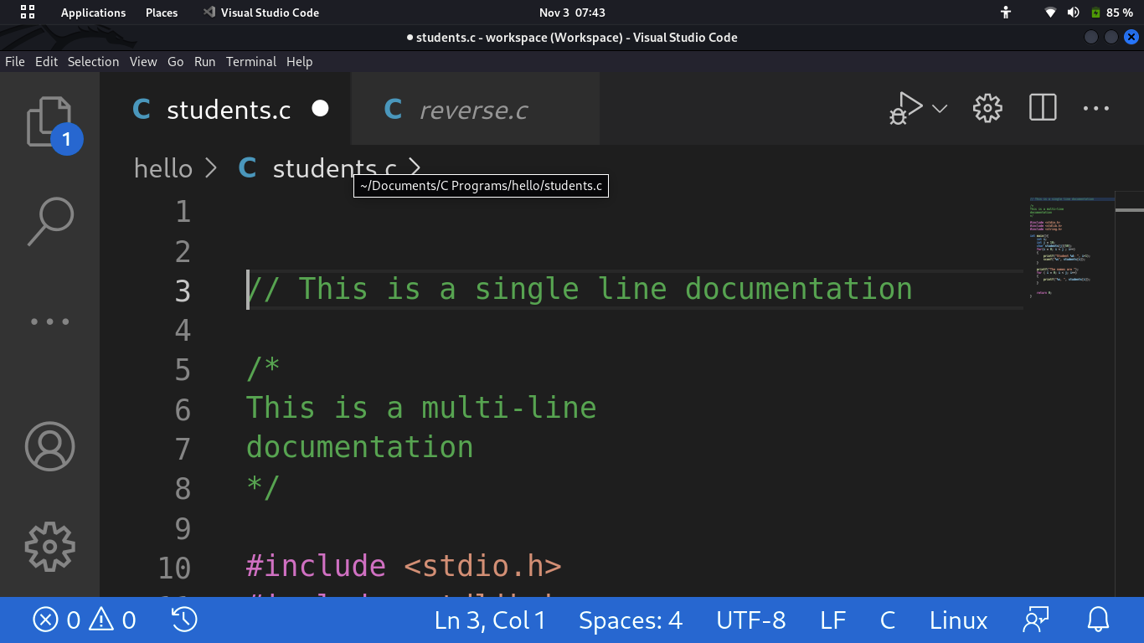

1. **Preprocessor Section**

This consists of all imports and header files to be used in the program with their various purposes

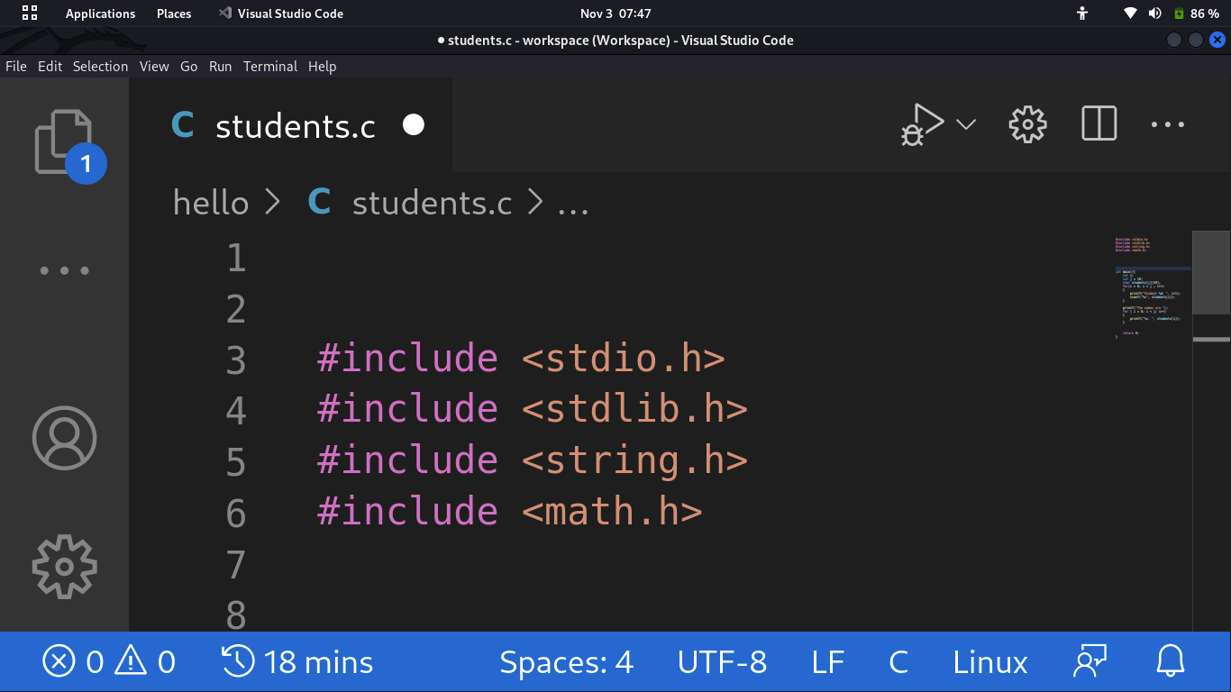

1. **Global Declaration**

This consists of all global declarations in the program. It may be represented as variables or user defined functions.

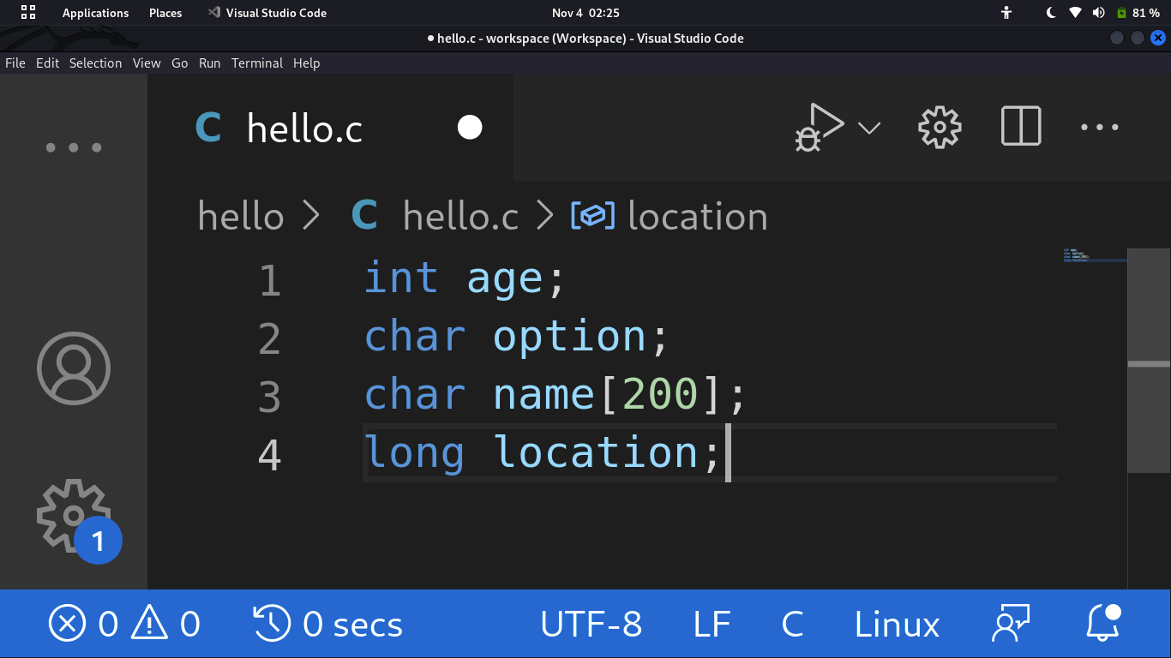

1. **Define Section**

This section consists of various constants declared using the ***define*** keyword, which is a preprocessor directive (These are lines of code in your program preceded by a **#**). The **define** keyword allows the definition of macros within your source code.

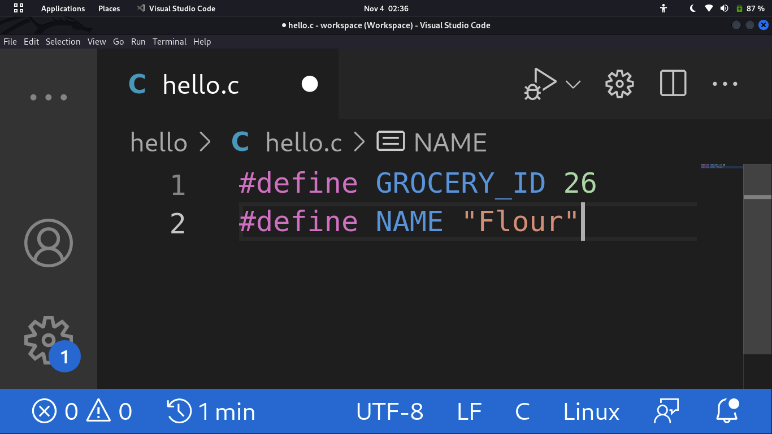

1. **Main Function**

The ***main()*** function is the initial function to be run by the computer. It is mandatory for a code to include the main() function. Parameters can be passed into such functions via the parentheses. Below is an example of a main function with return type of **int**

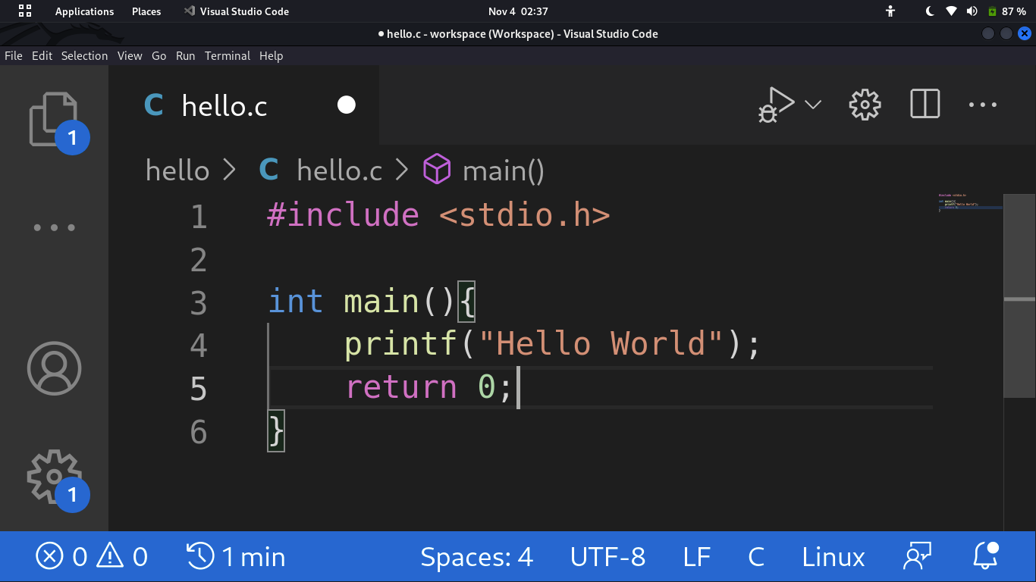

1. **User Defined Functions**

These are functions created according to the requirements of the user which may or may not return a value. An example of a function that prints a greeting to the user using their name.

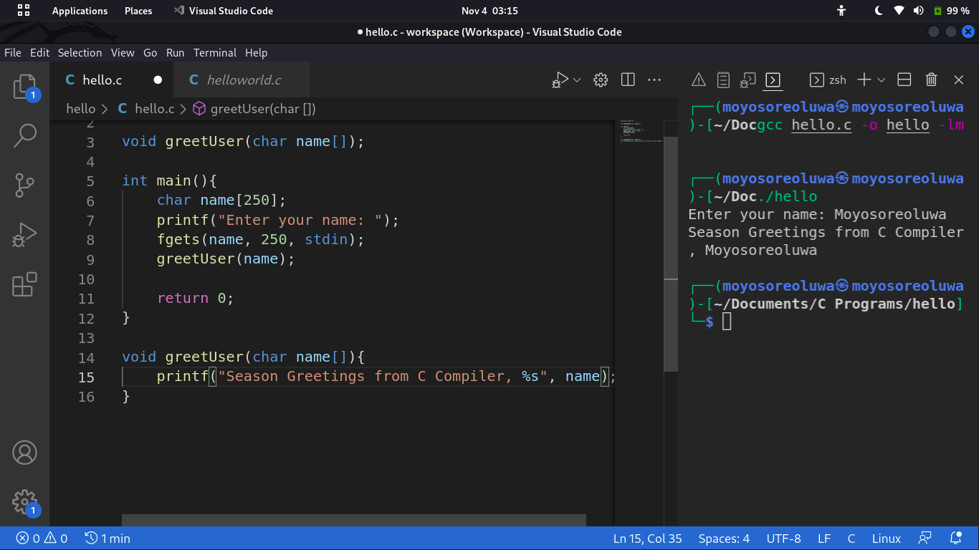

Reference: [Structure of a C Program](https://www.javatpoint.com/structure-of-a-c-program)

7. You can create a C Programming file in Linux by

1. Opening the terminal
2. Change your current directory to the location you want to create the file to, e.g

**cd ./*new-file-path***

1. Create a new directory/folder using the **chmod** command plus the name of the directory, e.g

**chmod c-files**

1. Navigate to the new directory using **cd ./c-files**
2. Use **touch** to create a new file e.g **touch new.c**
3. Run the program using **./new.c**

**Link to Project code on github** [**GitHub Link**](https://github.com/Odusola-Moyosoreoluwa-222489-M/222489_Project_1)