* ***Data Communication Terminologies: Baud, Baud rate, Bit rate, Bandwidth, Data Transfer rate,***

***Bit rate (KBPS,MBPS GBPS, TBPS)***

* ***Network Devices and their uses: Modem, Hub, Repeaters, Bridge, Router, Gateway, Switch.***

**Data Communication Terminologies**

**Channel:** The word channel refers to the portion of a link that carries a transmission between a given pair of lines. One link can have many (n) channels.

**Data Rate:** The data rate defines the number data elements (bits) sent in 1 second and is basically a measure of the speed at which data is transferred. The unit is bits per second (**bps**) or bytes per second (**Bps**). The data rate is sometimes called the **bit rate.** (Note: Uppercase B denotes byte)

**Baud Rate:** The baud rate is the numbers of signal elements sent in 1 second. The unit is **baud**.

The baud rate is sometimes called the **pulse rate,** the **modulation rate,** or the **Signal rate.** At times, the baud rate is the same as bit rate.

|  |  |
| --- | --- |
| In Fig 1, bit rate and baud rate are same since one signal period consists of one bit.  In Fig 2, bit rate is twice the baud rate since one signal period consists of 2 bits.  In Fig 2, bit rate is thrice the baud rate since one signal period consists of 3 bits. | **Image result for baud rate** |

**Bandwidth:** Bandwidth can be used in two different contexts with two different measuring values:-

**Bandwidth in Hertz:** In analog systems, Bandwidth in hertz is the range of frequencies contained in a composite signal or the range of frequencies a channel can pass. It refers to the difference between the highest and the lowest frequencies of a transmission channel.

**Bandwidth in Bits per Second:** In digital systems, the term bandwidth refers to the number of bits per second that a channel, a link, or even a network can transmit. For example, it takes more bandwidth to download a photograph in one second that it takes to download a page of text in one second.

Large sound files, computer programs, and animated videos require still more bandwidth for acceptable system performance. High bandwidth channels are called broadband channels and low bandwidth channels are called as narrowband channels.

**Data Transfer Units**

|  |  |
| --- | --- |
| **kilobit per second** (kbps)=1,000 bits per second  **megabit per second** (Mbps) =1,000 kilobits per second  **gigabit per second** (Gbps) =1,000 megabits per second  **terabit per second** (Tbps) =1,000 gigabits per second | **kilobyte per second** (**kBps**) =1,000 bytes per second  **megabyte per second** (**MBps**) =1,000 kilobytes per second  **gigabyte per second** (**GBps**) =1,000 megabytes per second  **terabyte per second** (**TBps**) =1,000 gigabytes per second |

* ***Network Devices and their uses: Modem, Hub, Repeaters, Bridge, Router, Gateway, Switch.***

# Network Devices

In smooth functioning of networks, many devices play an important role.

**Functions of network de**vices

* **Separating networks or expanding networks:** Networks cannot be made larger by simply adding new computers and more cables. Components are required to segment (divide) large LAN to form smaller LANs or vice versa e.g. repeaters, hubs, bridges, routers, switches, gateways
* **Remote access:** Enable communication over a telephone line. Eg Modems

**Modems**

* Allow computers to communicate over a telephone line
* Enable communication between networks or connecting to the world beyond the LAN
* Cannot send digital signal directly to telephone line since telephone lines can carry only analog signal
* Sending end: MODulate the computer’s digital signal into analog signal and transmits
* Receiving end: DEModulate the analog signal back into digital form
* Modems typically have the following I/O interface:
  + A serial RS-232 communication interface
  + An RJ-11 telephone-line interface (a telephone plug)
* Modem Performance Measures are Baud rate and bit rate

|  |  |
| --- | --- |
| FIG7-2 | FIG7-6 |

**Asynchronous Modems:** Do not need clocking devices; Commonly used in telephone networks;

Data is transmitted in a serial stream. Each character is turned into a string of 8 bits.

Each of these characters is separated by one start bit and one or two stop bits

**Synchronous Modems:** Need clocking devices to synchronize the number of bytes transmitted.

Data are transmitted in blocks. Used in digital networks

**Repeater**: is a network device used to regenerate or replicate a signal. Repeaters are used in transmission systems to regenerate analog or digital signals distorted by transmission loss. Analog repeaters frequently can only amplify the signal, which unfortunately also amplify noise as well as information. Digital repeaters can remove the unwanted noise in an incoming signal and can reconstruct a signal to near its original quality.

A repeater can thus extend the distance over which a network operates. It is the most economic way of expanding networks. It can connect different types of media.

**Limitations**:

Repeaters cannot join unlike segments eg segments with different access methods (e.g. CSMA/CD and token passing). They do not isolate and filter packets. A repeater cannot do the intelligent routing performed by bridges and routers.

|  |  |
| --- | --- |
| FIG7-8 | Image result for what is a hub in networking |
| Reapeter | Hub |

**Hub**: A **hub** is the most basic networking device that connects multiple computers or other network devices together. Unlike a network switch or router, a network hub has no routing tables or intelligence on where to send information and broadcasts all network data across each connection. Most hubs can detect basic network errors such as collisions, but having all information broadcast to multiple ports can be a security risk and cause bottlenecks. This places a lot of traffic on the network and can lead to poor network response times.

# In the past, network hubs were popular because they were cheaper than a switch or router. Today, switches do not cost much more than a hub and are a much better solution for any network. Compared to a standard switch, the hub is slower.

## A passive hub serves simply as a conduit for the data, enabling it to go from one device (or segment) to another. Passive hubs repeat any incoming signals to every port available, therefore does not act as a line repeater. Passive hubs do not regenerate the signals, which means that they do not extend a cable’s length. They only allow two or more hosts to connect to the same cable segment.

## *Active hubs* regenerate signals.

Intelligent hubs include additional features that enables an administrator to monitor the traffic passing through the hub and to configure each port in the hub. Intelligent hubs are also called manageable hubs.

**Bridge:** Has one input and one output and divides a LAN into segments. It is used to isolate network traffic and computers. It has the intelligence to examine source and destination addresses of incoming packets, but cannot interpret higher-level information. Hence cannot filter packet according to its protocol

**How Bridges Work**

Bridges work at the Media Access Control Sub-layer of the OSI model. A routing table is built to record the segment no. of an address. If destination address is in the same segment as the source address, transmission of the packet is stopped. Otherwise, the packet is forwarded to the other segment. This serves to reduce network traffic across segments.

**Difference between Repeater and Bridge**

|  |  |  |
| --- | --- | --- |
|  | Repeater | Bridge |
| Operation | At physical layer of OSI model | At data link layer of OSI model |
| Data regeneration | Regenerates data at signal level | Regenerates data at packet level |
| Reduce network traffic | No | Yes |
|  |  |  |

|  |  |
| --- | --- |
| FIG7-10 |  |
| Bridge | Switch |

**Switches:** Switches operate at the Data Link layer (layer 2) of the OSI model. They can interpret address information. Switches resemble bridges and can be considered as multiport bridges. By having multiports, switches can better use limited bandwidth and prove more cost-effective than bridge. Switches divide a network into several isolated channels. Packets coming from 1 channel will not go to another, if not specified. Each channel has its own capacity and need not be shared with other channels.

Switches work by creating a Switching Table based on the addresses of the sending computers. New addresses are added if they are not in the table.

**Advantages of Switches**

* Switches divide a network into several isolated channels (or collision domains) and reduce the possibility of collision. Collision only occurs when two devices try to get access to one channel and can be solved by buffering one of them for later access.
* Each channel has its own network capacity which matters for real-time applications, e.g. video conferencing. Hence, switches can provide better quality of service with channel isolation.
* Channel isolation is secure because data will only go to the destination, but not others devices on the network.

**Limitations of Switches**

* Although switches contain buffers to accommodate bursts of traffic, they can become overwhelmed by heavy traffic
* Switches cannot detect collision when buffer full

**Routers**

* Layer 2 Switches cannot take advantage of multiple paths. Routers, on the other hand, work at the OSI layer 3 (network layer). They use the “logical address” of packets and routing tables to determine the best path for data delivery.

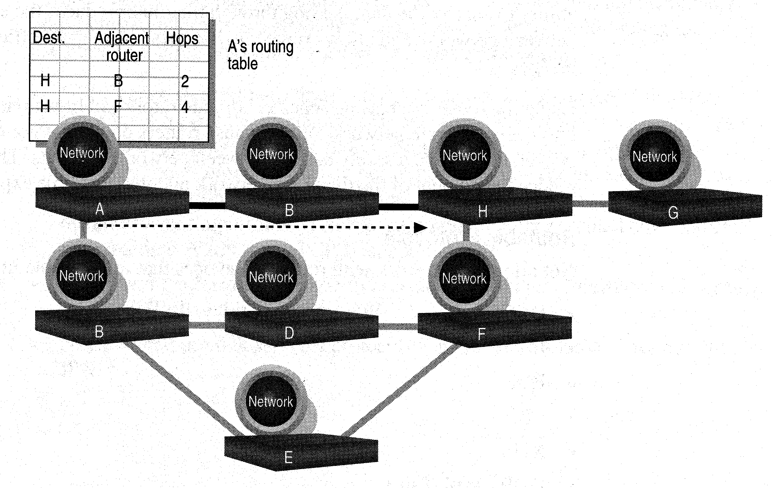

* Routers can route a packet from a TCP/IP Ethernet network to a TCP/IP token ring network (that is, routers can can connect different layer 2 technologies e.g. Ethernet, FDDI, token ring etc)

## Routers have the capability to interconnect network segments or entire networks (WANS/MANS).

## These devices examine incoming packets to determine the destination address of the data. It then examines its internal routing table to choose the best path for the packet through the network, and switches them to the proper outgoing port.

* Routers can listen to a network and identify its busiest part
* Routers select the most cost effective path for transmitting packets. In general case, best path refers to the shortest path. However, in case of traffic congestion, packets can go over a longer path.

**How Routing Table is formed**

Routers use a table to determine the best path. Routing table is formed based on communications between routers using “Routing Protocols”. Routing Protocols collect data about current network status and contribute to selection of the best path. Routers communicate within themselves and use the no. of hops between nodes to determine best path. Routers broadcast every 30 sec the routing table to neighbouring routers to convey routing information. Each router maintains a database of other router’s links. If link failure notice is received, router can rapidly compute an alternate path

**Gateway**: A gateway is a data communication device that provides a remote network with connectivity to a host network. Gateways serve as the entry and exit point of a network; all data routed inward or outward must first pass through and communicate with the gateway in order to use routing paths.

A gateway can be implemented completely in software, hardware, or in a combination of both. Generally, a router is configured to work as a gateway device in computer networks.

Because a network gateway, by definition, appears at the edge of a network, related capabilities like firewalls and proxy servers tend to be integrated with it.

Gateways are protocol converters. Often the two networks that a gateway joins use different base protocols. The gateway facilitates compatibility between the two protocols.

Summary

* Repeaters are the least expensive way to expand a network, but they are limited to connecting two segments
* Hubs broadcasts all network data across each connection.
* Bridges function similar to repeaters, but can understand the node addresses
* Switches can be considered as multiport bridges, can divide a network into some logical channels
* Routers interconnect networks and provide filtering functions. They can determine the best route
* Gateways serve as the entry and exit point of a network.

----- XXXX -----