CYBER SECURITY PRACTICAL –LAB ASSIGNMENT1
Title: Network Awareness and Port Security Using Nmap
Tool: Nmap
Instructor: Bijesh Thomas

OBJECTIVE
By the end of this 3-hour lab session, students will be able to:
- Identify live hosts in a network
- Detect open and closed ports
- Understand services running on a system
- Create an open port and then close it securely
- Develop basic defensive cybersecurity awareness
Rule: Students are allowed to scan ONLY their own system or college network. Scanning public websites or unknown IPs is strictly prohibited.

IMPORTANT TERMINOLOGIES
Term | Meaning
IP Address | Unique address of a device on a network
Host | Any connected device
Port | Digital door (0–65535)
Open Port | Accepts incoming connection
Closed Port | Exists but locked
Filtered Port | Blocked by firewall
Service | Program using a port
Firewall | Blocks unauthorized access
Subnet | Range of IP addresses
Localhost | Your own system (127.0.0.1)
Nmap | Network scanning tool
Write definitions for any 5 terms in your submission.

PART 1 – SETUP CHECK

Task 1: Check Nmap Installation
nmap --version
Write your Nmap version: 7.95

Task 2: Find Your IP Address
Windows:
ipconfig
Mac/Linux:
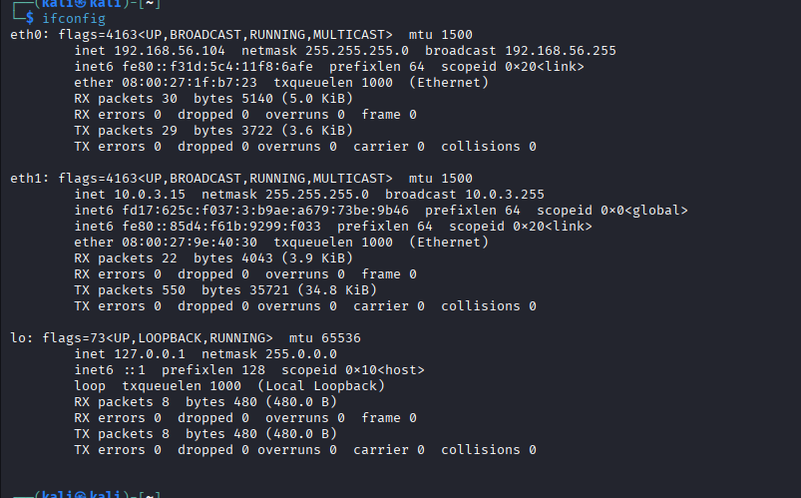
ifconfig

My IP Address: 10.0.3.15

Task 3: Find Your Network Range
Example:
If IP = 10.67.220.111
Then Network Range = 10.67.220.0/24
My Network Range: 10.0.3.0/24

PART 2 – NETWORK SCANNING

Task 4: Scan for Live Devices
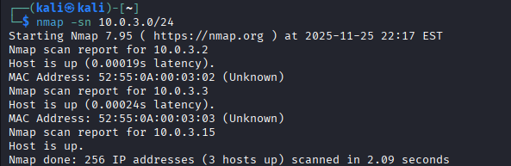
nmap -sn 10.0.3.0/24

Number of live devices found: 3
Write any 5 IP addresses found:
- 10.0.3.2
- 10.0.3.3
- 10.0.3.15
Question:
How many devices are sharing your network?
Ans: there are total of 3 devices active in my NAT.

PART 3 – PORT SCANNING

Task 5: Scan Your Own System
Nmap 10.0.3.15
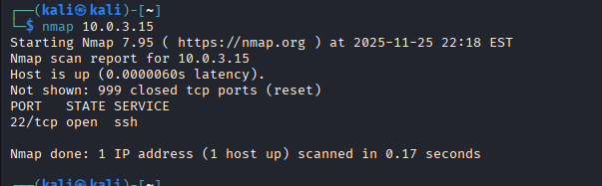

Port | State | Service
22/tcp | open | ssh
Question:
Why is it risky to have too many open ports?
Ans: Because there are vulnerabilities for many ports, and services that are running in them.

PART 4 – CREATE YOUR OWN OPEN PORT

Task 6: Open Port 8080
python3 -m http.server 8080
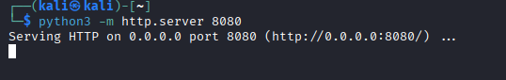

Task 7: Confirm Port is OPEN
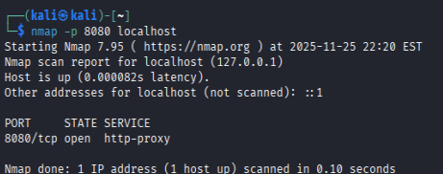
nmap -p 8080 localhost

What happened to port 8080?
Ans: A service started running in that.

PART 5 – CLOSE THE OPEN PORT
Press in the first terminal window:
CTRL + C
Then run:
nmap -p 8080 localhost
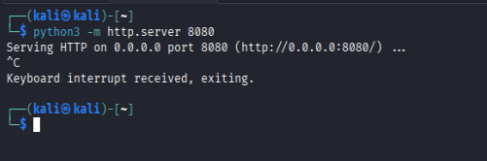

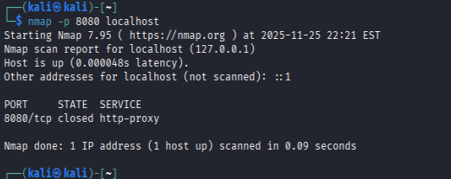

Why must we close unused ports?
Ans: Because Hackers can take advantage of the unmonitored ports to hack us.

FINAL REFLECTION
Write in your own words:
- What did you learn today?
Ans: what’s the basics of the nmap, and can open ports effect out network security.
- How many unknown devices were on your network?
Ans: Total of 2 unknown devices were there in my network, one known was mine own.
- Why is Nmap dangerous in the wrong hands?
Ans: Because it will let u know critical information which a hacker can use to cause harm to out networks.
- How has this lab changed your view on cybersecurity?
Ans: To me it hasn’t because, my view towards the Cybersecurity was already in the right direction to begin with.

