

SCHOOL OF COMPUTER SCIENCE AND
APPLICATIONS

Course Code : M23DE0207

JAVA LAB

Project Report on:
“ PERSONAL LIBRARY MANAGEMENT SYSTEM”
(JDBC Application using Swing)

Project Associates:

- RATHAN S SHET [R24DE137]
- PAVAN R [ R24DE119]
- PAVAN HC [R24DE118]
- RATHINDRA HALDER [ R24DE138]

Under the Guidance of
PROF.PINAKA PANI R
AssistantProfessor, School of CSA

TABLE OF CONTENTS

S.NO | DESCRIPTION | PAGE.NO
1 | MODULES | 1
2 | SOFTWARE REQUIREMENTS | 2
3 | DATABASE CONNECTIVITY | 6
4 | OUTPUT SCREENS | 8
5 | CODE | 18

ABSTRACT
This project aims to build a Personal Library Management System that will facilitate the interactive storage of whatever items the user is interested to store, may it be books, CDs, Movie Details, Music Playlist arrangement, etc.
The system will maintain item information such as Name, a primary key, called Code, Item Details, etc. All this Item information will be uploaded by the User and will be systematically stored after verification by the Admin.
The Personal Library Management System will also enable the User and Admin to easily spot trends and note statistics of items. For example the system will enable the User and Admin to find which type of Item is stored by the highest number of Users, and try to systematize the storage in a convenient and user friendly format.

1. MODULES
1.1 ADMIN MODULE:
The admin module will be used by the Admin Panel.

1.2 USER MODULE:
The user will be able to add items, submit reviews and apply to profiles they like

1.3 ITEM MODULE:
The Item stored remains in this module for respective user, and gets retrieved for every query of that particular user. This module is apparently monitored by the User Module, which is subsequently managed by the Admin Module.

1.4 ADVANTAGES MODULE:
SYSTEMAIC STORAGE OF ITEMS, ALSO USERS
EASY ACCESS TO THE ITEMS AND ITS DETAILS
1.5 DIS ADVANTAGES MODULE:
LIMITED NUMBER OF USERS AND ADMINS

1.6 TECHNOLOGY USED MODULE:
Front End: Java Swing
Back End: MySQL

2. SOFTWARE REQUIRMENT SPECIFICATIONS
2.1 PURPOSE :
It intends to help fast in fast access procedures in storage related activities and ensures to maintain the details of the items of particular user. Users logging should be able to upload their personal item information. The key feature of this project is that it is one time registration enabled. The Admin panel monitors the User to upload their desired items, along with their details, and retrieve those items whenever they feel it’s necessary. Also, Items can be issued for a certain period of time and it is done by the User. The User Module is further manipulated by the Admin Panel.
2.2 SCOPE:
Our project has more to do with personal usage. We can store information of items of respective User. Various Users can access their details. Acknowledgements are sent to Admins about the User Performance and actions.
2.3 OBJECTIVE:
The main objective of this project is to maintain the systematic storage of Users by admins, Items by Users.
It increases the efficiency of retrieval of items based on their primary keys, especially CodeNumber and optimize time.
There a facility to edit
User details and then let it be verified by the admin.

2.4 EXISTING SYSTEM:
The existing system describes the features of the previous working model and their drawback. Existing system does all processes manually. Admins register the information of Users. If any modifications or updates are required in the profile of any user, it has to be done manually. This is tedious and time consuming, lack of security of data, took more man power, consumes large volume of paper and space. This process is so difficult when number of user’s increases.

2.4 PROPOSED SYSTEM:
The aim of the proposed system is to develop a system with improved facilities. The proposed system can overcome all the limitation of the existing system, such as user’s information is maintained in the database, it gives more security to data, reduces paper work and save time, isolation is maintained for all users, it makes information flow efficient and paves way for easy report generation, reduce the space. proposed system is cost effective.

Advantages:
*Reduces Access time complexity.
*User can relay on security premises.
*It reduces the unnecessary maintenance of repeated data.

2.6 REQUIREMENT ANALYSIS:
Analysis focuses on producing a model of the system called the analysis model, which is correct
Complete, consistent and verifiable. Analysis model is composed mainly of three individual models.

*Functional model
*Analysis object model
*Analysis Dynamic model

The functional model is represents with use of case diagrams, the object model with class diagram and the dynamic model with state chart and sequence diagrams.

2.7 FUNCTIONAL REQUIREMENTS :
MODULES:
Personal Library Management System provides the modules like
User
Admin
Item
USER MODULE:
In this module, creation of user input records about few necessary details with facilities to modify the records and viewing changed records. The User views the Item details and verifies particular Item details and provides valid details for issue.
The users must register before logging into site and should remember their password
They let their stored items get verify by admin.
ITEM MODULE:
The item logins themselves and their User profile with help of login username as their User’s name and secret code generated by admin only a registered one.
Admin can view User details and choose the users from registered ones.
Also, select the items required by their choices and inform the user about their selection with the help of any communication source like e-mails.
ADMIN MODULE:
The admin is the main personnel who views the user details and item details.
He can also add a user to the user list and generate a UserId for the particular user.
To main the User details available. He can View user details, View s item details.
2.8 NON-FUNCTIONALREQUIREMENTS:
Non-functional requirement (NFR) is a requirement that specifies criteria that can be used to judge the operation of a system, rather than specific behaviors. They are contrasted with functional requirements that define specific behavior or functions. The plan for implementing functional requirements is detailed in the system design.

2.8.1 RELIABILITY:
Reliability, describes the ability of a system or component to function under stated conditions for a specified period of time. Reliability is closely related to availability, which is typically described as the ability of a component or system to function at a specified moment or interval of time.

2.8.2 COST:
The cost of production development and maintenance is minimum, as this project Uses all open source tools to develop the cost of construction is low.

2.8.3 PERFORMANCE:
The system is developed using high-level languages and using advanced languages for front end and back end. It will give response to user within less time.

2.8.4 SUPPORTABILITY:
The system is designed to cross platform supportable. The system is supported on wide range of hardware and any software platform, which is having JVM, built into system

2.8.5 SECURITY:
This avoid unauthorised users to modify the content in the database.

2.9 PSEUDO REQUIREMENTS:

2.9.1 SOFTWARE REQUIREMENTS:
1. JAVA - JDK13.0
2. Operating System - Supports WINDOWS,UNIX/LINUX,MAC-OS

2.9.2 HARDWARE REQUIREMENTS:
1. Processor - Intel core i3 and above
2. RAM - 2GB or above
3. Hard Disk - 250GB or above

3.DATABASE CONNECTIVITY
Table 3.1 ADMIN LOGIN
FIELD | TYPE
Username | Varchar2(25)
Password | Varchar2(15)

Table 3.2 USER LOGIN
FIELD | TYPE
UserName | Varchar2(25)
UserId | Varchar2(10)

Table 3.3 USER REGISTRATION:
FIELD | TYPE
Name | Varchar2(40)
Password | Varchar2(20)
Phone no | Number(10)
Email Id | Varchar2(20)
Address | Varchar2(30)
Table 3.4 ITEM DETAILS:
FIELD | TYPE
ISBN Number | Varchar2(40)
Name | Varchar2(40)
Quantity | Number(2)
Author | Varchar2(20)
Publisher | Varchar2(20)

Table 3.5 ACTUAL DETAILS
Table 3.5.1ADMIN LOGIN
Username | Password
aswanth | A@123
satya | S@123

Table 3.5.3 USER LOGIN
Name | Password | Phone No | Email | Address
Ashutosh | Hello123 | 9876543210 | Ashu123@gmail.com | Bvrm
Bikash | Bakhra123 | 6785656309 | Myaha123@gmail.com | VZA
Aashish | hiYou23 | 8852741963 | aashish2@gmail.com | Vizag
Pravin | world@3 | 6305123944 | Pravin3@gmail.com | TDPG
Utsab | Utsab23 | 8304193947 | Utsab2@gmail.com | JRG
Gaule | gaulo@10 | 8528529627 | gaule@gmail.com | TRPT

Table 3.5.4 ITEM DETAILS
ISBN Number | Name | Author/Creator | Publisher/Agent/Organisation
17N91A0104 | Harry Potter | JK Rowling | ABCD
17b91a01c4 | Joker | Hollywood | XYZ
17B91A0116 | Despacito | Luis Fonsi | JKLM
17b91a0132 | FIFA19 | EASports | TUVW
17b91a0161 | Vampire Diaries | Chernobyl | GHIJ

4.OUTPUT SCREENS
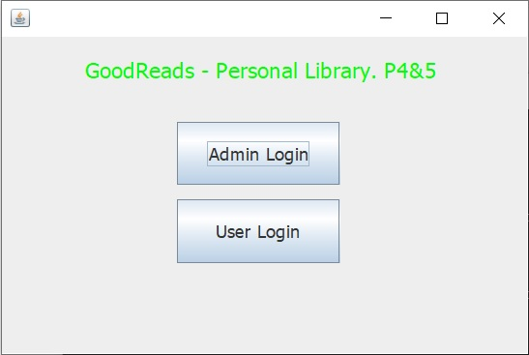

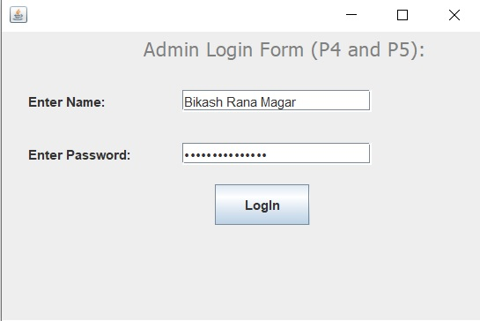

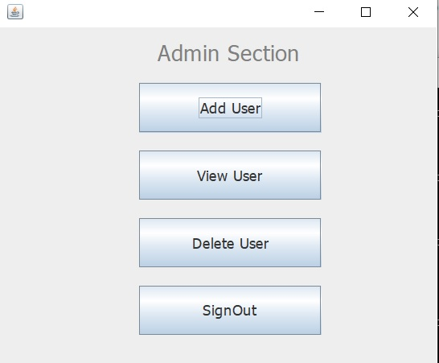

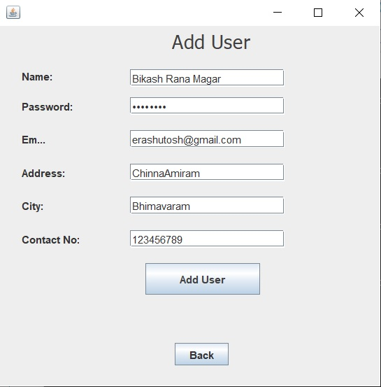

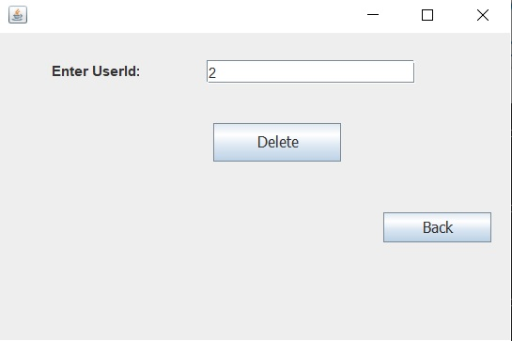

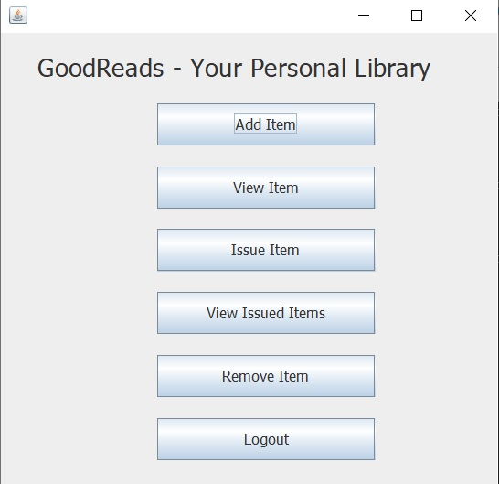

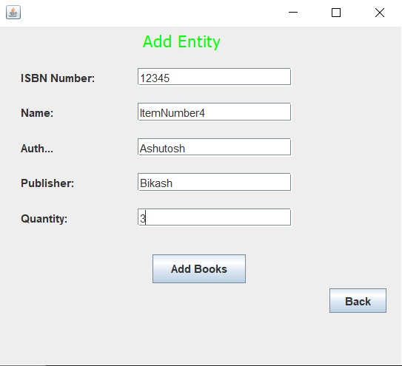

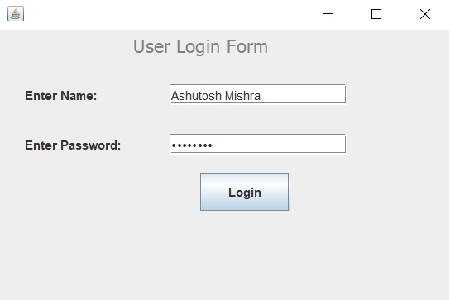

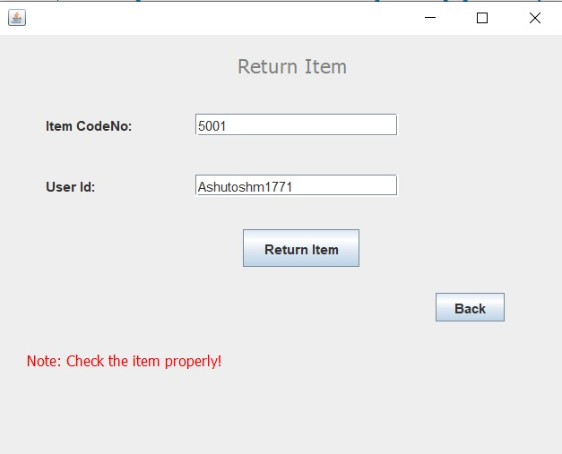

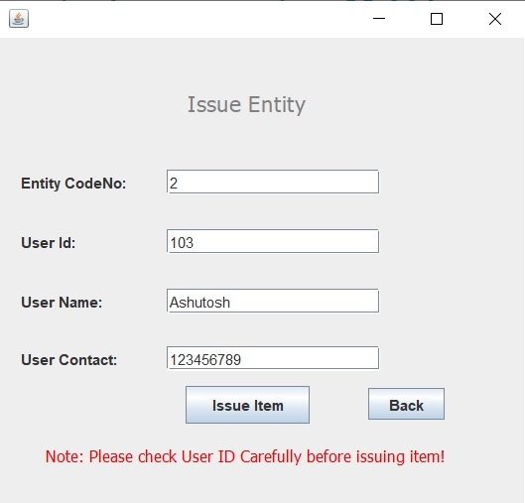

5. CODE
Home.java
import java.awt.BorderLayout;
import java.awt.EventQueue;

import javax.swing.JFrame;
import javax.swing.JPanel;
import javax.swing.border.EmptyBorder;
import javax.swing.GroupLayout;
import javax.swing.GroupLayout.Alignment;
import javax.swing.JLabel;
import java.awt.Color;
import java.awt.Font;
import javax.swing.JButton;
import javax.swing.LayoutStyle.ComponentPlacement;
import java.awt.event.ActionListener;
import java.awt.event.ActionEvent;

public class Library extends JFrame {
static Library frame;
private JPanel contentPane;

/**
* Launch the application.
*/
public static void main(String[] args) {
EventQueue.invokeLater(new Runnable() {
public void run() {
try {
frame= new Library();
frame.setVisible(true);
} catch (Exception e) {
e.printStackTrace();
}
}
});
}

/**
* Create the frame.
*/
public Library() {
setDefaultCloseOperation(JFrame.EXIT_ON_CLOSE);
setBounds(100, 100, 450, 300);
contentPane = new JPanel();
contentPane.setBorder(new EmptyBorder(5, 5, 5, 5));
setContentPane(contentPane);

JLabel lblLibraryManagement = new JLabel("GoodReads - Personal Library. P4&5");
lblLibraryManagement.setFont(new Font("Tahoma", Font.PLAIN, 18));
lblLibraryManagement.setForeground(Color.GREEN);

JButton btnAdminLogin = new JButton("Admin Login");
btnAdminLogin.addActionListener(new ActionListener() {
public void actionPerformed(ActionEvent e) {
AdminLogin.main(new String[]{});
frame.dispose();
}
});
btnAdminLogin.setFont(new Font("Tahoma", Font.PLAIN, 15));

JButton btnLibrarianLogin = new JButton("User Login");
btnLibrarianLogin.addActionListener(new ActionListener() {
public void actionPerformed(ActionEvent arg0) {
LibrarianLogin.main(new String[]{});
}
});
btnLibrarianLogin.setFont(new Font("Tahoma", Font.PLAIN, 15));
GroupLayout gl_contentPane = new GroupLayout(contentPane);
gl_contentPane.setHorizontalGroup(
gl_contentPane.createParallelGroup(Alignment.LEADING)
.addGroup(gl_contentPane.createSequentialGroup()
.addGroup(gl_contentPane.createParallelGroup(Alignment.LEADING)
.addGroup(gl_contentPane.createSequentialGroup()
.addGap(64)
.addComponent(lblLibraryManagement))
.addGroup(gl_contentPane.createSequentialGroup()
.addGap(140)
.addGroup(gl_contentPane.createParallelGroup(Alignment.TRAILING, false)
.addComponent(btnLibrarianLogin, Alignment.LEADING, GroupLayout.DEFAULT_SIZE, GroupLayout.DEFAULT_SIZE, Short.MAX_VALUE)
.addComponent(btnAdminLogin, Alignment.LEADING, GroupLayout.DEFAULT_SIZE, 135, Short.MAX_VALUE))))
.addContainerGap(95, Short.MAX_VALUE))
);
gl_contentPane.setVerticalGroup(
gl_contentPane.createParallelGroup(Alignment.LEADING)
.addGroup(gl_contentPane.createSequentialGroup()
.addContainerGap()
.addComponent(lblLibraryManagement)
.addGap(32)
.addComponent(btnAdminLogin, GroupLayout.PREFERRED_SIZE, 52, GroupLayout.PREFERRED_SIZE)
.addPreferredGap(ComponentPlacement.UNRELATED)
.addComponent(btnLibrarianLogin, GroupLayout.PREFERRED_SIZE, 53, GroupLayout.PREFERRED_SIZE)
.addContainerGap(70, Short.MAX_VALUE))
);
contentPane.setLayout(gl_contentPane);
}
}
Admin Login Form
import java.awt.BorderLayout;
import java.awt.EventQueue;

import javax.swing.JFrame;
import javax.swing.JPanel;
import javax.swing.border.EmptyBorder;
import javax.swing.GroupLayout;
import javax.swing.GroupLayout.Alignment;
import javax.swing.JLabel;
import javax.swing.JOptionPane;

import java.awt.Font;
import java.awt.Color;
import javax.swing.JTextField;
import javax.swing.JButton;
import java.awt.event.ActionListener;
import java.awt.event.ActionEvent;
import javax.swing.JPasswordField;

public class AdminLogin extends JFrame {
static AdminLogin frame;
private JPanel contentPane;
private JTextField textField;
private JPasswordField passwordField;

/**
* Launch the application.
*/
public static void main(String[] args) {
EventQueue.invokeLater(new Runnable() {
public void run() {
try {
frame = new AdminLogin();
frame.setVisible(true);
} catch (Exception e) {
e.printStackTrace();
}
}
});
}

/**
* Create the frame.
*/
public AdminLogin() {
setDefaultCloseOperation(JFrame.EXIT_ON_CLOSE);
setBounds(100, 100, 450, 300);
contentPane = new JPanel();
contentPane.setBorder(new EmptyBorder(5, 5, 5, 5));
setContentPane(contentPane);

JLabel lblAdminLoginForm = new JLabel("Admin Login Form (P4 and P5):");
lblAdminLoginForm.setForeground(Color.GRAY);
lblAdminLoginForm.setFont(new Font("Tahoma", Font.PLAIN, 18));

JLabel lblEnterName = new JLabel("Enter Name:");

JLabel lblEnterPassword = new JLabel("Enter Password:");

textField = new JTextField();
textField.setColumns(10);

JButton btnLogin = new JButton("LogIn");
btnLogin.addActionListener(new ActionListener() {
public void actionPerformed(ActionEvent e) {
String name=textField.getText();
String password=String.valueOf(passwordField.getPassword());
if(name.equals("admin")&&password.equals("p4p5")){
AdminSuccess.main(new String[]{});
frame.dispose();
}else{
JOptionPane.showMessageDialog(AdminLogin.this, "Oops, Username or Password Error","Login Error!", JOptionPane.ERROR_MESSAGE);
textField.setText("");
passwordField.setText("");
}
}
});

passwordField = new JPasswordField();
GroupLayout gl_contentPane = new GroupLayout(contentPane);
gl_contentPane.setHorizontalGroup(
gl_contentPane.createParallelGroup(Alignment.TRAILING)
.addGroup(gl_contentPane.createSequentialGroup()
.addGroup(gl_contentPane.createParallelGroup(Alignment.LEADING)
.addGroup(gl_contentPane.createSequentialGroup()
.addGap(124)
.addComponent(lblAdminLoginForm))
.addGroup(gl_contentPane.createSequentialGroup()
.addGap(19)
.addGroup(gl_contentPane.createParallelGroup(Alignment.LEADING)
.addComponent(lblEnterName)
.addComponent(lblEnterPassword))
.addGap(47)
.addGroup(gl_contentPane.createParallelGroup(Alignment.LEADING, false)
.addComponent(passwordField)
.addComponent(textField, GroupLayout.DEFAULT_SIZE, 172, Short.MAX_VALUE))))
.addContainerGap(107, Short.MAX_VALUE))
.addGroup(gl_contentPane.createSequentialGroup()
.addContainerGap(187, Short.MAX_VALUE)
.addComponent(btnLogin, GroupLayout.PREFERRED_SIZE, 86, GroupLayout.PREFERRED_SIZE)
.addGap(151))
);
gl_contentPane.setVerticalGroup(
gl_contentPane.createParallelGroup(Alignment.LEADING)
.addGroup(gl_contentPane.createSequentialGroup()
.addComponent(lblAdminLoginForm)
.addGap(26)
.addGroup(gl_contentPane.createParallelGroup(Alignment.BASELINE)
.addComponent(lblEnterName)
.addComponent(textField, GroupLayout.PREFERRED_SIZE, GroupLayout.DEFAULT_SIZE, GroupLayout.PREFERRED_SIZE))
.addGap(28)
.addGroup(gl_contentPane.createParallelGroup(Alignment.BASELINE)
.addComponent(lblEnterPassword)
.addComponent(passwordField, GroupLayout.PREFERRED_SIZE, GroupLayout.DEFAULT_SIZE, GroupLayout.PREFERRED_SIZE))
.addGap(18)
.addComponent(btnLogin, GroupLayout.PREFERRED_SIZE, 37, GroupLayout.PREFERRED_SIZE)
.addContainerGap(80, Short.MAX_VALUE))
);
contentPane.setLayout(gl_contentPane);
}
}
Admin Section
import java.awt.BorderLayout;
import java.awt.EventQueue;

import javax.swing.JFrame;
import javax.swing.JPanel;
import javax.swing.border.EmptyBorder;
import javax.swing.GroupLayout;
import javax.swing.GroupLayout.Alignment;
import javax.swing.JLabel;
import java.awt.Color;
import java.awt.Font;
import javax.swing.JButton;
import java.awt.event.ActionListener;
import java.awt.event.ActionEvent;
import javax.swing.LayoutStyle.ComponentPlacement;
import java.sql.*;
public class AdminSuccess extends JFrame {
static AdminSuccess frame;
private JPanel contentPane;

/**
* Launch the application.
*/
public static void main(String[] args) {
EventQueue.invokeLater(new Runnable() {
public void run() {
try {
frame = new AdminSuccess();
frame.setVisible(true);
} catch (Exception e) {
e.printStackTrace();
}
}
});
}

/**
* Create the frame.
*/
public AdminSuccess() {
setDefaultCloseOperation(JFrame.EXIT_ON_CLOSE);
setBounds(100, 100, 450, 371);
contentPane = new JPanel();
contentPane.setBorder(new EmptyBorder(5, 5, 5, 5));
setContentPane(contentPane);

JLabel lblAdminSection = new JLabel("Admin Section");
lblAdminSection.setFont(new Font("Tahoma", Font.PLAIN, 22));
lblAdminSection.setForeground(Color.GRAY);

JButton btnNewButton = new JButton("Add User");
btnNewButton.setFont(new Font("Tahoma", Font.PLAIN, 15));
btnNewButton.addActionListener(new ActionListener() {
public void actionPerformed(ActionEvent e) {
LibrarianForm.main(new String[]{});
frame.dispose();
}
});

JButton btnViewLibrarian = new JButton("View User");
btnViewLibrarian.addActionListener(new ActionListener() {
public void actionPerformed(ActionEvent arg0) {
ViewLibrarian.main(new String[]{});
}
});
btnViewLibrarian.setFont(new Font("Tahoma", Font.PLAIN, 15));

JButton btnDeleteLibrarian = new JButton("Delete User");
btnDeleteLibrarian.addActionListener(new ActionListener() {
public void actionPerformed(ActionEvent e) {
DeleteLibrarian.main(new String[]{});
frame.dispose();
}
});
btnDeleteLibrarian.setFont(new Font("Tahoma", Font.PLAIN, 15));

JButton btnLogout = new JButton("SignOut");
btnLogout.addActionListener(new ActionListener() {
public void actionPerformed(ActionEvent arg0) {
Library.main(new String[]{});
frame.dispose();
}
});
btnLogout.setFont(new Font("Tahoma", Font.PLAIN, 15));
GroupLayout gl_contentPane = new GroupLayout(contentPane);
gl_contentPane.setHorizontalGroup(
gl_contentPane.createParallelGroup(Alignment.TRAILING)
.addGroup(gl_contentPane.createSequentialGroup()
.addContainerGap(150, Short.MAX_VALUE)
.addComponent(lblAdminSection, GroupLayout.PREFERRED_SIZE, 151, GroupLayout.PREFERRED_SIZE)
.addGap(123))
.addGroup(Alignment.LEADING, gl_contentPane.createSequentialGroup()
.addGap(134)
.addGroup(gl_contentPane.createParallelGroup(Alignment.LEADING)
.addComponent(btnLogout, GroupLayout.PREFERRED_SIZE, 181, GroupLayout.PREFERRED_SIZE)
.addComponent(btnDeleteLibrarian, GroupLayout.PREFERRED_SIZE, 181, GroupLayout.PREFERRED_SIZE)
.addComponent(btnViewLibrarian, GroupLayout.PREFERRED_SIZE, 181, GroupLayout.PREFERRED_SIZE)
.addComponent(btnNewButton, GroupLayout.PREFERRED_SIZE, 181, GroupLayout.PREFERRED_SIZE))
.addContainerGap(109, Short.MAX_VALUE))
);
gl_contentPane.setVerticalGroup(
gl_contentPane.createParallelGroup(Alignment.LEADING)
.addGroup(gl_contentPane.createSequentialGroup()
.addComponent(lblAdminSection, GroupLayout.PREFERRED_SIZE, 40, GroupLayout.PREFERRED_SIZE)
.addGap(11)
.addComponent(btnNewButton, GroupLayout.PREFERRED_SIZE, 49, GroupLayout.PREFERRED_SIZE)
.addGap(18)
.addComponent(btnViewLibrarian, GroupLayout.PREFERRED_SIZE, 49, GroupLayout.PREFERRED_SIZE)
.addGap(18)
.addComponent(btnDeleteLibrarian, GroupLayout.PREFERRED_SIZE, 49, GroupLayout.PREFERRED_SIZE)
.addGap(18)
.addComponent(btnLogout, GroupLayout.PREFERRED_SIZE, 49, GroupLayout.PREFERRED_SIZE)
.addContainerGap(21, Short.MAX_VALUE))
);
contentPane.setLayout(gl_contentPane);
}
}

Add Item
import java.awt.BorderLayout;
import java.awt.EventQueue;

import javax.swing.JFrame;
import javax.swing.JPanel;
import javax.swing.border.EmptyBorder;
import javax.swing.GroupLayout;
import javax.swing.GroupLayout.Alignment;
import javax.swing.JLabel;
import javax.swing.JOptionPane;

import java.awt.Font;
import java.awt.Color;
import javax.swing.JTextField;
import javax.swing.JButton;
import java.awt.event.ActionListener;
import java.awt.event.ActionEvent;
import javax.swing.LayoutStyle.ComponentPlacement;

public class BooksForm extends JFrame {
static BooksForm frame;
private JPanel contentPane;
private JTextField textField;
private JTextField textField_1;
private JTextField textField_2;
private JTextField textField_3;
private JTextField textField_4;

/**
* Launch the application.
*/
public static void main(String[] args) {
EventQueue.invokeLater(new Runnable() {
public void run() {
try {
frame = new BooksForm();
frame.setVisible(true);
} catch (Exception e) {
e.printStackTrace();
}
}
});
}

/**
* Create the frame.
*/
public BooksForm() {
setDefaultCloseOperation(JFrame.EXIT_ON_CLOSE);
setBounds(100, 100, 450, 404);
contentPane = new JPanel();
contentPane.setBorder(new EmptyBorder(5, 5, 5, 5));
setContentPane(contentPane);

JLabel lblAddBooks = new JLabel("Add Entity");
lblAddBooks.setForeground(Color.GREEN);
lblAddBooks.setFont(new Font("Tahoma", Font.PLAIN, 18));

JLabel lblCallNo = new JLabel("ISBN Number:");

JLabel lblName = new JLabel("Name:");

JLabel lblAuthor = new JLabel("Author:");

JLabel lblPublisher = new JLabel("Publisher:");

JLabel lblQuantity = new JLabel("Quantity:");

textField = new JTextField();
textField.setColumns(10);

textField_1 = new JTextField();
textField_1.setColumns(10);

textField_2 = new JTextField();
textField_2.setColumns(10);

textField_3 = new JTextField();
textField_3.setColumns(10);

textField_4 = new JTextField();
textField_4.setColumns(10);

JButton btnAddBooks = new JButton("Add Books");
btnAddBooks.addActionListener(new ActionListener() {
public void actionPerformed(ActionEvent e) {
String callno=textField.getText();
String name=textField_1.getText();
String author=textField_2.getText();
String publisher=textField_3.getText();
String squantity=textField_4.getText();
int quantity=Integer.parseInt(squantity);
int i=BookDao.save(callno, name, author, publisher, quantity);
if(i>0){
JOptionPane.showMessageDialog(BooksForm.this,"Item added successfully!");
LibrarianSuccess.main(new String[]{});
frame.dispose();

}else{
JOptionPane.showMessageDialog(BooksForm.this,"Sorry, unable to save!");
}
}
});

JButton btnBack = new JButton("Back");
GroupLayout gl_contentPane = new GroupLayout(contentPane);
gl_contentPane.setHorizontalGroup(
gl_contentPane.createParallelGroup(Alignment.TRAILING)
.addGroup(gl_contentPane.createSequentialGroup()
.addGroup(gl_contentPane.createParallelGroup(Alignment.LEADING)
.addGroup(gl_contentPane.createSequentialGroup()
.addGap(150)
.addComponent(lblAddBooks))
.addGroup(gl_contentPane.createSequentialGroup()
.addGap(18)
.addGroup(gl_contentPane.createParallelGroup(Alignment.LEADING, false)
.addComponent(lblName, GroupLayout.PREFERRED_SIZE, 37, GroupLayout.PREFERRED_SIZE)
.addComponent(lblCallNo)
.addComponent(lblAuthor, GroupLayout.PREFERRED_SIZE, 37, GroupLayout.PREFERRED_SIZE)
.addComponent(lblPublisher, GroupLayout.DEFAULT_SIZE, 67, Short.MAX_VALUE)
.addComponent(lblQuantity, GroupLayout.PREFERRED_SIZE, 55, GroupLayout.PREFERRED_SIZE))
.addGap(47)
.addGroup(gl_contentPane.createParallelGroup(Alignment.LEADING)
.addComponent(textField_4, GroupLayout.PREFERRED_SIZE, 167, GroupLayout.PREFERRED_SIZE)
.addComponent(textField_3, GroupLayout.PREFERRED_SIZE, 167, GroupLayout.PREFERRED_SIZE)
.addComponent(textField_2, GroupLayout.PREFERRED_SIZE, 167, GroupLayout.PREFERRED_SIZE)
.addComponent(textField_1, GroupLayout.PREFERRED_SIZE, 167, GroupLayout.PREFERRED_SIZE)
.addComponent(textField, GroupLayout.PREFERRED_SIZE, 167, GroupLayout.PREFERRED_SIZE))))
.addContainerGap(125, Short.MAX_VALUE))
.addGroup(Alignment.LEADING, gl_contentPane.createSequentialGroup()
.addGap(161)
.addComponent(btnAddBooks, GroupLayout.PREFERRED_SIZE, 101, GroupLayout.PREFERRED_SIZE)
.addContainerGap(162, Short.MAX_VALUE))
.addGroup(gl_contentPane.createSequentialGroup()
.addContainerGap(359, Short.MAX_VALUE)
.addComponent(btnBack)
.addContainerGap())
);
gl_contentPane.setVerticalGroup(
gl_contentPane.createParallelGroup(Alignment.LEADING)
.addGroup(gl_contentPane.createSequentialGroup()
.addComponent(lblAddBooks)
.addGap(18)
.addGroup(gl_contentPane.createParallelGroup(Alignment.BASELINE)
.addComponent(lblCallNo)
.addComponent(textField, GroupLayout.PREFERRED_SIZE, GroupLayout.DEFAULT_SIZE, GroupLayout.PREFERRED_SIZE))
.addGap(18)
.addGroup(gl_contentPane.createParallelGroup(Alignment.BASELINE)
.addComponent(lblName)
.addComponent(textField_1, GroupLayout.PREFERRED_SIZE, GroupLayout.DEFAULT_SIZE, GroupLayout.PREFERRED_SIZE))
.addGap(18)
.addGroup(gl_contentPane.createParallelGroup(Alignment.BASELINE)
.addComponent(lblAuthor)
.addComponent(textField_2, GroupLayout.PREFERRED_SIZE, GroupLayout.DEFAULT_SIZE, GroupLayout.PREFERRED_SIZE))
.addGap(18)
.addGroup(gl_contentPane.createParallelGroup(Alignment.BASELINE)
.addComponent(lblPublisher)
.addComponent(textField_3, GroupLayout.PREFERRED_SIZE, GroupLayout.DEFAULT_SIZE, GroupLayout.PREFERRED_SIZE))
.addGap(18)
.addGroup(gl_contentPane.createParallelGroup(Alignment.BASELINE)
.addComponent(lblQuantity)
.addComponent(textField_4, GroupLayout.PREFERRED_SIZE, GroupLayout.DEFAULT_SIZE, GroupLayout.PREFERRED_SIZE))
.addGap(30)
.addComponent(btnAddBooks, GroupLayout.PREFERRED_SIZE, 31, GroupLayout.PREFERRED_SIZE)
.addPreferredGap(ComponentPlacement.RELATED)
.addComponent(btnBack)
.addContainerGap(53, Short.MAX_VALUE))
);
contentPane.setLayout(gl_contentPane);
}

}

Issue Items
import java.awt.BorderLayout;
import java.awt.EventQueue;

import javax.swing.JFrame;
import javax.swing.JPanel;
import javax.swing.border.EmptyBorder;
import javax.swing.GroupLayout;
import javax.swing.GroupLayout.Alignment;
import javax.swing.JLabel;
import javax.swing.JOptionPane;

import java.awt.Color;
import java.awt.Font;
import javax.swing.JTextField;
import javax.swing.JButton;
import javax.swing.LayoutStyle.ComponentPlacement;
import java.awt.event.ActionListener;
import java.awt.event.ActionEvent;

public class IssueBookForm extends JFrame {
static IssueBookForm frame;
private JPanel contentPane;
private JTextField textField_1;
private JTextField textField_2;
private JTextField textField_3;
private JTextField textField_4;

/**
* Launch the application.
*/
public static void main(String[] args) {
EventQueue.invokeLater(new Runnable() {
public void run() {
try {
frame = new IssueBookForm();
frame.setVisible(true);
} catch (Exception e) {
e.printStackTrace();
}
}
});
}

/**
* Create the frame.
*/
public IssueBookForm() {
setDefaultCloseOperation(JFrame.EXIT_ON_CLOSE);
setBounds(100, 100, 438, 414);
contentPane = new JPanel();
contentPane.setBorder(new EmptyBorder(5, 5, 5, 5));
setContentPane(contentPane);

JLabel lblNewLabel = new JLabel("Issue Entity ");
lblNewLabel.setFont(new Font("Tahoma", Font.PLAIN, 18));
lblNewLabel.setForeground(Color.GRAY);

JLabel lblBookName = new JLabel("Entity CodeNo:");

textField_1 = new JTextField();
textField_1.setColumns(10);

textField_2 = new JTextField();
textField_2.setColumns(10);

textField_3 = new JTextField();
textField_3.setColumns(10);

textField_4 = new JTextField();
textField_4.setColumns(10);

JLabel lblStudentId = new JLabel("User Id:");

JLabel lblStudentName = new JLabel("User Name:");

JLabel lblStudentContact = new JLabel("User Contact:");

JButton btnIssueBook = new JButton("Issue Item");
btnIssueBook.addActionListener(new ActionListener() {
public void actionPerformed(ActionEvent e) {

String bookcallno=textField_1.getText();
int studentid=Integer.parseInt(textField_2.getText());
String studentname=textField_3.getText();
String studentcontact=textField_4.getText();

if(IssueBookDao.checkBook(bookcallno)){

int i=IssueBookDao.save(bookcallno, studentid, studentname, studentcontact);
if(i>0){
JOptionPane.showMessageDialog(IssueBookForm.this,"Entity issued successfully!");
LibrarianSuccess.main(new String[]{});
frame.dispose();

}else{
JOptionPane.showMessageDialog(IssueBookForm.this,"Sorry, unable to issue!");
}//end of save if-else

}else{
JOptionPane.showMessageDialog(IssueBookForm.this,"Sorry, Codeno doesn't exist!");
}//end of checkbook if-else

}
});

JButton btnBack = new JButton("Back");
btnBack.addActionListener(new ActionListener() {
public void actionPerformed(ActionEvent e) {
LibrarianSuccess.main(new String[]{});
frame.dispose();
}
});

JLabel lblNewLabel_1 = new JLabel("Note: Please check User ID Carefully before issuing item!");
lblNewLabel_1.setFont(new Font("Tahoma", Font.PLAIN, 13));
lblNewLabel_1.setForeground(Color.RED);
GroupLayout gl_contentPane = new GroupLayout(contentPane);
gl_contentPane.setHorizontalGroup(
gl_contentPane.createParallelGroup(Alignment.LEADING)
.addGroup(gl_contentPane.createSequentialGroup()
.addContainerGap(10, Short.MAX_VALUE)
.addGroup(gl_contentPane.createParallelGroup(Alignment.LEADING)
.addGroup(gl_contentPane.createSequentialGroup()
.addGroup(gl_contentPane.createParallelGroup(Alignment.LEADING)
.addComponent(lblBookName)
.addComponent(lblStudentId)
.addComponent(lblStudentName, GroupLayout.PREFERRED_SIZE, 108, GroupLayout.PREFERRED_SIZE)
.addComponent(lblStudentContact, GroupLayout.PREFERRED_SIZE, 100, GroupLayout.PREFERRED_SIZE))
.addGap(10)
.addGroup(gl_contentPane.createParallelGroup(Alignment.LEADING)
.addComponent(textField_2, GroupLayout.PREFERRED_SIZE, 172, GroupLayout.PREFERRED_SIZE)
.addComponent(textField_1, GroupLayout.PREFERRED_SIZE, 172, GroupLayout.PREFERRED_SIZE)
.addComponent(textField_3, GroupLayout.PREFERRED_SIZE, 172, GroupLayout.PREFERRED_SIZE)
.addComponent(textField_4, GroupLayout.PREFERRED_SIZE, 172, GroupLayout.PREFERRED_SIZE))
.addGap(48))
.addGroup(Alignment.TRAILING, gl_contentPane.createSequentialGroup()
.addGap(20)
.addGroup(gl_contentPane.createParallelGroup(Alignment.TRAILING)
.addComponent(lblNewLabel_1)
.addGroup(gl_contentPane.createSequentialGroup()
.addComponent(btnIssueBook, GroupLayout.PREFERRED_SIZE, 100, GroupLayout.PREFERRED_SIZE)
.addGap(47)
.addComponent(btnBack)))
.addGap(100))))
.addGroup(gl_contentPane.createSequentialGroup()
.addGap(146)
.addComponent(lblNewLabel)
.addContainerGap(235, Short.MAX_VALUE))
);
gl_contentPane.setVerticalGroup(
gl_contentPane.createParallelGroup(Alignment.TRAILING)
.addGroup(gl_contentPane.createSequentialGroup()
.addGap(37)
.addComponent(lblNewLabel)
.addGap(43)
.addGroup(gl_contentPane.createParallelGroup(Alignment.BASELINE)
.addComponent(lblBookName)
.addComponent(textField_1, GroupLayout.PREFERRED_SIZE, GroupLayout.DEFAULT_SIZE, GroupLayout.PREFERRED_SIZE))
.addGap(28)
.addGroup(gl_contentPane.createParallelGroup(Alignment.BASELINE)
.addComponent(lblStudentId)
.addComponent(textField_2, GroupLayout.PREFERRED_SIZE, GroupLayout.DEFAULT_SIZE, GroupLayout.PREFERRED_SIZE))
.addGap(28)
.addGroup(gl_contentPane.createParallelGroup(Alignment.BASELINE)
.addComponent(lblStudentName)
.addComponent(textField_3, GroupLayout.PREFERRED_SIZE, GroupLayout.DEFAULT_SIZE, GroupLayout.PREFERRED_SIZE))
.addGap(26)
.addGroup(gl_contentPane.createParallelGroup(Alignment.BASELINE)
.addComponent(lblStudentContact)
.addComponent(textField_4, GroupLayout.PREFERRED_SIZE, GroupLayout.DEFAULT_SIZE, GroupLayout.PREFERRED_SIZE))
.addPreferredGap(ComponentPlacement.UNRELATED)
.addGroup(gl_contentPane.createParallelGroup(Alignment.BASELINE)
.addComponent(btnIssueBook, GroupLayout.PREFERRED_SIZE, 31, GroupLayout.PREFERRED_SIZE)
.addComponent(btnBack))
.addGap(18)
.addComponent(lblNewLabel_1)
.addGap(25))
);
contentPane.setLayout(gl_contentPane);
}
}
Return Item
import java.awt.BorderLayout;
import java.awt.EventQueue;

import javax.swing.JFrame;
import javax.swing.JPanel;
import javax.swing.border.EmptyBorder;
import javax.swing.GroupLayout;
import javax.swing.GroupLayout.Alignment;
import javax.swing.JLabel;
import javax.swing.JOptionPane;

import java.awt.Font;
import java.awt.Color;
import javax.swing.JTextField;
import javax.swing.JButton;
import javax.swing.LayoutStyle.ComponentPlacement;
import java.awt.event.ActionListener;
import java.awt.event.ActionEvent;

public class ReturnBook extends JFrame {
static ReturnBook frame;
private JPanel contentPane;
private JTextField textField;
private JTextField textField_1;

/**
* Launch the application.
*/
public static void main(String[] args) {
EventQueue.invokeLater(new Runnable() {
public void run() {
try {
frame = new ReturnBook();
frame.setVisible(true);
} catch (Exception e) {
e.printStackTrace();
}
}
});
}

/**
* Create the frame.
*/
public ReturnBook() {
setDefaultCloseOperation(JFrame.EXIT_ON_CLOSE);
setBounds(100, 100, 516, 413);
contentPane = new JPanel();
contentPane.setBorder(new EmptyBorder(5, 5, 5, 5));
setContentPane(contentPane);

JLabel lblReturnBook = new JLabel("Return Item");
lblReturnBook.setForeground(Color.GRAY);
lblReturnBook.setFont(new Font("Tahoma", Font.PLAIN, 18));

JLabel lblBookCallno = new JLabel("Item CodeNo:");

JLabel lblStudentId = new JLabel("User Id:");

textField = new JTextField();
textField.setColumns(10);

textField_1 = new JTextField();
textField_1.setColumns(10);

JButton btnReturnBook = new JButton("Return Item");
btnReturnBook.addActionListener(new ActionListener() {
public void actionPerformed(ActionEvent e) {
String bookcallno=textField.getText();
int studentid=Integer.parseInt(textField_1.getText());
int i=ReturnBookDao.delete(bookcallno, studentid);
if(i>0){
JOptionPane.showMessageDialog(ReturnBook.this,"Item returned successfully!");
LibrarianSuccess.main(new String[]{});
frame.dispose();

}else{
JOptionPane.showMessageDialog(ReturnBook.this,"Sorry, unable to return book!");
}
}
});

JLabel lblNewLabel = new JLabel("Note: Check the item properly!");
lblNewLabel.setForeground(Color.RED);
lblNewLabel.setFont(new Font("Tahoma", Font.PLAIN, 13));

JButton btnBack = new JButton("Back");
btnBack.addActionListener(new ActionListener() {
public void actionPerformed(ActionEvent e) {
LibrarianSuccess.main(new String[]{});
frame.dispose();
}
});
GroupLayout gl_contentPane = new GroupLayout(contentPane);
gl_contentPane.setHorizontalGroup(
gl_contentPane.createParallelGroup(Alignment.TRAILING)
.addGroup(gl_contentPane.createSequentialGroup()
.addGap(36)
.addGroup(gl_contentPane.createParallelGroup(Alignment.TRAILING, false)
.addComponent(lblStudentId, Alignment.LEADING, GroupLayout.DEFAULT_SIZE, GroupLayout.DEFAULT_SIZE, Short.MAX_VALUE)
.addComponent(lblBookCallno, Alignment.LEADING, GroupLayout.DEFAULT_SIZE, 78, Short.MAX_VALUE))
.addGap(56)
.addGroup(gl_contentPane.createParallelGroup(Alignment.LEADING)
.addComponent(textField_1, GroupLayout.PREFERRED_SIZE, 181, GroupLayout.PREFERRED_SIZE)
.addComponent(textField, GroupLayout.PREFERRED_SIZE, 181, GroupLayout.PREFERRED_SIZE))
.addContainerGap(139, Short.MAX_VALUE))
.addGroup(gl_contentPane.createSequentialGroup()
.addContainerGap(210, Short.MAX_VALUE)
.addComponent(btnReturnBook, GroupLayout.PREFERRED_SIZE, 104, GroupLayout.PREFERRED_SIZE)
.addGap(176))
.addGroup(gl_contentPane.createSequentialGroup()
.addContainerGap(205, Short.MAX_VALUE)
.addComponent(lblReturnBook)
.addGap(187))
.addGroup(gl_contentPane.createSequentialGroup()
.addGap(19)
.addComponent(lblNewLabel)
.addContainerGap(294, Short.MAX_VALUE))
.addGroup(gl_contentPane.createSequentialGroup()
.addContainerGap(355, Short.MAX_VALUE)
.addComponent(btnBack)
.addGap(46))
);
gl_contentPane.setVerticalGroup(
gl_contentPane.createParallelGroup(Alignment.LEADING)
.addGroup(gl_contentPane.createSequentialGroup()
.addContainerGap()
.addComponent(lblReturnBook)
.addGap(32)
.addGroup(gl_contentPane.createParallelGroup(Alignment.BASELINE)
.addComponent(lblBookCallno)
.addComponent(textField, GroupLayout.PREFERRED_SIZE, GroupLayout.DEFAULT_SIZE, GroupLayout.PREFERRED_SIZE))
.addGap(34)
.addGroup(gl_contentPane.createParallelGroup(Alignment.BASELINE)
.addComponent(lblStudentId)
.addComponent(textField_1, GroupLayout.PREFERRED_SIZE, GroupLayout.DEFAULT_SIZE, GroupLayout.PREFERRED_SIZE))
.addGap(29)
.addComponent(btnReturnBook, GroupLayout.PREFERRED_SIZE, 34, GroupLayout.PREFERRED_SIZE)
.addGap(23)
.addComponent(btnBack)
.addPreferredGap(ComponentPlacement.RELATED, 28, Short.MAX_VALUE)
.addComponent(lblNewLabel)
.addGap(72))
);
contentPane.setLayout(gl_contentPane);
}

}
View User
import java.awt.BorderLayout;
import java.awt.EventQueue;
import java.sql.Connection;
import java.sql.PreparedStatement;
import java.sql.ResultSet;
import java.sql.ResultSetMetaData;

import javax.swing.JFrame;
import javax.swing.JPanel;
import javax.swing.JScrollPane;
import javax.swing.border.EmptyBorder;
import javax.swing.JTable;

public class ViewLibrarian extends JFrame {

private JPanel contentPane;
private JTable table;

public static void main(String[] args) {
EventQueue.invokeLater(new Runnable() {
public void run() {
try {
ViewLibrarian frame = new ViewLibrarian();
frame.setVisible(true);
} catch (Exception e) {
e.printStackTrace();
}
}
});
}

/**
* Create the frame.
*/
public ViewLibrarian() {
setDefaultCloseOperation(JFrame.HIDE_ON_CLOSE);
setBounds(100, 100, 450, 300);
contentPane = new JPanel();
contentPane.setBorder(new EmptyBorder(5, 5, 5, 5));
contentPane.setLayout(new BorderLayout(0, 0));
setContentPane(contentPane);
String data[][]=null;
String column[]=null;
try{
Connection con=DB.getConnection();
PreparedStatement ps=con.prepareStatement("select * from Librarian",ResultSet.TYPE_SCROLL_SENSITIVE,ResultSet.CONCUR_UPDATABLE);
ResultSet rs=ps.executeQuery();

ResultSetMetaData rsmd=rs.getMetaData();
int cols=rsmd.getColumnCount();
column=new String[cols];
for(int i=1;i<=cols;i++){
column[i-1]=rsmd.getColumnName(i);
}

rs.last();
int rows=rs.getRow();
rs.beforeFirst();

data=new String[rows][cols];
int count=0;
while(rs.next()){
for(int i=1;i<=cols;i++){
data[count][i-1]=rs.getString(i);
}
count++;
}
con.close();
}catch(Exception e){System.out.println(e);}

table = new JTable(data,column);
JScrollPane sp=new JScrollPane(table);

contentPane.add(sp, BorderLayout.CENTER);
}

}

Thank You!

