STAT 345 Final Project - Real Estate

Ethan Manhart, Kayla Newman, Colin Fitzpatrick, Nick Kartschoke

## Introduction

## Code Breakdown

#players <- c(1,2,3,4)  
  
position <- dict()  
position[1] <- 1  
position[2] <- 1  
position[3] <- 1  
position[4] <- 1  
  
spaces <- dict()  
locations <- c(prop$Properties)  
i <- 0  
while(i < 41){  
 spaces[i] <- locations[i]  
 i <- i + 1  
}

#REFINED FUCNTIONS: (05-04-2021) #Updated all previous functions to work for the condition: “Go to Jail.” #Fixed a bug in the moving() and moving_doubles() functions

#SECTION 01: MOVEMENT (05-04-2021)

#Various Roll Dice Functions:

#All functions mimic rolling dice in a game of monopoly. roll_dice() is used for regular dice movement; force_doubles() and differing_dice() were used for testing.   
  
roll_dice <- function()  
{  
 dice <- sample(1:6, 2, replace = TRUE)  
 return(dice)  
}  
  
  
force_doubles <- function()  
{  
 dice <- sample(1:1, 2, replace = TRUE)  
 return(dice)  
}  
  
  
differing_dice <- function()  
{  
 dice <- sample(1:6, 2, replace = TRUE)  
   
 while (dice[1] == dice[2])   
 {  
 dice <- sample(1:6, 2, replace = TRUE)  
 }  
   
 return(dice)  
}

#Basic Movement Function

#The basic movement function takes an input of a player id and updates player position based on a roll to two six-sided dice. At this point in time, special movement, including rolling doubles, is not considered.  
  
#For clarity, the position of player i for i in {1, 2, 3, 4} is stored as position[i] <- return of basic_movement(). (This will always be an integer between 1 and 12.)  
  
basic_movement <- function(playerID)  
{  
 r <- sum(roll_dice())  
 pl <- position[[playerID]] + r  
   
 if(pl >= 41)  
 {  
 pl <- pl - 40  
 }  
   
 print(paste0("Player", playerID, " rolls: ", r))  
 print(paste0("Player", playerID, " moves ", r, " spaces and lands on: ", spaces[[pl]]))  
 return(pl)  
}

#Test:

#position[1] <- 1  
  
#for (i in 1:10)   
#{  
 #position[1] <- basic_movement(1)  
 #print(position[1])  
#}

#Heatmap with Simulation 2.1:

deeds_properties <- full_join(frequency_frame, deeds, by = "Properties")  
deeds_properties$Color[is.na(deeds_properties$Color)] <- "No Color"  
  
deeds_properties$Properties <- factor(deeds_properties$Properties, levels = deeds_properties$Properties)  
  
ggplot(deeds_properties, aes(Properties, value)) + geom_col(aes(fill = Color)) + labs(title = "Space Frequency", x = "Space", y = "Frequency") + theme(axis.text.x = element_text(angle = 90)) + scale_fill_manual(name = "Deed Colors", values = c("tan4", "blue", "forest green", "light blue", "magenta3", "grey78","chocolate1", "red2", "gold"))

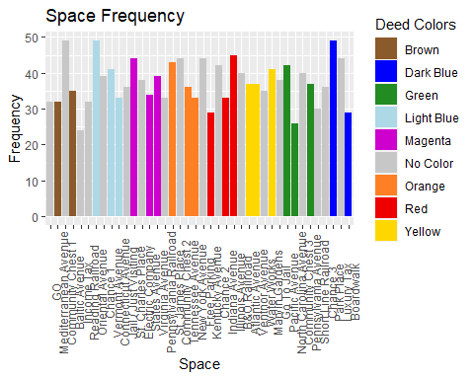

#Visualization: HeatMap  
frequency_subset <- frequency_frame %>% select(value)  
frequency_data <- unname(unlist(frequency_subset))  
#frequency_data  
  
monopoly_board_matrix <- matrix(data = c(frequency_data[21], frequency_data[22], frequency_data[23], frequency_data[24], frequency_data[25], frequency_data[26], frequency_data[27], frequency_data[28], frequency_data[29], frequency_data[30], frequency_data[31], frequency_data[20],0,0,0,0,0,0,0,0,0, frequency_data[32],   
frequency_data[19],0,0,0,0,0,0,0,0,0, frequency_data[33],   
frequency_data[18],0,0,0,0,0,0,0,0,0, frequency_data[34],  
frequency_data[17],0,0,0,0,0,0,0,0,0, frequency_data[35],   
frequency_data[16],0,0,0,0,0,0,0,0,0, frequency_data[36],   
frequency_data[15],0,0,0,0,0,0,0,0,0, frequency_data[37],  
frequency_data[14],0,0,0,0,0,0,0,0,0, frequency_data[38],   
frequency_data[13],0,0,0,0,0,0,0,0,0, frequency_data[39],   
frequency_data[12],0,0,0,0,0,0,0,0,0, frequency_data[40],  
frequency_data[11], frequency_data[10], frequency_data[9], frequency_data[8], frequency_data[7], frequency_data[6], frequency_data[5], frequency_data[4], frequency_data[3], frequency_data[2], frequency_data[1]), nrow = 11, ncol = 11)  
heatmap <- heatmap(x=monopoly_board_matrix, Colv = NA, Rowv = NA, scale = "none")

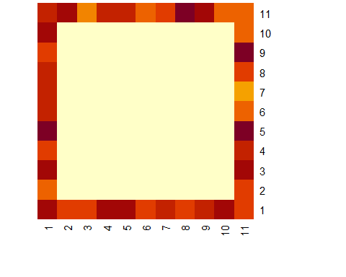

#df = as.data.frame(frequency_data)  
#ggplot(df,(aes(1:40,1))) + geom_tile(aes(fill = frequency_data))

#Heatmap with Simulation 2.2:

1. *Double Down* Improve your system to incorporate going to jail, including the doubles-rolling condition. Which properties are landed on most frequently now? Has this changed dramatically from the previous system (that didn’t account for jail)? Again, visualize this!

#Check Player’s Hand:

#In Jail/Exiting Jail (3):

#The In_Out_Jail() takes a player and, utilizing game rules and logical if/else statements, simulates a player entering and exiting jail. The statements are rather self-explanatory, but we would like to highlight the use of section3_jail_roll. This function allows us to move a player with starting location equal to Jail / Just Visiting = 11. (Implements the section3_moving and section3_moving_doubles functions explained later.)  
  
section3_In_Out_Jail <- function(player_identifer, counter = 0)  
{  
 position[player_identifer] <- 11  
   
 if(counter == 0)  
 {  
 print(paste0("Player", player_identifer, " is now in jail."))  
 section3_In_Out_Jail(player_identifer, counter + 1)  
 }  
   
 else  
 {  
 hand <- Check_Hand(player_identifer)  
 card <- hand %>% select(Get.Out.of.Jail.Free)   
   
 if(is.na(card) == FALSE)  
 {  
 players[player_identifer, ]$Get.Out.of.Jail.Free <- NA  
 print(paste0("Player", player_identifer, " uses a 'Get Out of Jail Free Card.'"))  
 section3_jail_roll(player_identifer)  
 }  
   
 else  
 {  
 funds <- hand %>% select(Bank)  
   
 if(funds >= 500)  
 {  
 players[player_identifer, ]$Bank <- players[player_identifer, ]$Bank - 50  
 print(paste0("Player", player_identifer, " pays $50 to exit jail."))  
 section3_jail_roll(player_identifer)  
 }  
   
 else  
 {  
 roll <- roll_dice()  
   
 if(roll[1] == roll[2])  
 {   
 print(paste0("Player", player_identifer, " rolls doubles to exit jail."))  
 section3_jail_roll(player_identifer)  
 }  
   
 else  
 {  
 if(counter < 2)  
 {  
 print(paste0("Player", player_identifer, " remains in jail."))  
 section3_In_Out_Jail(player_identifer, counter + 1)  
 }  
   
 else  
 {  
 funds <- hand %>% select(Bank)  
   
 if(funds >= 50)  
 {  
 funds[[1]] <- funds[[1]] - 50  
   
 print(paste0("Player", player_identifer, " pays $50 to exit jail."))  
 section3_jail_roll(player_identifer)  
 }  
   
 else  
 {  
 print(paste0("Player", player_identifer, " is bankrupted."))  
 #remove player from player dataset?  
 }  
 }  
 }  
 }  
 }  
 }  
   
 #return(exit_roll)  
 #invisible(players)  
}

Moving (3) allows us to move a player from a starting position. We found that using this function alone creates an issue for movement, as the function does not “remember” the previous roll when moving twice consecutively as is the case when rolling doubles.

#Moving (3):

#Moving Doubles (3):

#2) Moving Doubles (3) is used when multiple dice rolls need to be considered. This stores player's last location and moves the player from their last known location.  
  
section3_moving_doubles <- function(playerID, spaces_to_move, player_location)  
{  
 position[[playerID]] <- player_location  
 position[[playerID]] <- position[[playerID]] + spaces_to_move  
 user_place <- position[[playerID]]  
   
 #Restarts Count after Passing GO:  
 if(user_place >= 41)  
 {  
 user_place <- user_place - 40  
 }  
   
 print(paste0("Player", playerID, " moves ", spaces_to_move, " spaces and lands on: ", spaces[[user_place]]))  
 #position[playerID] <- user_place  
 return(user_place)  
}

#Jail Roll (3):

#Used for exiting jail; see section3_roll_to_move player for understanding of process.  
  
section3_jail_roll <- function(playerID, counter = 1, player_position = 11, type_of_roll = roll_dice())  
{  
 #position[[playerID]] <- player_position  
 p <- player_position  
   
 roll <- type_of_roll  
   
 if(roll[1] == roll[2])  
 {  
 if(counter == 3)  
 {  
 totalDice <- sum(roll)  
   
 print(paste0("Player", playerID, " rolls doubles for a third time!", " The sum of their roll is: ", totalDice))  
 print(paste0("Player", playerID, " returns to Jail for rolling too many doubles."))  
 section3_In_Out_Jail(playerID) #(Go_to_Jail implemented in following section)  
 }  
   
 else  
 {  
 totalDice <- sum(roll)  
   
 if(counter == 1)  
 {  
 print(paste0("Player", playerID, " rolls doubles!", " The sum of their roll is: ", totalDice))  
 new_position <- section3_moving_doubles(playerID, totalDice, 11)  
 player_position <- new_position  
 }  
   
 else  
 {  
 #print(roll)  
 print(paste0("Player", playerID, " rolls doubles again!", " The sum of their roll is: ", totalDice))  
 new_position <- section3_moving_doubles(playerID, totalDice, p)  
 player_position <- new_position  
 }  
   
 section3_jail_roll(playerID, counter + 1, new_position)  
 }  
 }  
   
 else  
 {  
 totalDice <- sum(roll)  
   
 if(counter == 1)  
 {  
 print(paste0("Player", playerID, " rolls: ", totalDice))  
 }  
   
 else  
 {  
 print(paste0("Player", playerID, " rolls again and rolls: ", totalDice))  
 }  
   
 section3_moving_doubles(playerID, totalDice, p)  
 }  
}

#Rolls for Movement (3):

#The following function rolls the dice for movement purposes; there are a couple parts worth noting:  
 #The roll_to_move_player function uses four functions: section3_roll_dice, section3_moving, section3_moving_doubles, and section3_In_Out_Jail.  
 #There are several cases to consider, but they are all designed to account for the count of the doubles and player location after each movement.  
  
section3_roll_to_move_player <- function(playerID, counter = 0, player_position = 1, type_of_roll = roll_dice())  
{  
 p <- player_position  
   
 roll <- type_of_roll  
   
 if(roll[1] == roll[2])  
 {  
   
 if(counter == 2)  
 {  
 totalDice <- sum(roll)  
   
 print(paste0("Player", playerID, " rolls doubles for a third time!", " The sum of their roll is: ", totalDice))  
 print(paste0("Player", playerID, " is sent to Jail for rolling too many doubles."))  
 section3_In_Out_Jail(playerID)  
 }  
   
 else  
 {  
 totalDice <- sum(roll)  
   
 if(counter == 0)  
 {  
 print(paste0("Player", playerID, " rolls doubles!", " The sum of their roll is: ", totalDice))  
 new_position <- section3_moving(playerID, totalDice)  
 player_position <- new_position  
 }  
   
 else  
 {  
   
 print(paste0("Player", playerID, " rolls doubles again!", " The sum of their roll is: ", totalDice))  
 new_position <- section3_moving_doubles(playerID, totalDice, p)  
 player_position <- new_position  
 }  
   
 section3_roll_to_move_player(playerID, counter + 1, new_position)  
 }  
 }  
   
 else  
 {  
 totalDice <- sum(roll)  
   
 if(counter == 0)  
 {  
 print(paste0("Player", playerID, " rolls: ", totalDice))  
 section3_moving(playerID, totalDice)  
 }  
   
 else  
 {  
 print(paste0("Player", playerID, " rolls again and rolls: ", totalDice))  
 section3_moving_doubles(playerID, totalDice, p)  
 }  
 }  
}

#Heatmap with Simulation 3.1:

deeds_properties <- full_join(frequency_frame, deeds, by = "Properties")  
deeds_properties$Color[is.na(deeds_properties$Color)] <- "No Color"  
  
deeds_properties$Properties <- factor(deeds_properties$Properties, levels = deeds_properties$Properties)  
  
ggplot(deeds_properties, aes(Properties, value)) + geom_col(aes(fill = Color)) + labs(title = "Space Frequency", x = "Space", y = "Frequency") + theme(axis.text.x = element_text(angle = 90)) + scale_fill_manual(name = "Deed Colors", values = c("tan4", "blue", "forest green", "light blue", "magenta3", "grey78","chocolate1", "red2", "gold"))

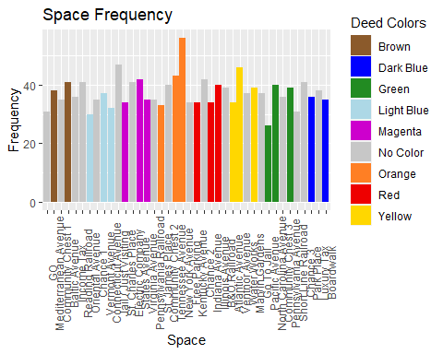

#Visualization: HeatMap  
frequency_subset <- frequency_frame %>% select(value)  
frequency_data <- unname(unlist(frequency_subset))  
#frequency_data  
  
monopoly_board_matrix <- matrix(data = c(frequency_data[21], frequency_data[22], frequency_data[23], frequency_data[24], frequency_data[25], frequency_data[26], frequency_data[27], frequency_data[28], frequency_data[29], frequency_data[30], frequency_data[31], frequency_data[20],0,0,0,0,0,0,0,0,0, frequency_data[32],   
frequency_data[19],0,0,0,0,0,0,0,0,0, frequency_data[33],   
frequency_data[18],0,0,0,0,0,0,0,0,0, frequency_data[34],  
frequency_data[17],0,0,0,0,0,0,0,0,0, frequency_data[35],   
frequency_data[16],0,0,0,0,0,0,0,0,0, frequency_data[36],   
frequency_data[15],0,0,0,0,0,0,0,0,0, frequency_data[37],  
frequency_data[14],0,0,0,0,0,0,0,0,0, frequency_data[38],   
frequency_data[13],0,0,0,0,0,0,0,0,0, frequency_data[39],   
frequency_data[12],0,0,0,0,0,0,0,0,0, frequency_data[40],  
frequency_data[11], frequency_data[10], frequency_data[9], frequency_data[8], frequency_data[7], frequency_data[6], frequency_data[5], frequency_data[4], frequency_data[3], frequency_data[2], frequency_data[1]), nrow = 11, ncol = 11)  
heatmap <- heatmap(x=monopoly_board_matrix, Colv = NA, Rowv = NA, scale = "none")

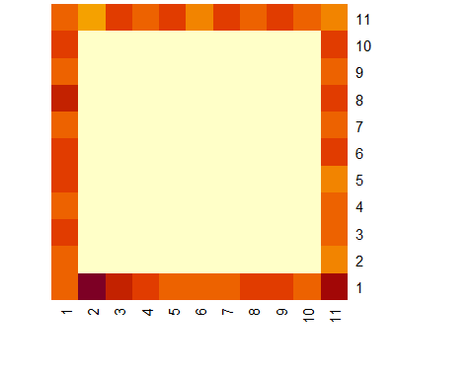

#df = as.data.frame(frequency_data)  
#ggplot(df,(aes(1:40,1))) + geom_tile(aes(fill = frequency_data))

#Heatmap with Simulation 3.2:

1. *Take a Chance* Incorporate the movement cards into your system. You can ignore the effects of non-movement cards, but not their existence! Which properties are landed on most frequently now? Has this changed dramatically from the previous system (that didn’t account for Chance)? Again, visualize this!

#Action Card Movement:

#Helper Functions for chance_or_community_chest() that performs the more challenging movement actions that appear on chance and community chest cards.  
  
#a) Distance Functions:  
  
maxnegative <- function(x)  
{  
 min(x)  
}  
  
minpositive <- function(x)  
{  
 min(x[x > 0])  
}  
  
#b) Movement Based on Action Card Description:   
  
action_card_movement <- function(playerID, player_location, card_text)  
{  
 rail_or_util_spaces <- c()  
   
 if(card_text == "Nearest Railroad")  
 {  
 rail_or_util_spaces <- c(6, 16, 26, 36)  
 }  
   
 if(card_text == "Nearest Utility")  
 {  
 rail_or_util_spaces <- c(13, 29)  
 }  
   
 if(card_text == "-3")  
 {  
 minus_3 <- player_location - 3  
   
 if(minus_3 <= 0)  
 {  
 minus_3 <- minus_3 + 40  
 }  
   
 print(paste0("Player", playerID, " moves back 3 spaces and lands on ", spaces[[minus_3]]))  
   
 return(minus_3)  
 }  
   
 if(card_text == "Jail / Just Visiting")  
 {  
 location_after_exiting_jail <- In_Out_Jail(playerID)  
 return(location_after_exiting_jail)  
 }  
   
 if((card_text != "Nearest Utility") && (card_text != "Nearest Railroad") && (card_text != "-3") && (card_text != "Jail / Just Visiting"))  
 {  
 print("You shouldn't be in here!")  
 return(player_location)  
 }  
   
 #player_position <- position[[playerID]]  
   
 difference <- rail_or_util_spaces - player_location  
   
 if (all(difference < 0))  
 {  
 #print("All values are negatives!")  
 distance <- maxnegative(difference)  
 }  
   
 else  
 {  
 distance <- minpositive(difference)  
 }  
   
 #print(distance)  
   
 nearest <- distance + player_location  
   
 print(paste0("Player", playerID, " moves to ", spaces[[nearest]]))  
  
 return(nearest)  
}

#Landing on Chance:

#chance_or_community_chest() prints the text of a chance and community chest card and performs the action when it is movement related.  
  
chance_or_community_chest <- function(playerID, player_position)  
{  
 chance_locations <- which(spaces %in% "Chance")  
 community_chest_locations <- which(spaces %in% "Community Chest")  
   
 #added:, "Jail / Just Visiting"  
 problem_cards <- c("Nearest Utility", "Nearest Railroad", "-3", "Jail / Just Visiting")  
   
 if(player_position %in% chance_locations)  
 {  
 chance_cards <- action_cards %>% filter(Card.Type %in% "Chance")  
 rand_num <- sample(1:15, 1, replace = TRUE)  
 specific_action <- chance_cards[rand_num,]  
 print(paste0("Player", playerID, " lands on Chance and draws a Chance card."))  
 print(paste0("Their card reads: ", specific_action$Objective))  
 location <- player_position  
   
 if(specific_action$Places != "")  
 {  
 #removed problem cards here  
   
 if(specific_action$Places %in% problem_cards)  
 {  
 #print(specific_action$Places)  
 location <- action_card_movement(1, player_position, specific_action$Places)  
 }  
   
 else  
 {  
 #print(specific_action$Places)  
 #Note fix magic appearance issue for passing go  
 location <- which(spaces %in% specific_action$Places)  
 }  
 }  
 }  
   
 if(player_position %in% community_chest_locations)  
 {  
 community_cards <- action_cards %>% filter(Card.Type %in% "Community")  
 rand_num <- sample(1:16, 1, replace = TRUE)  
 specific_action <- community_cards[rand_num,]  
 print(paste0("Player", playerID, " lands on Community Chest and draws a Community Chest card."))  
 print(paste0("Their card reads: ", specific_action$Objective))  
 location <- player_position  
   
 if(specific_action$Places != "")  
 {  
 #removed problem cards here  
   
 if(specific_action$Places %in% problem_cards)  
 {  
 #print(specific_action$Places)  
 location <- action_card_movement(1, player_position, specific_action$Places)  
 }  
   
 else  
 {  
 #print(specific_action$Places)  
 location <- which(spaces %in% specific_action$Places)  
 }  
 }  
 }  
   
 if((player_position %in% chance_locations) == FALSE && (player_position %in% community_chest_locations) == FALSE)  
 {  
 location <- player_position  
 }  
   
 return(location)  
}

#IMPLIMENT ALL FUNCTIONS

#In Jail/Exiting Jail (4):

#Jail Roll:

#Moving (Before Rolling Doubles):

#Moving (After Rolling Doubles):

#Rolls for Movement:

#Heatmap with Simulation 4.1:

deeds_properties <- full_join(frequency_frame, deeds, by = "Properties")  
deeds_properties$Color[is.na(deeds_properties$Color)] <- "No Color"  
  
deeds_properties$Properties <- factor(deeds_properties$Properties, levels = deeds_properties$Properties)  
  
ggplot(deeds_properties, aes(Properties, value)) + geom_col(aes(fill = Color)) + labs(title = "Space Frequency", x = "Space", y = "Frequency") + theme(axis.text.x = element_text(angle = 90)) + scale_fill_manual(name = "Deed Colors", values = c("tan4", "blue", "forest green", "light blue", "magenta3", "grey78","chocolate1", "red2", "gold"))

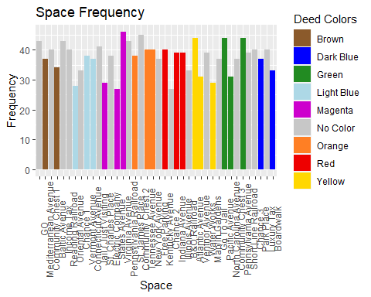

#Visualization: HeatMap  
frequency_subset <- frequency_frame %>% select(value)  
frequency_data <- unname(unlist(frequency_subset))  
#frequency_data  
  
monopoly_board_matrix <- matrix(data = c(frequency_data[21], frequency_data[22], frequency_data[23], frequency_data[24], frequency_data[25], frequency_data[26], frequency_data[27], frequency_data[28], frequency_data[29], frequency_data[30], frequency_data[31], frequency_data[20],0,0,0,0,0,0,0,0,0, frequency_data[32],   
frequency_data[19],0,0,0,0,0,0,0,0,0, frequency_data[33],   
frequency_data[18],0,0,0,0,0,0,0,0,0, frequency_data[34],  
frequency_data[17],0,0,0,0,0,0,0,0,0, frequency_data[35],   
frequency_data[16],0,0,0,0,0,0,0,0,0, frequency_data[36],   
frequency_data[15],0,0,0,0,0,0,0,0,0, frequency_data[37],  
frequency_data[14],0,0,0,0,0,0,0,0,0, frequency_data[38],   
frequency_data[13],0,0,0,0,0,0,0,0,0, frequency_data[39],   
frequency_data[12],0,0,0,0,0,0,0,0,0, frequency_data[40],  
frequency_data[11], frequency_data[10], frequency_data[9], frequency_data[8], frequency_data[7], frequency_data[6], frequency_data[5], frequency_data[4], frequency_data[3], frequency_data[2], frequency_data[1]), nrow = 11, ncol = 11)  
heatmap <- heatmap(x=monopoly_board_matrix, Colv = NA, Rowv = NA, scale = "none")

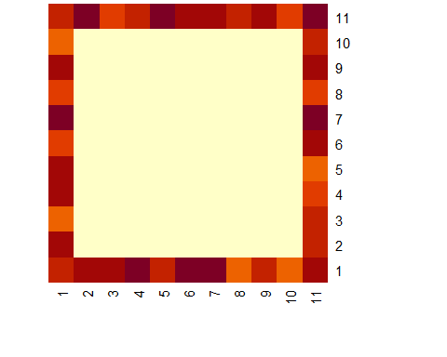

#df = as.data.frame(frequency_data)  
#ggplot(df,(aes(1:40,1))) + geom_tile(aes(fill = frequency_data))

#Heatmap with Simulation 4.2:

#Cost Benefit Analysis 4.3:

#The following code takes the frequency_frames created in the Heatmap with Simulations and creates a third column of the data that gives the percentage of the time a space is hit. We then remove all non-property spaces and evaluate the following code: (Profitability.Index = (Avg.Percent * (Hotel - 5*Cost.of.Houses.Hotels - List.Price))) to determine the most profitable property group.  
  
properties_we_want <- deeds %>% select(Properties)  
properties_we_want <- unname(unlist(properties_we_want))  
  
frequency_frame1 <- frequency_frame1 %>% mutate(percent.hit = value / times)  
frequency_frame2 <- frequency_frame2 %>% mutate(percent.hit = value / times)  
  
average_frequency <- full_join(frequency_frame1, frequency_frame2, by = "name") %>% mutate(Avg.Percent = ((percent.hit.x + percent.hit.y) / 2)) %>% select(name, Avg.Percent)  
average_frequency_properties <- average_frequency %>% filter(name %in% properties_we_want)  
  
  
  
cost_benefit_df <- deeds %>% select(Color, List.Price, Hotel, Cost.of.Houses.Hotels)  
  
combined_cost_benefit_df <- cbind.data.frame(average_frequency_properties, cost_benefit_df)  
combined_cost_benefit_df <- combined_cost_benefit_df %>% mutate(Profitability.Index = (Avg.Percent * (Hotel - 5*Cost.of.Houses.Hotels - List.Price))) %>% select(-c(Cost.of.Houses.Hotels, List.Price))  
  
  
most_profitable_property_groups <- combined_cost_benefit_df %>% select(Color, Profitability.Index)  
most_profitable_property_groups <- aggregate(most_profitable_property_groups$Profitability.Index, list(most_profitable_property_groups$Color), mean) %>% rename(Color = Group.1, Profitability.Index = x) %>% arrange(by = desc(Profitability.Index))  
  
most_profitable_property_groups

## Color Profitability.Index  
## 1 Dark Blue 8.3000000  
## 2 Orange 7.3133333  
## 3 Light Blue 5.0366667  
## 4 Magenta 3.8022222  
## 5 Yellow 3.7911111  
## 6 Red 2.2177778  
## 7 Brown 0.8533333  
## 8 Green 0.3827778

##Analysis

##Conclusion