- TO OPERATE VERSION 1.0:
  - Install Python https://www.python.org/downloads/windows/
  - Make sure pip is up to date by pasting python -m pip install --upgrade pip in terminal and hitting ENTER
  - Then same thing with pip install PyQt5
  - And also with pip install PySide6
2) Download and open the file
4) Select all the images you want and hit RUN
5)Follow the dialogue in the bottom left corner: basically just click these 4 points in order and then hit S
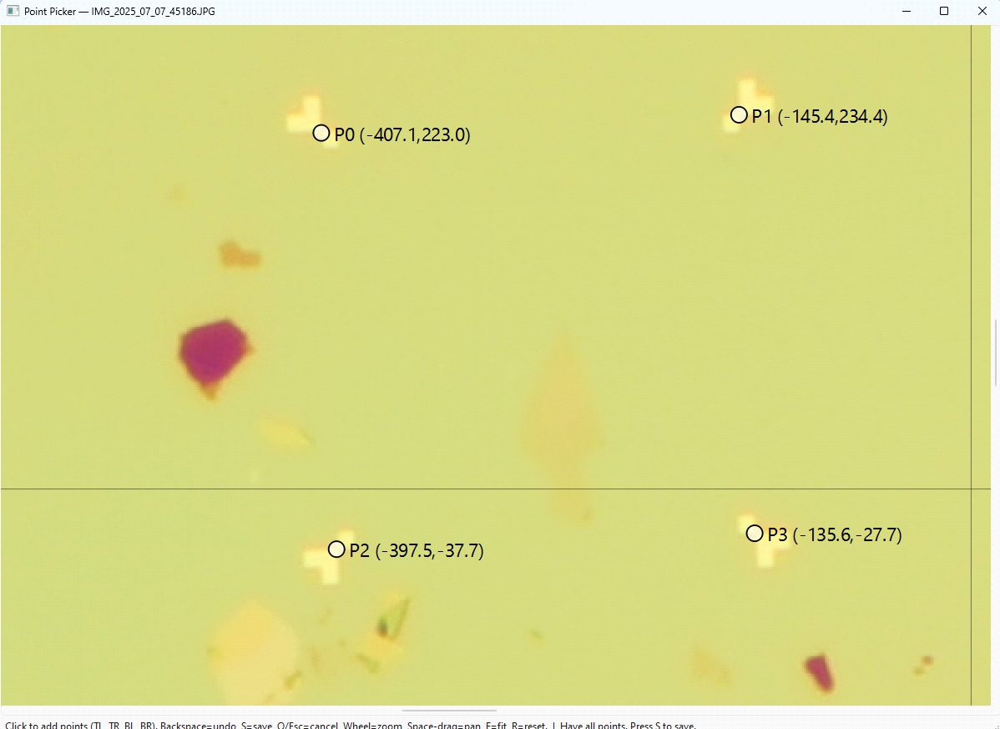
NOTE: Right now you must click on the center of the middle most arrow shapes!
If you want to see what happened, double click the session_combined file and open it in KLayout. If you want, you can also open the .gds file in KLayout to see how it all matches up.
Email gehl2@illinois.edu for any questions!

