Structural Change in the Russian SME Sector, 2024–2026
A reproducible, evidence-first re-analysis of a federal SME register — from a hand-cleaned Excel study to an automated, bootstrap-validated Python pipeline
I reworked my Excel-based SME-sector (Russian Federation) study project into a reproducible Python research project, replacing manual anomaly removal with an automatic detection and flow-stock reconciliation procedure, adding bootstrap uncertainty, sensitivity analysis, regression tests, and transparent alternative cleaning specifications. The analysis showed that the original headline result was highly sensitive to administrative register spikes and did not support the original business-fragmentation hypothesis.
Descriptive analysis only. No causal claim is made about any policy (tax, credit, or otherwise); form 1-NOM tax receipts and the CBR key rate are deliberately not linked. This is not investment advice.
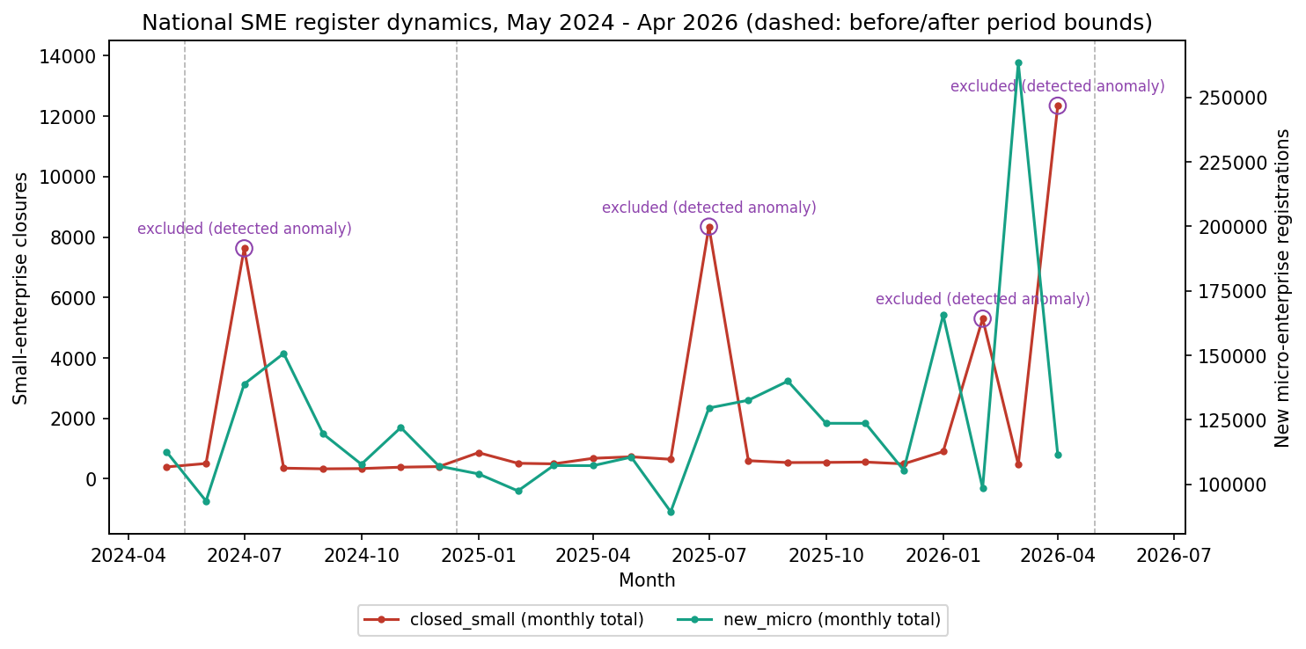
Figure 1. National monthly closures (left axis) and new micro-enterprise registrations (right axis), May 2024 – Apr 2026. Purple circles mark the four months flagged by the automatic anomaly rule; dashed lines mark the before/after period boundaries.

1. Motivation and Data
The Russian federal SME register publishes monthly counts of active, newly registered, and closed enterprises by region and two-digit OKVED industry class, split into micro, small, and medium size categories. An earlier, Excel-based version of this study tracked a “fragmentation coefficient” K — the ratio of new micro-enterprise registrations to small-enterprise closures — to ask whether small businesses were splitting into smaller units at a higher rate after a 2025 tax-policy change. That version reported a striking headline: small-enterprise closures up 342% year over year.
This project re-implements the same register analysis end to end in Python: identical source data, a materially more careful cleaning procedure, and explicit uncertainty quantification. The scope is deliberately narrower than the original ambition. A causal design (difference-in-differences across a region × quarter panel, linked to tax-receipt and interest-rate data) was considered and dropped: the policy change was national and simultaneous, so no credible control group exists in this register alone. What follows is a descriptive, statistically honest account of how the register moved — not an estimate of why.
Dataset: 176,647 rows (month × region × OKVED-2 class), May 2024 – April 2026, sourced from the Federal Tax Service SME register. Five region codes (00, 90, 93, 94, 95 — a service row and four regions with structurally incomplete reporting) are excluded throughout.

2. Method

2.1 Automatic anomaly detection
Rather than a hand-picked list of months to exclude — the approach taken in the original Excel study — this pipeline flags a month automatically whenever national closed_small or closed_micro exceeds three times its own series median. On the current data window this rule flags exactly four months: July 2024, July 2025, February 2026, and April 2026. A sensitivity sweep over thresholds from 2.0× to 5.0× flags the identical four months throughout — the nearest non-flagged month sits at roughly 1.7× its median, while the weakest flagged month sits at roughly 9.8×, so the 3.0× default sits deep inside an empty margin and is not a sensitive tuning choice.

2.2 Telling a register artefact from a real pattern
A flagged month is not dropped on magnitude alone. For each one, the flow of same-month registrations is reconciled against the observed change in the active-enterprise stock, and against registration activity in the neighbouring month. This reconciliation splits the four flagged months into three distinct patterns:
Month | closed_small | Compensating flow | Observed stock change | Label
2024-07 | 7,625 | new_small +1,364 (11.1× median), same month | +15,458 | churn
2025-07 | 8,343 | new_small +1,024 (8.4× median), same month | +11,931 | churn
2026-02 | 5,299 | new_small +4,907 in 2026-03 (≈93% of the loss) | −5,253 | lagged_compensation
2026-04 | 12,346 | no matching wave found within the data window | −12,299 | provisional_net_exit
The two July spikes show same-month compensation: registrations spike in step with closures and the active-enterprise stock actually grows — consistent with a routine annual register re-categorisation rather than real exits. A secondary, non-normative reference source states that the tax service runs an annual SME-register review on 10 July, re-checking prior-year reporting and category eligibility — which lines up with both spikes landing on the same calendar date two years running. This is corroborating, not primary, evidence.
February 2026 shows no same-month compensation, but the following month (March 2026) carries a new_small registration wave equal to about 93% of February's stock loss — a lagged version of the same pattern, one month delayed. April 2026 shows the same uncompensated stock loss as February, but its own t+1 month (May 2026) falls outside the data window, so the lagged-compensation check cannot be run for it; it is therefore carried as provisional rather than resolved. In no case does the aggregated, entity-anonymous register distinguish a genuine economic exit from an administrative reclassification with certainty — that would require tracking individual tax IDs across months, which this dataset does not provide.

2.3 Two cleaning specifications, reported side by side
Because the same magnitude-based flag covers both a compensation pattern and an unresolved pattern, the headline result depends on how February and April 2026 are treated. Two specifications are computed and published in full rather than collapsing to one preferred number:
Specification | Months dropped | Sample | closed_small Δ | 95% CI | K ratio
exclude_all_flagged (headline) | All four flagged months | 7m / 13m | +59.1% | [35.2, 86.2] | 0.697
exclude_compensation_patterns | Both Julys + 2026-02 only | 7m / 14m | +276.3% | [41.9, 749.5] | 0.292
The headline specification is conservative: it removes the unresolved April month along with the two compensation patterns. The alternative specification keeps the unresolved month in the sample, and its much wider confidence interval reflects that the result is then dominated by a single month whose own status is not fully settled. Neither figure is reported as a lower or upper statistical bound; they are two defensible readings of the same register, and the choice between them is disclosed rather than resolved.

2.4 Statistical inference
Every confidence interval in this report is a 95% percentile bootstrap interval built from 5,000 resamples of whole calendar months within each period (seed 42) — not of individual region × OKVED rows. Rows within the same month share common shocks (a national policy change, a register-wide reclassification), so resampling at the row level would overstate the effective sample size. Resampling at the month level means the “before” period's uncertainty is built from only 7 independent draws and the “after” period's from 13 — correctly narrow where the data supports it and correctly wide where it does not, rather than an artificially tight interval from pseudo-replicated rows.

3. Key Findings

3.1 National trend (Block 1)
Mean monthly small-enterprise closures rose from 384 to 611 (+59.1%, 95% CI [35.2, 86.2] — zero is not in the interval). New micro-enterprise registrations were essentially flat: +10.8%, CI [−9.5, 36.7], not distinguishable from no change. The fragmentation coefficient K fell from 295.4 to 205.8 (−30.3%, CI [−47.6, −5.2]); the ratio K_after / K_before = 0.697, CI [0.524, 0.948] — one is not in the interval. The change is therefore driven by the rise in closures, not by any pickup in new micro-enterprise formation, and it runs opposite to the original fragmentation hypothesis: fewer new micro firms appear per closure, not more.
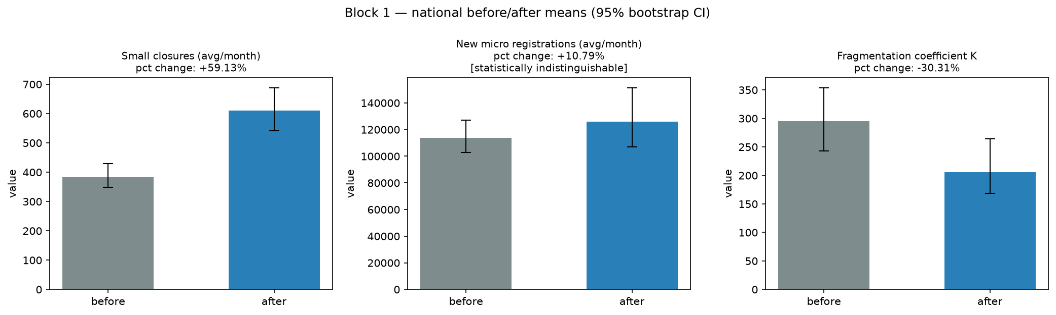
Figure 2. Before/after national means for closures, registrations, and the fragmentation coefficient K, with 95% bootstrap confidence intervals.

3.2 Industry classes (Block 2)
Ranked by after-period K, the highest-fragmentation classes are Education (K=1,043), Land transport (808), Other personal services (757), Professional/scientific services (690), and Computer repair (574). Under the cleaned periods, no top-class ratio confidence interval excludes one — a materially weaker class-level signal than the Excel report claimed, and K is noted to be unstable for classes with very low closure counts, so these rankings should be read alongside the underlying volumes, not as independent findings.
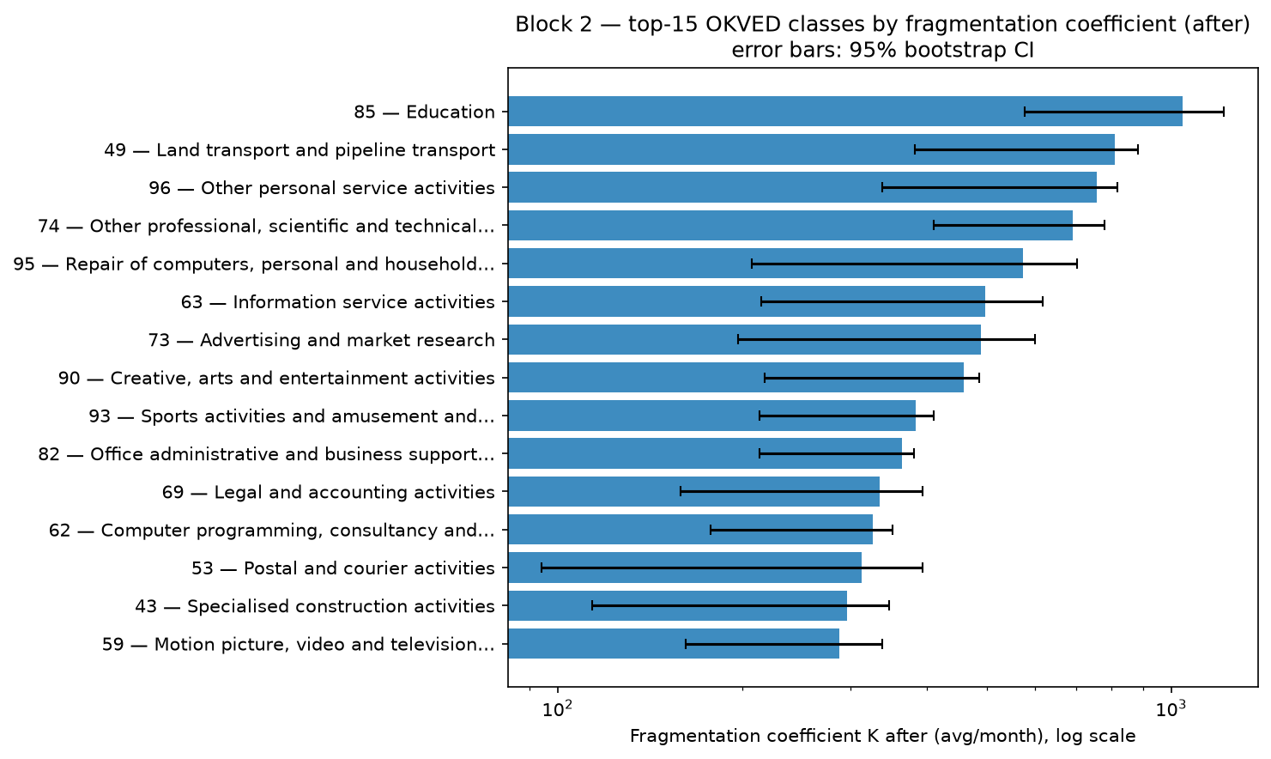
Figure 3. Top-15 OKVED classes by after-period fragmentation coefficient K, log scale, with 95% bootstrap confidence intervals.

3.3 Regional distribution (Block 3)
Closures concentrate in the largest economic centres: Moscow (122/month after, +51.5%), Saint Petersburg (57, +48.8%), Moscow Oblast (36, +57.2%), Sverdlovsk Oblast (22, +62.1%), and Krasnodar Krai (21, +49.2%). All 15 selected regions show confidence intervals excluding zero for the before/after difference — but these regions were selected because they show the largest observed effect, so the intervals are descriptive of the selected set, not independent pre-registered tests.
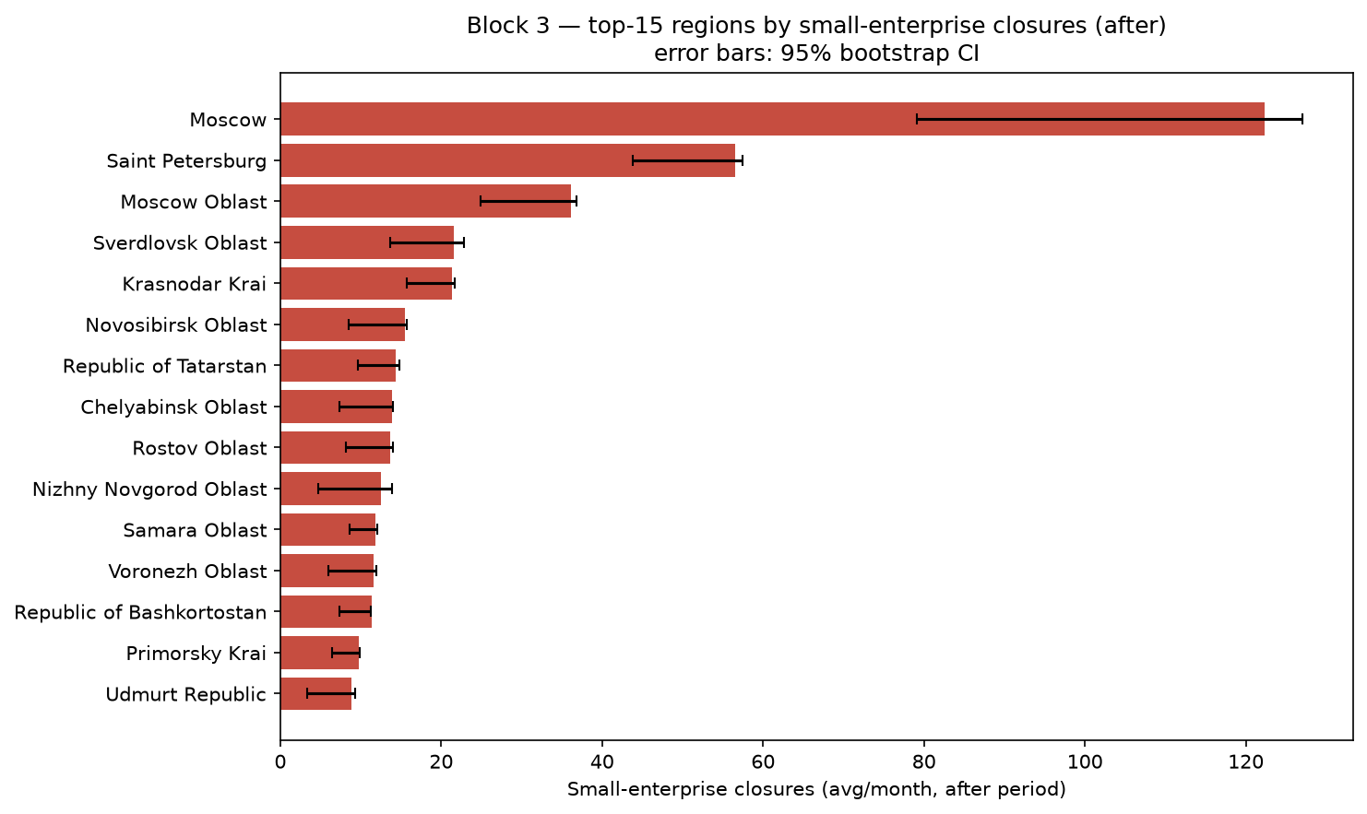
Figure 4. Top-15 regions by after-period monthly closures, with 95% bootstrap confidence intervals.

3.4 Region × industry matrix (Block 4)
Of 7,152 region×OKVED pairs with any recorded activity, 4,734 (66%) have at least three active months in both periods and are evaluated; the remainder are marked as insufficient data (NaN) rather than silently treated as “no change,” which was how the original Excel workbook handled them. Among the evaluated pairs, 61% show the fragmentation coefficient rising and 38% falling — a cell-level split that sits in tension with the falling national aggregate, a reminder that an aggregate trend need not hold uniformly across every cell.
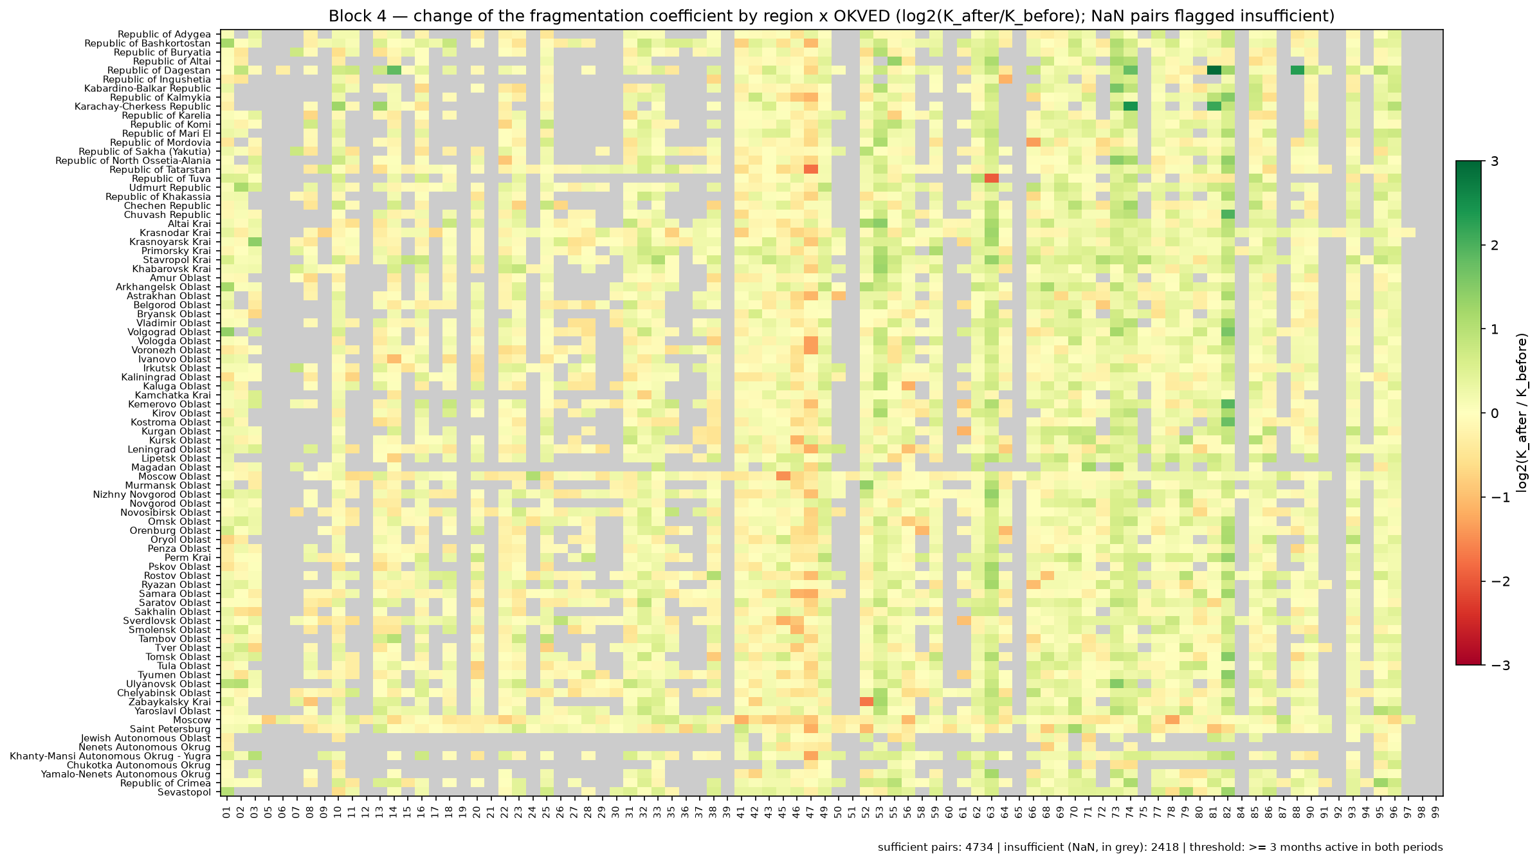
Figure 5. Region × OKVED matrix of log2(K_after / K_before). Grey cells have insufficient activity in one or both periods and are excluded, not imputed.

4. Robustness
The headline +59.1% replaces an unpublished +341.9% that the original hand-cleaning rule would have produced by missing the two 2026 months entirely. Nine cleaning variants were tested against the Block-1 headline:
Variant | Result
exclude_all_flagged (headline, 7m/13m) | +59.1%
exclude_compensation_patterns (7m/14m) | +276.3%
July kept, 2026 spikes only (8m/14m) | −9.8%
After = 2025 only (7m/11m) | +56.1%
Any single excluded region re-added | +59.1% … +59.5%
Every variant that removes the four flagged months — regardless of which specific region re-inclusion or period-truncation choice is made — clusters tightly around +56% to +60%. The wide spread only opens up when the unresolved April 2026 month is retained, confirming that a single month's classification, not the cleaning methodology in general, is the project's main remaining source of uncertainty.
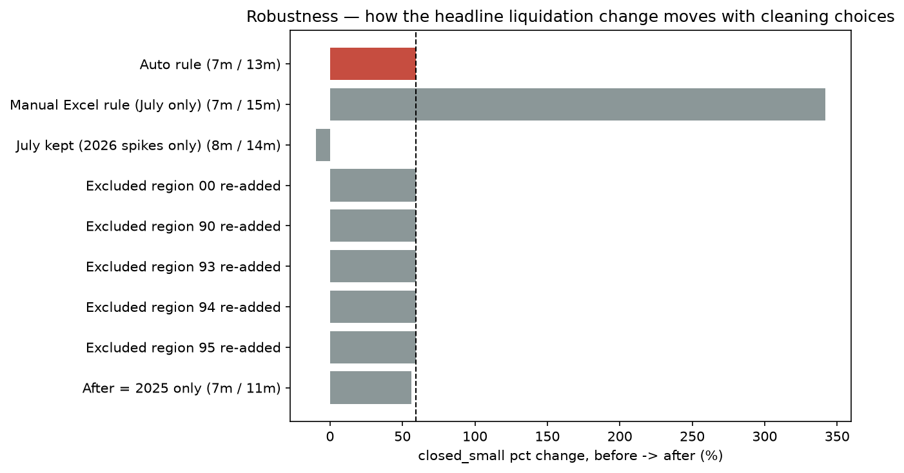
Figure 6. Headline closure change under nine alternative cleaning specifications; the headline (auto rule) is highlighted.

5. Limitations
- Descriptive only. A before/after comparison, however carefully cleaned, cannot isolate a policy effect from unrelated shocks. A causal design (difference-in-differences, a region×quarter panel, linked tax-receipt and interest-rate data) was deliberately scoped out: the policy change was national and simultaneous, so no internal control group exists.
- The cleaning fork is reported, not resolved. The all-flagged specification (+59.1%) is the headline; the alternative that retains the unresolved April 2026 month (+276.3%) is published alongside it rather than discarded.
- Aggregate, not entity-level data. The register is aggregated to month × region × OKVED × size class. It cannot establish whether the same enterprises moved between categories or months; a full identification of real exits versus administrative reclassification would require reconciling entity identifiers across monthly source files, which is outside the scope of this study.
- K is unstable for low-volume categories, notably in the Block 2 class ranking; rankings should be read jointly with the underlying closure and registration volumes, not in isolation.
- The Block 2/3 top-15 lists and the Block 4 matrix cells are selected after observing the data (largest effect first); their confidence intervals are descriptive and are not adjusted for multiple comparisons.
- The before and after periods are asymmetric (7 vs. 13 months) with no seasonal adjustment.
- The Laplace +1 smoothing on K, inherited from the original Excel study, shifts point estimates by roughly 0.1–0.3% relative to the unsmoothed ratio.
- The underlying ETL and register structure are reproduced from the original source files without independent re-verification against the source registries.
AI-assisted development. Claude (Anthropic) was used as an AI-assisted development and research support tool during this project. Its contribution included assistance with parts of the Python implementation, code review and debugging, discussion of alternative methodological approaches, and refinement of the research methodology and the wording of these limitations. The final analytical design, interpretation of the results, methodological decisions, validation of outputs, and responsibility for the submitted work remain with the author.

6. Conclusion
The original Excel study's headline — a 342% rise in small-enterprise closures, read as evidence that firms were splitting up to dodge a tax threshold — does not survive a more careful look at the same register. A large share of that figure traced back to two months with register-level anomalies rather than a uniform year-long trend, and separating a routine annual re-categorisation (the two Julys) from a less certain pattern in 2026 cuts the headline to +59.1% under the conservative, fully-resolved cleaning. Under either cleaning specification tested, the fragmentation coefficient itself falls rather than rises — the opposite of what the original fragmentation hypothesis predicted. The project's main deliverable is less a single number than a transparent account of how sensitive that number is to reasonable methodological choices, and an honest statement of where the data runs out.
Reproducibility: src/analysis.py (seed 42, 5,000 bootstrap iterations) regenerates every table, CSV, and figure in this report; tests/test_analysis.py (16 regression tests) locks the published figures against unintended change. See README.md and EXECUTIVE_SUMMARY.md for the full technical write-up.

