Structural Change in the Russian SME Sector, 2025–2026
A reproducible, evidence-first analysis of the federal SME register
Student research project, reworked into an open, reproducible Python pipeline. Every number below is regenerated from the raw register by src/analysis.py (seed 42, 5,000 bootstrap resamples); the narrative follows EXECUTIVE_SUMMARY.md and README.md of the companion repository.
Material: FNS SME register, May 2024 – April 2026 (176,647 region × class × month records).

1. Introduction — the register and the question
The dataset is the Russian Federal Tax Service (FNS) SME register, aggregated to month × region × OKVED-2 class. For every cell it records three stocks (micro, small and medium enterprises) and two monthly flows: new registrations and closures. This report concentrates on small-enterprise closures and micro-enterprise registrations, because together they answer a structural question: how many new micro firms does the sector create for every small firm that closes? The answer is summarised by the fragmentation coefficient K = (new_micro + 1) / (closed_small + 1). When K falls the sector produces fewer new micro firms per closed small firm — a sign of slowing rejuvenation rather than, say, a uniform contraction.
The project asks whether closures, new registrations and K shifted between the 2024 baseline and the 2025–2026 window. The surprising part is methodological: the answer turns out to depend on how the data are cleaned, and the cleaning hides two 2026 months that look nothing like the July register artefacts. Figure 1 shows the raw monthly series and the four months the cleaning rule removes.
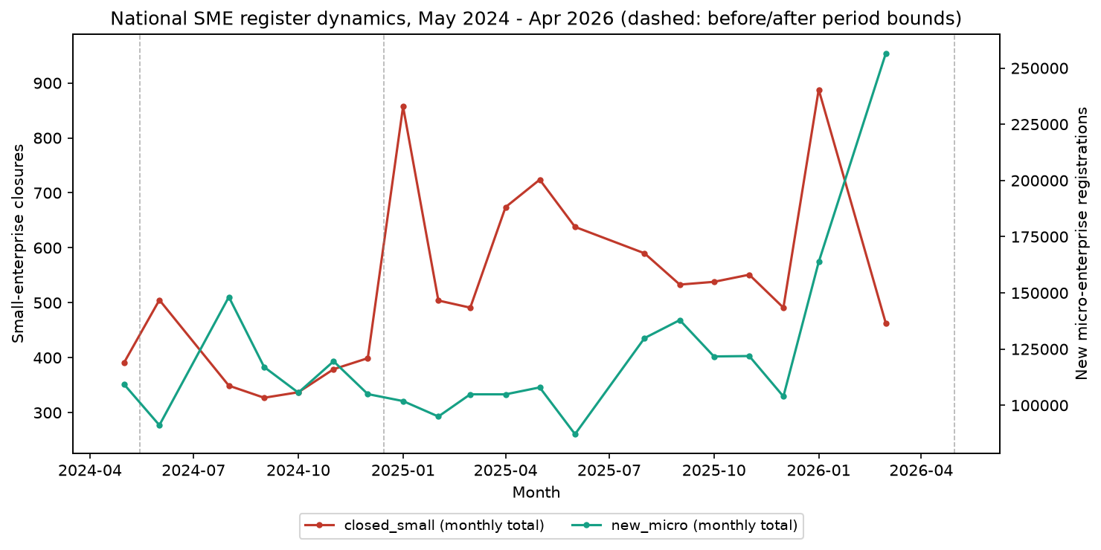
Figure 1 — raw national monthly series; circled points are the months excluded by the automatic rule (two Julys and February/April 2026).

2. Methodology — how the answer changed as the cleaning got honest

2.1 Where the old answer came from — and why it was fragile
The original Excel study removed anomalies by hand: it excluded the two July clean-ups and reported small-enterprise closures up **+276%**. The rule was trustworthy, but it was a static list — it could not see months the author did not know about.

2.2 An automatic rule instead of a hand-picked list
The reworked pipeline replaces the manual list with a single magnitude rule: a month is anomalous when the national total of closed_small or closed_micro exceeds its own series median by more than 3× (detect_anomalous_months). On this window the rule flags exactly four months — the two Julys, and two months the manual rule missed: **February and April 2026**.

2.3 The February/April 2026 finding — compensation turned pending
The two 2026 months do not look like an administrative spike at all. In 2026-02 and 2026-04 small-firm registrations stayed flat (49 and 51 firms, 0.40× and 0.42× their median), while closures jumped to 5,299 and 12,346 — and the register stock fell by almost exactly the number of closures (-5,253 ≈ −5,299 and -12,299 ≈ −12,346). That stock drop is an uncompensated exit pattern from the register; but for 2026-02 the pipeline finds a matching registration wave in 2026-03 (4,907 new_small firms, 93% of the February drop), so it labels the month **lagged_compensation** — a pattern consistent with a delayed registry adjustment rather than a proven economic exit. 2026-04 has no t+1 month inside the data window, so the same rule cannot run: the month is labelled **provisional_net_exit**, an unresolved exit pattern — aggregate data cannot verify that any flag represents an economic exit, so the label remains provisional.

2.4 Compensation vs exit patterns — flows reconciled with stocks
A flagged month is not dropped blindly. anomaly_diagnostics() reconciles the flow with the stock for each month: the flow-implied change new_small − closed_small is compared with the observed change of active_small, and a neighbouring registration wave is checked for a lagged match. The two Julys show churn — a register recategorisation (the FNS July methodology change): new_small itself spikes 11.1× and 8.4× the median and the small-enterprise stock actually grows. A secondary/reference source (not a primary normative act) points to the same calendar-day mechanism: the FNS runs an annual SME-register review on 10 July — excluding enterprises that no longer meet the criteria, checking prior-year reporting, removing previous-year registration marks — which matches both spikes landing on the same date in two consecutive years. 2026-02 shows a lagged compensation pattern (matched by the 2026-03 wave) and 2026-04 an unresolved exit pattern — its t+1 month is outside the data window, so the lagged-compensation rule cannot run for it.
Month | Closed (small) | New (small) | New vs median (×) | Δ stock (small) | Classification
2024-07 | 7,625 | 1,364 | 11.1 | 15,458 | churn
2025-07 | 8,343 | 1,024 | 8.4 | 11,931 | churn
2026-02 | 5,299 | 49 | 0.4 | -5,253 | lagged_compensation
2026-04 | 12,346 | 51 | 0.4 | -12,299 | provisional_net_exit

2.5 The cleaning fork — two defensible samples
Because the same flag covers an artefact (two Julys) and exit patterns (2026-02/04), two samples are defensible, and the pipeline publishes both (data/processed/cleaning_scenarios.csv):
`exclude_compensation_patterns` drops the two churn Julys and the lagged-compensation 2026-02 but keeps the unresolved 2026-04 month in the sample. Closures read **+276.3%** (CI [41.9, 749.5]), K_after/K_before = 0.292. `exclude_all_flagged` drops all four months; closures read **+59.1%** (CI [35.2, 86.2]), K_after/K_before = 0.697. The difference between the two readings is exactly the treatment of 2026-04 — a single month whose own classification cannot be resolved by aggregate data, so the fork is reported rather than hidden.
Scenario | Rule | Months (before) | Months (after) | Closures Δ% | 95% CI | K ratio | 95% CI
exclude_compensation_patterns | A: exclude compensation patterns (same-month + lagged), retain unresolved 2026-04 | 7 | 14 | 276.3 | [41.9, 749.5] | 0.292 | [0.121, 0.863]
exclude_all_flagged | B: exclude all four flagged months (headline cleaning) | 7 | 13 | 59.1 | [35.2, 86.2] | 0.697 | [0.524, 0.948]

2.6 Threshold 3.0 and the plateau 1.7×–9.8×
The 3.0 in the rule is itself a methodological constant — so the pipeline re-runs the whole flag → classify → clean → Block-1 chain at 2.0, 2.5, 3.0, 4.0 and 5.0 (data/processed/threshold_sensitivity.csv):
Threshold | Flagged months | Closures Δ% | 95% CI | K ratio | 95% CI
2.0 | 2024-07, 2025-07, 2026-02, 2026-04 | 59.1 | [35.2, 86.2] | 0.697 | [0.524, 0.948]
2.5 | 2024-07, 2025-07, 2026-02, 2026-04 | 59.1 | [35.9, 85.8] | 0.697 | [0.528, 0.953]
3.0 | 2024-07, 2025-07, 2026-02, 2026-04 | 59.1 | [35.2, 86.2] | 0.697 | [0.524, 0.948]
4.0 | 2024-07, 2025-07, 2026-02, 2026-04 | 59.1 | [35.1, 85.2] | 0.697 | [0.527, 0.953]
5.0 | 2024-07, 2025-07, 2026-02, 2026-04 | 59.1 | [35.5, 86.8] | 0.697 | [0.525, 0.945]
Every threshold in 2.0–5.0 flags the same four months, so the headline numbers do not move: no month appears or disappears anywhere in the range. The reason lies in the distance from the decision boundary (data/processed/spike_margins.csv):
Month | Closed (small) | × median | Micro × median | At 3.0
2024-07 | 7625 | 14.16 | 8.96 | flagged
2025-07 | 8343 | 15.49 | 8.86 | flagged
2026-02 | 5299 | 9.84 | 3.85 | flagged
2026-04 | 12346 | 22.93 | 4.93 | flagged
The four flagged months sit at 9.8×–22.9× the closed_small median; every clean month is below 1.67× (the nearest is 20). The decision boundary therefore lies inside an empty plateau — the constant could be anywhere between roughly 1.7 and 9.8 and nothing would change. That is what “the 3.0 threshold is non-critical” means: it is a calibrated default inside the dead zone between the highest clean month and the lowest flagged one, not a knife-edge choice. For transparency the 3.0 row reuses the headline Block-1 bootstrap itself, so its CI is literally the headline CI, not a second independent run.

3. Results by block

3.1 Block 1 — national before/after
Mean monthly small-enterprise closures rose from 383.9 to 610.8 — **+59.1%** (95% CI [35.2, 86.2]; 0 not in CI). Micro-enterprise registrations were essentially flat (+10.8%, CI [-9.5, 36.7] — not significant), so the sector was not collapsing on the entry side. The fragmentation coefficient K fell from 295.4 to 205.8 (-30.3%, CI [-47.6, -5.2]), and the ratio K_after/K_before = **0.697** (CI [0.524, 0.948]; 1 not in CI). Both effects point the same way: fewer new micro firms per closed small firm — an acceleration of exits, not a slowdown of entry.
The K ratio uses the Laplace +1 inherited from the Excel study. The +1 is immaterial to the finding: without it the raw coefficients are K_before = 296.2, K_after = 206.2, ratio 0.696.
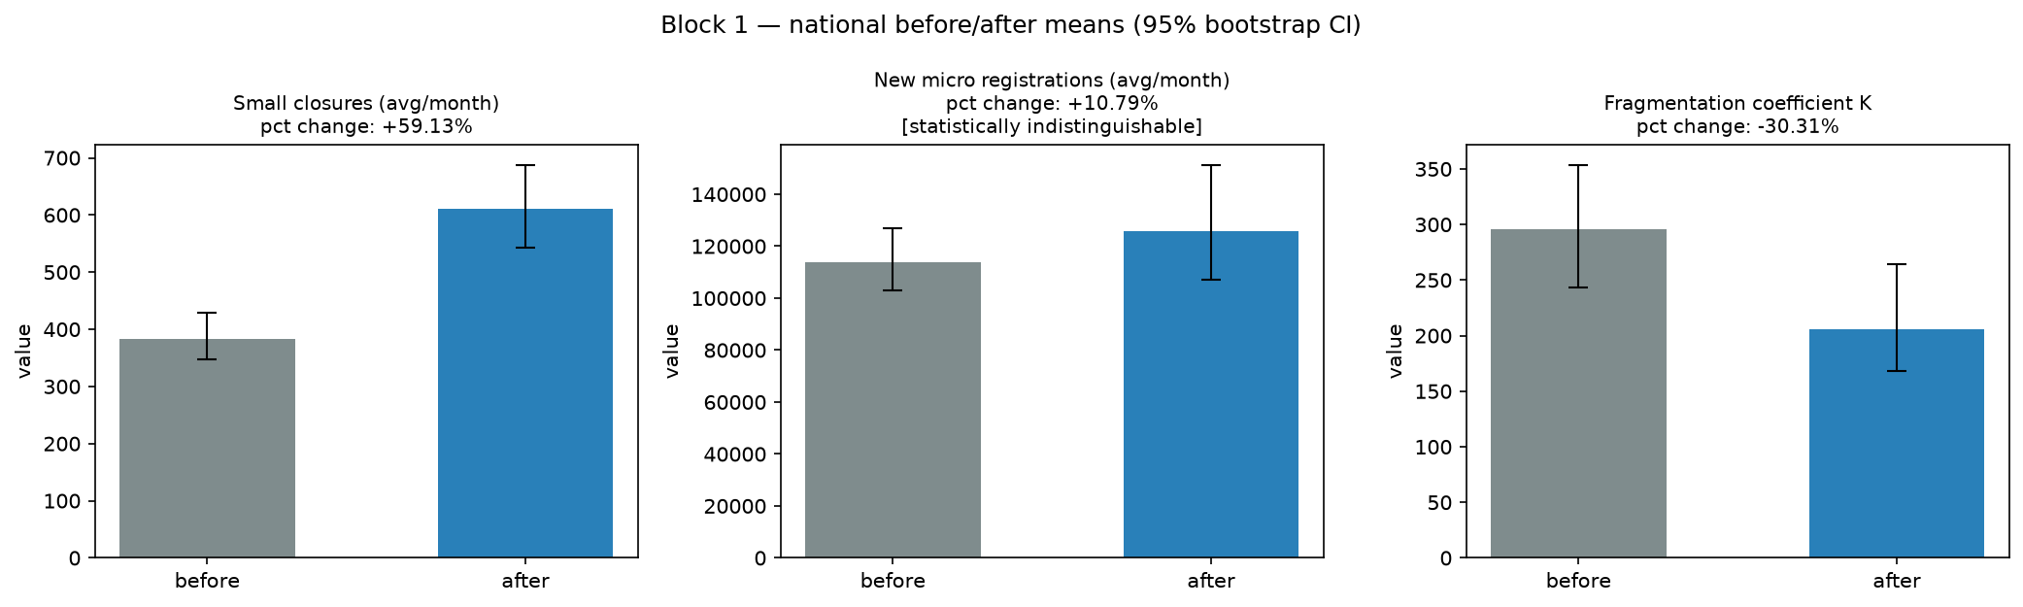
Figure 2 — Block 1 before/after means with 95% bootstrap CIs.

3.2 Block 2 — OKVED classes
Ranking the 88 OKVED-2 classes by after-period K, the most fragmented classes are 85 Education; 49 Land transport; 96 Other personal service activities; 74 Other professional; 95 Repair of computers (full top-15 in data/processed/block2_top15_okved.csv). Under the cleaned periods no top-class ratio CI excludes 1 — a weaker class-level picture than the Excel report suggested, and a sign that the headline signal is national rather than sectoral.
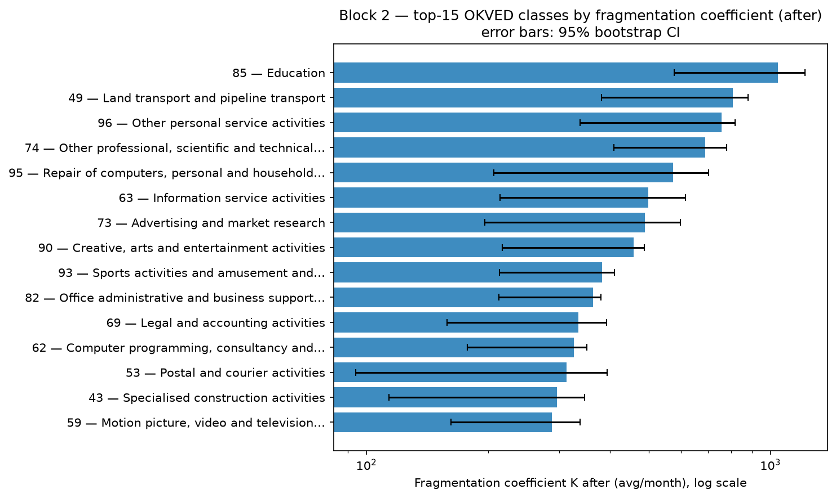
Figure 3 — top-15 OKVED classes by after-period fragmentation coefficient.

3.3 Block 3 — regions
After-period closures concentrate in the large agglomerations, and all top-15 regions show a rise with a CI excluding 0: Moscow (+51.5%); Saint Petersburg (+48.8%); Moscow Oblast (+57.2%); Sverdlovsk Oblast (+62.1%); Krasnodar Krai (+49.2%). The widest relative swings within the top-15 are Nizhny Novgorod Oblast (+107.7%) and Republic of Tatarstan (+76.7%), consistent with a wave of exits rather than a Moscow-only effect.
As in Block 2, the top-15 are highlighted after observing the data; they are not a set of pre-registered hypotheses, so the nominal CIs are read descriptively (no multiplicity correction).
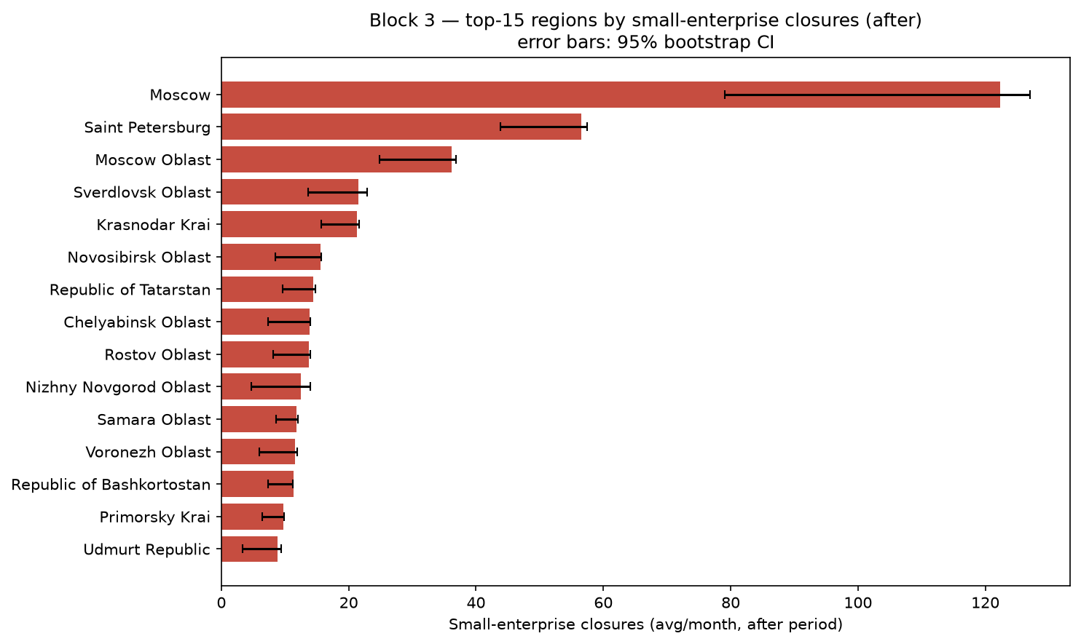
Figure 4 — top-15 regions by small-enterprise closures (after period).

3.4 Block 4 — region × OKVED matrix
Of 7,152 region×class pairs, 4,734 (66%) have at least 3 active months in both periods and are evaluated; 2,418 are marked insufficient (change ratio set to NaN, never silently set to 1, as the Excel version did — its substitution produced 19.7% 'no change'). Among the evaluated pairs, 2,887 (61%) show fragmentation up, 1,821 (38%) down, 26 unchanged. The heatmap paints the same picture as Block 1: rising fragmentation is widespread, with grey cells marking pairs for which no reliable reading exists.
The matrix evaluates 4,734 cells at once; these are not 4,734 independent tests, so the share of cells with a ratio away from 1 is descriptive evidence, not a multiplicity-corrected inference.
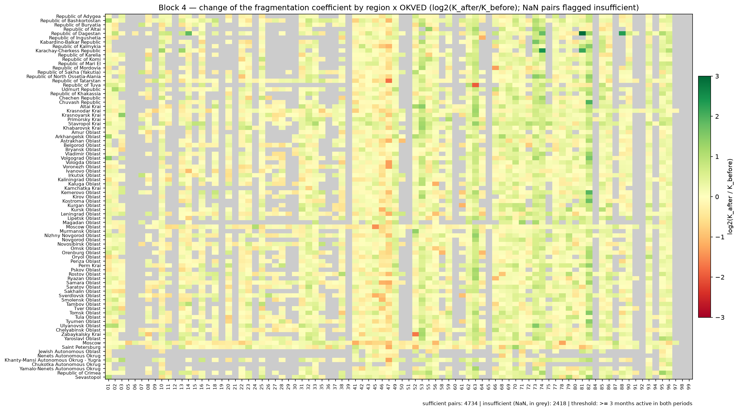
Figure 5 — heatmap of change_ratio = K_after/K_before (log2 scale); grey cells are insufficient pairs (2,418), never substituted.

4. Robustness — the magnitude is bracketed by the cleaning, transparently
Variant | Months b. | Months a. | Closures Δ% | Δ vs base (pp)
Auto rule (7m / 13m) | 7 | 13 | 59.1 | 0.0
Manual Excel rule (July only) (7m / 15m) | 7 | 15 | 341.9 | 282.7
July kept (2026 spikes only) (8m / 14m) | 8 | 14 | -9.8 | -69.0
Excluded region 00 re-added | 7 | 13 | 59.1 | 0.0
Excluded region 90 re-added | 7 | 13 | 59.1 | -0.0
Excluded region 93 re-added | 7 | 13 | 59.4 | 0.3
Excluded region 94 re-added | 7 | 13 | 59.5 | 0.3
Excluded region 95 re-added | 7 | 13 | 59.3 | 0.1
After = 2025 only (7m / 11m) | 7 | 11 | 56.1 | -3.0
The headline is a bracket, and both ends are now explained. All-flagged cleaning returns **+59.1%**; every other cleaning that removes the detected anomalies (2025-only, re-added regions, threshold forks) clusters around **+56% to +60%**. `exclude_compensation_patterns`, which keeps the unresolved 2026-04 in the sample, reads **+276.3%** — the whole gap between the two readings is that single month's treatment. The register artefact (July re-categorisation) is not the story: once it is removed, closures rose; whether the unresolved 2026-04 month is counted or not moves the answer between +59% and +276%. The band is wide, but it is now defined by a reproducible rule and explained by the data, not a silent choice.
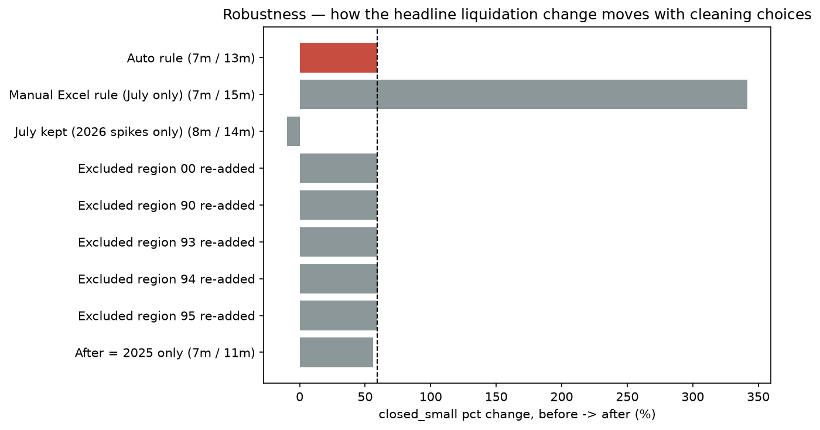
Figure 6 — how the headline closure change moves with the cleaning choice.

5. Limitations
The analysis is descriptive by design. A before/after comparison of a single register cannot isolate the effect of any policy from unrelated shocks; a causal design (DiD, a region×quarter panel, or linking tax receipts and credit data) was deliberately kept out of scope — this repository measures structural change, not policy effects.
The cleaning itself is a fork, and the headline number depends on how the flagged months are read. The classification and both scenarios are published precisely so the choice is transparent, and the spike threshold was shown to be non-critical within the tested 2.0–5.0 range. But 2026-02 and 2026-04 remain the crux: 2026-02 is treated as a lagged compensation pattern and 2026-04 as an unresolved exit pattern, and aggregate data alone cannot move either label past that point — the two readings (+59.1% vs +276.3%) are reported instead of arbitrated.
Methodological choices inherited from the source study are the Laplace +1 smoothing on K, asymmetric period lengths (7 vs 13 months) and the absence of seasonal adjustment. The register structure and ETL were reproduced from the original files without re-verification of the source statements themselves.

6. Conclusion
On the cleaned register, the Russian SME sector in 2025–2026 shows a consistent structural shift: small-enterprise closures are up and the fragmentation coefficient fell, meaning fewer new micro firms per closed small firm. The two 2026 months drive the magnitude — the gap between the all-flagged reading (+59%) and the reading that keeps the unresolved 2026-04 (+276%) is entirely their treatment — and the automatic cleaning rule, the anomaly classification and the threshold sensitivity now make that gap a documented, reproducible property of the data rather than an implicit judgment call.

