***D2D communication for mobile nodes in 5G networks***

***A Thesis Submitted in Partial Fulfilment of the Requirements***

***for the Degree of***

# Bachelor of Technology

**Nitin Shyam Gupta** (Roll no: 20CS8144)

**Sahil Kumar** (Roll no: 20CS8038)

**Aditya Tulsiyan** (Roll no: 20CS8033)

*Under the Supervision* *of*

**Prof. Tanmay De**

**Professor and Head**

**Department of Computer Science and Engineering**

**National Institute of Technology Durgapur**



**DEPARTMENT OF COMPUTER SCIENCE AND ENGINEERING**

**National Institute of Technology Durgapur**

**West Bengal – 713209**

**India**

**May, 2024**

**NATIONAL INSTITUTE OF TECHNOLOGY**

**DURGAPUR**



**C**

**ERTIFICATE**



It is certified that the work contained in the thesis entitled " D2D communication for mobile nodes in 5G networks **"** has been carried out by **Nitin Shyam Gupta (Roll no: 20CS8144), Sahil (Roll no: 20CS8038) and Aditya (Roll no: 20CS8033)** under the guidance of **Prof. Tanmay De,** the data reported here in is original and this work has not been submitted elsewhere for any other Degree or Diploma.

------------------------- ----------------- -------------------

**Nitin Shyam Gupta Aditya Tulsiyan Sahil Kumar**

Place…………………. Place……………. Place…………….

Date ……………… Date……………. Date…………….

This is to certify that the above declaration is true.

--------------------------------------

**Prof. Tanmay De**

Department of computer science and engineering

National Institute of Technology Durgapur

West Bengal – 713209, India

Place: ……………………………..

Date………………………………..



**DEPARTMENT OF COMPUTER SCIENCE AND ENGINEERING**

**NATIONAL INSTITUTE OF TECHNOLOGY**

**DURGAPUR, INDIA**

**CERTIFICATE OF RECOMMENDATION**

This is to certify that the thesis entitled “D2D communication for mobile nodes in 5G networks”, submitted by “Nitin Shyam Gupta (Roll No: 20CS8144), Sahil (), Aditya ()” of Department of Computer Science & Engineering, National Institute of Technology, Durgapur, in partial fulfillment of the requirements for the award of the degree in Bachelor of Technology in Computer Science & Engineering is a bonafide record of work carried out by him/her under my/our guidance during the academic year 2023 – 2024.

|  |  |  |
| --- | --- | --- |
| **Professor and Head**  Department of Computer  Science and Engineering  National Institute of Technology  Durgapur |  | **Prof. Tanmay De**  Professor  Department of Computer Science and Engineering  National Institute of Technology  Durgapur |



**DEPARTMENT OF Computer Science and Engineering**

**NATIONAL INSTITUTE OF TECHNOLOGY**

**DURGAPUR, INDIA**

**CERTIFICATE OF APPROVAL**

**T**his is to certify that we have examined the thesis entitled “*D2D communication for mobile nodes in 5G networks***”**, submitted by **Nitin Shyam Gupta (20CS8144), Sahil Kumar (20CS8038) and Aditya Tulsiyan(20CS8033)** and hereby accord our approval of it as a study carried out and presented in a manner required for its acceptance in partial fulfillment of the requirements for the award of the degree in Bachelor of Technology in Computer Science Engineering for which it has been submitted. It is to be understood that by this approval the undersigned do not necessarily endorse or approve any statement made, opinion expressed or conclusion drawn therein but approve the thesis only for the purpose for which it is submitted.

**Examiners:**

|  |  |
| --- | --- |
| **Name** | **Signature** |
|  |  |

**ACKNOWLEDGEMENT**

I would like to express my deepest gratitude to my supervisor, Prof.Tanmay De, for her invaluable guidance, unwavering support, and insightful feedback throughout the duration of this project. His expertise, encouragement, and mentorship have been instrumental in shaping this research endeavour and expanding my understanding of scheduling algorithm.

I extend my heartfelt appreciation to my peers for their collaboration, constructive discussions, and encouragement during the course of this project. Their diverse perspectives and collective efforts have enriched the research experience and contributed to its success.

Lastly, I would like to express my sincere gratitude to all the individuals, institutions, and organizations whose contributions, directly or indirectly, have made this project possible.

**Date: …………………**

**…………………………….**

**Nitin Shyam Gupta**

Roll No. - 20CS8144

Department of computer science and engineering

National Institute of Technology Durgapur

West Bengal – 713209, India

…………………………………………….

**Aditya Tulsiyan**

Roll No. – 20CS8033

Department of computer science and engineering

National Institute of Technology Durgapur

West Bengal – 713209, India

…………………………………………….

**Sahil Kumar**

Roll No. – 20CS8038

Department of computer science and engineering

National Institute of Technology Durgapur

West Bengal – 713209, India

**ABSTRACT**

Device-to-Device (D2D) communication has emerged as a promising technology for improving the efficiency and capacity of wireless networks. In D2D communication, mobile devices communicate directly with each other without routing through the base station, thereby reducing network congestion and latency. However, the performance of D2D communication networks can be affected by the mobility of the nodes.

This paper presents an approach for D2D communication in networks where the nodes are moving. We investigate the impact of node mobility on the performance of D2D communication networks.

Our study provides insights into the impact of node mobility on the performance of D2D communication networks and highlights the need for mobility-aware D2D communication protocols. The findings of this research can inform the development of efficient and reliable D2D communication protocols for mobile devices, which can enhance the overall performance of wireless networks.

**CONTENTS**

Certificate ……………………………………………………………… ii.

Certificate of Recommendation ……………………………………….. iii.

Certificate of approval ………………………………………………… iv.

Acknowledgement …………………………………………………... v.

Abstract ………………………………………………………………… vi.

Table of Contents …………………………………………………………… vii.

List of Figures ……………………………………………………………... viii.

List of Tables …………………………………………………………... ix.

1. Introduction
   1. Introduction of d2d communication
   2. Types of d2d communication
   3. Idea of d2d multicasting
2. Literature survey
3. Project description
4. Motivation
5. Proposed approach
6. Results and analysis
7. Conclusions
8. Future scope
9. References

**LIST OF FIGURES**

**Fig. No. Title Page No.**

Fig 1.1 In-Band and Out-Band 3

Fig 1.2 Underlay and Overlay 4

Fig 1.3: Multi-Casting 5

Fig 3.1: Simulation of Users 10

Fig 3.2: Initial Clustering of Users 11

Fig 3.3: Clusters after mobility 11

Fig 6.1: Served nodes vs. Number of Nodes 14

Fig 6.2: Average Energy Consumed vs. Number of Nodes 15

**1. INTRODUCTION**

**1.1 INTRODUCTION OF D2D COMMUNICATION**

Device-to-Device (D2D) communication in cellular networks is defined as direct communication between two mobile users without Base Station as an intermediary. It is generally non-transparent to the cellular network and it can occur on the cellular frequencies (i.e., inband) or unlicensed spectrum (i.e., outband).

Next-generation cellular networks need high capacity, power efficiency, and guaranteed Quality of Service (QoS). To achieve these goals D2D communication is an important technology for fifth-generation applications. In general, D2D is a technique used to connect devices with each other without the need for communication infrastructure, for example, access points (AP) and base stations (BS). In simpler terms, device-to-device (D2D) communication commonly refers to a type of technology that enables devices to communicate directly with each other without communication infrastructures such as access points (APs) or base stations (BSs). Bluetooth and WiFi-Direct are the two most popular D2D techniques. With the emergence of machine-to-machine (M2M) applications, D2D communication has assumed a very pivotal role. It facilitates the discovery of devices that are closer to each other and enables direct communication between them. This results in improved communication quality and reduces energy consumption and communication delays.

In a traditional cellular network, all communications must go through the BSeven if communicating parties are in range for proximity-based D2D communication. Communication through BS suits conventional low data rates mobile services such as voice calls and text messaging in which users are seldom close enough for direct communication. However, mobile users in today's cellular networks use high data rate services (e.g., video sharing, gaming, proximity-aware social networking) which could potentially be in the range for direct communications (i.e., D2D). Hence, D2D communications in such scenarios can greatly increase the spectral efficiency of the network. The advantages of D2D communications go beyond spectral efficiency; they can potentially improve throughput, energy efficiency, delay, and fairness.

D2D can deal in an integrated way with various techniques to improve Network performance such as the Internet of Things (IoT), Vehicle-to-Vehicle (V2V) Technology, Artificial Intelligence (AI), millimeter Waves (mmW) Technology, the other hand, may encounter many difficulties that must be taken into account. When implementing D2D technology, there is interference between centralized users (CUs) and distributed users (DUs) because they share the same resources in the same area. Other problems facing D2D technology such as peer discovery, delivery, management of radio resource allocation, optimization, and security issue in addition to energy consumption. Thus, many researchers and mobile operators have paid attention to D2D to enhance network performance without breaching any of the requirements of the service.

D2D aims to use the physical range of communication devices to increase the signal of mobile devices in a dispersed environment. To complement each other, D2D connections must work with cellular network services. The crucial factor to consider when designing D2D is the sharing of resources, in terms of power and spectrum, between D2D and cellular connectivity.Among the benefits that can be obtained from D2D is that it maintains the privacy of the content and anonymity. Because the central storage unit is not responsible for storing shared information. D2D communications can improve energy efficiency, productivity, fairness, and delay.This report represents a review of a set of proposed solutions aimed at improving security in D2D communications.

**1.2 TYPES OF D2D COMMUNICATION**

**INBAND AND OUTBAND COMMUNICATION**

InBand D2D Communication: In this type, both cellular communication and D2D use the same licensed spectrum. There is interference between D2D and cellular uses which is very challenging to handle. Moreover, resource allocation algorithms are very complex to develop.

OutBand D2D Communication: In this type, D2D uses unlicensed spectrum (2.4 GHz ISM band or 38 GHz mm-wave band) whereas cellular uses licensed spectrum as given by the network operator. There is no interference issue between cellular and D2D. However D2D users are affected by other ISM band users of wifi and bluetooth which is uncontrollable.

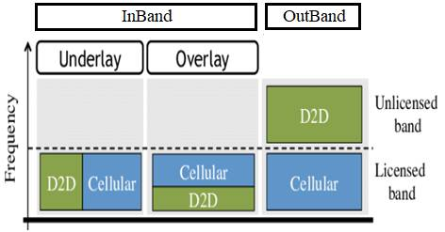

Fig 1.1 : InBand and OutBand

**UNDERLAY AND OVERLAY COMMUNICATION**

InBand D2D communication is further categorized into two types viz. Underlay and Overlay as described below.

**Underlay D2D communication**

* In this subtype, the licensed spectrum is not divided for D2D and Cellular use.
* The technique is more spectrum efficient but it is challenging to implement resource allocation between D2D and Cellular users.
* The Underlay D2D increases spectral efficiency by utilizing spatial diversity.

**Overlay D2D communication**

* In this subtype, the licensed spectrum is divided into non-overlapping parts as shown for D2D and cellular links.
* This technique is very simple to implement due to separate resource allocations.
* The overlay D2D reduces the chances of interference between D2D and cellular users.
* This technique requires more focus on avoiding the wastage of resources.

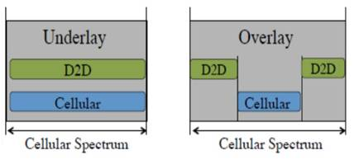

Fig 1.2: UNDERLAY AND OVERLAY

**1.3 IDEA OF D2D MULTICASTING**

Device-to-device (D2D) multicasting is a communication technique where data is transmitted simultaneously from one device to multiple nearby devices, without the need for an intermediary network. It is an efficient way to deliver content to multiple users in a local area, and can be used in various applications such as video streaming, file sharing, and gaming.

D2D multicasting utilizes the proximity and connectivity of nearby devices to create a direct communication link, which can improve the efficiency of data transfer and reduce network congestion. This approach can also enhance the reliability of data transmission, as the data can be transmitted via multiple paths and devices.

Research in D2D multicasting has been growing, and various approaches have been proposed to optimize the performance and efficiency of this technique. For example, researchers have proposed using network coding to improve the throughput of D2D multicasting, as well as developing algorithms to optimize the selection of devices for multicasting.

D2D multicasting has the potential to revolutionize local content delivery and improve the user experience in various applications. However, there are still some challenges to be addressed, such as interference management and ensuring the security and privacy of the transmitted data.

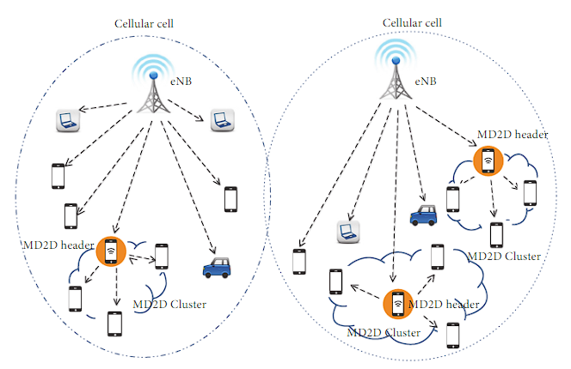

Fig 1.3: Multi-Casting

**2. LITERARY SURVEY**

The purpose of this literature survey is to provide an overview of the research conducted on device-to-device (D2D) communication and clustering in wireless networks. The survey aims to identify the benefits and challenges of these technologies, as well as the current state of research and future directions. The results of the survey will be used to gain insights into the use of D2D communication and clustering in wireless networks and provide recommendations for future studies.

The literature survey will be conducted using academic databases such as IEEE Xplore, ACM Digital Library, and Google Scholar. The survey will include research papers, journal articles, conference proceedings, and book chapters published between 2015 and 2022.

**D2D Communication:**

A number of studies have focused on the use of D2D communication in wireless networks. Research has shown that D2D communication can improve network efficiency, reduce latency, increase bandwidth, and enhance security. Some of the challenges associated with the deployment of D2D communication include interference with existing networks, security concerns, integration with existing systems, regulatory barriers, and lack of standardization.

**Underlay D2D Communication:**

Research in this area has explored various techniques to enable efficient underlay D2D communication while maintaining the quality of service for both D2D and cellular users. Studies have investigated resource allocation strategies, such as power control and frequency allocation, to mitigate interference and ensure coexistence with cellular users. Furthermore, advancements in spectrum sharing technologies, such as cognitive radio and dynamic spectrum access, have been proposed to improve spectral efficiency and accommodate the growing demand for wireless communication. Despite its potential benefits, underlay D2D communication faces challenges such as interference management, spectrum scarcity, and coordination among devices. Addressing these challenges requires innovative solutions in resource management, interference mitigation, and spectrum utilization to harness the full potential of underlay D2D communication in wireless networks.

**Overlay D2D Communication:**

Research in overlay D2D communication has focused on developing efficient routing algorithms, neighbor discovery mechanisms, and network formation protocols to enable seamless communication among devices. Moreover, studies have explored the integration of overlay D2D communication with existing wireless technologies, such as WiFi and Bluetooth, to create heterogeneous networks with enhanced coverage and connectivity. However, overlay D2D communication also presents challenges, including network scalability, routing overhead, and energy consumption. Overcoming these challenges requires innovative approaches in network optimization, protocol design, and energy-efficient communication mechanisms to realize the full potential of overlay D2D communication in wireless networks.

**D2D Clustering:**

Research has also been conducted on the use of D2D clustering in wireless networks. D2D clustering can improve network efficiency, reduce latency, increase bandwidth, and enhance security. The challenges associated with the deployment of D2D clustering are similar to those of D2D communication. Some studies have proposed solutions to these challenges, such as the use of cognitive radio technology, dynamic spectrum access, and distributed resource allocation.

**Future Directions:**

Future research in D2D communication and clustering could focus on addressing the challenges associated with deployment, such as interference with existing networks, security concerns, and lack of standardization. Studies could also explore the potential benefits of D2D communication and clustering in different types of wireless networks, such as cellular networks, ad hoc networks, and internet of things (IoT) networks.

**3. PROJECT DESCRIPTION**

Work is done on various software over here, such as:

**Python**

Python is a high-level, general-purpose programming language. Its design philosophy emphasizes code readability with the use of significant indentation. Python's flexibility allows it to be utilized for a multitude of purposes, whether it's scripting, automation, data analysis, machine learning, or building robust web applications.

The Python interpreter, which executes Python code, is predominantly written in C. This choice of implementation language offers a balance between performance, portability, and ease of interfacing with other systems and libraries.

Python's popularity stems from its open-source nature and strong community support. The language is maintained by the Python Software Foundation, ensuring its continuous development and improvement. Python's release cycle follows a predictable pattern, with major updates occurring approximately every 18-24 months with its current version being python 3.12.



**Windows**

Windows 10 is a widely-used operating system developed by Microsoft, renowned for its versatility and user-friendly interface. Built on a foundation of robustness and security, Windows 10 provides a stable platform for a diverse range of applications and workflows. Its intuitive graphical user interface (GUI) simplifies navigation and enhances productivity, making it accessible to users of all skill levels.

The core components of Windows 10 are primarily developed using C and C++, allowing for high performance and compatibility with a vast array of hardware and software. Major feature updates are released biannually, introducing new functionalities, enhancements, and security improvements to ensure a modern and secure computing experience. The latest version of Windows 10 is version 22H2.



**Initialisation**

First, N number of nodes are allocated randomly over a 500 x 500 area. Then, the nodes are grouped into clusters for D2D communication. The 0th node is considered as the base station. Clustering is done based on the number of resource blocks available and the minimum pairing distance. Overlapping clusters need to be allocated different resource blocks to prevent interference. Each of the resource blocks have been denoted with a different color in the NS2 simulator. An example allocation and clustering of 100 nodes is given below.

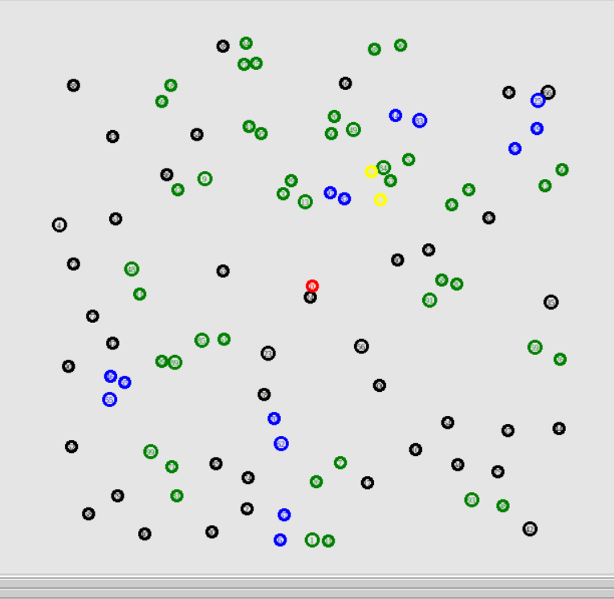

Fig 3.1: Simulation of Users

After this, data rate is calculated to each of the clusters by considering the data rate of the longest distance node from the cluster head. Then, mobility is assigned to the cluster nodes. All the nodes move with constant velocity to a randomly chosen destination coordinate. Mobility implementation is explained using the figures given below.

**Before mobility:**

Let us consider a simple 5G network with 3 clusters.

Here, each circle represents a cluster. Cluster heads are represented in blue and cluster members are represented in orange

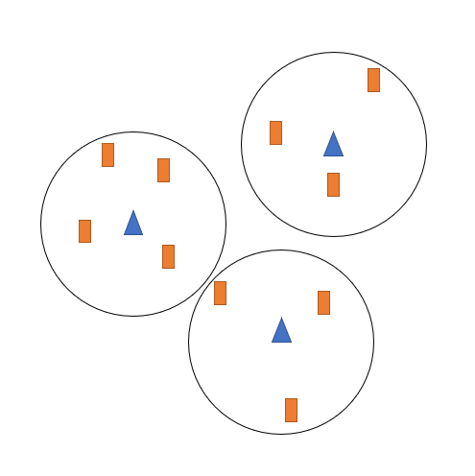

Fig 3.2: Initial Clustering of Users

**After mobility:**

Here, a few nodes have now moved from their initial positions to their final positions denoted by arrows.

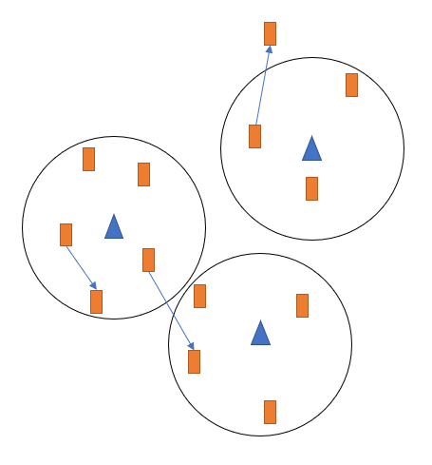

Fig 3.3: Clusters after mobility

After mobility, many of the nodes are getting a very low data rate (lesser than the threshold data rate of the network) from their respective cluster heads due to increased distance from cluster head. So they are removed from their respective clusters. Now hand-off is done for these nodes using our approach. In traditional hand off management, we consider only distance metric and try to add that node to the nearest cluster that provides the suitable data rate. But, in our approach, we consider the energy consumed by a cluster head when the node is added to that particular cluster and we try to minimize the consumed energy and also get the suitable data rate for each cluster.

**4. MOTIVATION**

In recent years, 5G communication is an emerging technology due to which devices can enjoy the benefit of fast access to the cellular spectrum. Several works have been done in 5G D2D communication but when the nodes are mobile, then it is a challenging issue to successfully implement the D2D communication and to establish communication between devices as they will change their positions. This is the motivation behind our work. We want to investigate the impact of mobility on D2D communication.

The exponential growth of wireless communication and data traffic, high demands for broadband mobile wireless communications, and the emergence of new wireless multimedia applications and services constituted the critical drivers to the development of the Long Term Evolution-Advanced (LTE-A) network. One of the main challenges of LTE-advanced is to recover the local-area services and enhance spectrum efficiency, increase data rate and reduce the energy consumed by the network. To achieve those goals technical capabilities are required. Device to Device (Device to Device (D2D) communications is a new technology that offers wireless peer-to-peer services and improves spectrum utilization in LTE-advanced networks. D2D communications were initially proposed in cellular networks as a new paradigm to enhance network performance. The motivation for D2D comes directly from the user requirements and D2D communications will serve specific future needs.

**5. PROPOSED APPROACH**

**For initial allocation of nodes:**

Random numbers are generated for the X and Y coordinates of N number of nodes in such a way that the range of X,Y is [0, 500] and the distance between two nodes is at least 10 meters. The coordinates generated are stored in text files so that they can be accessed later to run the simulations and take the results.

**For initial allocation of clusters:**

Clusters are formed from the allocated nodes by randomly selecting cluster heads from the nodes and keeping the minimum pairing distance as 30m. All the nodes within the minimum pairing distance of the cluster head that are not already allocated to any other cluster are allocated to the cluster head. The clustering is done in such a way that overlapping clusters are allocated different resource blocks to prevent interference.

**For assigning mobility to cluster nodes:**

For all the cluster nodes, the final coordinates for mobility are chosen randomly in such a way that they can travel there from the initial coordinates with a given velocity within a given time. Also, minimum distance criteria between nodes should be maintained. The coordinates of the final destination for all nodes are stored in text files so that they can be accessed later to run the simulations and take the results.

**For resource block allocation:**

We use resource block for transmitting signals. We are working on 3 resource blocks. Allocation proceeds sequentially while ensuring signal-to-interference-plus-noise-ratio at the receiver. We have to minimize this interference from other transmitter in the same resource block. A threshold of 6 decibels is enforced, indicating resource block allocation only to transmitters whose receivers achieve SINR >= 6dB.

**SINR= (Pₜ ⋅ g ⋅ dᵢⱼ^(-α) ⋅ |h₀|² ⋅ δ) / (σ² + Iₑ)**

where,

Pₜ is the transmit power (20 dB),

g is the channel gain (-33.58 dB),

dᵢⱼ is the distance between nodes transmitter i and receiver j,

α is the path loss exponent (4),

h₀ is the modulus of the channel gain (1),

δ is the signal power factor (4 dB),

σ is the noise power (σ² having value of -107 dBm),

Iₑ is the interference from other sources.

**6. RESULTS AND ANALYSIS**

In our experiment, we first analyzed the trends between the number of served D2D users after mobility and hand-off and the number of nodes (whose positions are fixed for the experiment). This is shown in figure 6.1 given below.

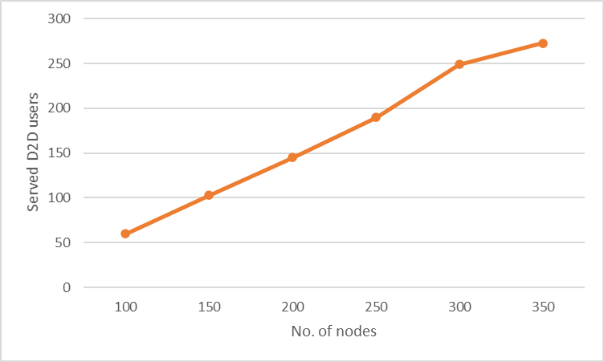

Figure 6.1: Served nodes vs. Number of Nodes

**7. CONCLUSIONS**

From figure 1, we can infer that the relation between the number of served users and the total number of nodes is nearly linear initially but it decreases a bit when the number of nodes is very high due to increased interference. The average percentage of served users here is approximately 75%.

From figure 2, we can infer that the average consumed energy of the network fluctuates between 0.25 and 0.35 J which is much lesser than the threshold energy of 1 J. Hence, we can say that using our approach we can minimize the consumed energy of the network and make the communication energy efficient.

**8. FUTURE SCOPE**

D2D communication will play a vital role in the upcoming future in certain technologies such as V2V communications, mmWave technology, social D2D networks, energy harvesting, and SWIPT. Other than we would like to find a solution that will increase the number of users that can use device-to-device communication simultaneously at affordable pricing. There are still many problems that we need to solve regarding this. We hope we would be able to deploy our hypothetical model for a dynamic environment too. We would be optimizing the model to move in this direction. We will continue with this experiment of network simulation in the near future too.

In future, we will further extend this project to investigate the impact of mobile users for next generation cellular networks like 6G.

**9. REFERENCES**

1. Zhou, Liang (2016-03-08). "Mobile Device-to-Device Video Distribution: Theory and Application". ACM Transactions on Multimedia Computing, Communications, and Applications. 12 (3): 38:1–38:23. doi:10.1145/2886776. ISSN 1551-6857
2. Asadi, Arash; Wang, Qing; Mancuso, Vincenzo (24 April 2014). "A Survey on Device-to-Device Communication in Cellular Networks". IEEE Communications Surveys & Tutorials. 16 (4): 1801–1819. arXiv:1310.0720. doi:10.1109/COMST.2014.2319555
3. Zhang, Yanru; Pan, Erte; Song, Lingyang; Saad, Walid; Dawy, Zaher; Han, Zhu (2015). "Social Network Aware Device-to-Device Communication in Wireless Networks". IEEE Transactions on Wireless Communications. 14 (1): 177–190. doi:10.1109/TWC.2014.2334661
4. [H. H. Hussein, H. A. Elsayed, and S. M. Abd El-kader, “Intensive Benchmarking of D2D communication over 5G cellular networks: prototype, integrated features, challenges, and main applications,” Wirel. Networks, vol. 26, no. 5, pp. 3183–3202, 2020, doi: 10.1007/s11276-019-02131-2.
5. M. Wang and Z. Yan, “A Survey on Security in D2D Communications,” Mob. Networks Appl., vol. 22, no. 2, pp. 195– 208, 2017, doi: 10.1007/s11036-016-0741-5. 6. Zeebaree, A. Z. S. R., Adel, A. Z., Jacksi, K., & Selamat, A. Designing an ontology of E-learning system for duhok polytechnic university using protégé OWL tool. J Adv Res Dyn Control Syst Vol, 11, 24-37.
6. D. Feng et al., “Device-to-Device Communications Underlaying Cellular Networks,” IEEE Trans. Commun., vol. 61, no. 8, 2013, pp. 3541–51.
7. A. Asadi, Q. Wang, and V. Mancuso, “A survey on device-to-device communication in cellular networks,” IEEE Commun. Surv. Tutorials, vol. 16, no. 4, pp. 1801–1819, 2014, doi: 10.1109/COMST.2014.2319555
8. https://www.rfwireless-world.com/Terminology/Underlay-D2D-vs-Overlay-D2D.html
9. I. Krikidis, S. Timotheou, S. Nikolaou, and C. Papandreou, "Device-to-Device Multicasting for Video Streaming in Cellular Networks," IEEE Transactions on Wireless Communications, vol. 13, no. 2, pp. 886-899, 2014.
10. Y. Li, D. Niyato, D. I. Kim, and Z. Han, "Optimal Device-to-Device Multicast with Network Coding in Cellular Networks," IEEE Transactions on Wireless Communications, vol. 14, no. 6, pp. 3202-3215, 2015.
11. Yang, Y., Zhang, J., Xu, L., & Zhao, J. (2017). Device-to-device communication in cellular networks: A survey. IEEE Communications Surveys and Tutorials, 19(4), 2470-2497.
12. Asadi, A., Wang, Q., Mancuso, V., & Gupta, R. K. (2016). A survey on device-to-device communication in cellular networks. IEEE Communications Magazine, 54(9), 154-162.
13. Lin, X., Chen, X., & Wen, X. (2018). Device-to-device communication: A comprehensive survey. IEEE Internet of Things Journal, 5(2), 581-601.
14. Liu, Y., Huang, Q., Liu, H., & Zhang, J. (2019). Device-to-device communication in 5G cellular networks: Opportunities and challenges. IEEE Network, 33(1), 92-100.
15. Sun, X., Wang, H., Li, X., & Li, L. (2016). A survey of device-to-device communication in 5G networks. IEEE Access, 4, 5356-5373.
16. Gao, X., et al. (2016). A survey on D2D communication: Architecture, applications and performance evaluation. IEEE Communications Surveys and Tutorials, 18(4), 2477-2495.
17. Cheng, H., et al. (2017). A survey on D2D communications for 5G: from PHY, MAC and routing perspectives. IEEE Access, 5, 23753-23772.
18. Zhou, X., et al. (2018). A survey on device-to-device communications in heterogeneous cellular networks. IEEE Communications Surveys and Tutorials, 20(1), 592-616.
19. Wu, D., et al. (2017). A survey of D2D communication in 5G: From research to standardization. IEEE Communications Magazine, 55(1), 66-72.
20. Wang, Y., et al. (2020). Device-to-device communications in the 5G era: Current research status and future directions. IEEE Wireless Communications, 27(3), 106-112.
21. Kizilirmak, R. G., & Altunbasak, Y. (2017). A survey on proximity-based mobile social networking. IEEE Communications Surveys and Tutorials, 19(1), 442-455.
22. Yan, G., et al. (2017). Device-to-device communication in the Internet of Things: A survey. IEEE Internet of Things Journal, 4(5), 1186-1198.
23. https://www.geeksforgeeks.org/basics-of-ns2-and-otcltcl-script/
24. Joe 'Zonker' Brockmeier (2007-08-08). "Use Linux over Windows with Xming". Linux.com. Retrieved 2009-06-08.
25. David Mair (2006-11-22). "Xming - A X Server for Windows". Novell. Retrieved 2009-06-09
26. Harrison, Colin. "Xming X Server for Windows - Official Website". wayback.archive-it.org.
27. Canonical. "Canonical and Ubuntu". ubuntu.com. Archived from the original on 2 May 2018. Retrieved 1 May 2018.