**Title: Ansible-Based Webserver Deployment on AWS VMs**

**Introduction**

This document provides a step-by-step guide to configuring two virtual machines (VMs) using Ansible to deploy and un-deploy a web server on AWS. The web server runs on port 8080 and displays the message: “Hello World from SJSU-X” where X is 1 or 2 depending on which webserver instance, VM1 or VM2.

**Setup Overview**

* **Cloud Provider:** AWS
* **Configuration Management Tool:** Ansible
* **Key File:** keypair.pem

Step 1: Setting Up VMs

Two EC2 instances were initialized for this project on AWS.

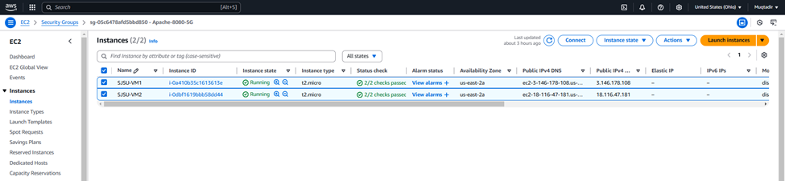

Networking was configured to enable SSH access between the VMs. Specifically, VM1 can access VM2 via SSH using .pem key files.

* **VM1 IP Address:** 3.146.178.108
* **VM2 IP Address:** 18.116.47.181

SSH connectivity was verified by initiating connections from VM1 to VM2.

VM 1:

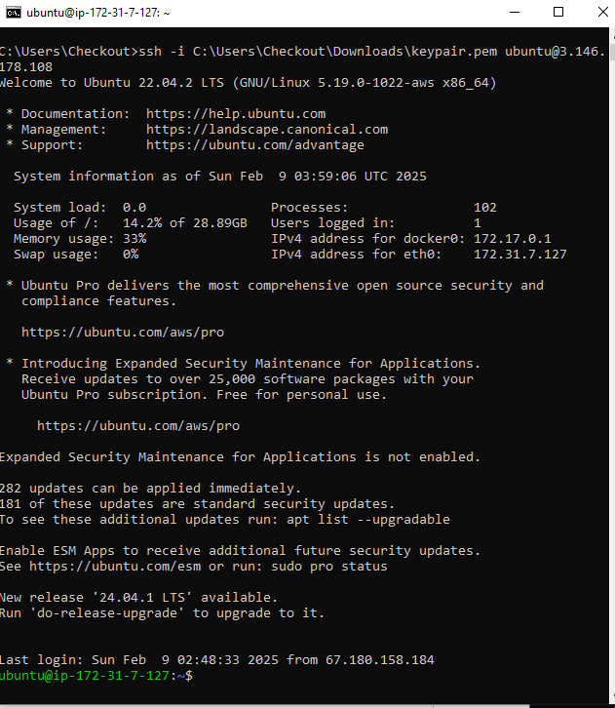

VM 2:

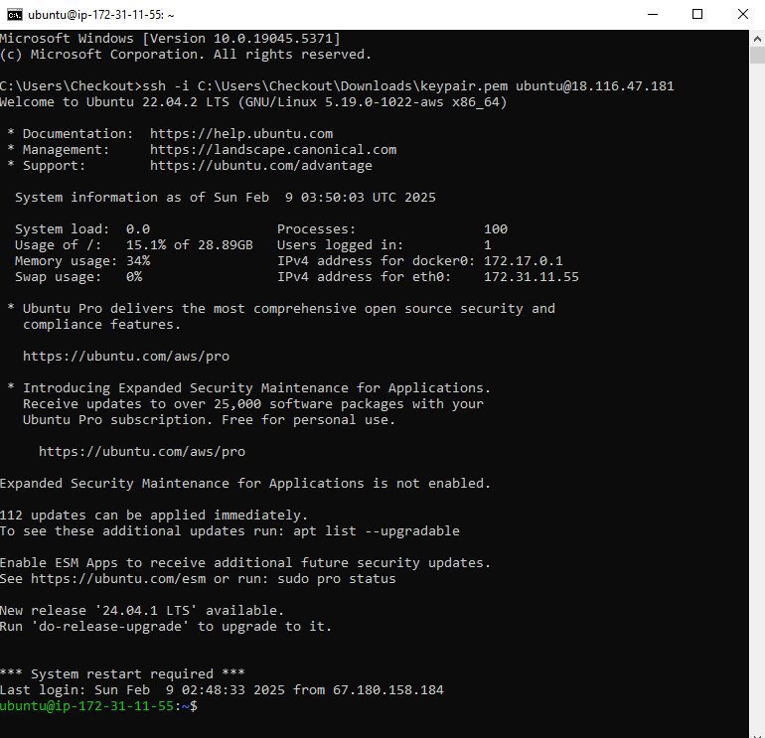

**Step 2: Configuring Ansible**

**Install Ansible:**

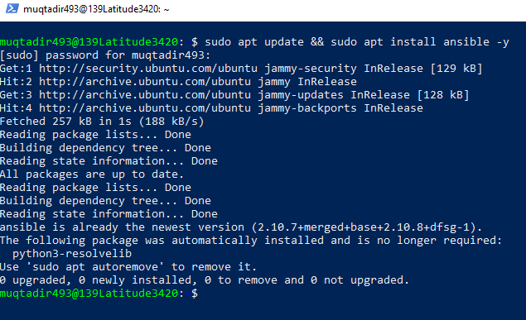

**Configure the inventory file (hosts.ini):**

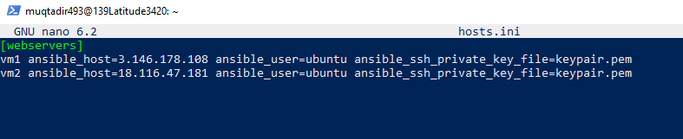

**Step 3: Ansible Playbook for Deployment** Create deploy_webserver.yml:

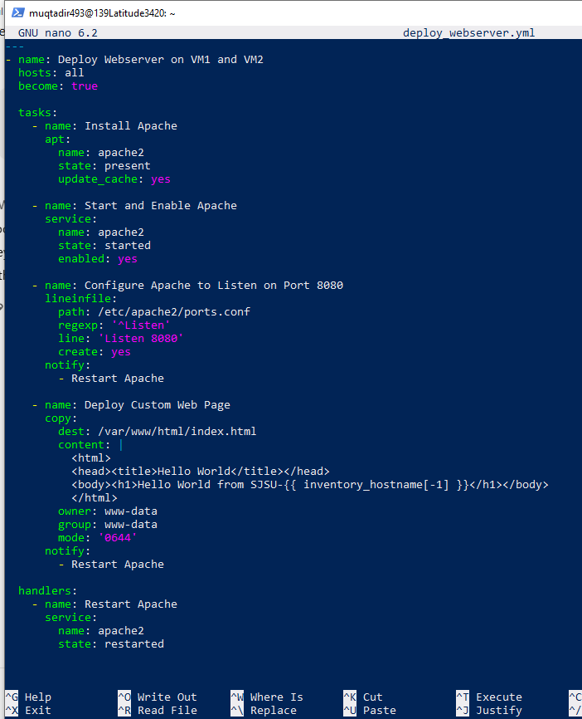

**Step 4: Running the Playbook**

Execute the following command:

**ansible-playbook -i hosts.ini deploy_webserver.ym**l

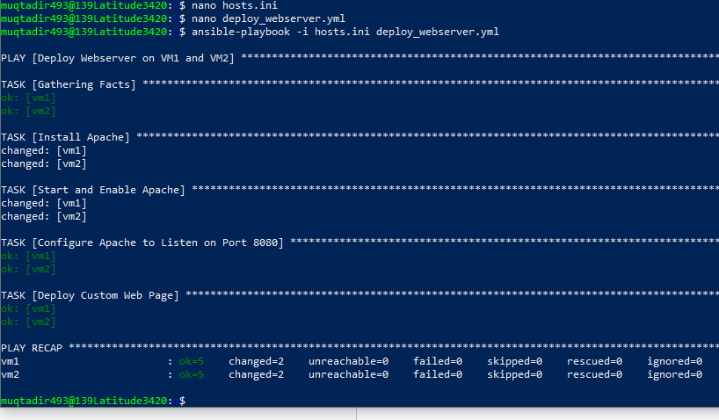

**Step 5: Testing the Deployment**

Open a web browser and enter:

* http://3.146.178.108:8080 (VM1)
* http://18.116.47.181:8080 (VM2)

**Output after deploying the HTTP server:**

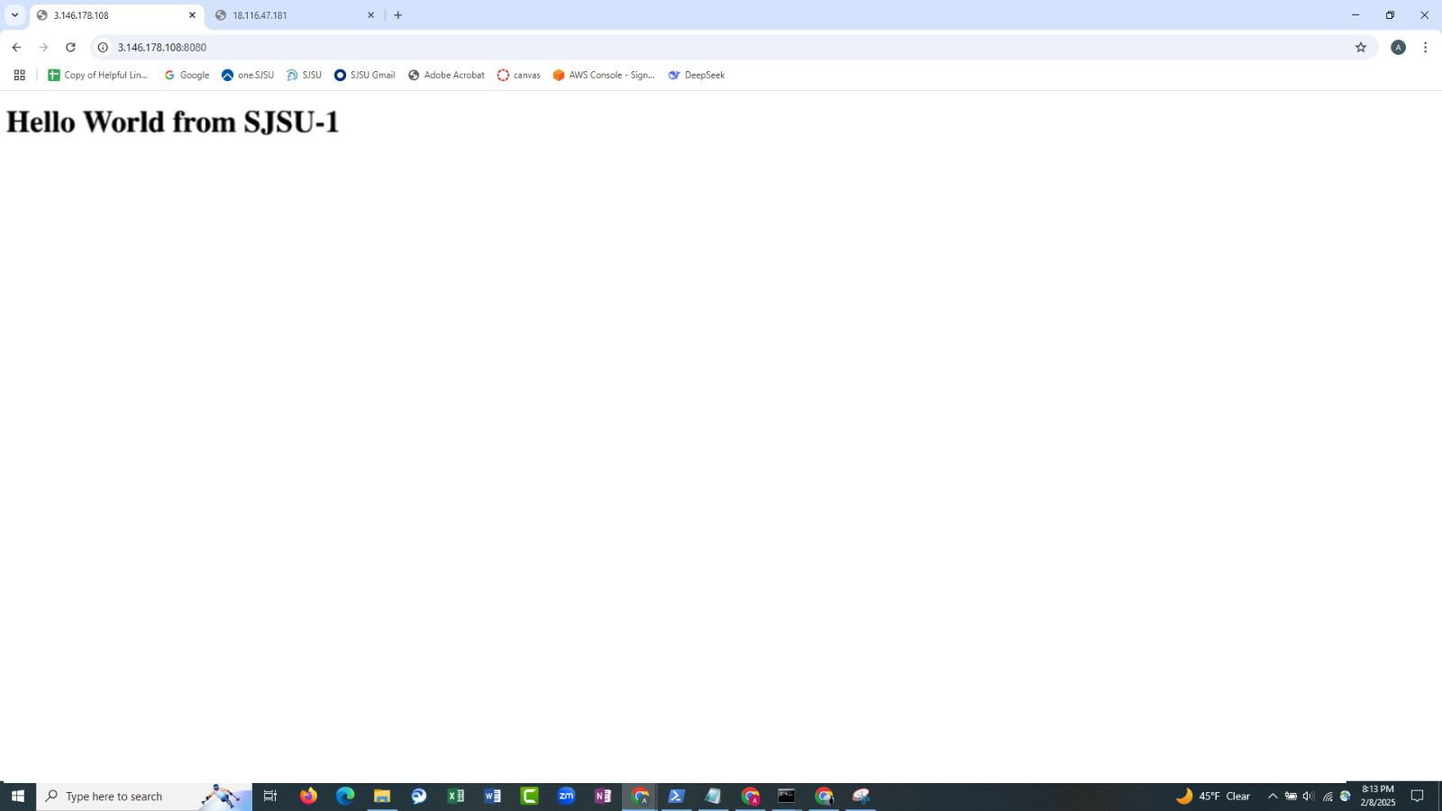

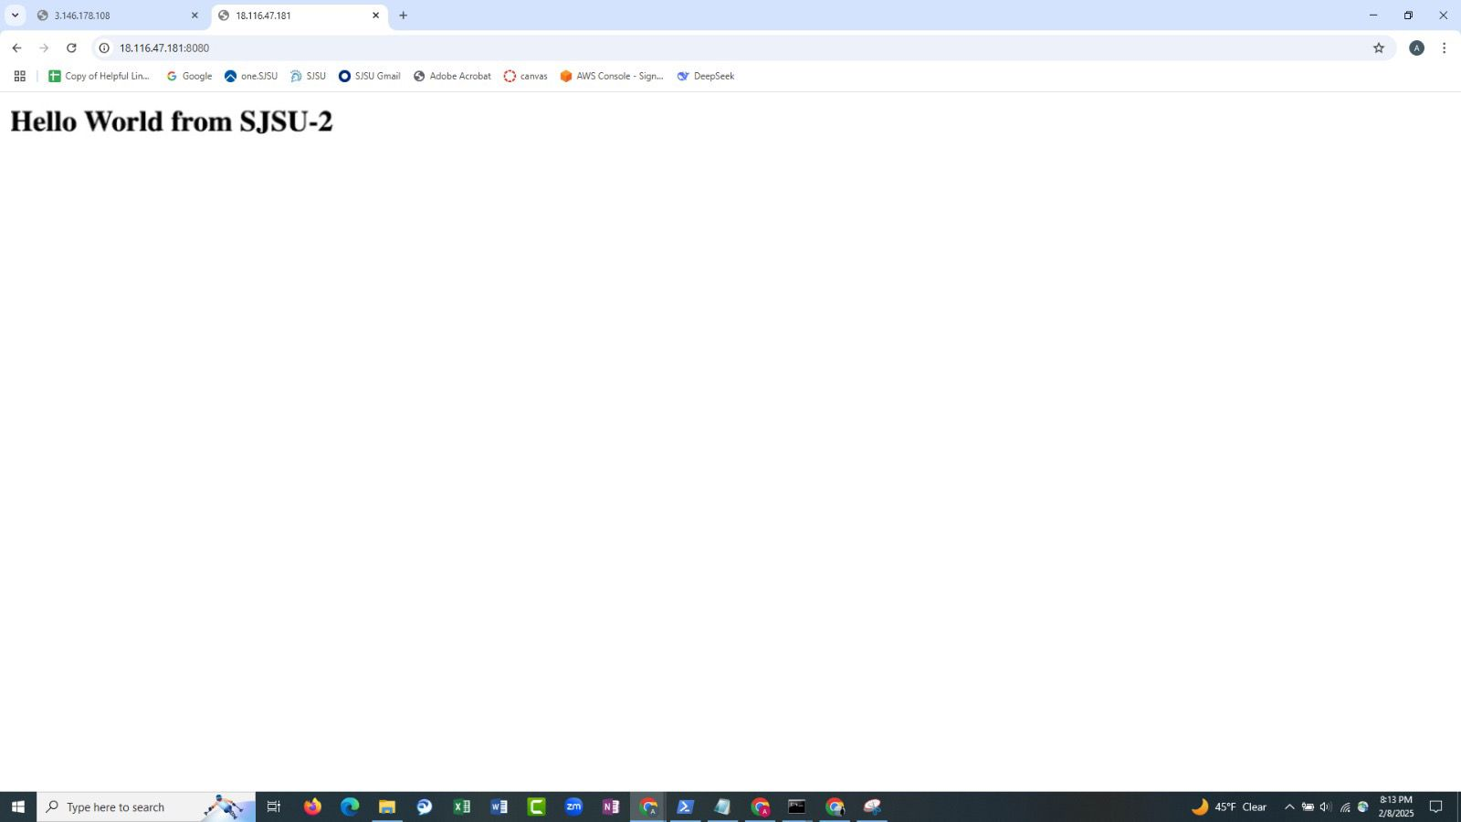

**Step 6: Running the Un-Deployment Playbook**

**Here is the playbook:**

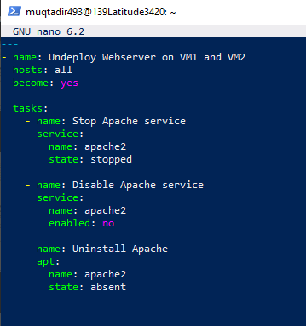

Execute the following command:

**ansible-playbook -i hosts.ini undeploy_webserver.yml**

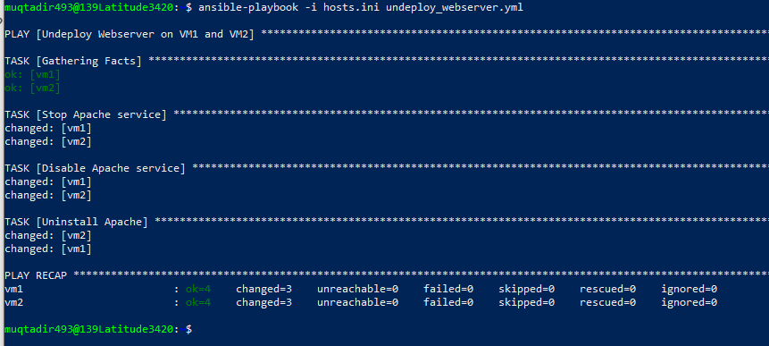

**Output after undeploying:**

**VM 1:**

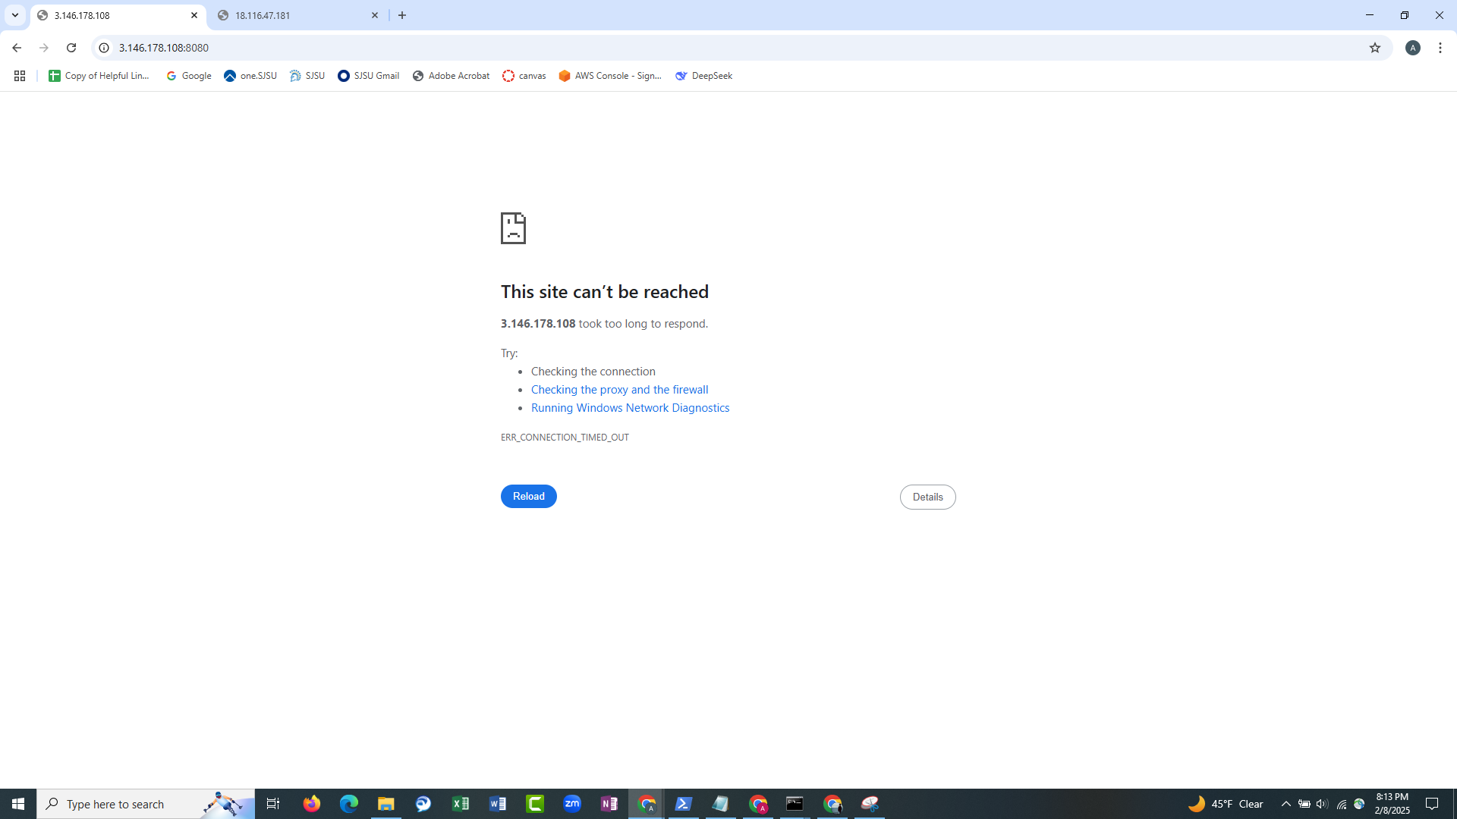

**VM 2:**

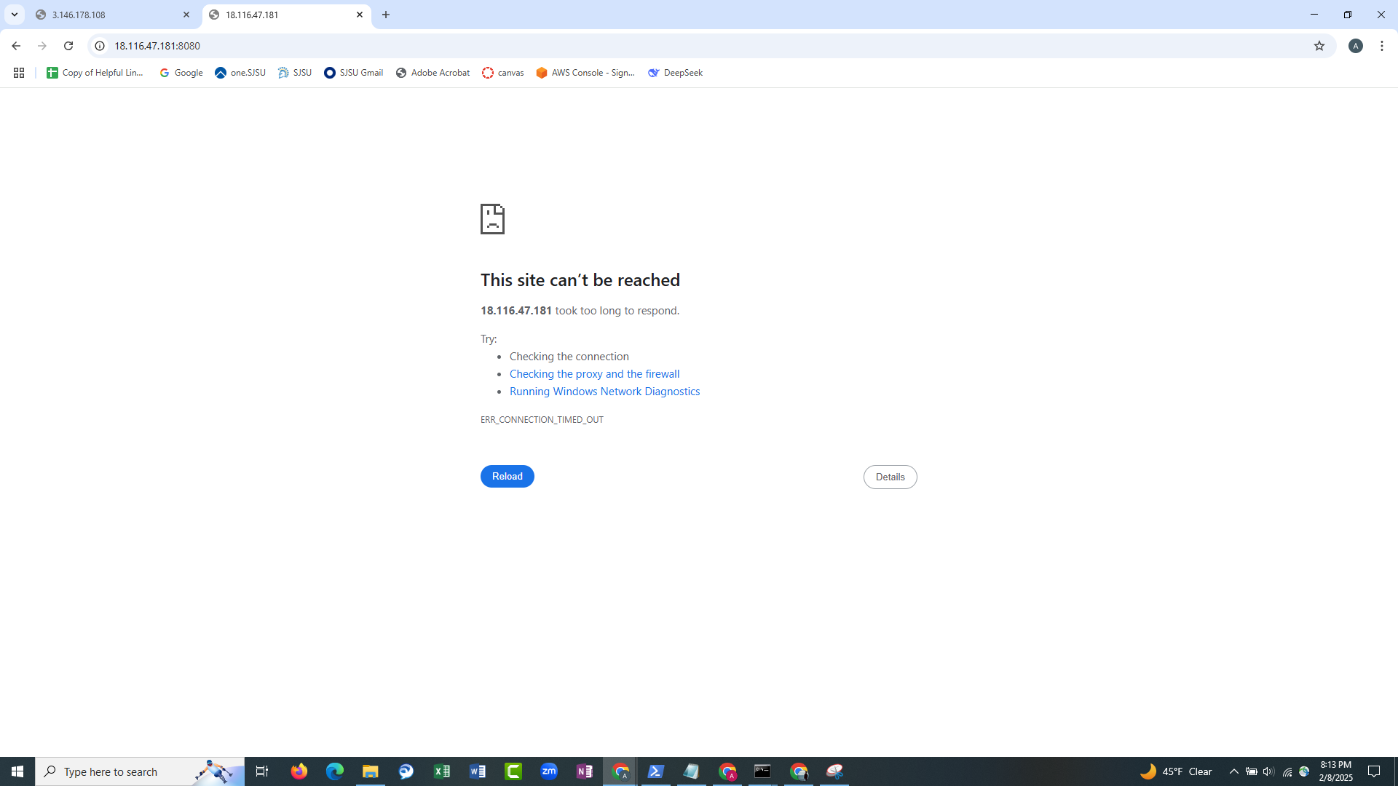

**GitHub Link**

All code and scripts are available in the following GitHub repository:

https://github.com/Crimsonbeetle/CMPE272-Assignments

**Conclusion**

The project successfully deployed a web server on VM1 and VM2 using Ansible. The web server was configured to run on port 8080 and displayed the customized message as required. The use of Ansible ensured an automated and consistent deployment process, making server management efficient and repeatable.