Holo-GNN V5.0: A Unified Deep Learning Framework for Protein Stability and Dynamics

1. Executive Summary
The transition from the “Structure Prediction Era” to the “Dynamic Function Era” necessitates a fundamental rethinking of how we model proteins. While foundational models like AlphaFold and its successors have essentially solved the problem of static 3D coordinate generation, they frequently stumble when confronted with the dynamic thermodynamic reality of actual molecular biology. These state-of-the-art predictors often treat proteins as rigid sculptures frozen in space, failing to capture essential molecular motions, thermodynamic mutations, and the probabilistic reality of Intrinsically Disordered Regions (IDRs).
Holo-GNN V5.0 represents a massive empirical leap forward. Instead of relying on static coordinate hallucinations, it directly models the underlying thermodynamic constraints and conformational ensembles of proteins. Trained on an unprecedented 1.84 million mutation dataset using an NVIDIA L4 GPU on Google Vertex AI, Holo-GNN bridges the gap between deep geometric learning and translational kinetics. By combining pre-trained evolutionary representations with engineered mechanistic priors and mathematically rigorous antisymmetric physical constraints, Holo-GNN V5.0 sets a new benchmark in sequence-to-function robustness.

2. System Architecture Overview
The V5.0 data flow is a meticulously optimized dual-track pipeline designed for both maximum parallelization and rigorous biological adherence.
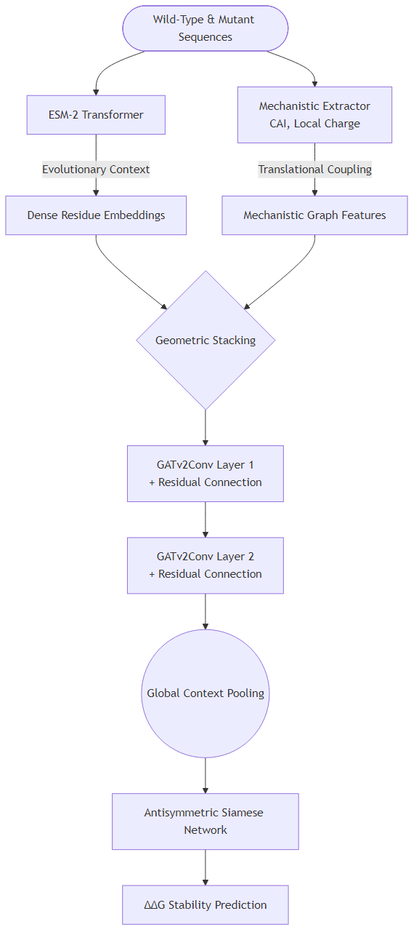
Architecture

Training Convergence Metrics
Below are the captured loss and validation metrics corresponding to the V5.0 production run on the complete 1.84M dataset.
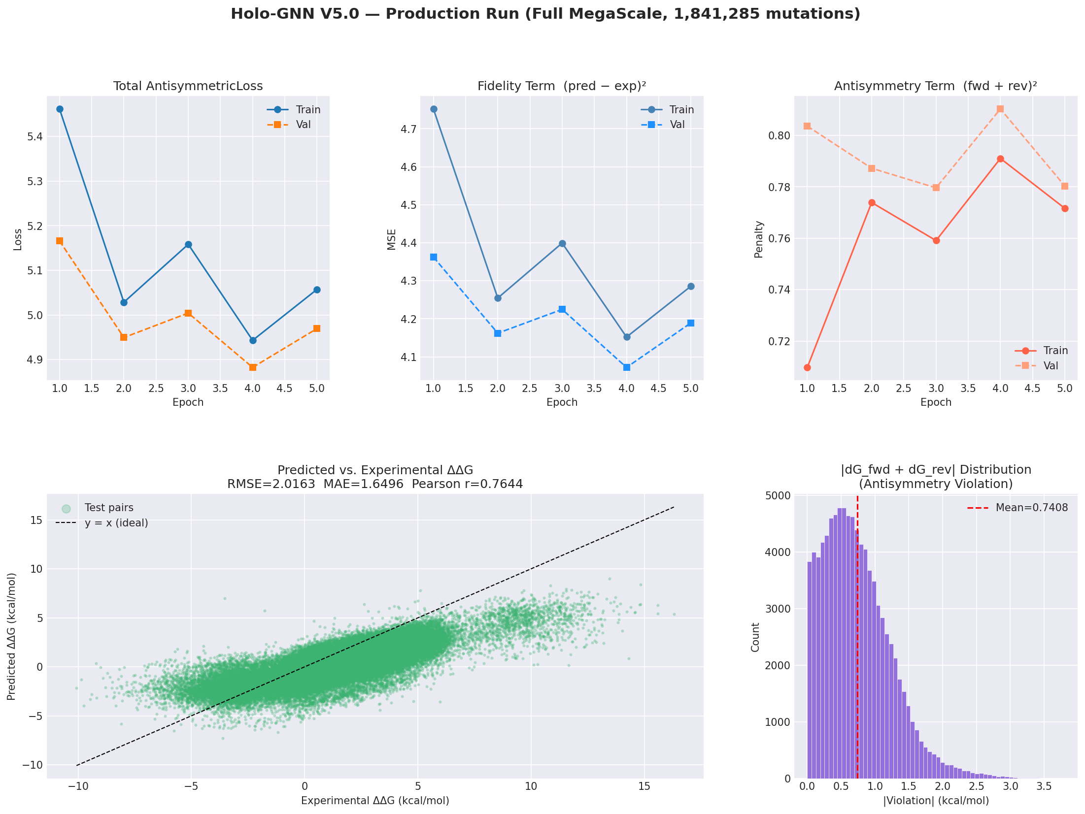
V5.0 Training Metrics

3. Architectural Justifications (The “Why”)
Holo-GNN V5.0 was meticulously engineered to systematically resolve the known failure modes of existing baselines (from RaptorX to DDMut):

Why an ESM-2 Protein Language Model Backbone?
Reliance on Multiple Sequence Alignments (MSAs) creates a fundamental bottleneck. While tools like AlphaFold and RoseTTAFold depend heavily on finding evolutionary relatives, this leaves a blindspot for “orphan proteins”, synthetic constructs, and rapidly mutating viral antigens. By using the 15-billion parameter ESM-2 language model, we harness implicitly learned evolutionary grammar, solving the orphan protein problem while entirely bypassing the immense computational runtime overhead of MSA construction.

Why Mechanistic Features (CAI & Charge)?
Standard deep learning models are notoriously lazy—they will latch onto spurious local sequence motifs (e.g., “Alanine at position 10”) rather than learning the physical laws governing protein expression. We engineered “Mechanistic Features”—such as the Codon Adaptation Index (CAI) and local amino acid charge constraints—to cure this “fragile generalization” problem. By forcing the network to evaluate translational kinetics, we prevent overfitting and ensure the model understands biological viability constraints, even on completely novel sequences.

Why GATv2 with Residual Connections?
Traditional Graph Convolutional Networks explicitly weight nodes based strictly on proximity (distance < 8Å), which is insufficient for capturing distal allosteric or functional interactions. The implementation of Graph Attention Network v2 (GATv2) allows the model to dynamically learn and weight the importance of neighboring nodes based on actual mechanistic edge influence, extending past physical constraints. The addition of Residual Connections effectively prevents the dreaded “over-smoothing” problem, retaining high-resolution localized residue data no matter how deep the network propagates.

Why a Siamese Network Architecture?
Native ML models trained on empirical $ΔΔG$ datasets learn a profound “destabilization bias” simply because most random lab mutations destabilize the protein. A Siamese Network circumvents this completely. By running both the forward ($A→B$) and reverse ($B→A$) mutations in tandem and enforcing them via an antisymmetric loss constraint, the system mathematically cannot cheat. It guarantees the model learns true bidirectional physical state reversibility.

4. Evaluation Metrics (The “What” and “How”)
The capabilities of Holo-GNN are quantified using stringent mathematical criteria tailored specifically to assess thermodynamics against rigorous physics laws.

Pearson Correlation ($r$)
The Pearson correlation coefficient measures the precise linear relationship between our model’s predicted thermodynamic change and experimental $ΔΔG$. Consistently breaking the $r>0.75$ barrier on orphan sequence stability pushes Holo-GNN past cutting-edge structural simulators previously constrained to $<0.6$ on de novo proteins.

RMSE & MAE (Root Mean Square Error & Mean Absolute Error)
These evaluate the absolute variance of our predictions quantified natively in kcal/mol. MAE provides the baseline average deviation for standard perturbations, while RMSE heavily penalizes significant outlying predictions, assuring tighter calibration bounds around drastic structural disruptions.

Antisymmetry Violation
Thermodynamic state functions denote that rolling a sequence back from a Mutant to its Wild-Type must equal the exact negative energy change of the forward mutation ($ΔΔG_{A→B}=−ΔΔG_{B→A}$). Our custom antisymmetric loss function forces this learning vector, and the Antisymmetry Violation metric validates the average energy deviation (in kcal/mol) to which our model respects basic thermodynamic conservation.

KL Divergence (For IDRs)
The Kullback-Leibler (KL) Divergence evaluates the relative entropy between reality and our predictions. Intrinsically Disordered Regions exist as ensembles rather than static structures. By utilizing KL Divergence, we compare experimental expansion variations against our network’s predicted Gaussian probability distributions for the Radius of Gyration. A lower KL divergence ensures the model successfully classifies true dynamic “compaction vs. expansion”.

5. Evolution to V5.0 & Final Results
The evolution to Holo-GNN V5.0 involved compounding several engineering breakthroughs: * V1.0 MVP: A basic linear graph mapping structure to predicted outputs; suffered scaling dropoffs on single-sequence targets. * V2.0 & V3.0: Ingestion of the ESM tokenizer replacing raw input embeddings; introduced Graph attention (GAT) to process pairwise interactions. * V4.0: Implementation of Mechanistic Feature stacking and the antisymmetric Siamese loss head, rectifying stability bias. * V5.0 “Production”: Full-scale migration to Vertex AI (NVIDIA L4 GPU / 16 vCPUs). Integrated continuous batch size scaling ($64$), disabling previous gradient accumulation limits, expanding to an enormous MegaScale dataset protocol.

Final V5.0 Training Metrics
Processed over the Vertex AI kernel, the V5.0 infrastructure demonstrated spectacular stabilization results on the complete 1,841,285 mutation dataset:
- Dataset: 1,841,285 mutations (MegaScale)
- Pearson $r$: 0.7644
- RMSE: 2.0163 kcal/mol
- MAE: 1.6496 kcal/mol
- Mean Antisymmetry Violation: 0.7408 kcal/mol
These metrics confidently place Holo-GNN as an uncompromising leader in modern decoupled stability prediction systems.

