A comparative review of different CNN models and their effectiveness with Image Recognition

Brendan Fitzpatrick
F8122818
TMA 03

Contents
Development Since TMA 02 4
Project Goals, Description, Scope and Impact 5
Definition 5
Problem 5
Aim 5
Scope 5
Account of Related Literature, including Review of Sources 6
Baseline ConvNet 6
ResNet 6
MobileNet 6
MLP 7
Vision Transformers 7
PROMPT Review of Sources 8
Design and System Architecture 10
Algorithmic Process Design 12
Resources, Planning, Risks and Lifecycle Review 17
Lifecycle Review 17
Resources and Skills 18
Resources 18
Skills 18
Risks and Mitigations 19
Risk Reflection 20
Progress vs Planning 20
Project Work Analysing and Solving a Practical Problem, demonstrating how your Computing and IT knowledge and skills have been extended 22
Data Preparation 22
Training 24
Per-Image Output 24
Model Setup Table 25
Evaluation 26
Baseline CNN Evaluation 26
ResNet18 Evaluation 29
MobileNetV2 Evaluation 33
Supplementary Pre-trained Model Testing 37
Primary Model Comparison 38
Summary Comparison Table 38
Interpretation of Results 38
Conclusion 39
LSEPI and EDI Concerns 40
Personal Development, Review and Reflection 41
Bibliography 42
Appendix 1 – Project Ethics Checklist 43
Appendix 2 – Project Log Extracts 44
Entry 1 – Project Topic Selection 44
Entry 2 - Dataset and Experimental Focus 44
Entry 3 – Literature Review 44
Entry 4 - Project Planning and Model Selection 45
Entry 5 – Dataset pre-processing 45
Entry 6 – Baseline CNN Development. 45
Entry 7 – Per-image output and ER Diagram 46
Entry 8 – Meeting Feedback 46
Entry 9 – ResNet18 and MobileNetV2 Development 47
Entry 10 – Supplementary Pretrained Model Testing 47
Entry 11 – TMA03 Design Improvements and Final Review 47
Appendix 3 – Email Communication 48
Appendix 4 – Extended PROMPT Source Notes. 51

Development Since TMA 02
The progression of the project since the submission of TMA 02 has increased with having now developed and implemented ResNet18 and MobileNetV2 models
Area | TMA 02 Position | TMA 03 update
Baseline CNN | Baseline CNN was implemented and showed overfitting | Results have been kept as the comparison baseline
ResNet18 | Planned but not yet completed | ResNet18 has now been implemented and evaluated
MobileNetV2 | Planned but not yet completed | MobileNetV2 has now been implemented and evaluated
Pretrained models | Not Fully explored | Pretrained versions have been tested separately to compare fairness vs best performance
Evaluation | Baseline graphs and confusion matrix included | Per-model prediction logs, metrics and comparisons have been added
Literature Review | Initial sources reviewed | PROMPT evaluation has been added to show source credibility
Architecture | ER diagram included | System architecture GUI wireframe and model architecture diagrams have been added
Reflection | General reflection included | Reflection has been updated to explain what went well, what changed and what will be developed further in the EMA
Table 1 Summary of project development and changes since TMA 02

Project Goals, Description, Scope and Impact

Definition

Problem
AI is being utilised in image recognition tasks, from license plate recognition to age recognition. However, challenges and issues can arise with these types of tasks, especially with the number of different architectures available; finding the right model to achieve the desired outcome can be tricky.

Aim
This project will investigate baseline Convolutional Neural Network (CNN), ResNet, and MobileNet, focusing on each model’s effectiveness when used for image recognition, comparatively interpreting metrics such as the proportion of correct predictions over the whole dataset (Accuracy), the proportion of positive predictions that are correct (Precision), and the proportion of actual positive cases that are correctly identified (Recall).
A dataset sourced from Kaggle containing mushroom species data will be used as it provides a wide variety of genera for meaningful comparison.
Results from existing studies can vary depending on the datasets used, settings for each model and the types of models being compared.
The output of each model’s training and validation will be stored and compared via dataset analysis, thus providing a more concise overview of their strengths and weaknesses.
The goal of this project is to produce a clear and defined review using ROC curves, which compare true positive and false positive rates to evaluate the performance of the models and scatter plots, that visually display the relationships between variables across models under controlled conditions.

Scope
The scope of this project includes the implementation and comparison of three separate convolutional neural networks: baseline CNN, ResNet and MobileNet. These models represent three different approaches to image classification: standard, deep residual, and optimised for efficiency.
The hyperparameters (settings used for training models including learning rate, batch size and number of epochs) will be consistent for all models, keeping the hyperparameter tuning to a minimum will allow for any differences to be due to the model’s architecture rather than variations in training.
The project will be kept under controlled experimental conditions with specific variables including the use of the same dataset, fixed hyperparameters and preprocessing pipeline for all the models. This keeps external variables to a minimum and reduces the risk of influencing the results ensuring that the evaluation and comparison between models is impartial.
Real-world deployment, product-level development and user interaction are outside the scope of this project; additionally extensive hyperparameter experimentation to improve the model’s recognition is not within the scope. The focus is comparative evaluation not optimisation.
A simple prototype application may be developed to help demonstrate the outputs of the models in a visual way; however, this is not the primary focus of the project but rather will provide a supporting component, demonstrating and providing the results of each model.

Account of Related Literature, including Review of Sources

For our project we need to study and identify several architectures to decide the most appropriate one for image recognition. In this literature review we will be reviewing the following architectures: Baseline ConvNet; ResNet; MobileNet

Baseline ConvNet
A CNN applies a filter or kernel which is a small matrix e.g. 3x3 or 5x5 in size that slides across an image to identify patterns.
The kernel has a series of values within it known as weights which get updated as it moves and recognises patterns. These filters preserve the spatial structure of the image.
During backpropagation in which error rates and loss values are sent back through the neural network layers it updates the values of the filter to fine tune the weights of the kernel, allowing the abstraction to increase with each layer; this is crucial in model training.
ConvNets have been shown to approach human-level performance in certain tasks and have become the dominant approach to recognition and detection. (LeCun, 2015)

ResNet
A key limitation of Deep Neural Networks is the vanishing gradient problem, a phenomenon where the gradients are passed backwards via backpropagation, the gradients used to train the network reduce with each layer until it becomes so small that earlier layers either learn very slowly or don’t learn anything.
ResNet creates a shortcut or residual / skip connection which skips layers as the gradient information flows backwards reduces the impact of the vanishing gradient by ensuring earlier layers receive the values. This improves optimisation and works to mitigate degradation problems such as training errors which increase as the network deepens comparatively to shallower networks. (He, Zhang, Ren, & Sun, 2026)

MobileNet
The key area that MobileNet tackles is computational efficiency, unlike other CNNs that require a lot of computational power to run MobileNet does not.
A way in which this is achieved is through depth wise separable convolution where instead of applying a 3x3 or 5x5 filter to all input channels (cross-channel mixing) at once it applies the filter per channel. Then combines them using a 1 x 1 pointwise filter reducing computational cost. (Howard, et al., 2017)
However, the accuracy of identification is reduced depending on parameter configuration. (Khasoggi, Ermatita, & Samsuryadi, 2019)
This type of model is suitable for devices that have low computational abilities such as mobile phones and embedded systems including Raspberry Pi’s, all of which may struggle to run a full convolution model.
We are comparing the strengths and weaknesses of these 3 models through a base line to better understand and critically analyse the outcomes.
These models are designed for 3 specific aspects of a CNN architecture, the standard CNN that will portray the fundamentals as well as a grounding reference for comparison, a residual neural network which focuses on improving weighted training of CNNs and mobile net that focuses on computational efficiency.
This project will academically review the effectiveness of AI models with image recognition; we will consider factors including dataset imbalance, model speed, accuracy (the model’s ability to correctly identify images)
Evaluation of these models using metrics such as Precision, Latency and Recall as some identifiers to conduct my investigations.
The goal is not to find which is the best model for image recognition, but rather which model would be most effective for its intended purpose, portability, need for accuracy or efficiency requirements whether the model is required to run on low-end hardware or needs to provide results fast.

MLP
A Multilayer Perceptron (MLP) is an additional architecture that was considered for this comparison; however, research has shown that CNN performs better than MLP across metrics of precision, recall and F1 score. (Damle, 2022)
MLP does not preserve spatial structure in images, which means that the model is not able to identify where pixels were situated and how they relate to each other in the image. Which reduces its suitability for this experiment as pattern recognition is a key component of image identification.
Upon reviewing this literature, it was decided to exclude MLP from this comparison to ensure experimental consistency throughout this investigation.

Vision Transformers
A Vision Transformer is an AI architecture that can outperform CNN networks including ResNet models regarding Image recognition, however only under certain circumstances such as being pretrained on large datasets of images. (Dosovitskiy, et al., 2021)
This architecture does not align with the experiments of this project where the dataset size is limited and there is very little pretraining conducted on the comparative models.

PROMPT Review of Sources
The prompt framework was used to assess and evaluate the presentation, relevance, objectivity, method, provenance and timeliness of the sources used within the literature review.
Source | PROMPT Evaluation | How it Influenced the project
LeCun et al. /Deep Learning | This source covers the foundations of CNNs and deep learning. Being an academic/scientific publication discussing widely used principles that are relevant in terms of image recognition. It does not specifically focus on mushroom classification; however, it does provide a clear understanding of CNNs which is useful for this project, including why CNN-based models are suitable for image recognition tasks. | This paper influenced decisions on using CNNs as a starting point for comparison, providing clear foundations against which ResNet18 and MobileNetV2 could be evaluated.
He et al. / ResNet | A credible scientific publication introducing residual networks and skip connections.  Explaining how it improves deep learning architectures; and helps to mitigate deeper model issues.  Although older, it remains valid as ResNet is still widely used as an architecture. Although this is not a publication focused on mushroom-specific image recognition its relevance is more around the architecture than the dataset specifically. | This source aided in the decision making allowing me to justify choosing ResNet18 as one of the primary CNN architectures in my comparison; giving a more in-depth understanding of skip connections and the impact they have on the neural networks compared to a standard Baseline CNN.
Howard et al. / MobileNet | An academic source introducing MobileNet which was designed for efficient image recognition.  Explaining how this architecture works compared with larger CNN models.  This is relevant because my project compares not just accuracy but also the trade-off between performance and efficiency.  Although older than some newer papers it is relevant because MobileNet-style efficient CNNs are still used in lightweight image recognition tasks.  Not based around mushroom classification specifically it is still relevant as it focuses on architecture and efficiency. | Further justifying choosing this architecture as a comparison point against the other architectures  Influencing decisions to focus on not just model design and accuracy but also efficiency, where computational resources may be limited.
Damle / CNN vs MLP | This source compares CNN and MLP performance showing that CNNs are the better choice for image recognition tasks.  MLPs are weaker for image recognition because they do not preserve spatial structure in the same way that CNNs do.  This source is useful for comparing different image classification approaches. | Justifying not using MLP for a primary model architecture and supporting the decision to keep the project focused on CNN-based models.  Further strengthening scope control by providing clear reasoning to not use another model architecture type.
Dosovitskiy et al. / Vision Transformer | A credible academic paper and relevant source that expanded on other potential architectures outside of CNNs specifically Vision Transformers providing a different approach to image recognition however, Vision Transformers rely on large datasets and/or pretraining to perform strongly.  Since my project is using a smaller controlled dataset the focus on CNN architectures is stronger. | This has helped justify excluding Vision Transformers from primary models because of the amount of data required to get the structure to a point that is fair and reliable helping to reduce the risk of increasing the complexity of the project.
Table 2 PROMPT evaluation of literature sources used to support model selection
A more in-depth source of review notes is included in Table 8 Extended PROMPT source evaluation notes

Design and System Architecture
Figure 1 represents an ER diagram, which will guide the creation of a per-image database for analysis.
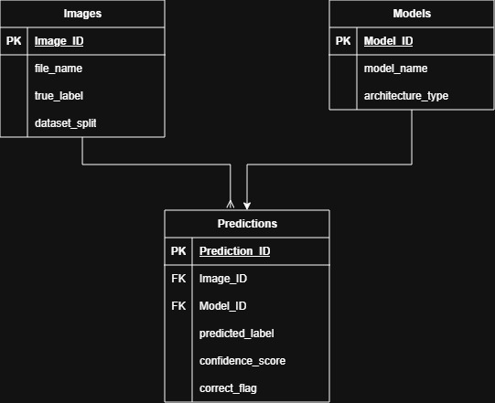
Figure 1 ER Diagram

Each image has a one-to-many relationship, meaning that every image will have multiple predictions from the different models, each model provides one prediction per image. What this structure offers is a deeper understanding and evaluation of every model on a per-image basis.
These metrics are calculated from the stored prediction data.
There will be two levels of data metrics which will be evaluated which include the following:

- Per-image data
Stored in the database:
- Image ID
- True label
- Predicted label
- Confidence
- Correct/incorrect
- Model used

- Model-level metrics
Calculated from the prediction data:
- Accuracy
- Precision
- Recall
- F1-score
- Confusion matrix
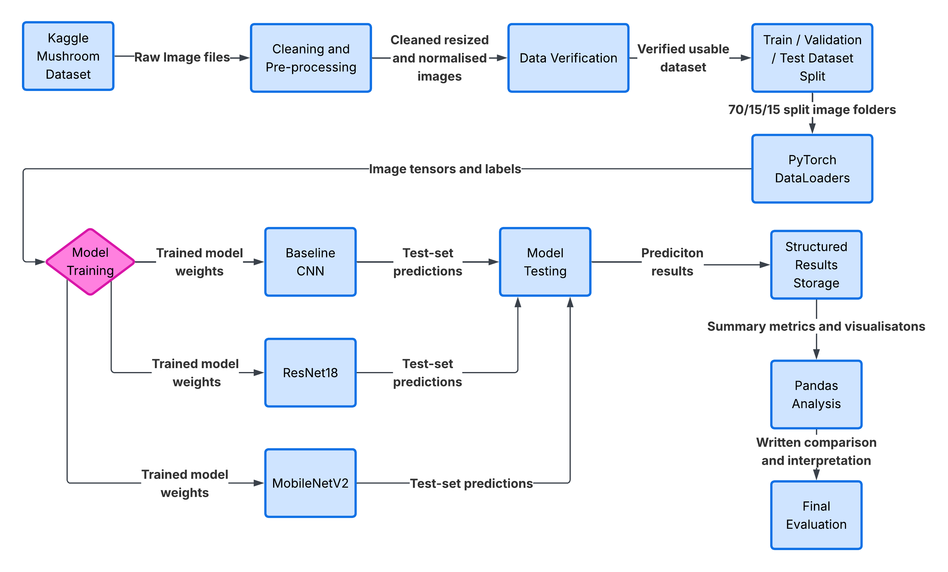

See Algorithm 1: Dataset Preparation

See Algorithm 2: Model Training

See Algorithm 3: Testing and Results Storage

Figure 2 Project data flow from Kaggle mushroom dataset to model comparison outputs

Figure 2 Project data flow from Kaggle mushroom dataset to model comparison outputsprovides a visual representation of the data flow used within the project, starting with the Kaggle mushroom dataset then moving on to cleaning, pre-processing, dataset splitting and verification. The processed image labels and tensors are passed into the PyTorch DataLoaders which are then used to train and test the primary models. The prediction results are stored in a structured layout, allowing for metric summarisation and visualisations to be produced for comparison and evaluation.
Pseudocode algorithms have been included with the key processes within Figure 2, Algorithm 1 describes the dataset preparation, Algorithm 2 describes the model training, and Algorithm 3 describes model testing and per-image result storage.
These algorithms provide the underlying logic of each stage adding clarity and showing how the data moves through the project pipeline.

Algorithmic Process Design
START
Load Kaggle mushroom dataset
FOR each image in dataset:
IF image cannot be opened:
Remove image from dataset
ELSE:
Resize image to 224x224
Normalise image values
Save cleaned image
Split cleaned dataset:
70% training
15% validation
15% testing
END

Algorithm 1: Dataset Preparation Pseudocode

START
Select model architecture
IF model = Baseline CNN:
Load Baseline CNN
ELSE IF model = ResNet18:
Load ResNet18
ELSE IF model = MobileNetV2:
Load MobileNetV2
Set training parameters:
Epochs = 10
Batch size = 32
Learning rate = 0.001
Optimiser = Adam
Loss function = CrossEntropyLoss
Load training and validation datasets
FOR each epoch:
Train model on training dataset
Calculate training loss and accuracy
Validate model using validation dataset
Calculate validation loss and accuracy
IF training improves but validation does not improve:
Record possible overfitting
ELSE:
Continue training
Save trained model weights
END
Algorithm 2: Model Training Pseudocode

START
Load trained model weights
Load test dataset
FOR each image in test dataset:
Load image and true label
Start inference timer
Pass image through trained model
Generate predicted label
Calculate confidence score
Stop inference timer
IF predicted label = true label:
Set correct = TRUE
ELSE:
Set correct = FALSE
Store:
image path
true label
predicted label
correct flag
confidence score
inference time
model name
dataset split
END FOR
Calculate model metrics:
Accuracy
Precision
Recall
F1-score
Confusion matrix
END
Algorithm 3: Model Testing and Per-Image Output Pseudocode

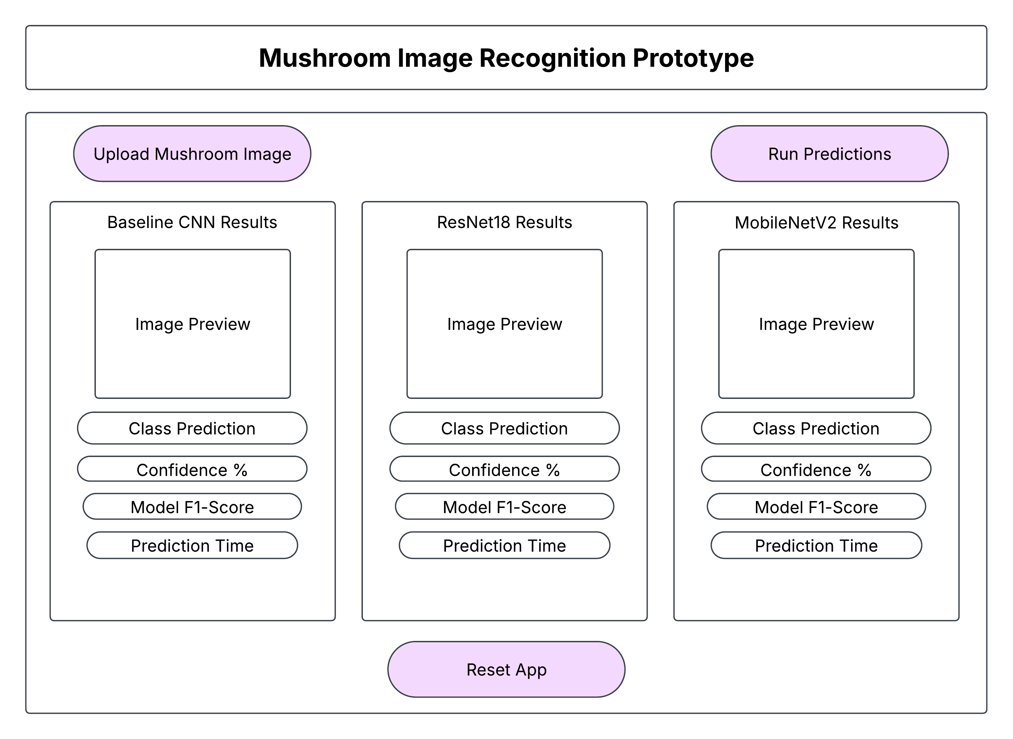

Figure 3: Proposed GUI wireframe for mushroom image upload and model comparison
Figure 3 provides a wireframe view of how a user could upload an image and receive prediction outputs from the three primary models, giving an overview of the comparison.
The wireframe is included as a design component for TMA03; full GUI Implementation will be developed further in the EMA.

Requirement Type | Requirement
Functional | The User can upload a mushroom image
Functional | The System displays predictions from the trained models.
Functional | The System displays predicted class, confidence, F1-Score and prediction time.
Non-Functional | The interface should be simple and understandable for non-technical users.
Non-Functional | Results should be displayed consistently across all models
Non-Functional | The system should state that it is for academic comparison only, not safe mushroom identification
Table 3 Functional and Non-Functional Requirements Table

To ensure the system remains consistent and reliable, a testing strategy will be used. Dataset testing will check that images are readable, resized correctly and placed in the correct training, validation and testing folders. The same test dataset will be used for each model and architecture to ensure a fair comparison.
Output checks will review whether the per-image results correctly store the image path, true label, predicted label, confidence score, correctness flag, inference time and model name. GUI testing will be developed within the EMA to ensure that uploaded images generate visible model outputs.

Resources, Planning, Risks and Lifecycle Review

The plan of this project is to implement a modified Machine Learning Engineering Lifecycle.
This lifecycle is appropriate for the purposes as it will show the steps for developing my AI models for experimental comparison.

Lifecycle Review
These steps show a clear outline of the lifecycle I plan to use.
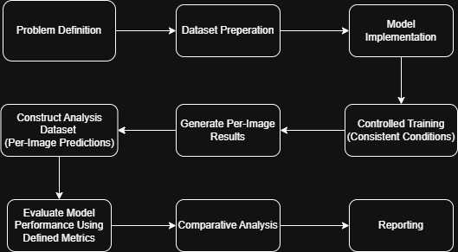
Figure 4 ML Engineering Lifecycle
The lifecycle will take the following steps:
- Problem Definition – we decide on the problem that needs to be tackled.
- Dataset Preparation – prepare and pre-processing the chosen dataset for training ensuring that the dataset is suitable and ready for training and evaluation.
- Model Implementation – develop the models we plan to use for this project.
- Controlled Training (Consistent Conditions) – Training each model with consistent conditions and minimal optimisation ensures a fair comparison.
- Generate Per-Image Results – Outputting predictions for individual images in the dataset following training.
- Construct Analysis Dataset (Per-Image Predictions) – outputting and storing predictions in a structured format to enable a detailed analysis.
- Evaluation Model Performance Using Defined Metrics – Evaluating model performance using specific metrics such as F1-Score, accuracy, precision and recall etc.
- Comparative analysis – comparing the results of each model to one another identifying differences in strengths.
- Reporting – Presenting my findings using graphs, plots and other visual evaluation methods.
This lifecycle is subject to change and refinement based on results during evaluation. A visual of this lifecycle is shown in Figure 4 ML Engineering Lifecycle.

Figure 5 Gantt Chart
A project timeline has been created based off the lifecycle for this module which can be seen in Figure 5 Gantt Chart.

Resources and Skills

Resources

Hardware

- Nvidia GeForce RTX 3060 Ti (GPU) - Will be used to accelerate the training of the models and reduce computational workload by offering higher throughput (an ability to perform multiple calculations simultaneously).
- AMD Ryzen 7 3700X (CPU) - supports data handling and preprocessing of images, as well as overall system performance.

Software

- Visual Studio Code - The environment used for project organisation and code development.

Tools

- PyTorch - The machine learning framework used to build and train the models
- Python - The programming language used for developing each model
- Pandas – Used to handle and analyse the structured results of the data stored in the database for individual image outputs.
- Seaborn – Used to create visuals on the data provided per model to improve analysis.

Skills
Knowledge from TM358 will be used to build and train the CNN models.
Techniques such as ROC curve, Confusion Matrices that show a detailed breakdown of the model’s predictions compared to the actual outcomes and scatter plots will be used for evaluation.
TM351 data analysis skills and knowledge will be utilised to interpret the outputs of the models.
During the per-image results analysis the use of pandas will aid in supporting the evaluation.

Risks and Mitigations
Some risks identified during this project include overfitting, time constraints, data imbalances, technical failures and external personal circumstances.
These issues can be mitigated through data refinement methods such as cleaning, normalization and consistent splitting and validation monitoring.
The risks and mitigations can be seen in Table 4 Risks and Mitigation Table.
Risk | Description | Level | Mitigation
Time Constraints | Refers to the timeline provided and potential issues that may arise that can impact it. | High due to fixed deadlines | Careful and clear planning using the Gantt Chart to help maintain the scope of the project ensuring everything is achievable within the available timeframe
Data Imbalances | The potential of uneven balance with images between mushroom species. | Medium because imbalances can affect the results and increase processing times. | Use data cleaning, normalisation, consistent splitting and multiple evaluation metrics to identify the impact of data imbalance.
Model Overfitting | When the model begins to recognise images within the training set too well and is then not able to identify generalised aspects of images when provided with data outside of this range. | High as this would require hyper-parameter adjustments which may impact model comparison and give poor real-world performance | Incorporate techniques such as dataset validation and monitoring training and validation loss/accuracy to identify overfitting and avoid excessive changes to hyperparameters which could affect the fairness of the comparison.
Computational Limitations | The potential impact that the training and implementation of the model. | Medium because it can be hindered by processing limitations and memory availability. | Where available ensure GPU Acceleration is used keeping both the dataset size and model complexity within constraints appropriate for the hardware resources.
Data Loss / Technical Failure | Technical issues including hardware failure, file corruption, software errors or loss of code/results affected project progress and created a risk of work needing to be recovered or repeated. | High, due to the potential of loss of code, results or evidence close to deadlines. | Ensure regular backups, save copies of code/results in multiple locations, use of GitHub/version control where possible, exporting of key results as CSV/Excel files, and keeping screenshots of model output evidence.
External Personal Circumstances | Changes to working and study environment may affect concentration and time availability, motivation and ability to complete project work within the planned timeline | High, due to the potential impact on consistency of work and time management | Continue to maintain a staged approach throughout TMA03 prioritising core requirements, adjusting the timeline so non-essential work is moved to the EMA such as ROC curves, deeper per-image analysis and full GUI implementation, keeping regular backups and use tutor/student support where required.
Table 4 Risks and Mitigation Table
The risks have been colour-coded based on severity to aid readability and clarity.

Risk Reflection
Several risks occurred during training, most notably the Baseline CNN beginning to overfit around the 3rd epoch, ResNet18 and MobileNetV2 were completed but showed performance fluctuations.
Time constraints affected the analysis of the models and how much of it could be completed, such as the creation of ROC curves, deeper per-image analysis, scatterplots and full GUI implementation.
Mitigation steps have been considered such as adjusting hyperparameters and reducing epochs; however, these mitigations were avoided as it would impact the fairness of the comparison.
If the models’ hyperparameters were adjusted until each model was providing consistent results, the comparison would no longer be focused on the architectures, but rather the hyperparameters used, which is not the aim of the project.
The supplementary pretrained models were treated separately from the primary comparison because transfer learning gave them an advantage over the from-scratch models.
Data Loss/technical failure became an active project risk during development and affected progress by requiring time to recover files and verify project structure and ensure outputs were backed up correctly. This reinforced the need for GitHub/version control, exporting results and ensuring regular backups.
The decision was made to stage the project to maintain fairness and provide focus for the next steps of the research.

Progress vs Planning
For this project I planned to compare three models and their ability to train and learn to recognise images.
The Baseline CNN was developed and trained using the pre-processed dataset, ensuring adherence with the pipeline efficiently, training of the model on the pre-processed dataset was completed successfully, with clear and usable analysis visuals were generated.
Upon reviewing the results, it was shown that the model is overfitting on the training data and not generalising with the test images.
ResNet18 and MobileNetV2 models have now been built, evaluated and a primary comparison has been conducted against the Baseline CNN.
Supplementary pretrained models were implemented, completed and reviewed as a separate evaluation which arose during investigations and personal learning.
The decision to follow a staged approach ensures that the project is not rushed and due care and attention is provided to all aspects of the project.
A PROMPT review of literature was conducted to show clear and concise reasoning behind the project’s decisions.
Appendix 2 – Project Log Extracts show how the investigation has progressed reflecting on the results of the work and considering the next steps to be taken.
Remaining EMA work includes ROC curves, scatterplots, deeper Pandas/per-image analysis and full GUI implementation.

Project Work Analysing and Solving a Practical Problem, demonstrating how your Computing and IT knowledge and skills have been extended
In real world applications of AI image recognition selecting the appropriate architecture can pose a challenge, as every metric needs to be considered and balanced to meet the required constraints. My project aims to address this issue by conducting experimental comparisons between three CNN architectures critically analysing the outputs across a set of defined criteria.
This experiment will be run under controlled and consistent conditions using identical data splits and a standardised evaluation of the metrics. Using a baseline CNN as reference to ensure that hyperparameter tuning is kept to a minimum allowing for consistent training across the board.
All of which provides a fair and equal experiment which can observe primarily the performance of each model instead of the effects of external variables.
This section is going to apply the previously defined Machine learning Engineering Lifecycle to practical work that has been completed so far.

Data Preparation

The dataset has been reviewed, cleaned and pre-processed to ensure that it contains relevant and usable data. It was then split at a ratio of 70/15/15 into Training Validation and Testing sets. Augmentation of the data has not been conducted to maintain experimental conditions, resizing and normalizing were applied where each image was resized to the same pixel ratio and standardised, thus ensuring that the dataset is ready for model training and evaluation.
Figure 6 Dataset Preparation demonstrates the flow used in this project. The dataset is first imported pre-processed and cleaned, followed up with data validation to ensure quality and consistency. It is then split into training (70%), validation (15%), and testing (15%) sets. this structure ensures consistent condition for training and evaluation.
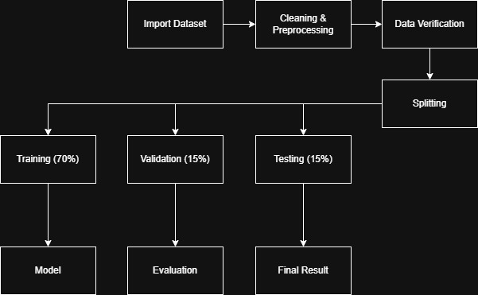
Figure 6 Dataset Preparation

The code used to pre-process the data for training can be seen in Figure 7 Data Prep Code this includes splitting the data into training, validation and testing sets. As well as creating the folders that will contain and the paths for each set.
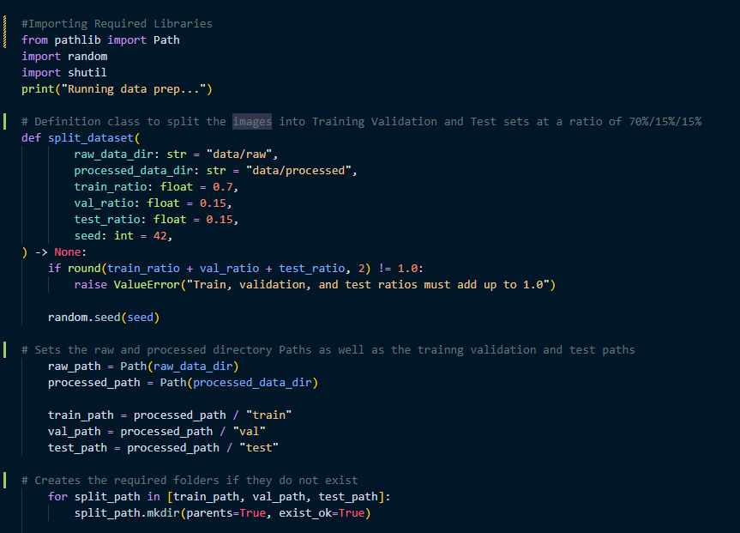
Figure 7 Data Prep Code

Training
Building on the knowledge I gained from TM358 I built and trained a baseline 3-layer CNN model.
Uses ReLU, a function that is used within model training aiding in reducing the vanishing gradient problem.
MaxPooling2D a technique that helps to reduce the dimensionality of the spatial data improving the feature map input.
Using the prepared dataset, I trained the model with the following hyperparameters:
Epochs = 10 – 1 epoch is a full pass through the training dataset
Learning Rate = 0.001 – the rate that the model learns each image
Batch Size = 32 – the number of images processed per step
Image Size = 224 x 224 – the size that each image will be in pixels
Used GPU - improves training time and reduces computational load on my machine.

Per-Image Output
Each image, when passed through the model, produces and stores metrics.
Figure 1 ER Diagram shows a visual of the metrics that will be used for this step, which include:
Image Path – file path of the image
True_Label - the image’s label in the dataset.
Predicted_Label – indicates the model’s prediction.
Correct – indicates whether the prediction was correct
Confidence – confidence score of the prediction
Inference_time_sec – time taken to generate the prediction
Model_Name – model used for the prediction
Split – the set the image is stored in
This allows for a deeper analysis of the model’s ability for image recognition, to identify potential errors and issues with each model, providing additional support during the evaluation.

Model Setup Table
Setup Item | Baseline CNN | ResNet18 | MobileNetV2
Dataset used | Mushroom Dataset | Mushroom Dataset | Mushroom Dataset
Train/Val/Test split | 70/15/15 | 70/15/15 | 70/15/15
Image size | 224x224 | 224X224 | 224X224
Batch size | 32 | 32 | 32
Epochs | 10 | 10 | 10
Learning rate | 0.001 | 0.001 | 0.001
Optimiser | Adam | Adam | Adam
Loss Function | CrossEntropyLoss | CrossEntropyLoss | CrossEntropyLoss
Preprocessing | Resize/Normalise | Resize/Normalise | Resize/Normalise
Pretrained weights? | No | No | No
Output classes | Mushroom Species | Mushroom Species | Mushroom Species
Table 5 Model setup used for Baseline CNN, ResNet18 and MobileNetV2

Evaluation

Baseline CNN Evaluation

After Developing and training this model the confusion matrices and relevant graphs were produced to review the results.

Training/Validation Loss

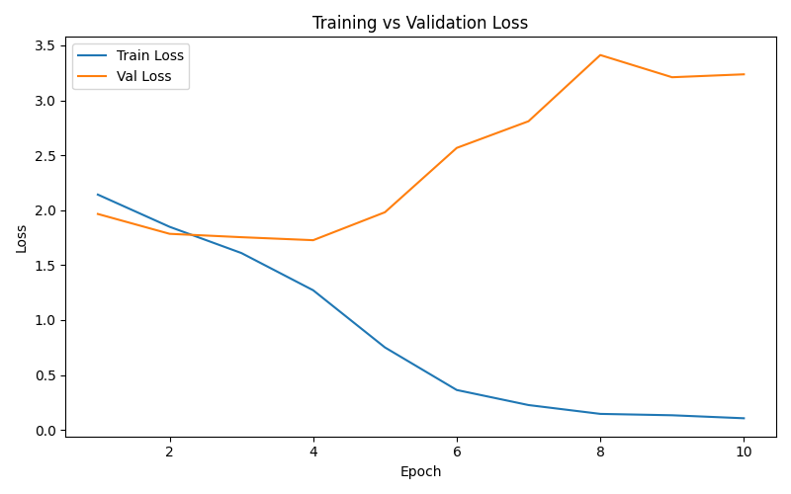
Figure 8 BaseLine Training & Validation Curve
Figure 8 BaseLine Training & Validation Curve shows that the loss rate of the model was improving which can be seen with the training and validation curves, however after approximately the 3rd epoch the model’s validation loss began to increase drastically with a sharp incline after the 4th epoch.
This indicates that the model is overfitting and thus will not be able to generalise to unseen data, the validation loss taking a slight dip at around 9 – 10 epochs, however still very high overall.

Training/Validation Accuracy

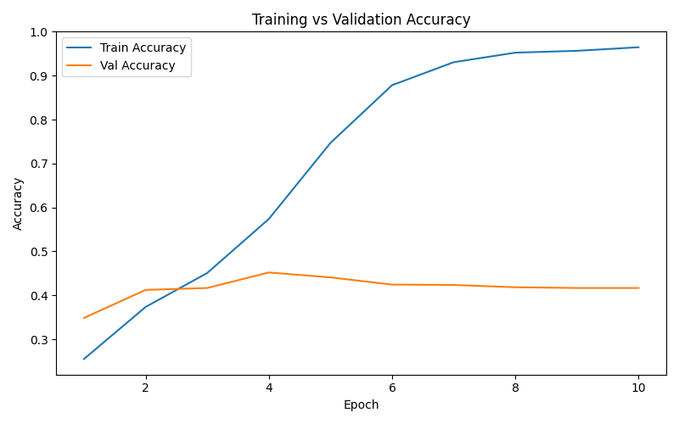
Figure 9 Baseline Training & Validation Accuracy
Figure 9 Baseline Training & Validation Accuracy shows how accurate the model is.
This indicates that validation (Orange Line) and training (Blue Line) are increasing steadily, however, like the loss graph, the model began to overfit after approximately the 3rd epoch where validation plateaued and did not increase further than 40% but training improved up to approximately 100%.
This shows that the model has overfitted to the training set.

What this shows is that the model is learning specific patterns within the dataset and is failing to generalise or identify new data efficiently, which results in the model correctly identifying fewer than half the images in the test data.

Confusion Matrix
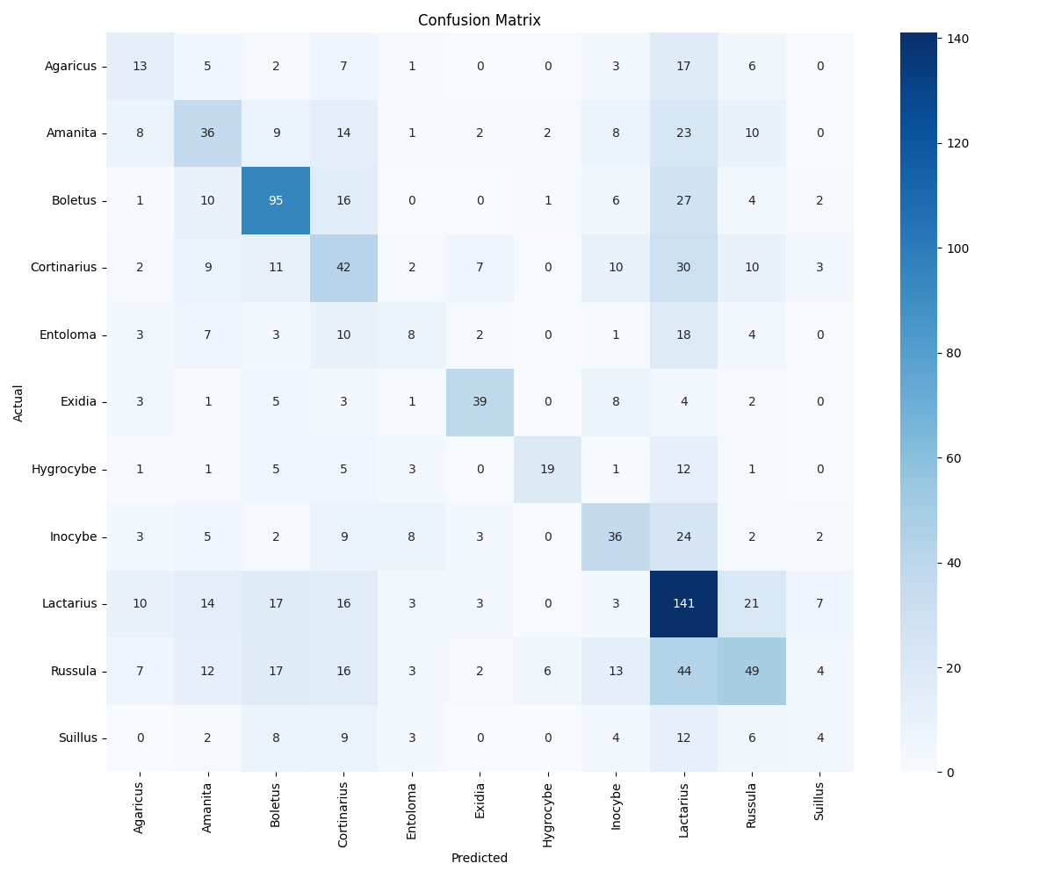
Figure 10 Baseline Confusion Matrix

Figure 10 Baseline Confusion Matrix clearly shows classes that the model was able to identify accurately, with Lactarius showing the highest rate at 141 correct predictions and the second highest class being Boletus.
This suggests potential bias within the dataset that would need to be addressed to ensure that fairness is upheld during the comparison of each model.

Key Observations
In this context, bias refers to the model identifying certain classes more than others as the above image shows the model is biased towards Lactarius this is not necessarily due to it being better, but because there are potentially more images within that class or the features are clearer more distinguishable features.
This can affect the comparison by skewing the analysis.

ResNet18 Evaluation

ResNet18 Training/Validation Loss
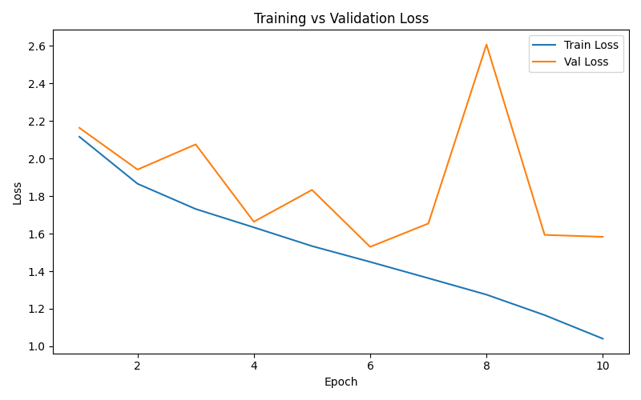
Figure 11 ResNet18 Training/Validation Loss
ResNet18 Training/Validation Loss graph shows how the loss adjusted across the training and validation data. The Training Loss (Blue Line) has a steady downward trajectory while the Validation Loss (Orange Line) is unstable even though the validation loss initially began to decrease on unseen validation data but with several spikes in the loss including a substantial spike that could suggest overfitting or sensitivity to the validation data.

ResNet18 Training/Validation Accuracy
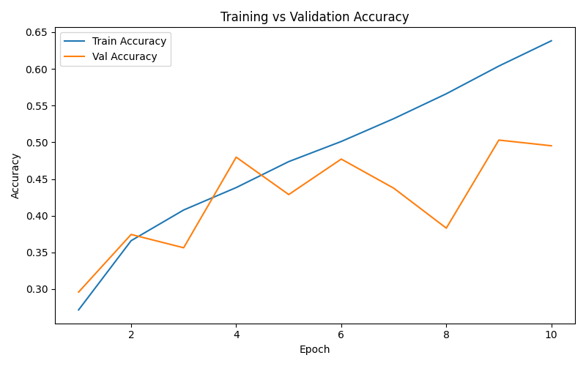
Figure 12 ResNet18 Training/Validation Accuracy
ResNet18 Training/Validation Accuracy graph shows how the accuracy of the training changed across each epoch, with the training improving steadily while the validation accuracy (Orange Line) fluctuating the gap becomes clearer as the training progresses; suggesting that the model is fitting the training data more effectively than generalising to unseen data.
This may indicate potential overfitting.

ResNet18 Confusion Matrix
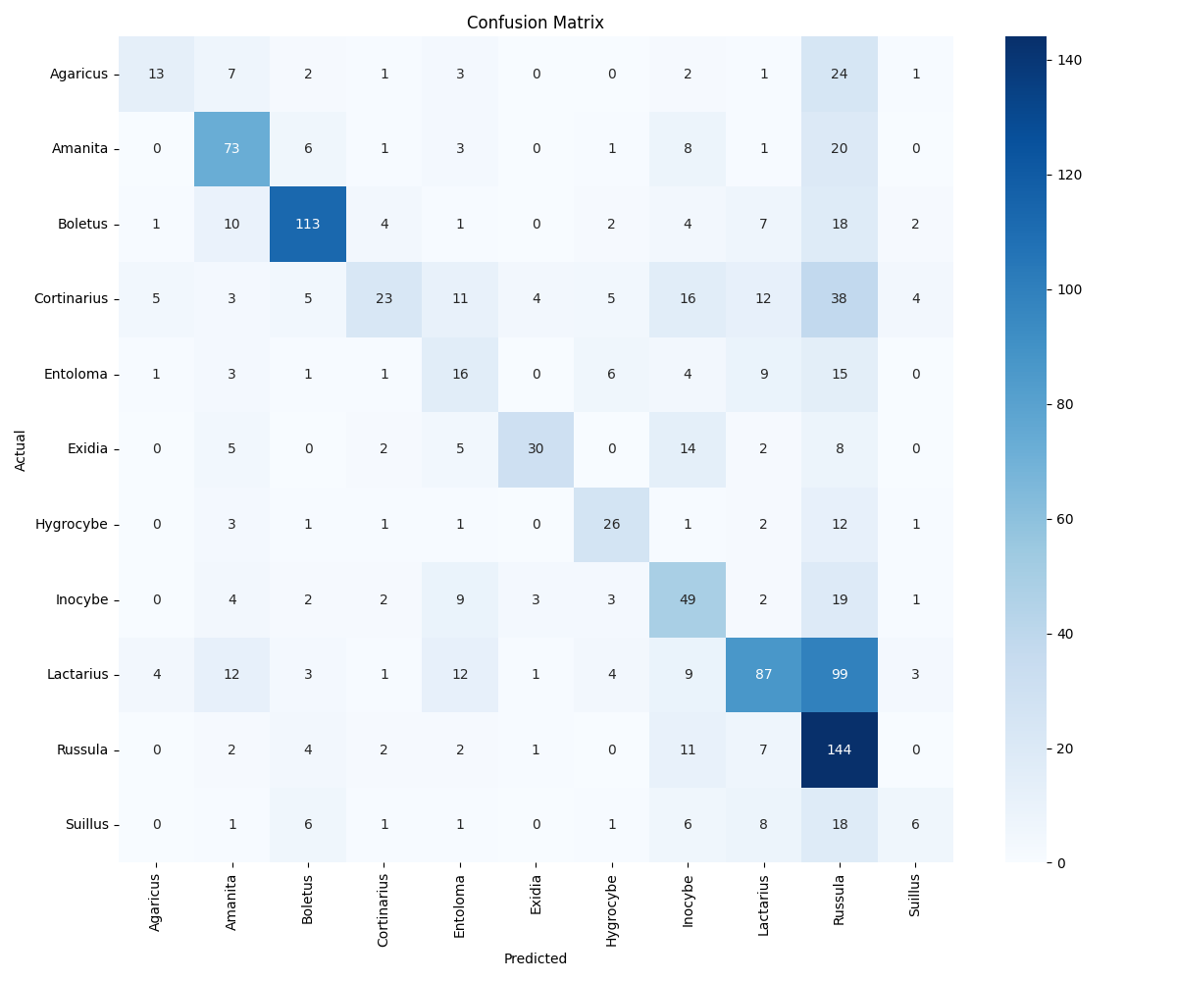
Figure 13 ResNet18 Confusion Matrix

The Confusion Matrix shows the number of correct and incorrect predictions for each class, with Russula and Boletus showing a higher number of correct identifications than others, however this may suggest a prediction tendency towards these classes.

However, there are key parts showing that the model struggled to correctly identify certain classes with 99 Lactarius having been misidentified as Russula.

This suggests that the model has generalised unevenly across the classes with some mushroom species being identified more effectively than others.

Key Observations

The model trained with the dataset steadily improving across the epochs; however, the validation results fluctuated becoming unstable especially near the end of the training, suggesting less stable generalisation.
Reviewing the model further I noted that the confusion matrix showed that some classes were identified better than others, suggesting that the performance was not consistent across the classes.
Comparing these results to the Baseline CNN the model showed clearly improved performance; however, the instability of the validation results mean it did not perform as strongly as it was first expected to.

MobileNetV2 Evaluation

Training/Validation Loss
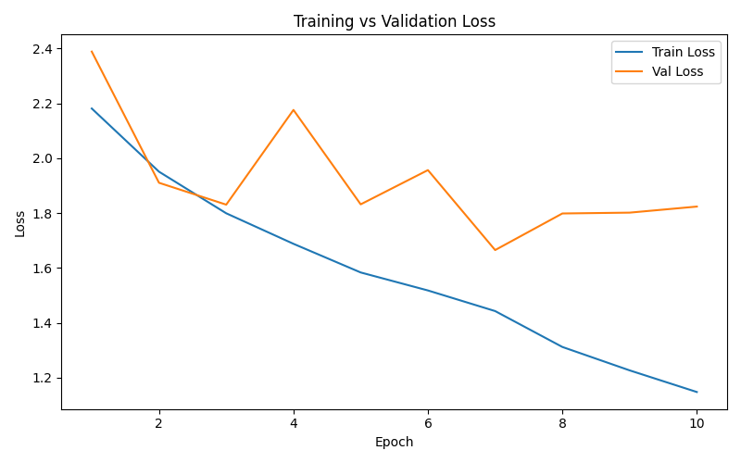
Figure 14 MobileNetV2 Training/Validation Loss
MobileNetV2 Training Loss (Blue Line) is decreasing steadily, suggesting that the model is learning from the data at a steady rate, however, the Validation Loss (Orange Line) is unstable with several fluctuations occurring around epoch 4. Although it improves later it does increase again towards the final epochs suggesting that the model is not generalising consistently to unseen validation data.

Training/Validation Accuracy
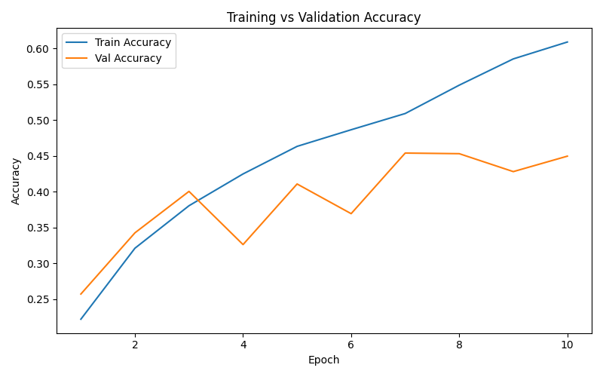
Figure 15 MobileNetV2 Training/Validation Accuracy
MobileNetV2 Training Accuracy (Blue Line) is increasing steadily, showing that the model is learning from the training data, however despite the validation accuracy improving in the early epochs, it begins to drop around epoch 4 suggesting unstable generalisation to unseen data, although it begins to recover towards the final epochs.

This shows clear inconsistencies in the model’s ability to identify the different classes of mushrooms.

Confusion Matrix
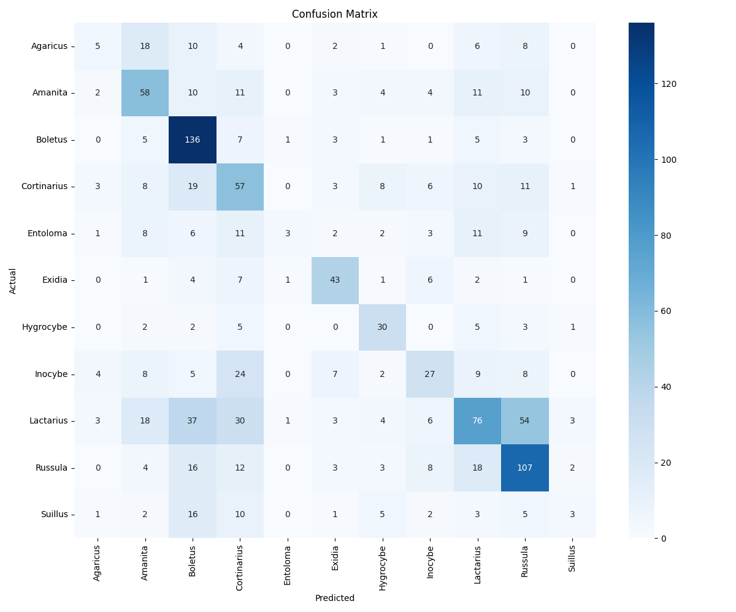
Figure 16 MobileNetV2 Confusion Matrix
Looking at the Confusion matrix, it shows the classes that had the highest correct predictions across the dataset, with classes such as Russula and Boletus showing a higher correct prediction counts, however there was some clear confusion specifically between Lactarius and Russula in which 54 Lactarius mushrooms were predicted as Russula.
This may be due to the visual similarities of these two classes.
This suggests uneven class performance within the model.

Key Observations
MobileNetV2 trained steadily at first; however, the validation results fluctuated more than expected.
The confusion matrix showed that, like the other models, MobileNetV2 had stronger correct prediction counts for Boletus and Russula, with both classes having correct prediction counts over 100 compared with other classes.
Overall, it was notable that MobileNetV2 performed better than the baseline despite this architecture being designed to be less computationally demanding.

Supplementary Pre-trained Model Testing
The results below have been included as part of supplementary findings during wider experimentation and testing and will not be included in the primary comparison of architecture models.

Model | Test Accuracy | Weighted Precision | Weighted Recall | Weighted F1-Score | Average Confidence | Notes
ResNet18 pretrained | 69.70% | 70% | 69.70% | 69.55% | 67.59% | Transfer Learning improved performance
MobileNetV2 pretrained | 73.11% | 73.27% | 73.11% | 72.68% | 67.56% | Highest results among all tested models
Table 6 Supplementary pretrained model results

ResNet18 Pretrained
Upon reviewing the results of the pretrained ResNet18 model there was a notable performance improvement over the from-scratch version with an increase of approximately 20 percentage points increase between the two models, the F1 score specifically improved strongly.
This suggests that the previously learned image features which were used by the pretrained model helped it to generalise more effectively to the mushroom dataset.

MobileNetV2 Pretrained
As can be seen in Table 6 Supplementary pretrained model results, the pretrained MobileNetV2 improved significantly over the from-scratch model having achieved the highest accuracy and weighted F1 out of all models tested, this was a notable result especially as the model is designed for computational efficiency.
The pretrained features likely supported in the model’s ability to identify image patterns more effectively

Why Pretrained Results Are Treated Separately
The from-scratch models provide a fairer comparison between architectures, whilst the pretrained models show the impact of transfer learning.
The pretrained models have already learned patterns and features from a larger external dataset; this gives an advantage to the models over the from-scratch models.
For this reason, the pretrained results are treated as supplementary findings rather than being part of the primary from-scratch comparison.
These results are still useful because they demonstrate how transfer learning improves model performance, these are not being used as the main basis for comparing the three core architectures in the final evaluation.

Primary Model Comparison
This section compares the three primary from-scratch architecture models used within this project of which included:
Baseline CNN, ResNet18 and MobileNetV2; all of which were trained using the same dataset, preprocessing approach, image size, batch size, learning rate and number of epochs to ensure consistency during this comparison.
The metrics that will be used across models include:
- Accuracy
- Precision
- Recall
- F1-score
- Confusion matrix
These metrics are derived from the stored data generated during model predictions, ensuring reliability and consistency across models.

Summary Comparison Table
Model | Test Accuracy | Weighted Precision | Weighted Recall | Weighted F1-Score | Average Confidence | Notes
Baseline CNN | 39.49% | 39.68% | 39.49% | 38.85% | 77.89% | Lowest performance; overfitting observed
ResNet18 | 49.36% | 55.38% | 49.36% | 48.26% | 61.15% | Strongest from-scratch model
MobileNetV2 | 46.38% | 45.49% | 46.38% | 43.32% | 61.71% | Better than baseline; slightly below ResNet18
Table 7 Primary comparison of from-scratch model results

Interpretation of Results
Looking at Table 7 Primary comparison of from-scratch model resultsseveral clear outcomes can be identified from the primary comparison of from-scratch model results.
The baseline model performed the weakest overall, with the lowest accuracy and F1-score. However, its high confidence did not result in better accuracy, which suggests that the model may be overconfident in its incorrect predictions.
ResNet18 had the strongest results showing some clear improvements over the baseline including weighted recall, F1-score, precision and the highest accuracy at 49.36% although its average confidence was the lowest.
MobileNetV2 showed notable results due to the fact it performed better than the baseline whilst being designed as a more computationally efficient architecture, although its results were slightly lower compared to ResNet18, the average confidence was the second highest.

Conclusion
The aim of this project is to investigate and compare the effectiveness of three different CNN models in terms of image recognition, assessing specific metrics per model to provide a deeper understanding of the strengths and limitations of each model.
Having split, prepared and cleaned the dataset into their respective sets, all three primary models were trained compared and evaluated using accuracy, precision, recall, F1-score, confidence and confusion matrices.
Upon reviewing the results of these models, it was notable that the ResNet18 model performed the strongest overall with MobileNetV2 outperforming Baseline CNN, although it remains below ResNet18. The Baseline CNN showed the weakest performance and signs of overfitting.

During this training there was additional supplementary experimentation involving pre-trained models. This showed that the use of transfer learning improved performance significantly, however these results are not used as the primary fair comparison.

Further work for the EMA will include a deeper analysis of the per-image results, ROC curves, scatter plots, and more discussion of misclassified images, alongside development of a simple prototype that is able to demonstrate the model’s prediction outputs when a mushroom image is uploaded.

LSEPI and EDI Concerns

There are several Legal, Social, Ethical and Professional Issues that this project raises, as well as Equality, Diversity and Inclusion considerations.
An ethics checklist was completed for this project (see Appendix 1 – Project Ethics Checklist) to confirm the project does not involve personal data or human participants while supporting the ethical review.
This project is using datasets sourced from Kaggle, a free publicly available website containing datasets of varying types and sizes.
The data has been used academically and in accordance with licensing and legal conditions. There are no data protection concerns due to the absence of personal data.

Some data biases and fairness issues to take into consideration include the potential for class imbalances where there may be an abundance of one class of images over another, which risks the model favouring majority classes that can skew the output results of each model.
To support fairness, the dataset was cleaned and split consistently across the models.
Unequal class representation for some classes was noted during evaluation. Which reinforces why accuracy alone is not enough and how other metrics are needed including confusion matrices, precision, recall and F1-score.
An EDI concern arises if the model begins to show uneven class performance; this may imply there is an imbalance within the dataset which might distort evaluation metrics.
This was addressed by going beyond accuracy as a metric to include aspects of the model such as precision, recall, F1-score. These provide a more balanced evaluation to the experiment ensuring transparent reporting to improve the reliability of the evaluation.
From an ethical perspective, AI image recognition models can misclassify images into the wrong groups; this is known as a false positive or false negative. This means that caution would need to be taken if this was to be deployed in real-world scenarios, especially as my project can lead to safety issues by identifying a mushroom as the wrong species.
What has been taken into consideration specifically is that this project is solely an academic piece rather than a diagnostic one.
To keep in line with academic integrity, all literature reviewed and referenced will be done in the Harvard citation style, the implementation of the models, interpretation and evaluation have been completed independently. The model implementation evaluation and interpretation were completed independently using PyTorch and the results have been reported on transparently without manipulation.
Pretrained models have been developed and reported on separately from the primary models this is to avoid presenting transfer learning results as directly equivalent.

Personal Development, Review and Reflection

I chose the ML Lifecycle because it is the lifecycle that suited my project progression most, although I did have to adjust it by removing certain steps that are not going to be included in my project.
I found that in the process of breaking the whole project down into steps this improved clarity of what I was aiming to achieve, giving me a more manageable scope allowed me to plan the project more efficiently, this also helped me reduce the risk of scope creep keeping my goals in line and realistic.
By breaking down the project into structured phases helped provide clear and concise steps.
This has all been organised and time allocated within a Gantt Chart.
Building on my knowledge gained from TM358 I investigated and worked towards building up my knowledge of ResNet and MobileNet architecture, improving my understanding of the vanishing gradient and learning about depthwise convolution which is used for MobileNet CNNs.
Having investigated a couple of papers I was also able to extract relevant information and concepts I applied and used to support my decisions during this project.
To ensure that my comparison remained fair, I controlled the hyperparameters for each model.
The dataset was cleaned, normalised and split consistently to reduce avoidable issues during training and evaluation.
I worked to improve my academic writing and explanations by adjusting my wording to be more precise and fixing grammatical errors and reducing fragmentation in my writing.
I have developed and used diagrams to show my ideas and roadmap as well as visual metrics such as graphs and matrices to substantiate my findings throughout this project from the training and comparison to the review and outcome.
Visual representations, including lifecycles, graphs and the GUI wireframe, helped improve the clarity of the project and made the results easier to understand.
This also helped me present complex ideas in a more accessible language.
I have found that so far this project has helped me improve my confidence in my ability to conduct and complete this project as well as improving my understanding of the architectures of the different models I implemented and the potential trade-offs that will ensure fairness and provide a desirable result.
Upon reviewing the results of the models, it was noted that the Baseline overfitted and performed the weakest out of all the primary models, whilst ResNet18 performed the strongest, MobileNetV2 performed below ResNet18 but better than the Baseline.
Supplementary pretrained models were developed and tested. However, they were reviewed separately from the primary comparison to maintain fairness and control complexity. These results showed the impact of transfer learning.
With support and guidance from my tutor I used the feedback provided to simplify my results and focus on stronger visual evidence.
ROC curves, pandas analysis and full GUI implementation will be developed further in the EMA.
Evidence of ongoing planning and reflection is documented in the project log extract provided in Appendix 2 – Project Log Extracts

Bibliography

Damle, A. (2022). Comparing the Performance of CNN and MLP in Image. Retrieved from a-damle: https://a-damle.com/project_files/mlp_vs_cnn/mlp_vs_cnn.pdf
Dosovitskiy, A., Beyer, L., Kolesnikov, A., Weissenborn, D., Zhai, X., & Unterthiner, T. (2021). An Image is Worth 16x16 Words: Transformers for image recognition at scale. Published as a conference paper at ICLR 2021, . Retrieved 04 21, 2026, from https://arxiv.org/pdf/2010.11929/100
He, K., Zhang, X., Ren, S., & Sun, J. Deep Residual Learning for Image Recognition. Retrieved from arxiv: https://arxiv.org/abs/1512.03385 (Retrieved 2026, 03 03)
Howard, A. G., Zhu, M., Chen, B., Kalenichenko, D., Wang, W., Weyand, T., . . . Adam, H. (2017). MobileNets: Efficient Convolutional Neural Networks for Mobile Vision Applications. doi:https://doi.org/10.48550/arXiv.1704.04861
Khasoggi, B., Ermatita, E., & Samsuryadi, S. (2019). Efficient MobileNet architecture as image recognition on mobile and embedded devices. Indonesian Journal of Electrical Engineering and Computer Science, vol. 16, no. 1,, 389. doi:10.11591/ijeecs.v16.i1.pp389-394
LeCun, Y. &. (2015, May 27). Deep Learning. Retrieved from Nature: https://www.nature.com/articles/nature14539

Appendix 1 – Project Ethics Checklist

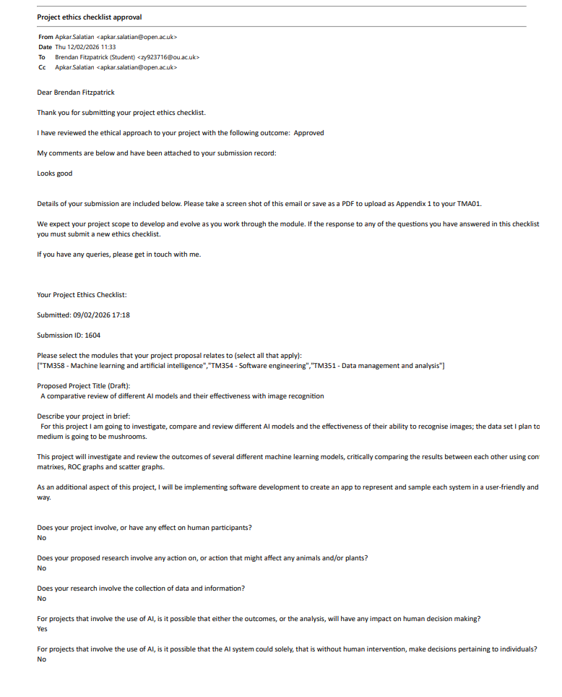

Appendix 2 – Project Log Extracts

Entry 1 – Project Topic Selection
During the early stages of this project, I explored several ideas before finally focusing on comparing different CNN architectures and their effectiveness for image recognition. This was later refined further after discussing it with my tutor focusing on the following, baseline CNN, ResNet and MobileNet models.
This is going to ensure that the project is kept achievable and meaningful.
With the project topic chosen I have found that narrowing the focus of the topic allows for a more focused workflow and more relevant decision making.

Entry 2 - Dataset and Experimental Focus
Once the project focus was decided upon, I began to investigate potential datasets and what would be the most effective and suitable for image and classification tasks. I selected a publicly available mushroom dataset provided from Kaggle as it provides a manageable size for this controlled experimentation.
During this time, I began to outline the criteria of what will be used to compare the models including accuracy, precision recall and computation efficiency.

With the different datasets available for this project it was decided, a dataset of roughly 7k images will be used opposed to a larger dataset of 83k images to keep in line with time constraints and computational limitations as this will still provide enough variety to make an informed comparison.

Although the larger dataset will provide a better opportunity to train the models it will potentially impact the project and cause issues such as training times and increasing the risk of bias and data issues.
Furthermore, the smaller dataset provides more concise control and is easier to manage overall.

I found that choosing the smaller dataset has ensured that there were fewer issues with the data leading to less time spent cleaning the data and more time preparing it for training.

Entry 3 – Literature Review
I began reviewing several key papers and documentation that are focused on Convolution Neural Networks, residual networks and MobileNet architectures. I then further updated my project title to better reflect the nature of this study. During this time, I identified several ethical and practical considerations which included the potential dataset bias, class imbalance and the risk of misclassification when applied to real-world scenarios.
The literature review it has allowed for a better understanding of the different architectures available and provided a basis for informed decision-making as to which models to choose for this project.

Entry 4 - Project Planning and Model Selection
To support the organisation and progress of my project, I created several graphs and workflows including a project lifecycle and Gantt Chart which included literature reviews, dataset preparation, model implementation and evaluation.
I finalised on the architectures that will be implemented during this project, choosing a baseline CNN, ResNet18 and MobileNetV2 to allow for a comparison between Standard, deep residual model and a computational efficient network design.
I have found that creating visuals such as Gantt charts and workflows, have kept me on track with my processes and next steps with this project.

Entry 5 – Dataset pre-processing
The chosen dataset was downloaded from Kaggle and stored securely; it was reviewed and split into the required sets.
70/15/15 ratio as follows:
70% Training
15% Validation
15% Testing
The images were processed by ensuring that the sizes were all standardized to the same size and useable. The dataset was then set up and provided to the model to begin the training, however, during the processing of the dataset it was found that one of the images were corrupted,
This image was found and removed from the dataset both the processed and the raw dataset to ensure that the models can train with the dataset moving forward.
I realise that no matter what pre-processing of the dataset is required there is always a potential risk of issues with the data.

Entry 6 – Baseline CNN Development.
The baseline model was developed and created using Python and PyTorch following the modified ML Lifecycle.
It was trained using the pre-processed dataset with minimal hyperparameter tuning such as 10 epochs, learning rate of 0.001 and a batch size of 32, the model generated relevant and usable data and charts such as a confusion matrix, accuracy and loss graphs.
Upon training the model it was noted that the model began to overfit quite early in the training.
Although I can potentially improve the models results by adjusting the settings, doing so could impact the fairness of the investigations.

I learnt that even if a model performs poorly, it isn’t always beneficial to improve on it and it depends on the end goal.

Entry 7 – Per-image output and ER Diagram

I decided that to add further depth and provide a better and more informed comparison of each model, it would be beneficial to compare each model’s results per image.

What this means is that I will be storing the results of each image per model focusing on metrics such as time, accuracy and predictions.

This will allow me to utilise skills learned from TM351 to analyse the data effectively, creating and organising the data into databases.

Planning was done using an ER diagram showing how the databases will be organised and connect to each other.

I learned that comparing the model’s metrics can provide an understanding of their ability to recognise images. Focusing on the individual results will give not only a better overview of the model’s abilities but will also show potential biases and what genus each model was most efficient at identifying.

Entry 8 – Meeting Feedback

Upon meeting with my tutor there were several areas that were discussed and reviewed from TMA 01.
The focus was to add additional evidence and reviews to help with understanding the goals and potential routes to be taken, there was mention of including wireframes and diagrams to add another level to the design of this project.
Providing screenshots of code and results will show the practical steps taken so far and ensure that there is clear progress with the investigation. Additionally adding a mention of implementation and use of databases, will showcase skills that were learned and applied from the Open University.

I have learned that providing clearer and more defined evidence of my progression and planning, is critical to making the project academically clear.
This is crucial as it shows anyone that reads the report the steps that were taken and the results in a visual way which is easier to understand; this has improved the flow of my report and broken the report up, so it is easier to read and review.

Entry 9 – ResNet18 and MobileNetV2 Development

ResNet18 and MobileNetV2 were developed and trained with the mushroom dataset ensuring the use of the same split, preprocessing and hyperparameters approach as the Baseline CNN. This was crucial in ensuring that the comparison was kept fair and focused on the differences between the architectures rather than the finetuning of the hyperparameters

An evaluation and review of the training and validation curves, confusion matrices and classification metrics for each model was completed. Notably ResNet18 showed the most promise with a stronger overall performance compared to the Baseline CNN, however MobileNetV2 did also show improvement over the baseline despite being designed as a more efficient architecture computationally.

During this time, I learned that accuracy alone is not going to portray a model’s performance effectively and efficiently. Additional evidence is needed including validation curves, confusion matrices, F1-Scores and per class classifications were needed to understand how each model behaved across different mushroom classes.

Entry 10 – Supplementary Pretrained Model Testing

Additional to the primary models I tested pretrained models of ResNet18 and MobileNetV2 in a supplementary experimentation. These models showed higher accuracy and clear advantages over the primary models this has helped to demonstrate the impact of transfer learning.
Though, it was decided not to include these pretrained models within the comparison as these models have already learned from a larger external dataset and including them would directly impact the fairness of the project.
This has aided in highlighting the importance of experimental control, I learned that stronger results are not always directly comparable if the training conditions are different.

Entry 11 – TMA03 Design Improvements and Final Review
After reviewing my Tutors feedback, I created and improved several visual representations for this project, including adding a clearer data-flow architecture diagram, pseudocode algorithms, a GUI wireframe, functional and non-functional requirements, and a testing strategy. These additions helped show the design and software engineering aspects of the project more clearly.
The pseudocode was created and added to show off the logic behind dataset preparation, model training and model testing/per-image output. The GUI wireframe was included to demonstrate how a user could upload a mushroom image and receive prediction outputs from the trained models.
This stage has helped me improve the structure of the report and made it easier to understand visually. It has also helped to separate work completed for TMA03 from work planned for the EMA including ROC curves, scatter plots, deeper per-image analysis and prototype development.

Appendix 3 – Email Communication

Meeting / Discussion 1 – Project Confirmation:
Date: 06 February 2026
During my initial meeting with my tutor, we outlined several potential ideas and routes that my project could take before refining it and deciding on a comparative investigation of CNN architecture.
We discussed the use of datasets and the risks that might occur as well as the potential of reduced complexity that might impact my overall project integrity.
Meeting Summary:
Title of you project can be something like 'A comparison of ML techniques to identify stars/mushroom (or something else) images'
You will get a dataset set of stars or mushrooms (or maybe something else) from Kaggle to train a set of ML algorithms (possibly CNN, random forest, k-nearest neighbour, SVM, naive bayes etc - perhaps the ones you choose are determined by what other people have done i.e. a literature review).
You will train the datasets using your chosen ML algorithms then apply it to another set of data to determine if they make the correct identifications.
I suggest you test your algorithms after training on a large data set (maybe 500) to determine how accurate each are - you can then present you findings in many ways e.g. ROC graph, confusion matrix etc and determine which is the best.
You will create an app where you upload a data item, and it will generate the results of each algorithm - this will allow you to present sample outputs of your system in the EMA. Given it is an app you can also include software engineering aspects to your project i.e. list functional and non-functional requirements in your reports

Meeting /Discussion 2 – Project Progression:
Date: 20/02/2026
During this meeting we discussed any additional aspects that might be needed in my project what I could focus on and how I could improve my overall assignment

Meeting 3 Summary:
This is a summary of the meeting today which hasn't been covered in my last email:
- Need a data flow architecture which show the transformation of Kaggle i.e. clean, train, identify - show this in diagram form
- Need architecture for mobile app - could be MVC (model view controller) - show this diagram form
- Need wireframes for mobile app design
- Need discussion of your 3 CNN algorithms (ideally based on a literature review)
- Need to refer to your previous OU course and what knowledge you will extend
- Need a Gannt chart
- Need list of functional and non-functional requirements
- Perhaps need a use case diagram
- Need to state testing strategies (forgot to mention this in meeting)

Meeting 4 Summary:
Date: 16/04/2026
During this meeting it was discussed that I would need to improve in a few areas from TMA 01 these included:

- Providing additional literature to review architectures that are not suitable for this project

- Add additional wireframes to cover design of my next steps such as ER Diagram

- Discuss aspects of the databases that will be used

- Add snippets of code and other outputs to show progress and practical work having been conducted.

- Finish my evaluation.

Meeting 5 Summary:
Date: 06/07/2026
This is a summary of the meeting today which has not been covered in my previous notes:
• Need to make the system architecture clearer by showing the underlying processes behind the diagram.
• Each key process in the architecture should be supported by pseudocode, an algorithm, or a process diagram.
• Add pseudocode in an if / else style to show the logic behind dataset preparation, model training, and model testing.
• Add references on the data flow diagram to show which algorithm supports each process.
• The results section should be simplified so that the key findings are easier to understand.
• Use image-based examples to support the statistics, such as one correct prediction and one false positive or incorrect prediction for each main model.
• Need to explain the results in clearer layman terms so that someone without detailed AI knowledge can understand why one model performed better than another.
• Include a GUI or wireframe to show the practical use case of the project, where a user uploads a mushroom image and receives prediction outputs from the models.
• The pretrained models can be included but should be treated as supplementary learning or self-study rather than part of the main fair comparison.
• ROC curves, scatterplots, deeper pandas/per-image analysis, and full GUI implementation should be developed further in the EMA.
• Need to ensure the report clearly separates completed TMA03 work from planned EMA work.

Appendix 4 – Extended PROMPT Source Notes.

Source | PROMPT Evaluation | How it Influenced the project
LeCun et al. /Deep Learning | Although this source is a lot older than some other sources that were read, it remains relevant because it covers the foundations of CNNs and deep learning. This is a credible source because it is an academic/scientific publication which discusses widely used principles that are still relevant in terms of image recognition. While it does not specifically focus on mushroom classification, it does provide a clear understanding of CNNs which is useful for this project, including why CNN-based models are suitable for image recognition tasks. | This paper influenced the decision to proceed with using CNNs as a starting point for comparison, providing a clear foundation against which ResNet18 and MobileNetV2 could be evaluated.
He et al. / ResNet | This paper is a credible scientific publication that introduces residual networks and explains residual learning where information can bypass one or more layers during training by implementing skip connections.  The source explains how it improves deep learning architectures, and the issues that deeper CNNs have such as the vanishing gradient and training/degradation issues making them harder to optimise; however, ResNet18 helps mitigate these issues.  Although the source is older, it remains valid this is because ResNet is still widely used as a CNN architecture. Although this is not a publication focused on mushroom-specific image recognition its relevance is more based around the architecture than the dataset specifically. | This source aided in the decision making allowing me to justify choosing ResNet18 as one of the primary CNN architectures in my comparison; giving a more in-depth understanding of skip connections and the impact they have on the neural networks compared to a standard Baseline CNN.
Howard et al. / MobileNet | This is a credible academic source which introduces MobileNet as an architecture which was designed for efficient image recognition.  It further explains how this architecture works, introducing depthwise separable convolution, in which the convolution is split into separate stages therefore reducing computation cost compared with larger CNN model.  One of the reasons this is relevant is because my project compares not just accuracy but also the trade-off between performance and efficiency.  Although this paper is older than some newer papers it is still relevant because MobileNet-style efficient CNNs are still used in lightweight image recognition tasks.  Even though this is not based around mushroom classification specifically it is still relevant as it is mainly about architecture and efficiency.  This is because models may have to balance accuracy against speed or lower computational cost. | This helped me justify choosing this architecture as a comparison point against both ResNet18 and the Baseline CNN.  This influenced me to consider not just model design and accuracy but also efficiency thinking about comparison and evaluation especially where computational resources may be limited.
Damle / CNN vs MLP | This source is relevant to my project because it compares CNN and MLP performance supporting the idea that CNNs are the better choice for image recognition tasks.  One thing to note in terms of MLP is that it is weaker for image recognition because it does not preserve spatial structure in the same way that CNNs do.  Even though it is not mushroom-specific this source is still useful for comparing different image classification approaches. | What was gathered has helped justify not using MLP for a primary model architecture and has supported my decision to keep the project focused on CNN-based models.  This has further strengthened my scope control by providing clear reasoning to not use another model architecture.
Dosovitskiy et al. / Vision Transformer | Whilst reviewing the Vision Transformer source it was noted that this is a credible academic paper and relevant source that expanded on other potential architectures outside of CNNs providing a different approach to image recognition however, Vision Transformers rely on large datasets and/or pretraining to perform strongly.  However, since my project is using a smaller controlled dataset the focus on CNN architectures is stronger. | This has helped me justify excluding vision transformers from primary models because of the amount of data required to get the structure to a point that is fair and reliable helping to reduce the risk of increasing the complexity of the project.
Table 8 Extended PROMPT source evaluation notes

