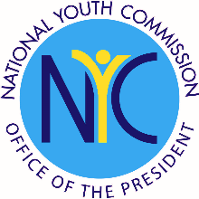
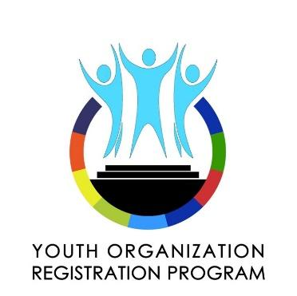
Office of the President of the Philippines
National Youth Commission
“The Voice and Advocate of the Youth”

YOUTH ORGANIZATION REGISTRATION PROGRAM
Directory of Officers & Advisers

Please attach a clear scanned copy or photograph of a valid identification card of head of the organization following the prescribed template below in order to speed-up the verification process. You may add rows if necessary.
POSITION | NAME  First Name, Middle Initial, Surname | AGE | SEX* | GENDER IDENTITY** | ADDRESS  Barangay, City/Municipality, Province | PERSONAL E-MAIL | CONTACT NUMBER  09XX XXXX XXX
ADVISERS
* Sex assigned at birth (M for male, F for female)
** Gender identity (L for lesbian, G for gay, B for bisexual, T for transgender, Q for queer, I for intersex, M for male and F for female)

Please attach digital copy of the identification card of the head of organization.

Name:

Position:

IDENTIFICATION CARD (FRONT)
IDENTIFICATION CARD (BACK)

