LARAVEL

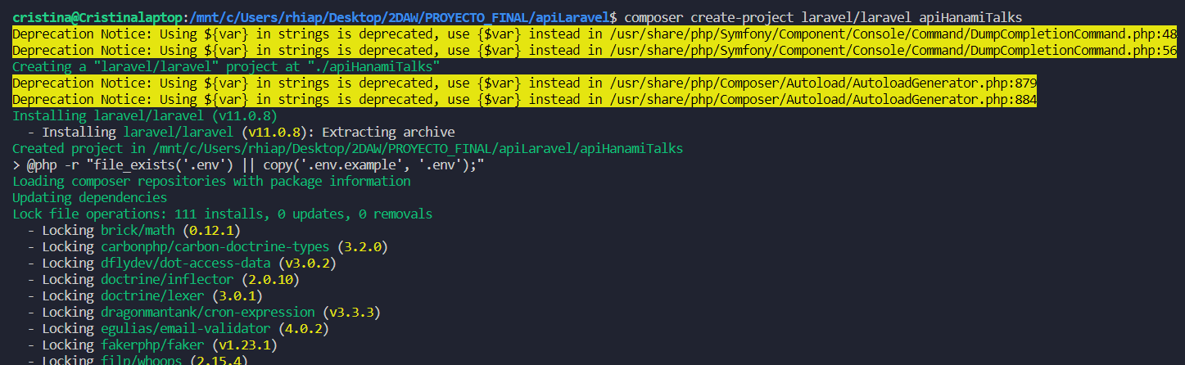

LARAVEL/SANCTUM

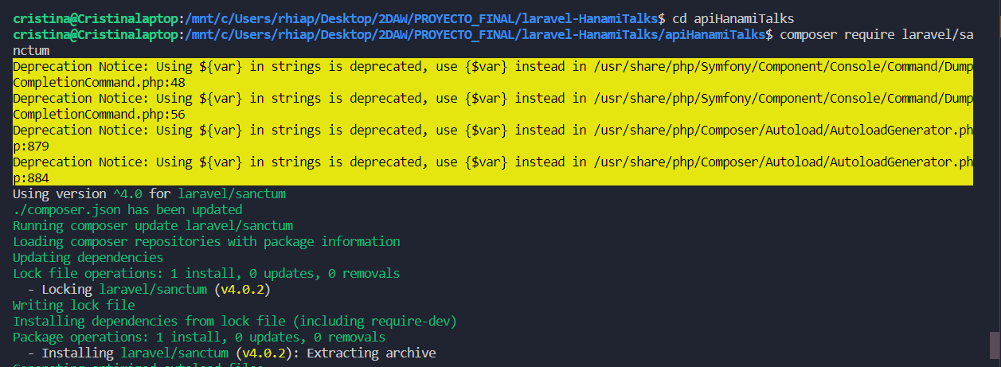

SAIL

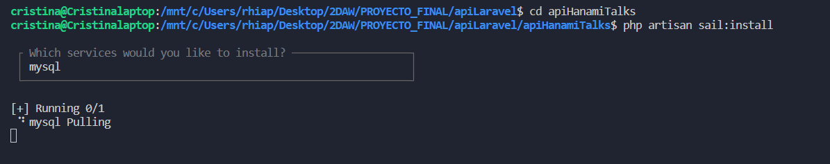

NPM

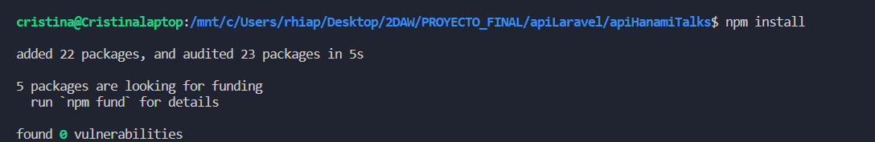

SAIL UP



MIGRACIONES