**CHAPTER 1**

**PROJECT AND ITS BACKGROUND**

**PROJECT CONTEXT**

The Philippines has an abandoned children problem. About 1.8 million children in the country, more than 1% of its entire population, are “abandoned or neglected”, according to United Nations’ Children’s Rights & Emergency Relief Organization. Some are victims of extreme poverty; others of natural disasters and armed conflicts in the country are riven south.

The Department of Social Welfare and Development (DSWD) is responsible for ensuring that many of these children find homes. (Some end up overseas – American families adopted 1,350 Filipino children between 2009 and 2015, according to U.S. Department. Yet the country’s adaptation bureaucracy is forbidding that scores of aspiring adoptive parents are left in the cold, and abandoned children left to grow up without parents.

The Philippine constitute recognize that there are children that need to be observe regularly, taken care and have a better future for themselves. The Department of Social Welfare and Development (DSWD) is a government agency that helps the foster kids or children of every municipality in the Philippines. Normally the DSWD of the distinctive regions particularly in provincial areas manually keep foster kids records, activities, articles and law with respect to adoption, and application forms. A few districts have taken their own particular activities to set up computer file-based system, stand-alone systems and local area network facilitated system.

Regardless of the said systems, provided only limited access to the foster kids information or database only a few region or urban communities are able to establish their individual DSWD sites by just giving just static data and downloadable forms. In totality, there is no specific responsive and interactive system that can combine big data about the foster kids records or data, figures, reports, news plan and exercises in the Philippines.

The thrust and priorities of LSPU System in accordance to directions set forth in the National Education Research Agenda 2, which support the higher education sector’s goal to develop high level and globally competitive workforce, generate/ transfer knowledge and technology for enhancing productivity and quality of life, which the following thrust arid priorities are adopted. This conducted research is balanced attention to basic and applied research shall be given due importance.

**PROJECT DESCRIPTION AND PURPOSE**

The said web-based application is to be utilized as a tool upon secure and easy processes of adopting a child from foster homes around the premises of the 4th District of Laguna and for the foster parents to have ease upon looking for children that are willing and also for them to know what the legal processes are upon adopting children. It also aims to ensure the safety of the said children upon living with their foster families.

The researchers think and organized the advancement and development of innovation to help the Municipal Social Welfare and Development Office and Non-Government Organizations. The proponents conduct an interview on MSWDO (Municipality of Mabitac, Laguna).

**PROJECT OBJECTIVES**

**General Objective**

To develop a web application portal for the Municipal Social Welfare and Development Office Adoption and Foster Care Unit and for the foster parents to have ease upon locating orphans for them to adopt through the use of the internet that is commonly used today.

**Specific Objectives:**

1. To design a system for the Municipal Social Welfare and Development Office with the following capabilities:
2. Consolidate reports and update the records of the orphan members of the communities in a distributed database;
3. Communicate with the orphans regarding their current situation after being adopted.
4. To construct a user-friendly web-based management system that will handle and transact all the data of orphan children.
5. To determine a child’s eligibility for issuance of CDCLAA (Certification Declaring a Child Legally Available for Adoption) and facilitate its issuance when recommended.
6. To facilitate the permanent placement of a child that is eligible for adoption.
7. To help certain agencies regarding the process of adopting children to be more easy.

**CONCEPTUAL FRAMEWORK**

As a foundation of the foregoing concepts, theories and findings of related literature, studies presented, and insights are taken from them, a conceptual model was applied as a shown on the next page.

Figure 1 shows the basis for the study of the “Development of Portal for Municipal Social Welfare and Development Office Adoption and Foster Care Unit”. The conceptual framework is made out of input, process, output, and the evaluation components. Input is something from the external environment that is fed into the system. The Input components are consists of knowledge requirements development techniques or methodologies where Analysis, Design, Code, Testing, Maintenance, and Deployment of the proposed system takes place. Software requirements to use and see the hardware necessities to make and run the framework. Then the output components demonstrate the outcome of the proposed system.

**OUTPUT**

**PROCESS**

**INPUT**

Development of Portal for Municipal Social Welfare and Development Office Adoption and Foster care Unit

**KNOWLEDGE REQUIREMENTS**

* Web development
* Development methodology
* Database Management System

**SOFTWARE REQUIREMENTS**

* PHP programming language
* Adobe Photoshop
* Web browser
* HTML programming
* MySQL

**HARDWARE REQUIREMENTS**

* Laptop
* Access point/Router

Survey Interviews

Planning

Designing

Development

Rapid application development

Testing

Evaluation

**Figure 1. Conceptual Framework**

**SIGNIFICANCE OF THE STUDY**

The study aims to help the orphans to have a permanent and suitable family that will provide their needs. Almost all has an access with the internet that’s why it is easy for the individuals to access the web-based application. The system is a user-friendly and can also serve as a connection between the foster homes and the individuals that is willing to adopt.

The study also aims to create the web-based application to be a trustworthy and area precise platform upon giving the orphans the proper nurture and homes as well as for the adoptive parents to have ease upon locating where the specified adoptee is located.

**Municipal Social Welfare and Development Office (MSWDO).** For the system to help manage the data both of the children and their possible adoptive parents to make processes secure and for it to be easy.

**Foster Care Center** to ensure the safety of the children from the adoptive parents who have the capabilities of giving them support once they were released from their care.

**Foster Parents** for the process of adopting can be accessible through simple devices that can bring ease to the usual hassle way of adopting.

**Future Developers** forthe future developers to gain some thought on how to enhance the system and can have additional perspective on the development process related to the system.

**SCOPE AND LIMITATIONS**

This study involves the development of dynamic web application services employing responsive and rapid application development. It deals with the consolidation of foster kid’s information in different municipalities in 4rth District of Laguna. The system will have children’s record, articles and law for adoption, report archiving, activity monitoring, requirement/supporting documents and process/procedures. It will also assist foster parents and foster homes to make the process of adoption much faster and all background and information that is needed that will be stored in the system. The main focus of the study or development is to make use of the available programming tools in enhancing or improving the management transactions of the municipal social welfare and development office.

The limitation of the study entitled “Development of Municipal Social Welfare Development Office Adoption and Foster Care Unit" is that it just spotlight on the data (reports, forms, and occasions) inside the premises of various towns on the 4th District of Laguna.

The study also limits itself to be a tool that will serve as an index or an easy way of finding children to adopt and for the possible foster parents to have ease on finding children and to enlighten them where they can find them. But the other legal processes regarding adoption will not be under the use or influence of the said web-based application.

**PROJECT DEFINITION OF TERMS**

In order for this study to be understood easily. Here are a portion of the familiar and unfamiliar words expressed in the study which are characterized operationally.

**MSWDO** refers to the organization that will handle the system.

**FOSTER CARE UNIT** is a system enabling a child without parental support and protection to be placed with a person or family to be cared for, usually by local welfare services or by court order. The foster parent(s) do not have custody, nor is there an adoption, but they are expected to treat the foster child as they would their own in regard to food, housing, clothing and education. Most foster parents are paid by the local government or a state agency.

**PHP** is a recursive acronym for Hypertext Protocol and also an HTML-embedded Web scripting language.

**HTML** or Hyper Text Markup Language refers to a language for creating documents on the World Wide Web by using a variety of tags and attributes.

**WEB BASED APPLICATION** is any program that is accessed over a network connection using HTTP.

**MySQL** is an Oracle-backed open source relational database management system based on Structured Query Language.

**ACCESS POINT** is a device, such as a wireless router, that allows wireless devices to connect to a network.

**WEB DEVELOPMENT** is the work involved in developing a web site for the Internet or an intranet.

**HTTP** or Hypertext Transfer Protocol is the underlying protocol used by the World Wide Web and this protocol defines how messages are formatted and transmitted, and what actions Web servers and browsers should take in response to various commands.

**CHAPTER 2**

**REVIEW OF RELATED LITERATURE AND STUDIES**

**Introduction**

This chapter shows the related literature and related system that give a reliable source which the proponents perceived relevant to the conduct of their research.

**Adoption**

According to Townsend (2009) and by Harvel (2006) children who lack parental care have long been a matter of concern. Children in such circumstances have typically experienced significant early life adversity and face many challenges in their development. It can be difficult to make sense of the numerous contradictory beliefs that exist among professionals, policy makers, and the general public about looked-after and adopted children, and to separate fact from fiction and there has not been much systematic research on open adoption. This practice involves anything from sharing non-identifying information through an intermediary to regular face-to-face fully identifying information-sharing and contact between all members of the adoption triangle — the birthparent/s, the adoptive parents and the adoptees. Open adoption appears to offer birthparent/s the greatest benefits. Although adoptive parents express varying degrees of positive reactions to being involved in open adoptions, there are instances of discomfort and reservations expressed by some. With no studies investigating adoptees' own perceptions around contact with their birthparent/s, the potential risks and/or benefits of open adoption for the children involved, is inferred from adoptive parents' reports and theoretical perspectives. Adoption practitioners advocating openness in adoption should be prepared for additional investments in time, effort and emotional energy in order to facilitate what is not a discrete event in time, but an on-going process.

Based on article written by Child Welfare Information Gateway (2012) foster parents are the most important source of adoptive families for children in the child welfare system. According to the Adoption and Foster Care Analysis and Reporting System (AFCARS), in fiscal year 2011, 54 percent of children adopted from foster care were adopted by their foster parents (U.S. Department of Health and Human Services, 2012). Data from the 2007 National Survey of Adoptive Parents (NSAP) and the 2007 National Survey of Children’s Health (NSCH) show that among children adopted from foster care by nonrelatives, 8 out of 10 (80 percent) were adopted by their foster parents (Office of the Assistant Secretary of Planning and Evaluation, 2011).

**Foster Care**

However it is already given that there are a lot of children here in the Philippines specifically in the highly urbanized areas that needs foster care. Being left out in the streets by their parents to ask for alms and loiter around roads selling things and worse getting influence into using dangerous drugs that can lead to severe psychological damages and death. These kids are those who needs care from parents and clearly their parents cannot provide due to poverty or the simple fact that they are not yet that mentally ready and prepared to handle children of their own. This is the part where foster care and the agencies both government supported and NGOs comes in. Giving the nurture and support the kids deserve to get from their biological parents. Below are the statements to support foster care and to the units that can provide them.

Wiseman (2008) stated that Foster care can be provided in a variety of settings including: pre-adoptive homes, group homes, institutions, supervised independent living, and foster homes provided by both relatives and/or non-relatives. It is also refers to 24 hours substitute care for all children placed away from their parents or guardians and for whom the State agency has placement and care responsibility.

Queen’s University Belfast; Harkin and Houston (2016) cited that young people in long-term foster care are at risk of experiencing poor social, emotional, behavioral and educational outcomes. Moreover, these placements have a significantly greater chance of breaking down compared to those involving children. This article critically evaluates the factors associated with this particular outcome. The findings evidenced that, apart from overriding safety concerns, placement breakdown was not a one-off event but rather a complex process involving the interplay between a range of dynamic risk and protective factors over time, operating in the wider context of the young person’s history and life experiences.

Luke and Seba (2014) declared that parent-and-child fostering represents a small but significant proportion of the fostering landscape. This type of specialist foster care is offered to support and assess vulnerable families from the community whose custody of their children is under threat, as well as teenagers who become parents while already in care. It is an option alongside alternatives such as parent-and-child assessment units and supported housing schemes. Service providers selecting foster care for their parent-and-child provision need to know that it is effective in producing the post fostering outcomes that are in the best interests of the child. These outcomes might include an increased likelihood of parent and child staying together, promoting skills in independent living and increased understanding of children’s needs; equally, a decision to separate the child from their parent can be seen as a ‘good’ outcome, provided the assessment is transparent and produced in good time, allowing the child to move to a permanent living arrangement without undue delay.

**Foster Parents**

De Wilde (2019) stated that [Foster care](https://www.sciencedirect.com/topics/social-sciences/foster-care) is currently preferred over institutional care when children are in the care of the state. There seems to be a consensus on the voluntary origins of foster care, nonetheless there also seems to be a growing momentum for the [professionalization](https://www.sciencedirect.com/topics/social-sciences/professionalization) of this form of youth care. We contribute to the debate by means of an analysis of 33 [semi-structured interviews](https://www.sciencedirect.com/topics/social-sciences/semi-structured-interview) with [foster families](https://www.sciencedirect.com/topics/social-sciences/foster-family) in Flanders, exploring the tensions between voluntary and professionalizing tendencies in foster care. [Foster parents](https://www.sciencedirect.com/topics/medicine-and-dentistry/foster-parent) overall labelled themselves as loving volunteers as this creates a space to fail. Yet, they also appropriate themselves a specific know-how necessary to make educational decision concerning the child. Foster parents oscillate between the position of professional and volunteer, as becomes clear in discussions on how the [foster child](https://www.sciencedirect.com/topics/social-sciences/foster-child) should name its foster parents, as well as in how foster parents conceptualize the past of the foster child, metaphorically conceptualized as its backpack. The search for the ‘right name’ and ‘the backpack’ metaphor illustrate the inescapable complexity of the foster placement. Conclusions on the nature of foster care are related to the conception of ‘the parent’ and ‘the nuclear family’, as well as to what shared [upbringing](https://www.sciencedirect.com/topics/social-sciences/child-rearing) may bring to the discussion.

In relation to that Miller (2019) said that [Foster parents](https://www.sciencedirect.com/topics/social-sciences/foster-parent) play a critical role in the lives of youth in [foster care](https://www.sciencedirect.com/topics/social-sciences/foster-care), experience myriad [stressors](https://www.sciencedirect.com/topics/psychology/stressors), have high rates of turnover and in turn the [child welfare](https://www.sciencedirect.com/topics/social-sciences/child-welfare) system ultimately over relies on relatively small numbers of [caregivers](https://www.sciencedirect.com/topics/social-sciences/caregiver) to care for the majority of [foster children](https://www.sciencedirect.com/topics/social-sciences/foster-child). While there is a small literature that includes an examination of how foster parents care for themselves and maintain their well-being, to date there is only one study that has primarily examined foster parents' [self-care](https://www.sciencedirect.com/topics/psychology/self-care). The purpose of the current article is to highlight the need for greater attention to foster parent self-care and integrate the research literature about foster parent stressors and self-care to propose a conceptual model of foster parent self-care. This [manuscript](https://www.sciencedirect.com/topics/social-sciences/manuscripts) describes the stressors faced by foster parents to illustrate the need for greater attention to foster parent self-care. It then proposes a conceptual model that seeks to expand the notion of self-care beyond a set of practices to an understanding of self-care practices as the result of internal and external factors that contribute to or inhibit foster parent self-care. The authors make recommendations for foster parents, researchers and agencies interested in improving the [health and well-being](https://www.sciencedirect.com/topics/social-sciences/health-and-well-being) of foster parents.

**Monitoring System**

Monitoring system is very important in terms in record keeping used in school or business transaction, to secure all information and avoid the record redundancy or lost data information because the manual process, but using computerize this problem is removed from the easy, faster and not time consuming system for the good result transaction.

Barredo (2011) cited that registration system is important for students to allow update the information especially in billing we need update from student to the system, responsibility pay he/she account and organizational performance. Monitoring information these important aspects through automation has made things better and simpler for managers. Rather than manually, the system is easy to used. With the use of automation systems to the gathered information and to update the information of the student. Through this system, the resources information of the student needed for the tracing, monitoring and updating information on time.

**Management System**

According to the Republic Act No. 10175 known as the Cybercrime Law (2012); The State recognizes the importance of providing an environment conductive to the development, acceleration and rational application and exploitation of information and communications technology (ICT) to attain free, easy and intelligible access to exchange and/or delivery of information; and the need to protect and safeguard the integrity of computer, computer and communications systems, networks, and databases, and the confidentiality, integrity, and availability of information and data stored therein, from all forms of misuse, abuse and illegal access by making punishable under the law such conduct or conducts.

**Hyper Text Markup Language**

Same with Su and Saskachewan (2006) the Internet is a huge information Centre consisting of billions of web pages. The Hyper Text Markup Language (HTML) is perhaps the most popular specification for constructing web pages on the Internet. Methodologies have been developed to search and query HTML web pages. Search engines such as Google can match given keywords on web pages and identify the most relevant pages. However, search engines can only match keywords and are not able to query web pages in the same manner that one can query databases. Query languages can specify requests for retrieving information by treating web pages as semi-structured data on which to perform queries, but previously existing data models for query languages either cannot capture the hierarchical structure within an HTML web page or can only present the structure at a low level.

**PHP (Hypertext Pre-processor)**

Parallel to the study of Kunda and Siame (2017) some of the research work done in the evolution of PHP applications that have been around and are bvastly used. PHP is currently one of the most popular programming languages, widely used in both the open source community and in industry to build large web-focused applications and applications frameworks. This review looks at how PHP applications object-orientation paradigm, the evolution of complexity and security. The results suggest that these systems undergo systematic maintenance and evolution is helping the underlying programming language to grow.

By means of Kumari and Nandal (2017) their research discussed the various useful tools and techniques that are used in a development of a website. We also discuss about the procedure follow in a website, mostly focused on a local host named Xampp tool .Next, we compare different development frameworks web application. In addition, we discuss life cycle model and framework development of web application. In this report, various review papers result also included for understanding of problems can be facing by the users. This Paper tells about the technologies used in this development, PHP and explained in result its functionality with Xampp with screenshots. It is hoped it will gives a useful framework for guiding the process.

**CHAPTER 3**

**PROJECT METHODOLOGY**

**PROJECT DESIGN**

In creating and developing the system, the proponents conducted a research, group discussion and library works to gather data and information. The researchers also identified all necessary software and hardware devices that can contribute in creating the system. Then gathering the relevant information and preparing software and hardware devices.

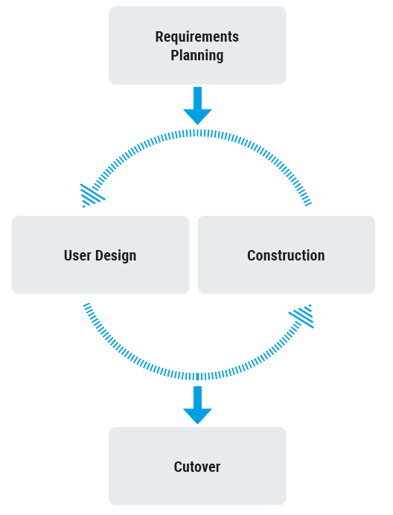**MODELING PROCESS**

**Figure 2. Rapid Application Development**

As shown on figure 2. Rapid Action Design was utilized to show how the system was built. The researchers conducted initial investigations about the aim, purpose and the background problems of the researchers’ project to find out as much as they can about it. The initial of the investigation of requirements will be used as primary basis upon prototyping the whole system and show to the users (adoptive parents) for their suggestion and evaluation thus filling out the questions on where to adjust or put features for their satisfaction. Then the researchers will start the designing and development of the system from gathered user’s requirement. After the researchers will then test the whole system for bugs and other malfunctions for the system to be revised and produce minimal errors. Then the researchers will now start implementing the developed system.

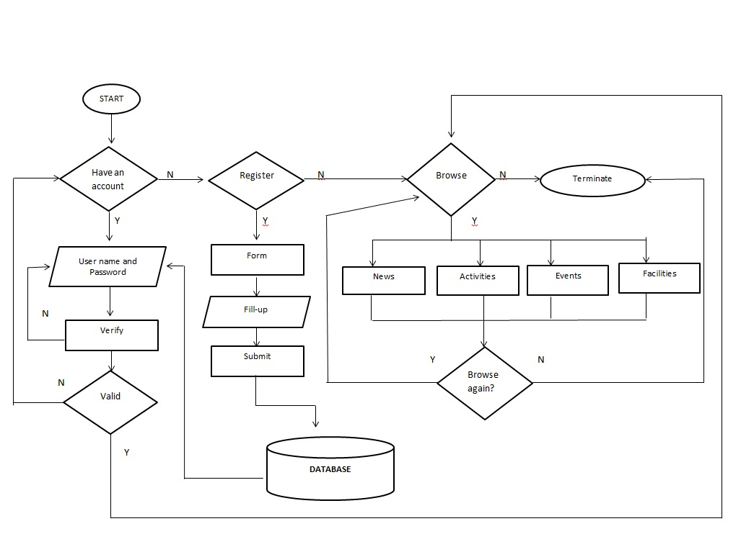

**Figure 3. Flowchart (Guest)**

Figure3. Shows the system’s flowchart for Guest users of development of portal for municipal social welfare and development office adoption and foster care unit. The following flowcharts indicate how the system for having an account and being a guest of the application works. Starting from asking if the certain application user wants to have an account so that the database of the application will store the details an information they used to apply then they will have the advantage of browsing the index of several orphans to be possible foster parents or to just browse freely at the application as guest which will not get information to store at their database and only be granted to the news and gallery section of the web-based application.

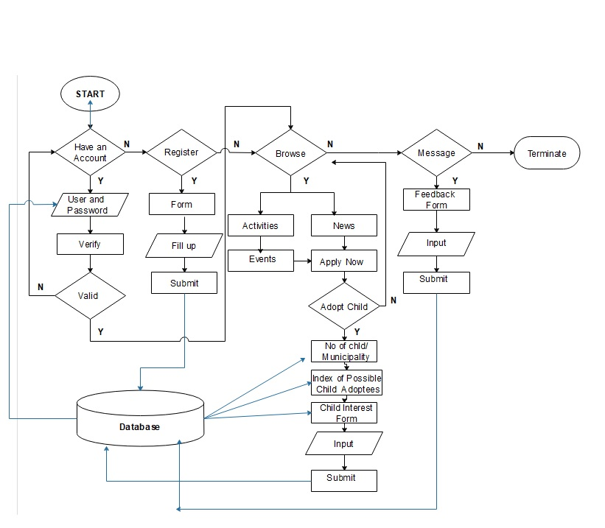

**Figure 4. Flowchart (User)**

Figure4. Shows the system’s flowchart for User for development of portal for municipal social welfare and development office adoption and foster care unit. The following flowcharts indicate how the systems work. Starting at the user logging in with their username and password to be granted access to the index of possible adoptees . Users will have full access on the features of the web-based application giving them the access to features like viewing the index of possible orphans, seeing activities and happenings regarding the orphanage or care house where they met their adoptive children and sending feedbacks to the orphanage and the web-based app itself.

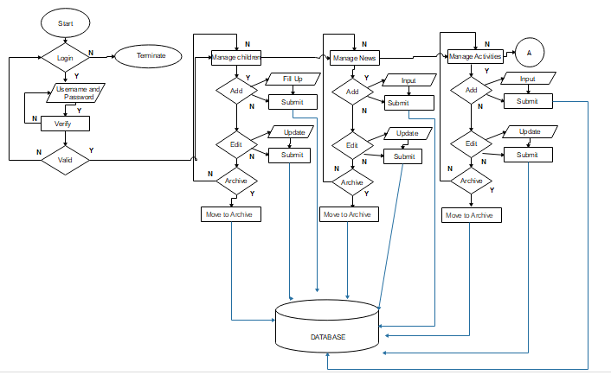

**Figure 5. Flowchart (Foster Home Admin)**

Figure5. Shows the system’s flowchart for Admin for development of portal for municipal social welfare and development office adoption and foster care unit. The following flowcharts indicate how the systems work. Long story short admin users will be the managers of both data and processes of whatever the web-based application encounters. Having the advantage of searching and modifying the archive of orphans to validating whether the possible foster parents are eligible to adopt children, having full access on the data inside the database of the application, validation and approval of accounts and other features both for upgrading and maintaining the web-based application.

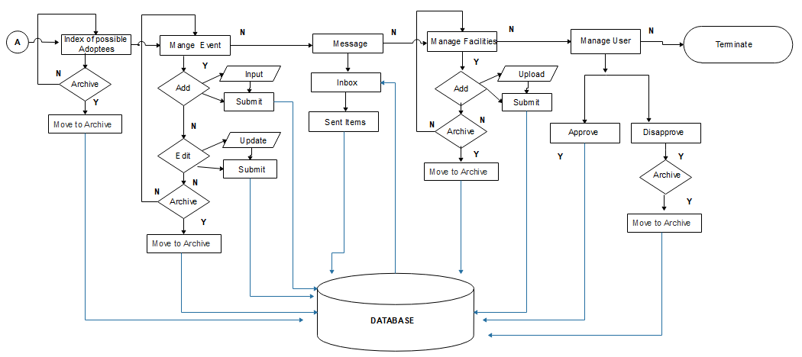

**Figure 6. Flowchart (Foster Home Admin)**

Figure6. Shows the system’s flowchart for Admin for development of portal for municipal social welfare and development office adoption and foster care unit. The following flowcharts indicate how the systems work. Long story short admin users will be the managers of both data and processes of whatever the web-based application encounters. Having the advantage of searching and modifying the archive of orphans to validating whether the possible foster parents are eligible to adopt children, having full access on the data inside the database of the application, validation and approval of accounts and other features both for upgrading and maintaining the web-based application.

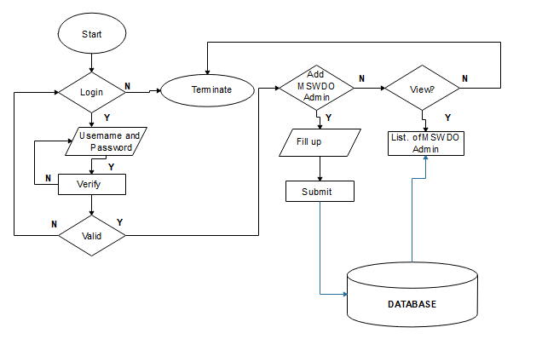

**Figure 7. Flowchart (PSWDO Admin)**

Figure7. The flowchart above shows how the system works on the part of PSWDO Admin users. Starting from admin validation, viewing the index of MSWDO admins and adding data of those who are eligible to be MSWDO admins.

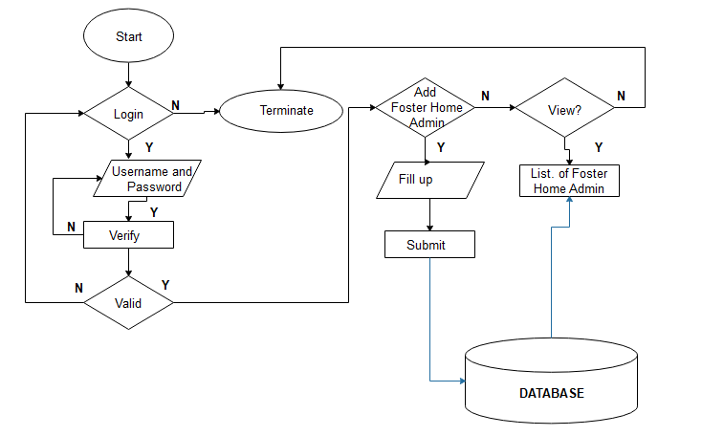

**Figure 8. Flowchart (MSWDO Admin)**

Figure8. The flowchart above shows how the system works on the part of MSWDO Admin users. Starting from admin validation, viewing the index of Foster Home admins and adding data of those who are eligible to be Foster Home admins.

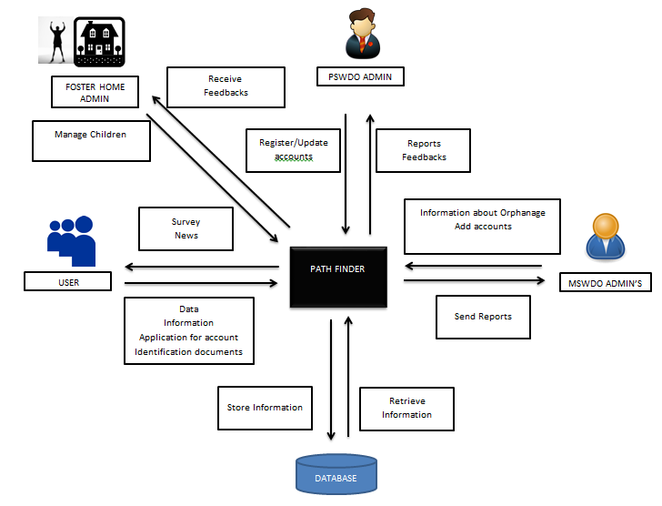

**Figure 9. Data Flow Diagram**

Figure9. The following data flow diagram shows the processes of the Path Finder web application by its different users. The possible foster parents will input their information along with some legal identification documents for them to be verified by the system they can receive updates and news from the app sent or created by the admin or developers. The Municipal Admins can add accounts and information such as location or orphanages with children or children that are possible to be adopted in return they will receive reports such for accomplishments and updates about the transactions and processes done for adoption. Admin users can register and update accounts for there can be possible changes for every account that registered in the application’s system they can also receive feedback from both the parents and the municipal admins. All data processed within the application will be stored in the application database which can be also retrieved.

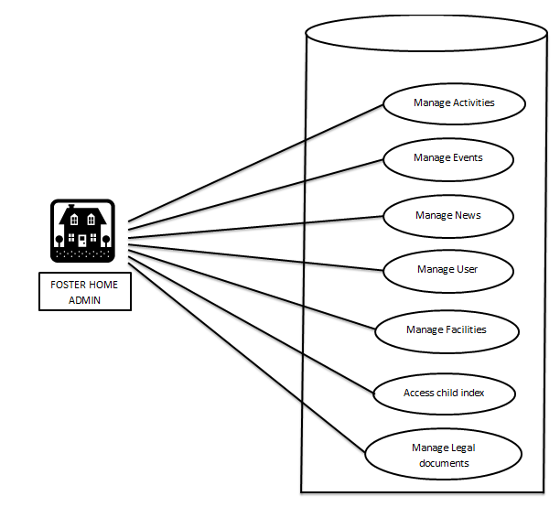

**Figure 10. Use Case Scenario for Foster Home Admin**

Figure10. Shown in the figure above are the processes that the foster home admin users can do in the program like managing news, users, events, adding information on the child index, managing facilities, legal documents and activity managements.

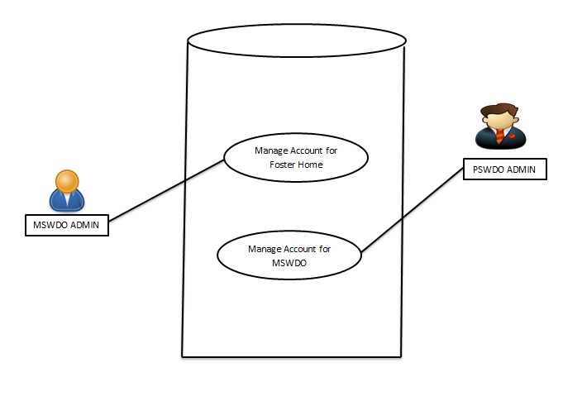

**Figure 11. Use Case Scenario for MSWDO and PSWDO**

Figure11.. Shown in the figure above is the use case scenario for both MSWDO and PSWDO admin users.

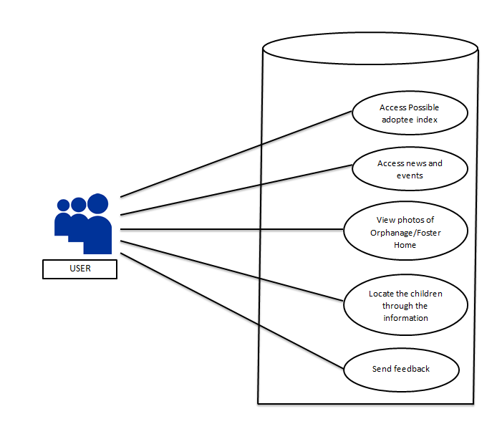

**Figure 12. Use Case Scenario for User**

Figure12. Shown in the figure above are the processes that a user can do such as accessing the index of possible adoptees, view the gallery of areas within the premises of an orphanage or foster home. Access to the details of news or events, location of children and where they can be found and send feedbacks whether the processes went smooth or hassle free.

|  |  |  |  |  |  |  |
| --- | --- | --- | --- | --- | --- | --- |
|  | **DOCUMENTATIONS** | |  | **QTY** |  | **COST(PHP)** |
|  |  |  |  |  |  |  |
| **Laptop/Netbook** |  |  |  | 1 |  | 25,000 |
| **Bond Paper** |  |  |  |  |  | 1,000 |
| **Flash Drive** |  |  |  | 1 |  | 450 |
| **Ballpen** |  |  |  |  |  |  |
|  | **TOTAL** | |  |  |  | 26, 450 |

**Table 2. Cost of the Development of the proposed system**

|  |  |  |  |  |  |  |
| --- | --- | --- | --- | --- | --- | --- |
|  | **DOCUMENTATIONS** | |  | **QTY** |  | **COST(PHP)** |
|  |  |  |  |  |  |  |
| **Laptop** |  |  |  | 1 |  | 25,000 |
| **Internet Connection** |  |  |  |  |  | 1,500 |
| **Webhost** |  |  |  | 1 |  | 450 |
| **Ballpen** |  |  |  |  |  |  |
|  | **TOTAL** | |  |  |  | 26, 450 |

**Figure 13. Project Implementation Cost**

Figure13. Shown in the figure above are the estimated cost of all the materials required upon making the system work properly both for the users and the admin users.

**PROJECT DEVELOPMENT PROCEDURES**

The proponents will use the Rapid Application Development. The researchers define this Methodology as follows;

1. **Requirements Planning** - In this phase, the proponents will identify the scope of the propose study, if the proponents will choose to make a navigation and management system application of the unpopular graveyard spot or the famous spots and also the requirements we will be needing like mobile phone and laptop or computer, the user will study the Android Studio and HTML (DBMS) for the coding of the application and the website.
2. **User Design** - In this phase, the proponents will start of creating user interface since it is navigation system; the proponents need to align the route and location properly. The proponents need to identify user interface to begin the construction phase
3. **Construction** - After the creation of the user interface, the proponents will begin the marks the create on that spot where the grave is. Then the next is the coding of the application, then the proponents will test the application to check if there’s something wrong in the design or in the coding.
4. **Cutover**- After the Construction phase, of course the next is testing of the navigation and management system application and then the last is the implementation of the proposed study..

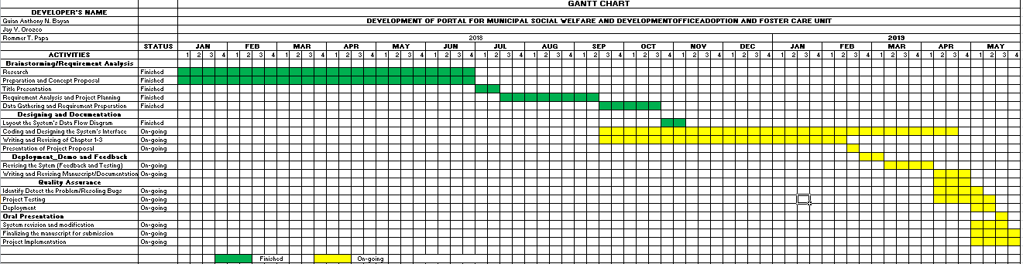**Figure 14. Gant chart**

Figure14. shows the timely record of every task that has been conducted towards the development of the system.