Cristobal Droguett

EECE 574

Milestone 1

DFF Schematic

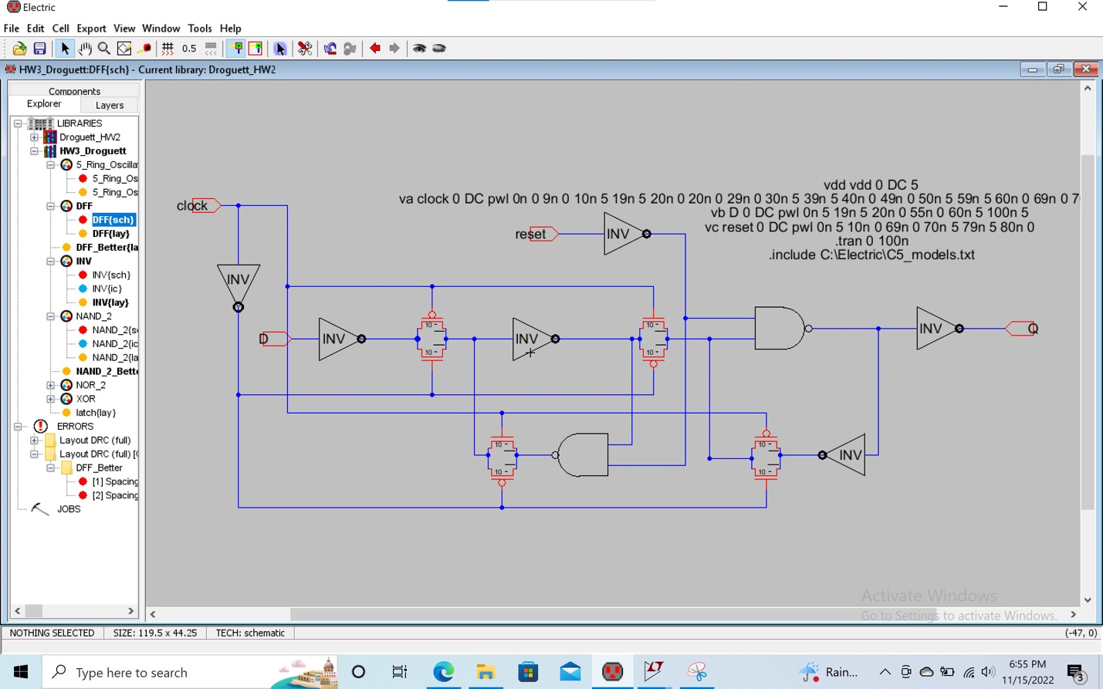

Passing DRC

Schematic Simulation

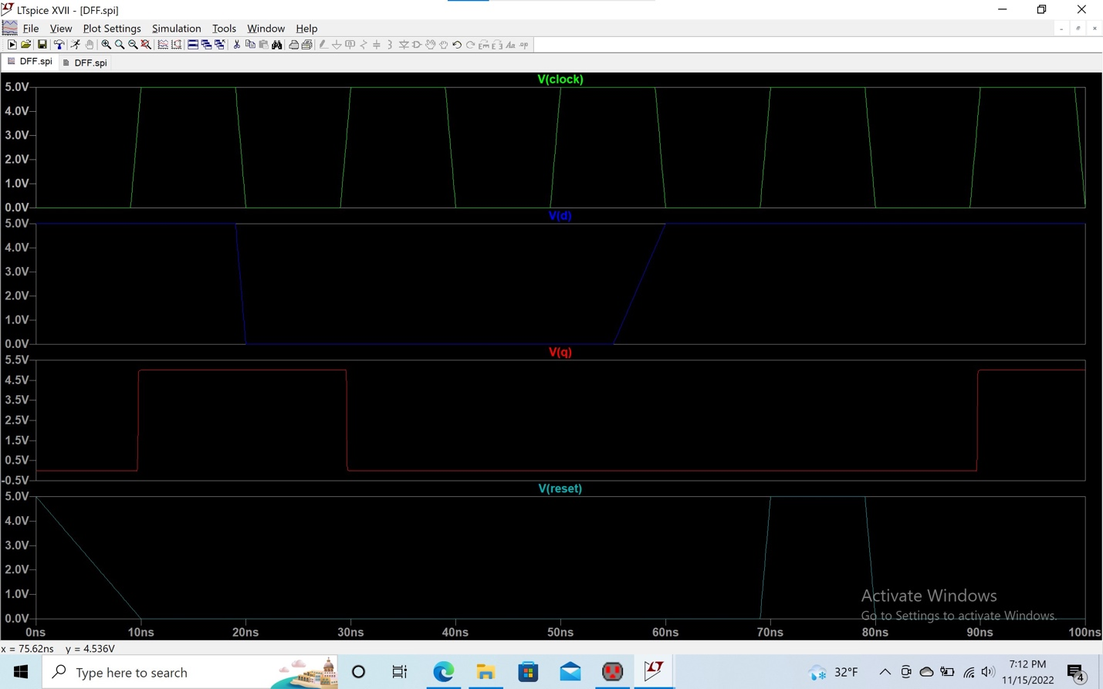

DFF Layout

Passing ERC and DRC

Layout Simulation

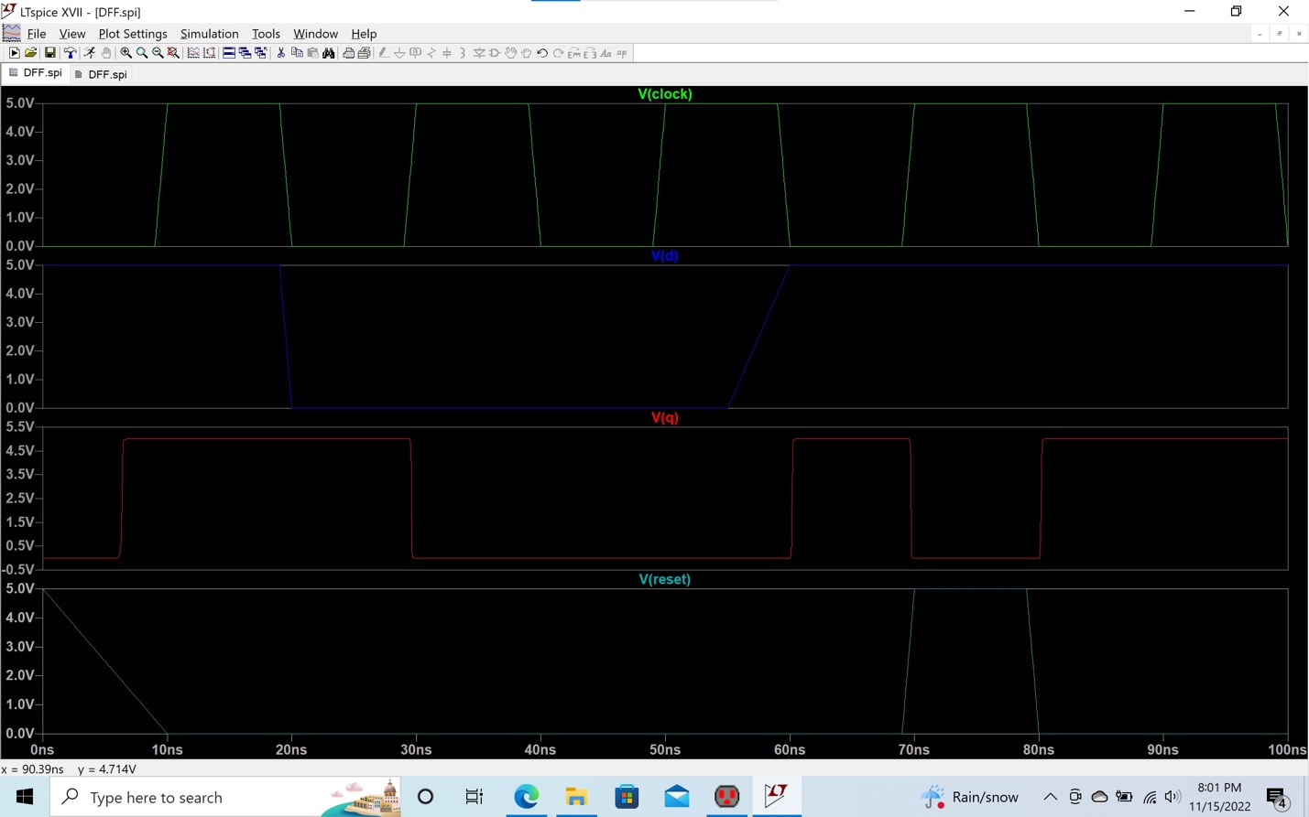

The output Q for the layout is a little different than the output Q for the schematic. The output Q goes high around 10ns earlier than it goes high in the schematic simulation. Also, Q goes high right before the reset signal goes high whereas in the schematic simulation this doesn’t happen. For some reason Q is not sampling D at the rising edges of the clock like it had in the schematic. I can conclude that the layout just does not provide good simulation readings.

NRC Check

Another issue I had was with the NRC check. I was not able to get my schematic and layout to pass the NRC check. I have an issue where there is an unequal number of parts in my schematic and layout. Again, I am not sure how this could be possible because for my layout I build it mimicking my schematic so I am not sure how there can be a different number of parts. I then have almost double the wires in the schematic versus the layout. I am not sure how this happened, but I will investigate it prior to moving towards the next milestone.