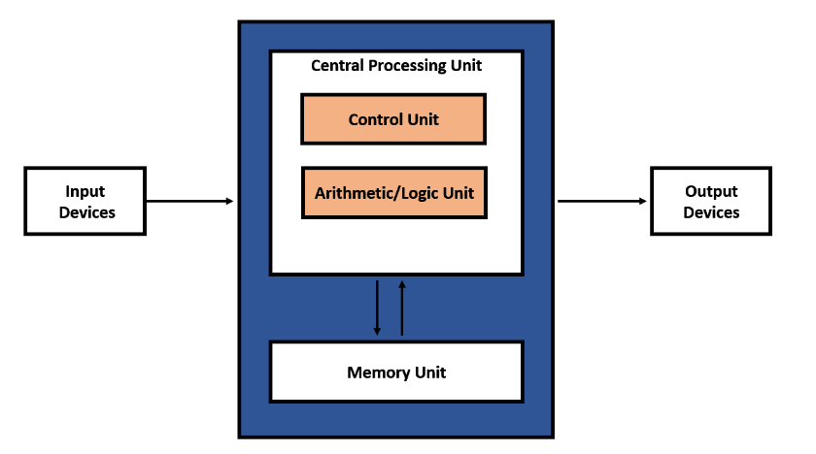

VON NEUMANN ARCHITECTURE

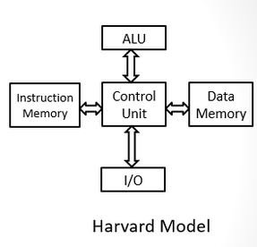

Harvard Architecture

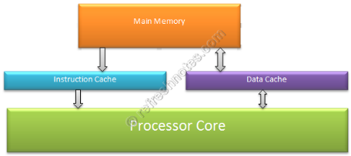

Modified Harvard Architecture

**Clock speed** - The clock speed measures the number of cycles your CPU executes per second, measured in GHz (gigahertz ) one billion ticks per second

**Instruction Set Architecture (ISA)** - is part of the abstract model of a computer that defines how the CPU is controlled by the software.

**Memory bandwidth** - is the amount of information that can be transferred to and from memory per unit time.

**Cache size** - reduce the workload on the CPU.

**L1 CACHE**

* Fast
* Small
* Embedded in the CPU

**L2 CACHE**

* Hold more than L1 (Computer performance)
* Can be embedded or be on a separate chip

**L3 CACHE**

* Improve the performance of L1 and L2 Caches
* Still twice as fast as DRAM

Pipelining results in faster processing because the CPU does not have to wait for one instruction to complete the machine cycle. Parallel processing is a method in computing of running two or more processors (CPUs) to handle separate parts of an overall task.