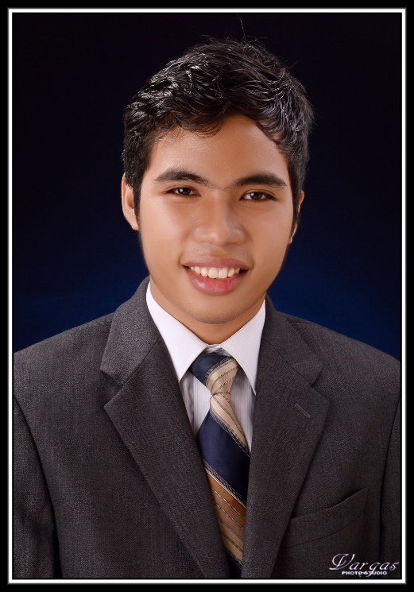

CRISANDRO BASOY



**WORK EXPERIENCE**

* April – June 2014 UV – University of the Visayas

As an **IT Support (OJT)**.

* July – October 2016 Roccatech

As a **SEO (Practicum)**.

* May 2017 – February 2018 Sizmek

As a **Creative Developer**. We use the company's campaign management software to create and administer rich media content, including online, mobile, and in-game advertisements.

* July 2018 – Current Wipro

As a **Content Moderator** for social media firm.

Email icon - Free download on IconfinderDownload Logo Icon Location Map Free Download PNG HQ HQ PNG Image |  FreePNGImgCall, phone, telephone icon - Download on Iconfinder

09993161603

1101 – A.A Gen. Maxilom Ext., Cebu City

[basoycrisandro@gmail.com](mailto:basoycrisandro@gmail.com)

[crisandro.github.io/](https://crisandro.github.io/)



**John Erick Madduma**

ReactJs Developer – Arcanys



09331556968

**Dawn Arcenal**

Assistant Supervisor (Design Team)– Proweaver



[dawnarcenal@gmail.com](mailto:dawnarcenal@gmail.com)

09171332391

**Blaezer Piedad**

Design Specialist – Newfold Digital



[blaezerpiedad26@gmail.com](mailto:blaezerpiedad26@gmail.com)

09052968262

**REFERENCES**

Version Control (GitHub)

WordPress

ReactJs

jQuery

Illustrator & Photoshop

HTML 5

CSS3

Javascript



**SKILLS & EXPERTISE**

* 2004 – 2009 Carreta Elementary School

**Elementary**

* 2009 – 2013 Mabolo National High School

**Secondary**

* 2013 – 2017 UV – University of the Visayas

**College**   
Bachelor of Science in   
Information Technology



**EDUCATION**