

E-BOTO: A WEB-BASED STUDENT VOTING MANAGEMENT SYSTEM IN

UM TAGUM COLLEGE

### A PROJECT PROPOSAL FOR CCE 106/L

# APPLICATION DEVELOPMENT AND EMERGING TECHNOLOGY

**SUBMITTED TO:**

CARLA JEAN ZOZOBRADO

**SUBMITTED BY:**

AMIN, ZIYAD

BANQUIL, CRIS

BALBUENA, WENIBRANDO JR.

LUMANDA CLENT VJ

PADERES ARNZ LOUIE

### SEPTEMBER, 2025

**Cover Page**

**Table of Contents Page**

#### Chapter 1 – Project Context

1. A Web Based Student Voting Management System in Um Tagum College …..
2. Project Context ................................................................................................1
3. Statement of the Problem ............................................................................... 2
4. Objectives ....................................................................................................... 3
5. General Objective ................................................................................ 3
6. Specific Objective ................................................................................ 3
7. Scope and Limitations .................................................................................... 4

#### Chapter 2 – System Design

1. Prototype(wireframes) ...................................................................................... 5

2. System Diagram:

1. UML Diagram ...................................................................................... 13
2. User Case Diagram ............................................................................ 14
3. Context Diagram Level 0 .................................................................... 15
4. Entity Relationship Diagram ............................................................... 16
5. Flow Chart .......................................................................................... 17

#### Chapter 3 – System Requirements

1. Functional requirements .................................................................................. 18

2. Non-functional ................................................................................................. 18

3. Software Testing Plan (User Acceptance Testing results) ................................ 19

**CHAPTER I**

**INTRODUCTION**

# PROJECT CONTEXT

At the University of Mindanao Tagum City, student elections are still conducted manually. Students choose officers in different timelines in their respected classroom for voting of officers. This conventional method is not only time-consuming and is also vulnerable to human errors, and those who were absent in class will not be able to cast votes, and it may cause issues of fairness. The limitations of this system underscore the need for a more productive and credible voting process within the university setting.

Newly published studies have highlighted the possible of online and electronic voting systems to improve voter participation, and using modern electoral procedures covering different contexts. Internationally, research on Ecuadorian citizens living abroad during 2021 national elections, found that Internet-based voting significantly increased voter turnout, particularly among female voters, and in presidential elections whereas on-site electronic voting had little effect on participation E-voting and Non-resident Citizens Voter Turnout: A Quasi-e, 2021). Similarly, in Ontario, Canada, Goodman and Stokes 2018) showed that, although the effect varies depending on elements like public trust, and technological accessibility, online voting can lower the "costs" of voting, such as time, effort, and travel, hence promoting civic involvement. Despite acknowledging voting as a civic duty, overseas Filipino voters in Japan during the 2016 elections faced practical hurdles like distance, administrative burden, and logistical challenges, which decreased participation in voting election. These findings are consistent with observations made in the Philippine context Jaca and Torneo, 2019). Locally, Naval De Los Santos 2020) evaluated a Web App Voting System (WAVS), at Eastern Visayas State University Tanauan Campus, and reported excellent usability in terms of performance and user satisfaction. However, their study highlights usability with limited focus on the security, scalability, and system usability. Another study similarly occurs back in 2020, Pereyras 2020) proposed a computerized touchscreen voting system at Pangasinan State University, highlighting improvements in performance, but without integrating comprehensive back-end or online capabilities Pereyras 2020). Taken together, these studies suggest that while online and electronic voting systems can enhance accessibility and productivity, there is a critical need to develop systems that combine usability, security, and scalability to fully realize their potential in increasing voter engagement both locally and internationally.

In order to overcome the deficiency and complications of the University of Mindanao Tagum City current manual student election method, this study suggests developing an automated real-time online voting platform. provide real-time reports on voter turnout, facilitating organizers and students to track participation percentages in real time. Non-confidential information, such as the number of votes cast for each position, and the overall turnout figures will be shown on a dashboard accessible to the public, in order to maintain transparency. And only eligible students able to cast votes, due to voter credentials which will be implemented, through a verified login process that requires student ID numbers. In order to optimize participation and promote equitable competition, the system will also have features like automated reminders, encouraging messages, and to ensure that each student will only be able to cast one vote each, to ensure fairness in elections, accessible on website platforms, works online, and admin will be responsible for managing the process of election through a separate admin login, such as candidates and monitoring election integrity.

# STATEMENT OF THE PROBLEM

Currently, the University of Mindanao is having difficulties overseeing its student-selected candidate election process. candidates are chosen by hand, which frequently leads to restrictions and low student turnout. Because of this, some students who are absent during the officer election are unable to cast their votes leading to low percentage of vote, validity, and transparency as a whole.

1. What mechanisms can be implemented to ensure reliable student registration and login before voting?
2. How can administrators manage candidate profiles when setting up election events?
3. How can students register and log in authentically before voting?
4. How can students register and log in authentically before voting?
5. How can students access candidate profiles and platforms prior to voting?
6. How does the mechanism guarantee that every student casts a single vote?
7. How can the system tally votes and release election results promptly?
8. How can the system produce reports on voter turnout, candidate statistics, and other election-related data?
9. How can the system be made accessible and user-friendly for students online?

# OBJECTIVES

To design a verified and transparent Student Voting Management System that will replace the traditional manual election system at the University of Mindanao Tagum City.

This project aims to:

1. Develop a Web-based application that will:

1. To allow students to register and log with authenticity before voting.
2. Admins need to be able to create and configure election events, as well as manage candidate profiles.
3. To provide students with access to candidate profiles and platforms before voting.
4. To ensure “one student, one vote” by checking the IDs at the point of submission.
5. To tally votes and generate election results.
6. To generate reports regarding voter turnout, candidate statistics and other election-related data.
7. Ensure the system is accessible on a website platform.

# SCOPE AND LIMITATIONS

The system will cater all the student government elections in University of Mindanao Tagum City. It will facilitate student registration, logging in and authentication for verified participation. Admins will be able create, edit and manage election information and candidate schedules. Students, however, will be able to read about the candidates who are running and vote online. The system will provide automatic vote counting and instant results issuance, as well as monitoring reports and reports on election results and participation.

However, the system has limitations. Registered students (UMTC members) will be the only people to be able to access and make use of the platform and its use case is limited to only school related elections. The security of the system will mainly rely on how well students and administrators manage their accounts; lost or shared credentials may lead to possible threat. The system biometric data will not be used for identification, and login will depend solely on a student ID and password.

### CHAPTER II

### SYSTEM DESIGN

#### Prototype

The following images showcase the high-fidelity prototype illustrating the design and detailed representation of the final product of both mobile and desktop application, with desktop on the left-side and mobile on right-side.

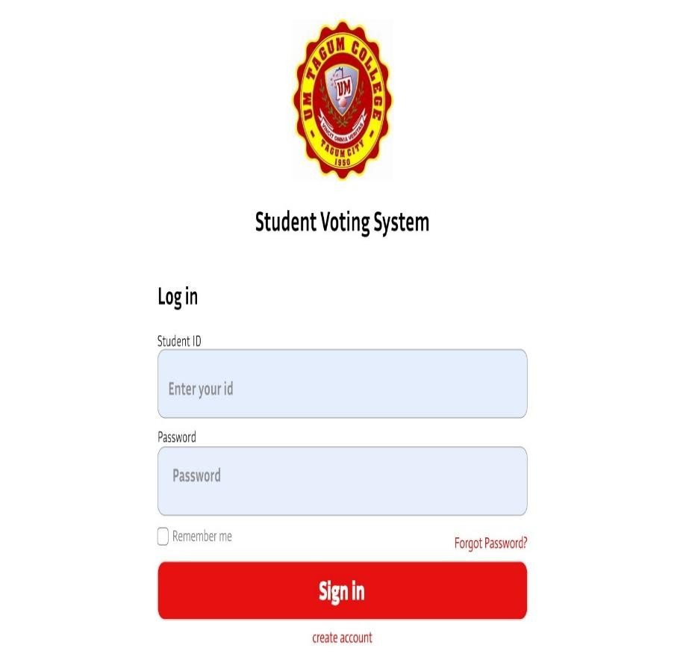

##### **Figure 2.1** Student Login

Student login allows them to access the web-based system, in order to participate in voting election.

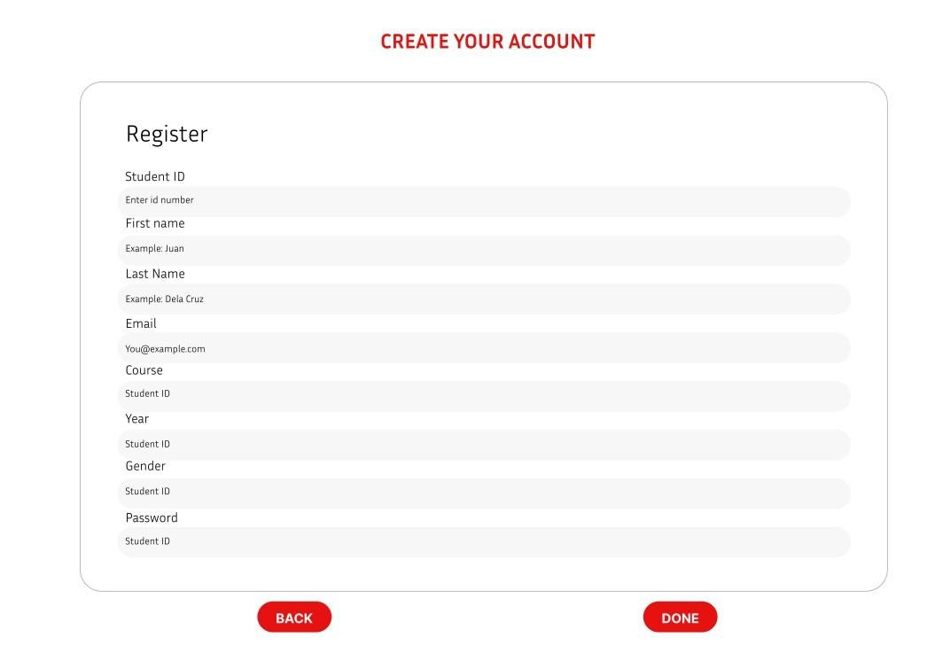

##### **Figure 2.2** Create Account

Students create account to set up their personal information in order to have a credentials to access the E-boto system.

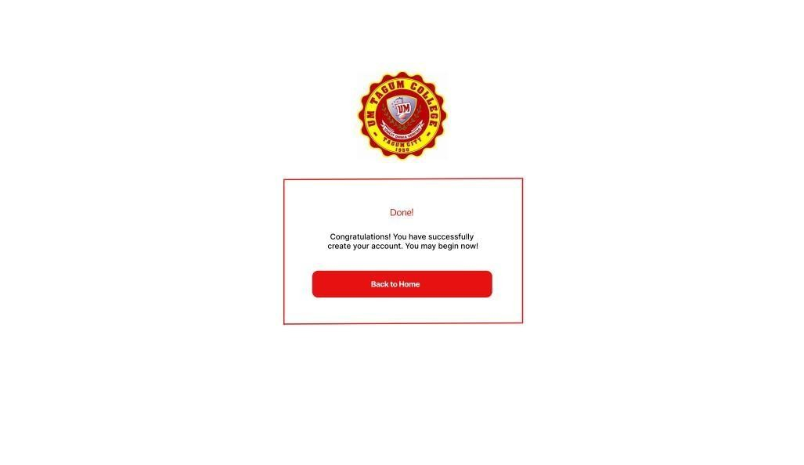

##### **Figure 2.3** Created Account

Already have a student account in E-boto system, simply go back to home and login using student ID and password.

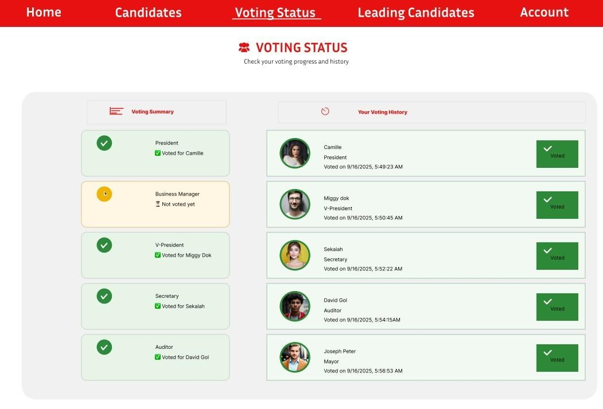

##### **Figure 2.4** Voting Status

It shows the voting summary and history in order for the students who have already voted can manage and check their voting status.

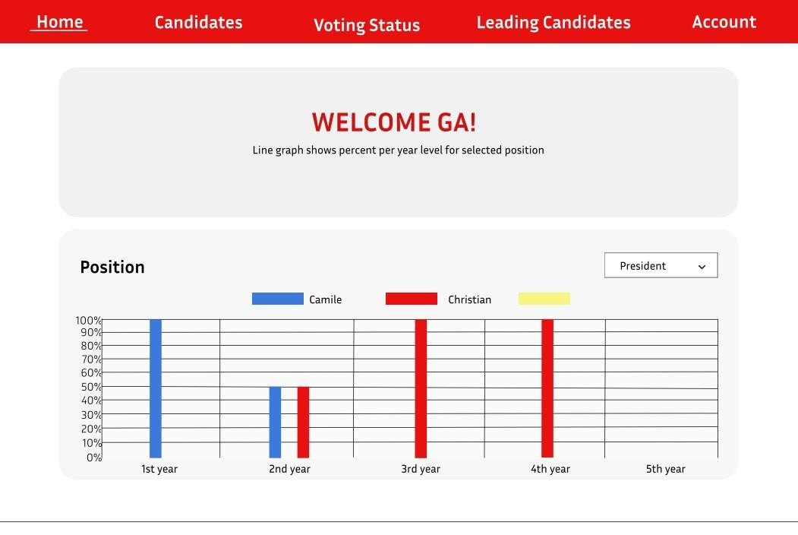

#### Figure 2.5 Home

The home page, where students can check the statistic, to ensure that the system have transparency and accessibility for all.

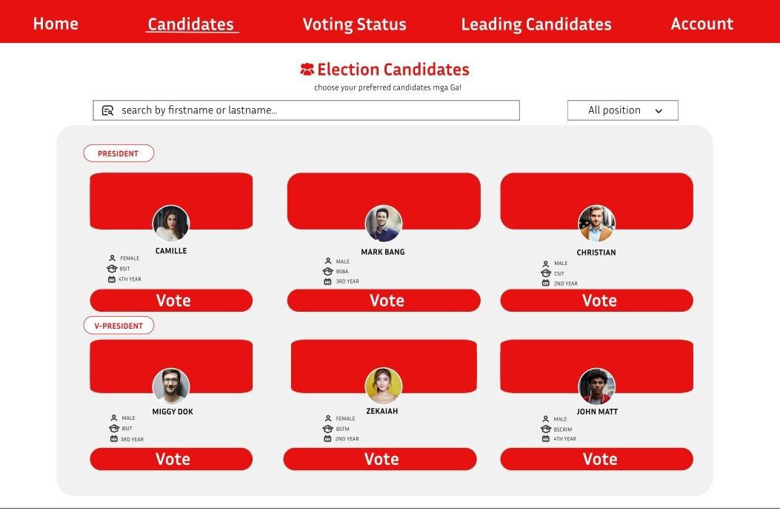

##### **Figure 2.6** Candidates Page

Candidates page, where students view all the running candidates and provide information on candidate’s profile, and cast votes with legitimacy.

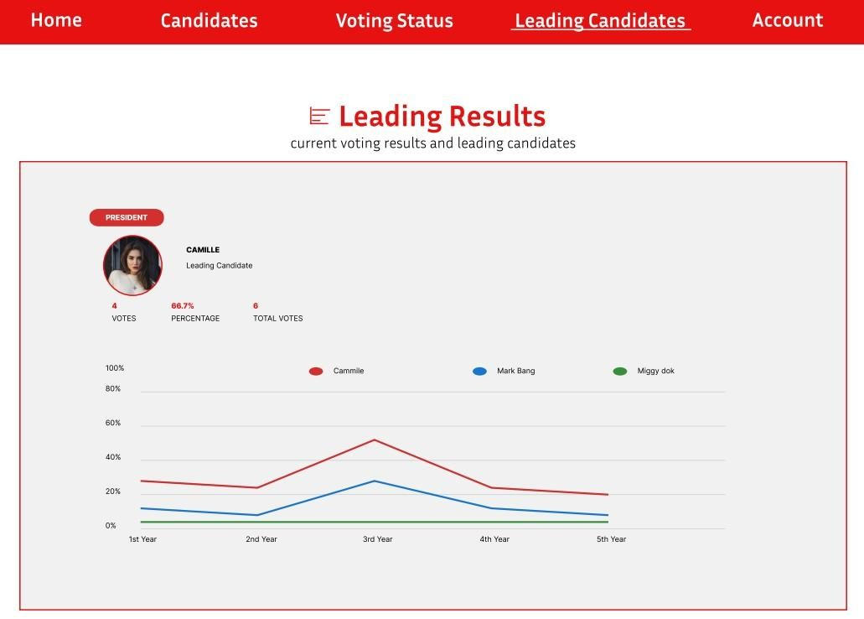

##### **Figure 2.7** Leading Candidates

Leading candidate’s page, where to can verify the statistic of each candidate, and check who is currently leading the election. It detailed vote counts and percentage, and check result with transparency.

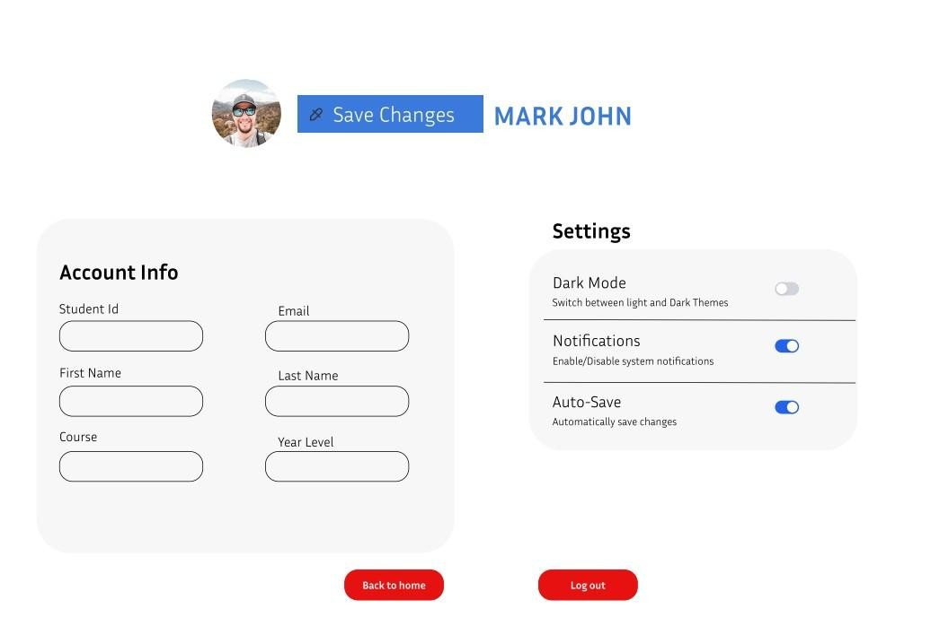

##### **Figure 2.8** Account Information

Account information page, where students edit their profile information and customize settings base on student preference.

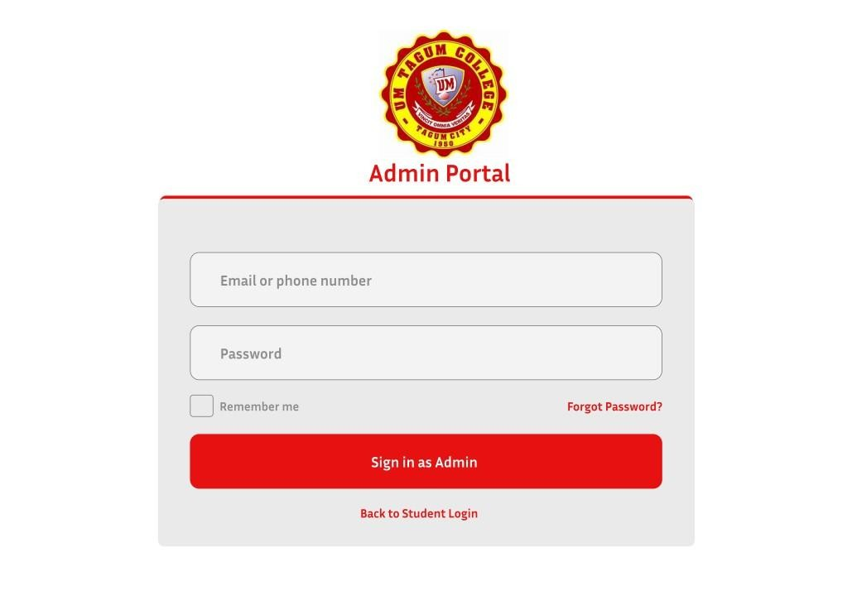

##### **Figure 2.9** Admin Portal

Admin portal page, where admin fill their login credential, and only authorized users can access the admin portal in order for them to manage system settings and student user data.

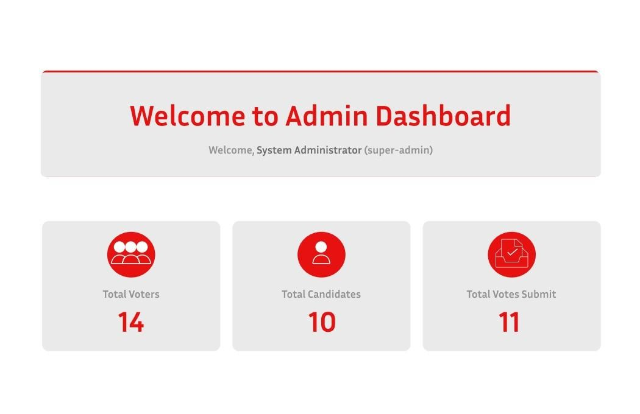

##### **Figure 2.10** Admin Dashboard

Admin dashboard page, where admin can verify the total voters, candidates, and the total submit votes, and monitor verify all key statistic regarding the student election.

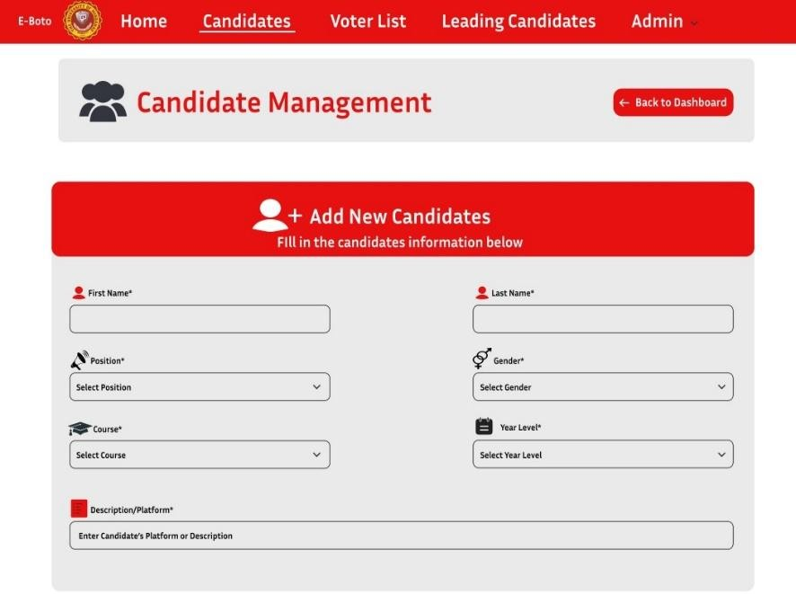

##### **Figure 2.11** Candidates Admin

Candidate admin, where admin adds candidates and managed their information profile in order for the candidates to properly registered and verified for the election.

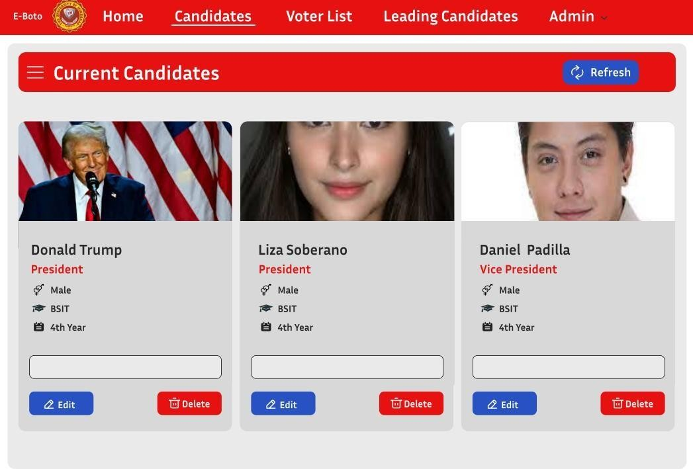

##### **Figure 2.11** **part2** Candidates

Candidate admin, where admin adds candidates and manages their information profile and delete if any errors are found, admin can edit or delete directly from this page.

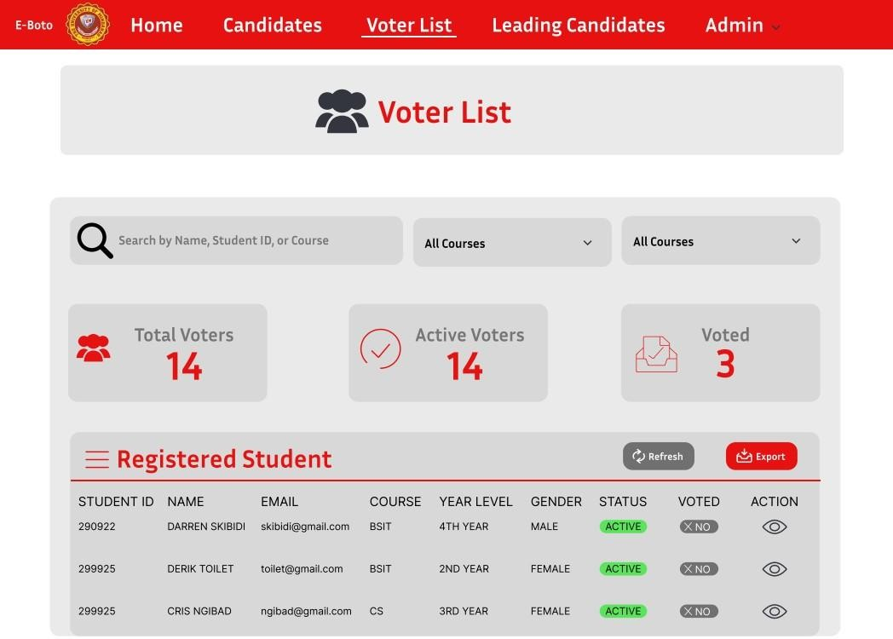

#### Figure 2.12 Voter List

Voter list, where admin manage and verify all the student voters in the election of officers. And verify all of their courses, total voters, active voters, and who’d voted.

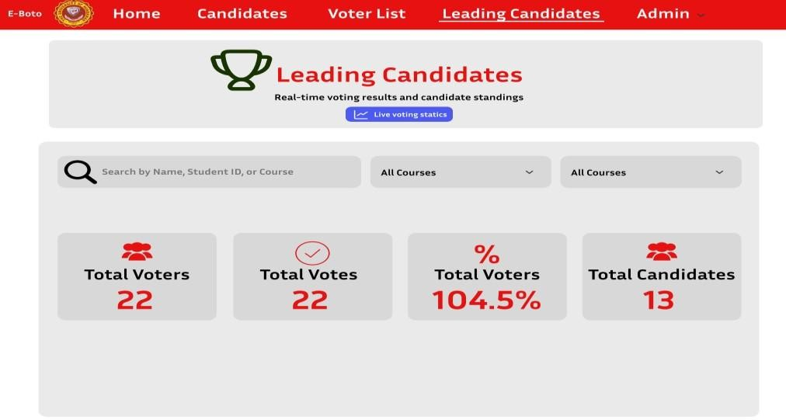

##### **Figure 2.13** Leading Candidates

Leading Candidates admin page, where admin verify all total voters, total candidates and total votes, admin also able to access student names by searching in search bar.

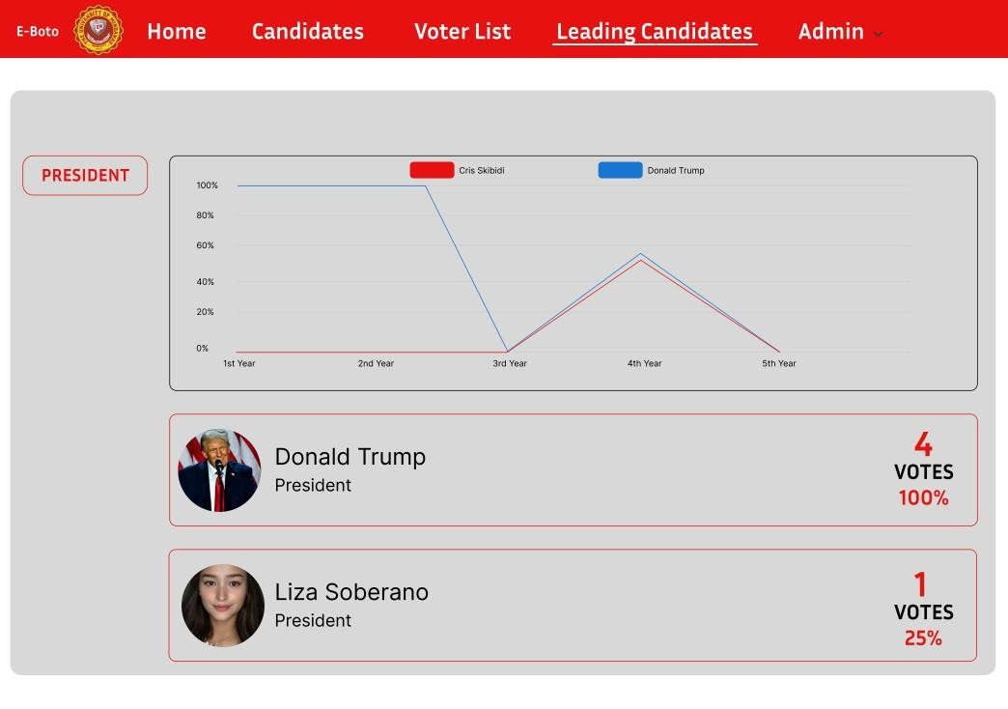

##### **Figure 2.13 Part 2** Leading Candidates Admin

Leading Candidates Admin, displays all statistical data regarding the percentage of votes each candidate has received, and shows how many voters have voted for each candidate.

# System Diagram

This section consists of images that show the system diagram that visually illustrates the feature and the interaction within the system.

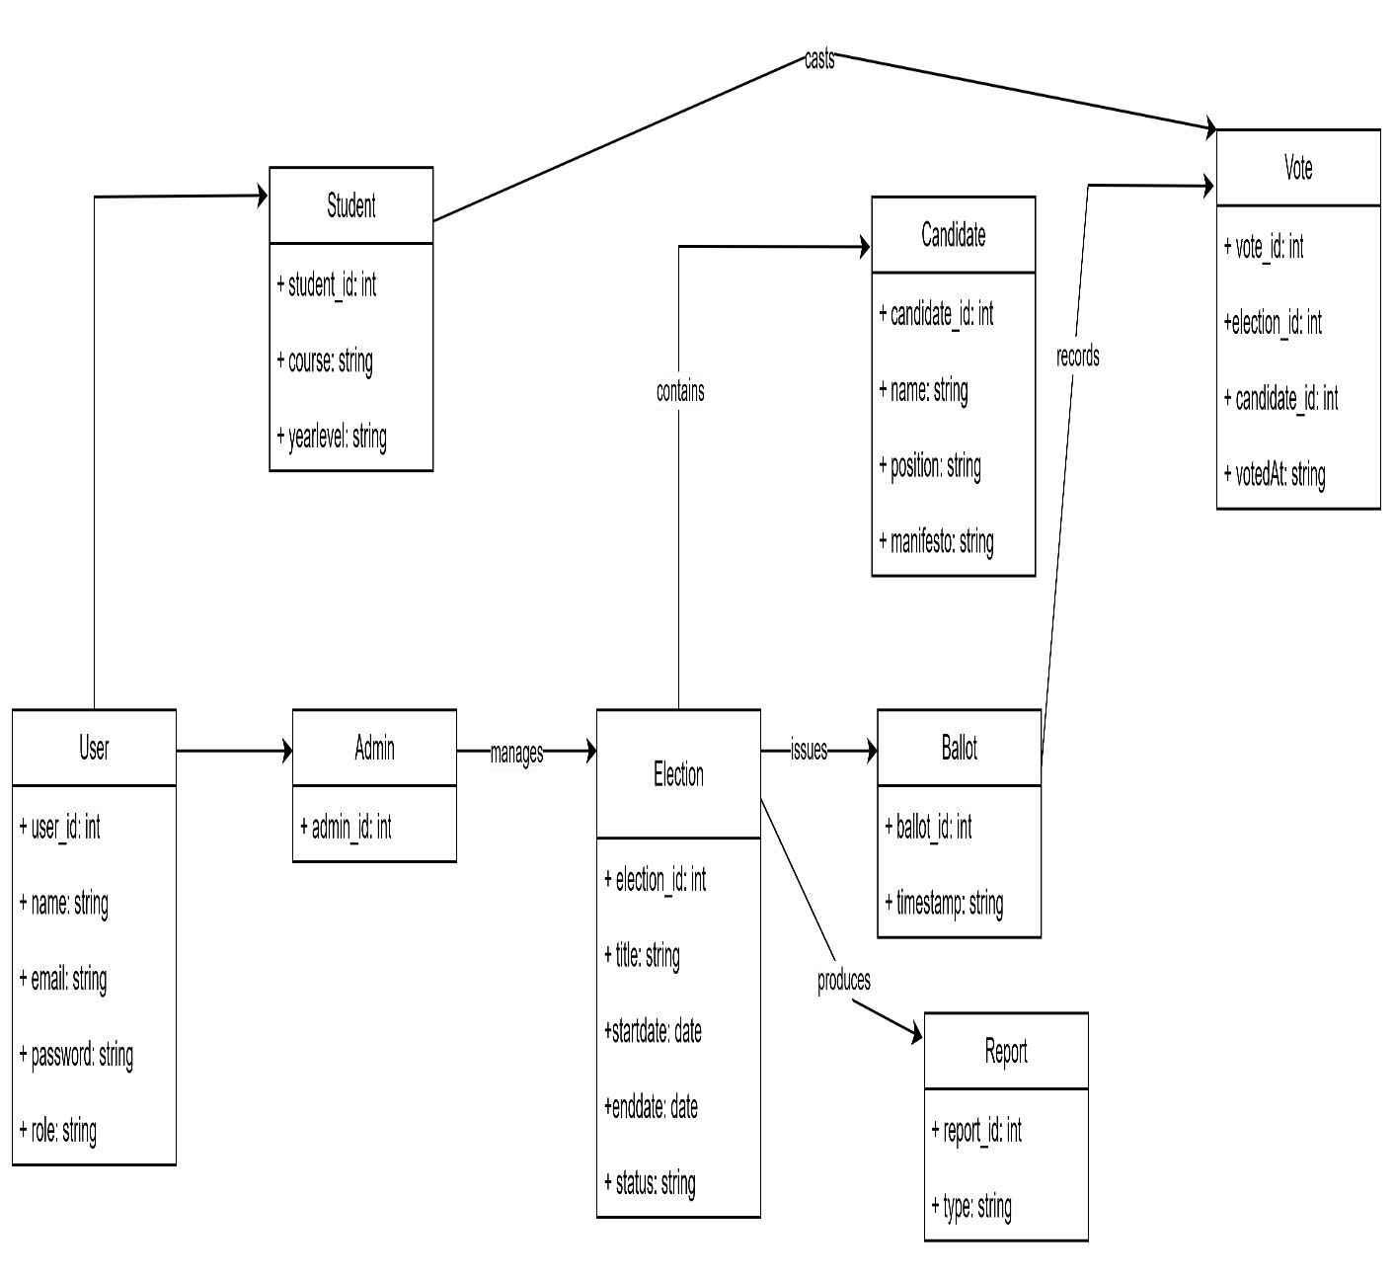

**Figure 2.14** UML Diagram

This diagram illustrates the data model for an online voting platform, defining classes such as User, Student, Admin, Election, and vote along with their key attributes. It establishes the structural relationships between entities, clarifying how users interact with elections and how votes are recorded and managed.

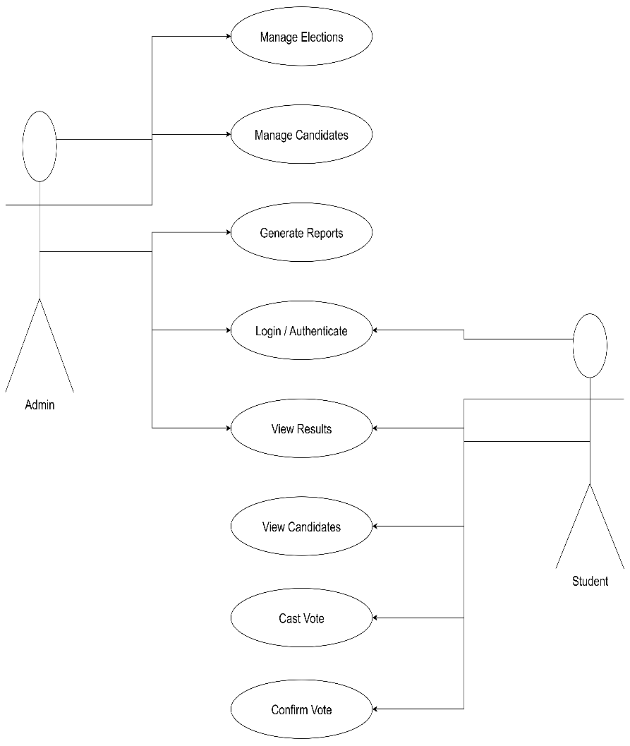

## **Figure 2.15** User Case Diagram

An overview of how admin and student voters use the web-based voting system is given by this use case diagram. after student login they will interact with frontend (seeing candidates, casting their ballots), while admin organize the backend (elections, candidates, reporting).

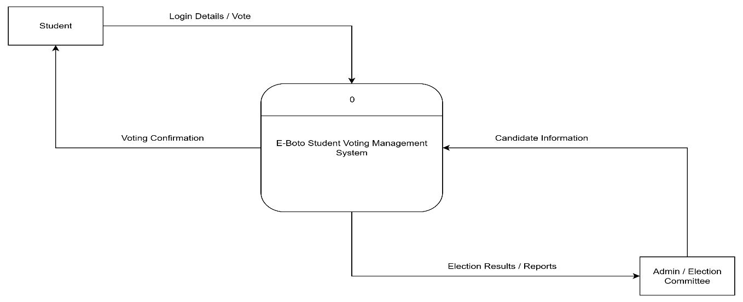

## **Figure 2.16** Context Diagram Level 0

The Context Diagram show the structure and connection between user and the E-boto Students Voting Management System. It features what the data is flowing in and out.

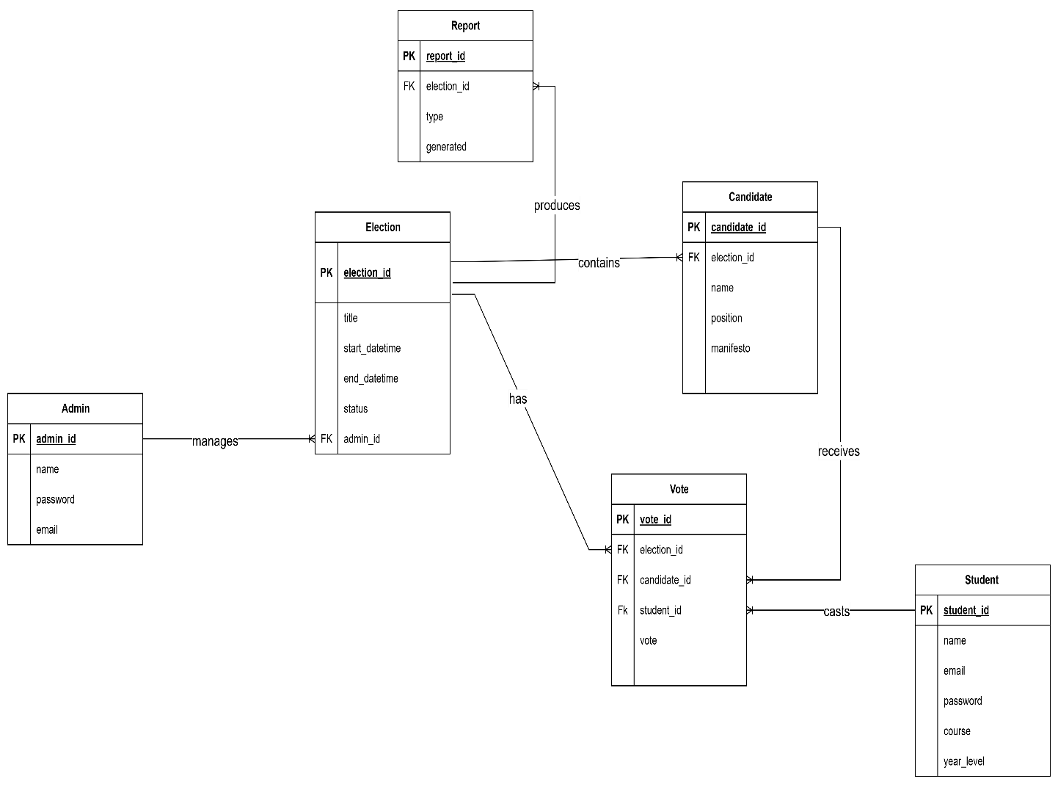

## **Figure 2.17** Entity Relationship Diagram

This Entity-Relationship Diagram (ERD) shows the core structure of an election management system by defining key entities and their relationships. It illustrates how an admin manages an election, which contains votes cast by students.

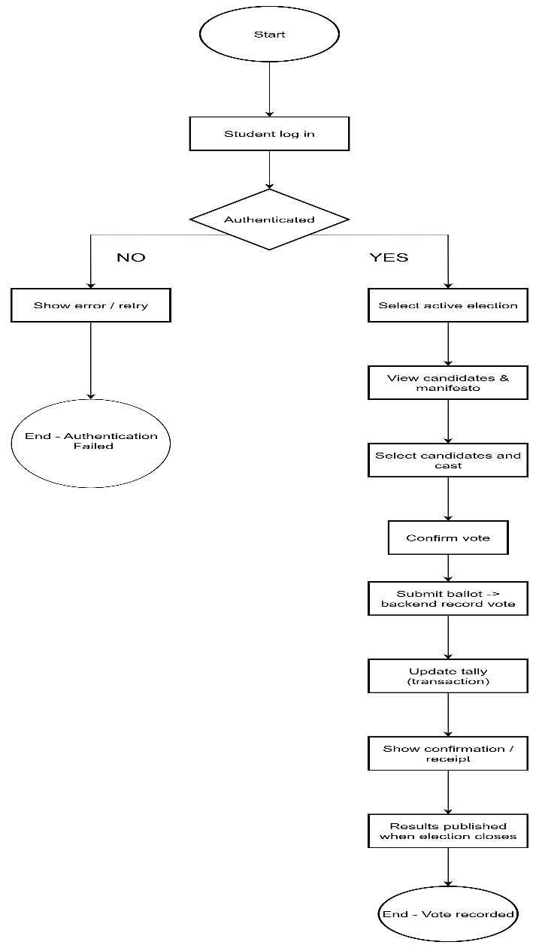

## **Figure 2.18** Flow Chart

Flowchart illustrates the student voting process for an online election. It begins with user authentication, followed by candidate selection, secure ballot submission, and concludes with the recording of the vote and the publishing of results.

**CHAPTER III**

**SYSTEM REQUIREMENTS**

# FUNCTIONAL REQUIREMENTS

* The system must allow students to register with their university-issued email ID and a password.
* Only authorized users (students) can access the voting portal, verified via authentication.
* Admins must be able to specify eligibility criteria.
* The system must display the list of candidates for each election, including candidate details (name, photo).
* The system must confirm that the student’s vote has been successfully cast after submission.
* The system must prevent duplicate voting.
* The system must prevent unauthorized access to the voting portal.
* The system must display the current leading candidate in real-time during active elections.
* The system must allow users to view their personal voting history and previous elections participated in.
* The system must provide graphical representations of election results to help visualize voting data.

# NON-FUNCTIONAL

* The user interface must load within 2 seconds under normal network conditions.
* The system authenticate both students and admins account using encrypted credentials.
* The leading candidate information must refresh in real-time or with minimal delay (under 5 seconds).
* The system must display voting status updates with less than 2 seconds latency.

# Software Testing Plan (User Acceptance Testing result

**User Acceptance Test Form for [E-BOTO: A WEB-BASED STUDENT VOTING MANAGEMENT SYSTEM IN UM TAGUM COLLEGE]**

|  |  |
| --- | --- |
| **General Information** | |
| **Project Name: (University of Mindanao Tagum College)** | **Date:**  **September 22, 2025** |
| **Application Name: E-BOTO** | |
| **Developers: Banquil, Tomol, Paderes, Lumanda, Amin, Balbuena** | |

|  |  |  |  |  |  |
| --- | --- | --- | --- | --- | --- |
|  |  | **[System/Application Name]** | | |  |
|  | **Action/Functionalities** | **Expected Result** | **Actual Result** | **Pass/Fail** | **Additional Comments/Remarks** |
| 1 | **Dashboard** | Can view the dashboard | Allowing access to the dashboard (of user) |  |  |
| 2 | **Student Registration** | Students can create an account by entering their details (Student ID, Name, Course, Year level, Email, Password). | Adding a student to the form (of user) |  |  |
| 3 | **Generate Reports** | Can generate election reports (winners, total votes, turnout). | System successfully generates election reports and allows download (PDF/Excel). |  |  |
| 4 | **Login/Authentication** | User must log in with the correct credentials. | Login works with valid credentials, rejects invalid. |  |  |
| 4. | **Manage Candidate** | Can add, edit, and delete candidates | Candidate information successfully managed. |  |  |
| 5. | **Notification / Confirmation** | System shows confirmation after successful actions (e.g., vote submitted). | Confirmation messages displayed correctly. |  |  |
| 6 | **Voting Module** | User (student) can cast vote once. | Vote successfully recorded, prevents double voting. |  |  |
| 7 | **Leading Candidate Display** | System shows current leading candidate per position based on live vote count. | Leading candidates are displayed correctly with updated vote totals., |  |  |
| 8 | **Voting Status** | System shows list of students with status (Voted / Not Yet Voted). | Voter list with statuses displayed correctly in the system. |  |  |
| 9 | **View List of Candidates** | Student can view the complete list of registered candidates with their details (Name, Position, Party). | Candidate list displayed correctly on the student dashboard. |  |  |
| 10 | **Profile Information Student/User** | Student can view and update their profile information (Name, Last Name, Course) | Profile details displayed correctly; updates are saved successfully. |  |  |

Prepared by: Tested by:

Cris Banquil

Arnz Louie Paderes

John Paul Tomol

Clent Vj Lumanda

Wenibrando Balbuena

Ziyad Amin

### REFERENCES

Naval De Los Santos, J. R., Naval, Galangue De Los Santos, M., De Los Santos, G., & Batan, M. (2020, July). Web App Voting System in a Philippine State University: An ISO 9241-11 Evaluation.

Goodman, N., & Stokes, L. C. (2018). Reducing the cost of voting: An evaluation of internet voting’s effect on turnout. British Journal of Political Science, 50(3), 1155–1167. https://doi.org/10.1017/s0007123417000849.

E-voting and non-resident citizens’ voter turnout: A quasi-e. (2021). REDI. Retrieved October 5, 2025, from https://redi.cedia.edu.ec/document/159517.

Design and Implementation of an Aadhaar-Based E-Voting System with Facial Recognition for Enhanced Security and Accessibility. (2025, January 18). IEEE ConferencePublication|IEEEXplore. https://ieeexplore.ieee.org/abstract/document/10940330

Ekiring,I.P. (2023). Student online voting system: http://ir.busitema.ac.ug/handle/20.500.12283/3795.

Jaca, G., & Torneo, A. (2019, December). Explaining (non) participation in overseas voting: the case of overseas Filipino voters in Japan in the 2016 elections.

ResearchGate.RetrievedOctober5,2025,from https://www.researchgate.net/publication/338172728_Explaining_non_participation_in_overseas_voting_the_case_of_overseas_Filipino_voters_in_Japan_in_the_2016_elections.

Pereyras, J. (2020, May 14). A computerized touchscreen student voting system for the universities and colleges. Google Scholar.

Shirmyradov, R., & Serdarova, A. (2025, March 11). ONLINE VOTING SYSTEM PYTHON. https://mpcareer-google.ru/index.php/journal/article/view/1063.

Research Gate. Retrieved October 5, 2025, from https://www.researchgate.net/publication/344526407_Web_App_Voting_System_in_a_Philippine_State_University_An_ISO_9241-11_Evaluation

Impact of online election system on voter turnout and participation: A case of Student Representative Council election at the University of Namibia. (2025, June 1). Google Scholar. Retrieved October 6, 2025, from https://journals.co.za/doi/abs/10.31920/2752-602X/2025/v5n1a5