Cagaoan, Crischin Charm C. November 27, 2019

2ECE-C

PANDAS

Problem 1:

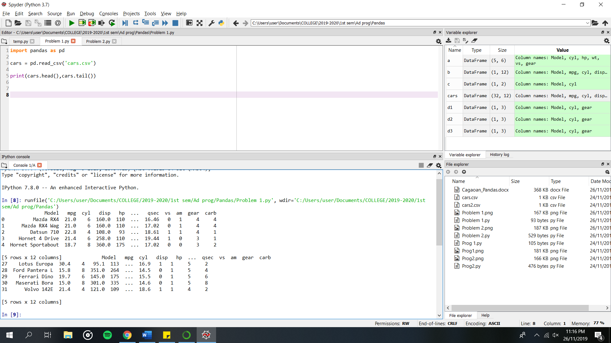

Problem 2:

