



General Term = **2n-1/2n**

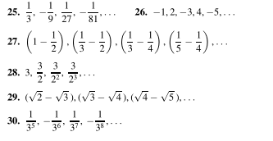

**29.) limit? General Term = sqrt(n+1)-sqrt(n+2)**

**30.) Limit? General term = (-1)n-11/34+n**

**Q.)** How to determine if the sequence converges?

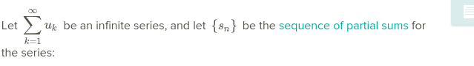

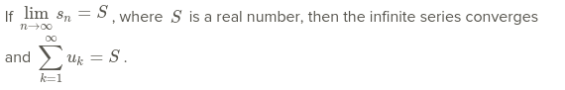

Q.) What exactly is the sequence of partial sums?

Q.) What is the logic of a summation representing an infinite series?

Q.) Given that {sn} is the sequence of partial sums for the series, how exactly would you implement it into the limit written above to be able to find if S is a real number? (more specifically is {Sn} where you just plug in the general term and solve the limit?)

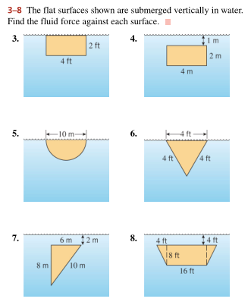

6Q.) Able to find the height of the triangle, but what would be the formula for the changing base in the integral?

8Q.) Clarification on how to solve. Is it the sum of the area of the two triangles plus the area of the rectangle.