**Front-end**

**Overview**

HH is a project to manage patient transfers between hospitals and clinics. Its features allow the user to login with proper authentication. The user would have access to the information of a module Patients allowing them to view and modify the database. The main function of the front-end is to carry out a good handling of data and information between the user's controller view and the database, facilitating the handling of the application.

This project is not a derivation of any other, it began to be programmed from scratch and it seeks to follow up to satisfy the client according to their requirements, in such a way that each step has a foundation and must be preserved unless the client wishes to change

**Technologies used:**

The technologies that will be mentioned below will facilitate the creation of the project since it was concluded, in previous comparisons with other technologies, the advantages that we obtain when using them

**HTML and CSS**: both web programming languages required for the development of a website. Specialized CSS to be attractive.

**JavaScript**: it’s a programming language implemented to accompany the development of websites, where it allows you to perform necessary functions, and not only display information such as HTML and CSS.

**NodeJS**: is a runtime environment for JavaScript built with Chrome's V8 JavaScript engine. Another description is: NodeJS is a general purpose application development technology. It basically consists of a Javascript execution platform, which is known as a "runtime", on which all kinds of programs can be executed.

**Bootstrap**: Bootstrap is a CSS framework used in front-end applications, which allows us to adapt to any screen of any device, in such a way that the website is standardized.

**Angular**: Angular is a web application framework developed in TypeScript, open source, maintained by Google, used to create and maintain single page web applications.

**Typescript**: is a free and open source programming language. TypeScript can be used on the client (Angular) or server (Node.js) side. It is programmed in this language, so that the compiler itself converts it to JavaScript.

**Brackets**: With focused visual tools and preprocessor support, Brackets is a modern text editor that makes it easy to design in the browser. It's crafted from the ground up for web designers and front-end developers.

**Sublime text 3:** In the same way as brackets, sublime text 3 can be used for project editing.

**It’s necessary to install a compiler for these languages:**

We will start with the installation of "Brackets" or "sublime text 3" to start editing the project from the front-end. It is possible to open the files in the browser of choice, however, here comes the participation of Angular.

**Hot to install Angular?**After installing the Id, we downloaded and installed Node<https://nodejs.org/es/download/>is required for Angular. Select the correct Operative System and installing.

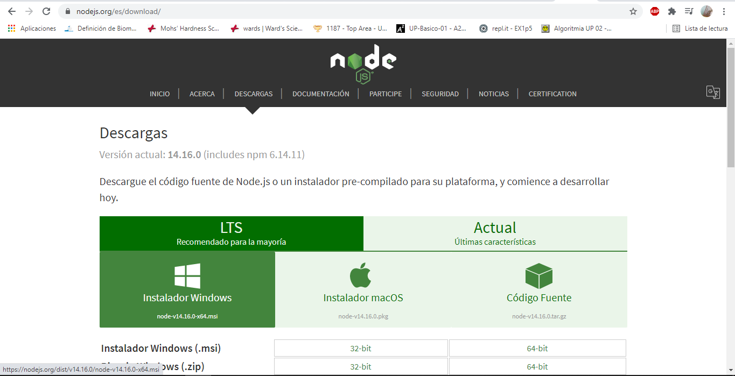

Now we are going to install the Angular CLI, which will help us create an angular project from scratch. The installation will be global so that it is available in all the projects on your computer. It is recommended to run this command as an administrator. In terminal “cmd”, type the following command:

npm install -g @ angular / cli

If the installation asks you to choose some type of style sheets, we will use CSS

Having the files of the Hospital Hidalgo, inside the folder belonging to the front-end currency “Hospital”, we will be shown more folders, we will access it in the console to enter the following code we will use the “src” folder to start working.

ng serve -o

Something like this should appear, then the page will open in your default browser.

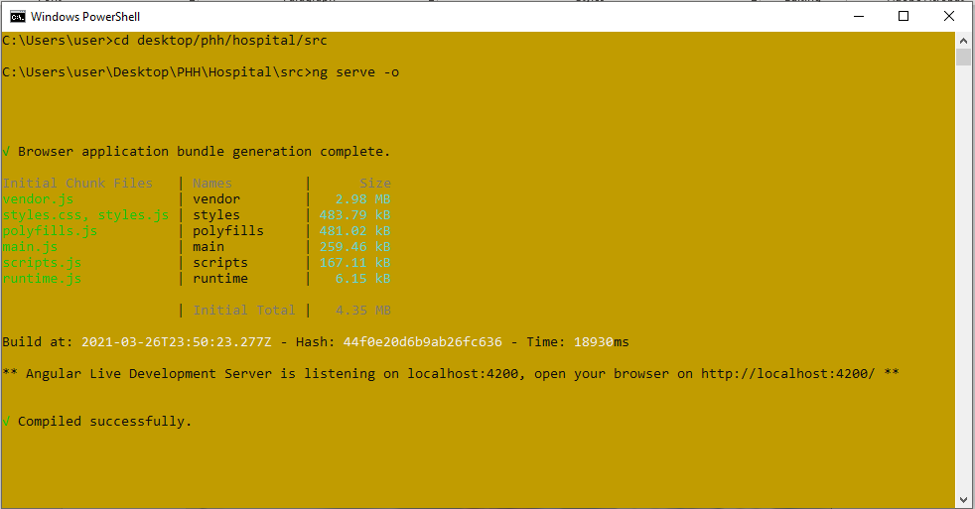

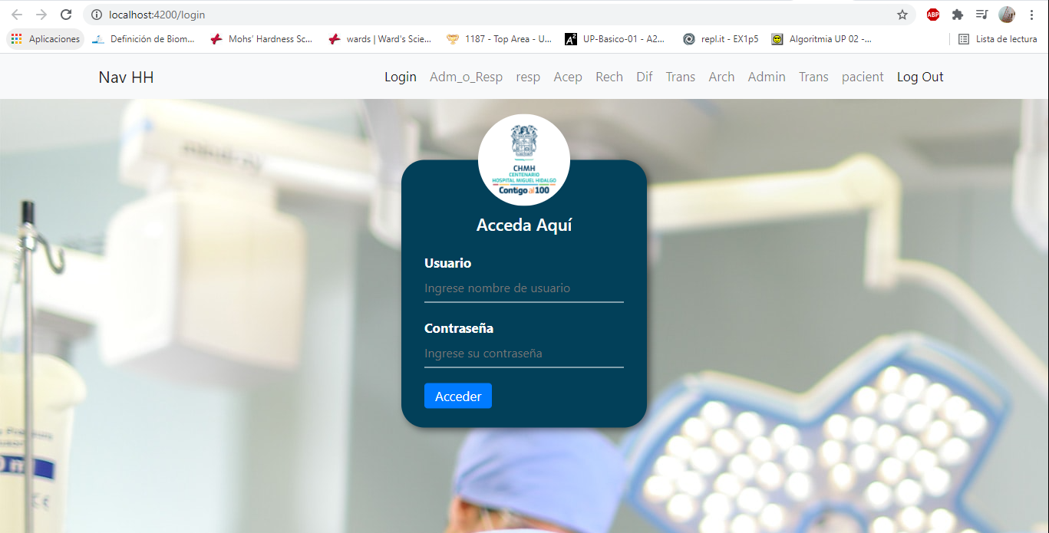

In this way we will have the project in our browser. Now we are going to edit it using our preferred ID.

We just open the ID and look for the “src” folder of our project in Angular.

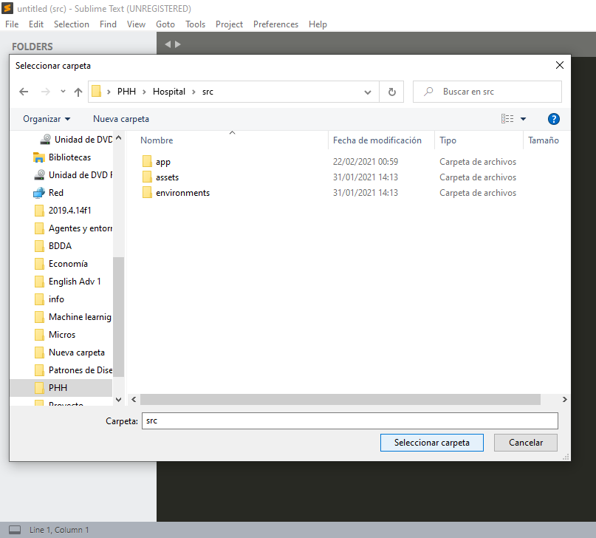 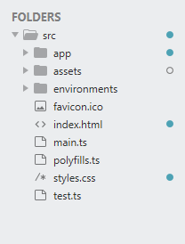

Now that our folder appears, it is worth mentioning that within "app" you will find the components that I will explain step by step to ease the search of our templates, one by one, together with their style sheets and their connection with the back-end . They are Angular functions that allow us to have a better handling of our information.

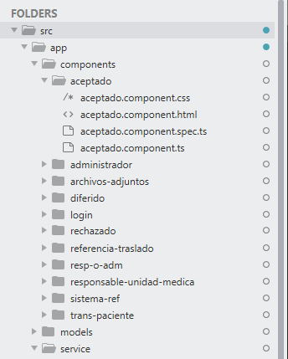Each component inside the "components" folder shows us individually each template used in the project, divided into 4 files, "html, css, spect.ts and .ts(TypeScript)".

HTML: will be our template created in html5 and bootstrap language, to facilitate editing and optimize project creation time, in such a way that any changes the client wishes can be made more easily

CSS: Bootstrap does not always meet our expectations 100%, for this reason, css style sheets are still used to manipulate our template.

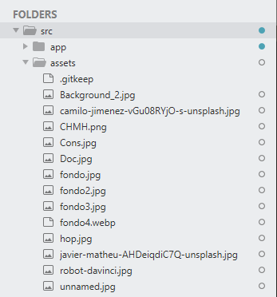The "assets" folder, similarly, generated by Angular, is where the img, icon and background files are stored, to have a better order and redirect more easily in our .html components, for example img = "assets / background1.png "