**Gym Client Management System – User Manual**

**By Racila, Cristian & Neflas, Florence Keith**

**Features:**

**User Controls and Visual Inheritance**

First and foremost, all the forms we created visually inherit the following Form. The latter consists of three user controls: languages, time and exit.

Figure : Base Page

**First Form**

As the user (the employee) opens the application, they should be welcomed to the Welcome page and must enter a unique username and password which is only known to employees (Figure 1). **The user must type in ‘user’ inside the textbox next to ‘Enter Username’ and ‘123’ inside the password textbox. Once that is complete, they can click on the ‘Login’ button. (Figure 2)**

Figure : First Page of the application

Figure : User inputting username and password

**However, if the user enters invalid username or password, the user receives a warning message box that indicates that the user has 3 tries left to login before the application closes:**

Figure : Attempts message box

**After the user enters the valid username and password and clicks on the ‘Login’ button, the following message box will appear indicating that the user successfully logged in.**

Figure : Successfully logged in

**Second Form**

**Tab Page -1**

After logging in successfully, the user is greeted with the first tab which is to **view all clients. As shown in Figure 5, this feature included a scroll bar to view all the clients and their information (which consists of their ID, first name, last name, email, address, postal code and age). If a client is banned, this will be mentioned first and foremost, as shown in Figure 6.  
**

Figure : View all the clients inside a rich textbox

**Tab Page -2**

The next tab displays one client at a time. This window has a ‘Previous’ and ‘Next’ button that is used to navigate through the list of clients. The clients are sorted by their ID, so the first client to appear would be the smallest ID value, and the last client to appear would have the highest ID value. Also, if the user presses ‘Previous’ when at the beginning of the list of clients, they would view the last client of the list. This same behaviour is applied when the user views the last client and clicks on ‘Next’, which brings them to the first client of the list.

Figure : Navigate through the list of clients one by one

**Tab Page -3**

Next, the last tab page will be used to add or modify a client. Here, **the user must fill up the textboxes that require the first name, last name, age, phone number, email, address and the postal code. Giving invalid input for the first and last name would output the Figures 9 and 10.**

Figure : ‘Add/Modify a Client’ Tab Page

Figure : Invalid First Name format

Figure : Invalid Last Name format

The age textbox limits the user to only input ages from 12 to 99. Typing an extra digit for example to the phone number will make the message box from Figure 11 appear. Also, the address must be formatted in a way that included the street number and street name as shown in Figure 12. Lastly, the postal code must follow a certain format as well for the client to be successfully added, shown on Figure 13.

Figure : Invalid phone number format

Figure : Invalid home address format

Figure 13: Invalid Postal Code format

When the user successfully adds a client, a message box will appear mentioning that the client added successfully. 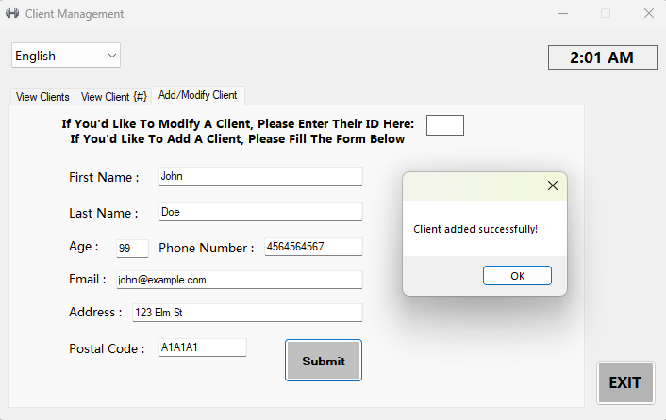

Figure : Client successfully added message box

The tiny textbox situated on the top right of the page is used to input an existing client’s ID (shown in Figure 15). If the user inputs an invalid/nonexistent client ID, then the output will be shown in Figure 16. Additionally, if the employee enters the ID of a banned client, then a message box will appear mentioning that only the manager can access them (as shown in Figure 17). After entering a valid the ID inside this textbox, the employee user must press ‘Enter’ on the keyboard to proceed with the following options: “Manage Subscription and Payments”, “Ban This Client” and “Delete This Client”. Also, entering an existing client ID will fill in the textboxes with their corresponding information, which can be shown in Figure 18. Let’s say the user wants to ban a client: a prompt will pop up to notify the user that this action is irreversible (Figure 19). Same goes for the delete button: a message box will appear to let the user confirm if they want to delete the certain user (Figure 20)

Additionally, the employee can set the client’s membership as shown in Figure 21. Initially, when the employee is inside this page, the buttons are checked for ‘Regular’ and ‘Monthly’. The user can have the option to choose either regular membership or premium membership and choose the payment plan. It is important to keep in mind that you can only choose one membership and one payment plan for the client. If you click Pay’, the user will receive a message box in the last figure (Figure 22).

Figure : ID Textbox

Figure 16: After entering a non-existent Client

Figure : Trying to gain access to Banned Client as a regular staff

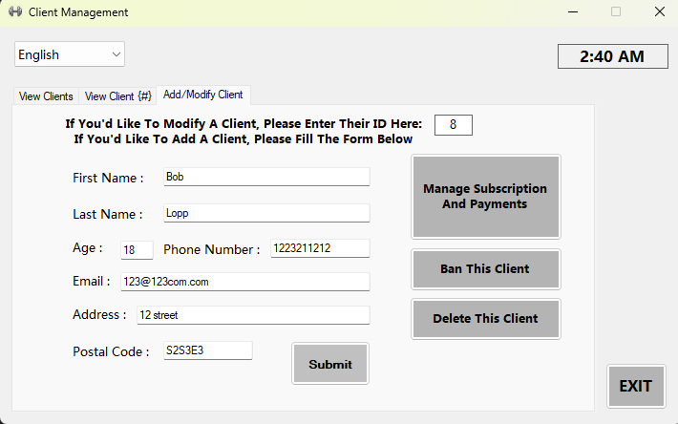

Figure : After entering an existing client ID inside the textbox

Figure 19: Ban a Client prompt

Figure : Delete a User prompt

Figure : Payment Membership Management window, which is opened by clicking the ‘Manage Subscription And Payments’

Figure

**This is where the application ends**

**Languages:**

The user has the option to choose another language other than the default language (English) for this application.

**Additional Features:**

All forms are not resizable and appear at the center of the user’s window.