Authorisation and Privacy Policies in Patient-Centric Blockchain

Project Report

BACHELOR OF TECHNOLOGY

in

Chemical Engineering

Submitted by
Chris Cyprian Pinto
160903016

Under the guidance of

Dr. Rohini R Rao  Assistant Professor- Senior Scale  Department of Computer Applications | Dr. Manjunath Vishweshwar Hegde  Assistant Professor  Department of Computer Applications


DEPARTMENT OF CHEMICAL ENGINEERING
MANIPAL INSTITUTE OF TECHNOLOGY
(A constituent unit of MAHE), MANIPAL-576104

June 2020
18 June 2020

CERTIFICATE

This is to certify that the project work entitled “Authorisation and Privacy Policies in a Patient-Centric Blockchain” submitted to MAHE during June 2020, for the partial fulfilment of Bachelor of Technology in Chemical Engineering by Chris Cyprian Pinto is a bonafide record of original work carried out by him during the period from January 2020 to June 2020. The work reported herein does not form part of any other thesis or dissertation on the basis of which any degree, diploma, associateship, fellowship or other titles was awarded.

Dr. S. V. S. R. Krishna Bandaru Dr. Rohini R. Rao

Professor and Head Assistant Professor – Senior Scale
Department of Chemical Engineering Department of Computer Applications

ACKNOWLEDGEMENT

I would like to express my special thanks of gratitude to my guide Dr. Rohini Rao for all her guidance and support throughout the duration of the project. Despite the onset of the pandemic which forced all of us to work remotely, I was able to satisfactorily complete the project under her supervision despite only having an ardent interest in this technology and no prior experience. I would also like to extend my gratitude to Dr. Manjunath Hegde, who was always there to assist whenever needed. His expertise on the subject matter proved to be incredibly beneficial. Through their support, I was able to dip my feet into a whole area of technology that I someday wish to continue working for.



SYNOPSIS

In the age where data is considered to be one of the most precious assets, the same could be said for data pertaining to our personal medical data. Medical data, from early paper-based records to its evolution to the digital form owing to the advent of IT has come a long way. But with these strides in improvement and the proliferation of terabytes of data, concerns revolving security and privacy crept in. With data breaches, hacking and theft being commonplace, measures need to be taken to ensure that the privacy of every individual’s medical data. Blockchain offers one potential solution to these problems. In this project, we specifically looked towards the particular use case of e-referrals from a Primary Health Centre (PHC) to a Government Hospital in the case of pregnancies. A PHC issues a referral for a patient when certain complications arise in which they do not have adequate resources to treat the patient at the premises. This an occur during the prenatal, postnatal or delivery stages of a pregnancy. The properties of blockchain surrounding decentralization, privacy through anonymity, security through authentication systems and the possibility of interoperability of data make it a perfect candidate for its use case in the medical field, specifically in the storage and protection of medical records. In this project, we develop a novel blockchain based solution in a patient-centric scenario.
Firstly, the design of three different levels of privacy between different stakeholders was identified. This has a significant impact in developing the network topology. The network setup and its topology had been obtained during the first half. A network between government, primary health centre and government hospitals had been created, and a sample token transaction has been implemented to test the network. During the second half of the project, a smart contract (explained in the third paragraph) specific to the use case was built to move a patient from the different states of registration, request for a check-up, treatment and referral. Following this was the creation of applications for the different stakeholders to interact with these smart contracts to process the transactions on to the blockchain. Finally, a benchmarking test was conducted to evaluate the performance of the network and the different transactions to understand the possibility of scalability in the Indian reality.
Authorization and privacy policies are the key focus to ensure that only the right users have access to the right data. This is enabled through the use of access control built into the software, combined with the dynamic use of smart contracts. Smart contracts are pieces of code that are used to trigger some sort of transaction (appendment of the ledger) based on the access control and identity of the individuals or organization. Hyperledger Fabric was used entirely to design and implement the network alongside the use of Docker to simulate different organizations and their peers. JavaScript through NodeJS was used as the primary language for the smart contracts. Hyperledger Caliper was used for benchmarking purposes.
The future scope of the project includes expanding the current model for more stakeholders such as research centres, private hospitals and insurance companies, as well as integrating a robust UI to interact with the smart contract logic.
LIST OF TABLES

Table No | Table Title | Page No
1.4.1 | Project Schedule | 4
2.1.1 | Blockchain-based approaches for an EHR system | 6
3.6.1 | Key Variables Table | 21
3.6.2 | Registration of Patient | 22
3.6.3 | Request PHC Check-Up | 22
3.6.4 | PHC Treatment | 22
3.6.5 | Government Hospital Treatment | 22
3.6.6 | Issue of E-referral | 23
3.6.7 | Acceptance of E-referral | 23

LIST OF FIGURES

Figure No | Figure Title | Page No
3.2.1 | System diagram for the implementation of our framework | 9
3.2.2 | Diagram of a peer | 10
3.3.1 | The state transition diagram for a patient | 12
3.4.1 | Transaction 1 | 13
3.4.2 | Transaction 2 | 13
3.4.3 | Transaction 3 | 14
3.4.4 | Transaction 4 | 15
3.4.5 | Transaction 5 | 15
3.4.6 | Transaction 6 | 16
3.4.7 | Query Method | 16
3.4.8 | PatientList.js file calling the Fabric Methods | 16
3.4.9 | addState method which uses the putState API | 17
3.4.10 | getState method which uses the getState API | 17
3.4.11 | updateState method which uses the putState API | 17
3.5.1 | Enrolling a user | 18-19
3.5.2 | Request Application | 19-21
4.1.1 | Running the byfn.sh script to start the network | 25
4.1.2 | Channel being created and patient peer joining the channel | 25
4.1.3 | Chaincode installed on peer | 26
4.1.4 | Chaincode instantiated on the channel | 26
4.1.5 | ‘instantiate’ function from contract being called | 26
4.2.1 | Enrolling and Registering admin and user for the Patient Organisation | 26
4.3.1 | Running the Register Application | 27
4.3.2 | Running the Request Application | 27
4.3.3 | Running the Referral Issue Application | 28
4.3.4 | Running the Referral Acceptance Application | 28
4.3.5 | Running the Government Hospital Treatment Application | 29
4.3.6 | Running the Query All Details Application | 29-30
4.4.1 | Summary of Transactions (PC1) | 31
4.4.2 | Register Transaction Benchmark (PC1) | 31
4.4.3 | Register Transaction Resource Consumption (PC1) | 31
4.4.4 | Register Transaction Resource Consumption Bar Plot (PC1) | 32
4.4.5 | Summary of Transactions (PC2) | 33
4.4.6 | Register Transaction Benchmark (PC2) | 33
4.4.7 | Register Transaction Resource Consumption (PC2) | 33
4.4.8 | Register Transaction Resource Consumption Bar Plot (PC2) | 34
5.1 | GitHub Structure | 38

Contents
 |  |  |  |  | Page No
Synopsis |  |  |  |  | i
List of Tables |  |  |  |  | ii
List of Figures |  |  |  |  | ii-iii
Chapter 1 |  |  | INTRODUCTION |  | 2
 | 1.1 | Security in healthcare and its Importance |  |  | 2
 | 1.2 | Motivation |  |  | 3
 | 1.3 | Objective |  |  | 4
 | 1.4 | Project schedule |  |  | 4
Chapter 2 |  |  | BACKGROUND THEORY |  | 5
 | 2.1 | Literature Survey |  |  | 5
Chapter 3 |  |  | METHODOLOGY |  | 8
 | 3.1 | System Configuration and Software Implementation |  |  | 8
 | 3.2 | Network Setup and Topology |  |  | 9
 | 3.3 | Patient Lifecycle |  |  | 11
 | 3.4 | Smart Contract and Transactions |  |  | 12
 | 3.5 | Applications |  |  | 18
 | 3.6 | Identity and Data Management |  |  | 21
 | 3.7 | Benchmarking |  |  | 24
Chapter 4 |  |  | RESULTS AND DISCUSSIONS |  | 25
 | 4.1 | Running the Network |  |  | 25
 | 4.2 | Enrolling the Admins and Users |  |  | 26
 | 4.3 | Running the Applications |  |  | 27
 | 4.4 | Simulation Results |  |  | 30
 | 4.5 | Result Discussion |  |  | 34
Chapter 5 |  |  | CONCLUSION |  | 36
REFERENCES |  |  |  |  | 37
SUPPLEMENTARY RESOURCES |  |  |  |  | 38

CHAPTER 1
INTRODUCTION

Smart technologies have significantly improved over the last decade. Healthcare systems which are used by hospitals have also adapted to these technologies. These technologies have become increasingly competent in handling large datasets. This section introduces relevant smart technologies which are currently in use in the health industries [1][2]. Also, it introduces to some of the previous works and its shortcomings. At the end of this chapter, we will have good clarity on what we want to achieve and the importance of the result.
When the healthcare provision started in 1970, the development of measured IT frameworks has been observed. This timeframe was called Healthcare 1.0. During this time, healthcare frameworks were constrained and not facilitated with digital frameworks because of the absence of resources. Also, bio-medical machines had not been developed and integrated into networked devices. Due to which, prescriptions and reports were mainly in written form, which in turn increased the cost and time involved [1]. Next came the Healthcare 2.0 era. In this time, information technologies and health were combined to form the healthcare ecosystem. During this time, digital tracking was introduced, which provided imaging systems for a better understanding of the patient’s health. Simultaneously, new user enabled advancements started to develop in the healthcare industry, surfacing close by the advent of social media. Medicinal services suppliers started to make online networks for information and data sharing, storing health data on cloud servers, and give access to archives and patient records through mobile devices, empowering pervasive access for both the supplier and patient.
Next came the Healthcare 3.0, enabling user customisation of health records. During this time, the introduction of Electronic Health Records (EHRs), wearable and implant systems took place. The era of Healthcare 4.0 started from 2016 to the present day. This time was derived from the idea of Industry 4.0, where Hi-tech and Hi-contact frameworks are being presented, such as cloud computing, big data analytics, blockchain and AI [3]. During this time, EHRs were shared on networks like social media, between clinicians. Interaction and exchange of data has become very simple.

1.1. Security in healthcare and its importance
Introduction to the online exchange of health data and connection to a networked environment created its set of disadvantages. This digital environment created important requirements in the security and privacy of the patient’s health data. Privacy meant that having proper rights to view health records. It is also the point of determining who is allowed to access that information [4]. Due to these, many guidelines have been created to secure the data. Health data are often stored in cloud storage or centralised server, making it a very easy target for malicious attacks and private information being illegally shared. Health data typically includes a record of services received, conditions of those services, and clinical outcomes consequent of those services [5]. Another major challenge facing electronic health record systems (EHR) is to make it interoperable. For a complete picture of the patient, all of the important systems should be able to communicate with each [6] [7].
Security is to protect data from attacks, stealing of data, and it is very much important for addressing privacy [8]. In 2018 alone, there have been many data breaches which have resulted in 13 million healthcare records exposed in the US. Speaking about India, during the period of 1st October 2018 to 31st March 2019, a staggering total of 6.8 million health records were stolen [7]. These databases were sold in the underground. The most common electronic method used by hospitals to transmit health info was via a health information systems provider (HISP). Some of the other methods of information transmission are single EHR vendor, local health information, multi-EHR. Mailing or faxing are some of the common methods of data transmission [9].
EHR standards 2016 for India: Current laws regarding data ownership are [10] the physical or electronic records, which are generated by the healthcare provider, are held in trust by them on behalf of the patient. The patient owns the contained data in the record, which are the protected health information of patients. The healthcare provider will own the medium of storage or transmission of such electronic medical record. The “sensitive personal information (SPI) and personal information (PI)” of the patient is owned by the patient himself/herself. Security and Privacy Rules: The requirements for privacy and security are given in the following standard. ISO/TS 14441:2013 Health Informatics – Security & Privacy Requirements of EHR Systems for Use in Conformity Assessment [10].

1.2. Motivation
The patients are the true owners of their health data, but this is usually not the case. Hospitals and other health data centres own our health data. This project focuses on designing a system which gives this ownership as well privacy back to the patients. Usually, the main identifiers are removed from the health records and are sold for third parties like research labs and companies. However, with enough attributes put together, these companies can backtrack to the patients. This results in a lack of privacy for the patients and also this can be taken advantage of. This project designs a network keeping the ownership ideas in mind. To achieve this, blockchain technology is used for the development of the network. The fundamental properties of the blockchain are privacy and security. Using these properties, a patient-centric blockchain model was created particularly for the e-referral use case in a Primary Health Centre (PHC), whereby a patient, coming in for delivery or a prenatal/postnatal check-up is treated or referred to a government hospital in the case where a complication arises at the PHC. Authorisation is enforced through the use of the designed smart contracts, where only the right users have the access to trigger them, causing some update/change in the contents of the blockchain.

1.3 Objective
The primary objective is to build and enable the logic of smart contracts for the e-referral use case while identifying the access permissions of an entity before providing the data. Also, to provide privacy policies in order to ensure that only the right people have the permission to access/get the records.

1.4 Project schedule
Table 1.4.1 Project Schedule
January | Literature survey, review of previously proposed work and study of different cryptosystems was done. The course “Introduction to Blockchain Technologies” by INSEAD was completed.
February | Choosing the technology stack, design of the network topology and creation of the initial three organization (Patient, Government Hospital and PHC) network.
March | Learning of JavaScript on NodeJS, and initial building of the smart contract while perfecting the network components.
April - May | Completion of the entire smart contract code, creation of organization enrolment and registration files and creation of application files to interact with the smart contract to commit changes or query from the blockchain.
June | Benchmarking of the created smart contract on the same/similar network configuration.

CHAPTER 2
BACKGROUND THEORY

In this section, we review some of the articles in terms of privacy and authorization. The major objective is to introduce access control for medical data by using blockchain technology. Comprehensive literature survey of some of the past articles which focus on blockchain in healthcare and some of them in privacy and authentication systems. Table 2.1.1 indicates some of the blockchain-based approaches to EHR systems.
There are four main stages for including blockchain technology in the health sector. Firstly, healthcare providers like hospitals have direct access to the blockchain network. That is, all health data are stored in the existing systems. There are many transactions like making appointments or doctor’s prescriptions in the network. All these transactions are done using the patient’s public and relevant data like patient’s IDs are stored in the blocks. The smart contracts bound all the transactions. If any of the third parties want to access the patient’s data, then the patient must authorise it, only then data will be made available. Data made available to third parties will be properly masked, and the data will be confidential for those who do not have access to it.

1.1 Literature Survey
Storing of health data in a secured state is very much important. Currently, these data are stored in a centralised server or doctor-client servers. If these servers are not well up to date in terms of security updates, then these networks are prone to hacking and may result in serious data breaches. Storing data in the cloud has become more common in healthcare 4.0 systems. Storing health data with the third party is also dangerous if proper methods are not taken beforehand. All these systems have vulnerabilities. Yup et al. [11] had investigated the approach of using the blockchain framework in healthcare services with regards to security and privacy of the client. They proposed a data access control scheme for maintaining privacy and designed the healthcare data gateway. Zhang et al.[12]also proposed a PSN based system to make a secure healthcare ecosystem. He proposed protocols in sharing and authentication. Xia et al. proposed a blockchain-based system called MedShare [13]. This system had access control, provenance and security of medical records. Jiang et al. [14] proposed a system for the exchange of medical data using blockchain. This system also included off-chain and on-chain methods of storing medical data. There are different projects done by many other researchers addressing the privacy and security concerns of the digital health data, but the very few of it discusses the concepts of ownership of the health data.
Some of the previous work of blockchain in healthcare in terms of privacy have been listed out. Uddin et al. [15] have implemented system architecture on a continuous patient monitoring system. This uses the patient-centric model. They have increased the security and privacy of the system and implemented them using network simulation. Gaby et al. [16] proposed a blockchain framework called Ancile. The main idea behind this framework was access control and interoperability of health records. Privacy-preserving framework for access control and interoperability of electronic health records using blockchain technology. It uses Ethereum blockchain and uses smart contracts for access control and uses cryptographic techniques for security. They have followed HITECH and HIPAA guidelines. Abdullah et al. [17] and the team proposes blockchain-based platform names Medibchain. This framework follows patient-centric management and uses blockchain technology as security for storage in the cloud. This helps in maintaining privacy. They have used permissioned blockchain; as a result, anyone who wants to access the network requires permission.
Sundeep et al. [2] have implemented a patient-centric blockchain application for satisfying the needs of the healthcare 4.0. This article proposes algorithms for access control and shows metrics on experimental analysis. Faisal et al. [18] have implemented a blockchain model for drug supply chain management. The main idea was to make a system such that they can track medicine from the manufacture to the pharmacy and helping in identifying counterfeit drugs. In this, they have discussed network topology, and the experimental analysis has been done. It uses Hyperledger Fabric framework for implementation.
Previous work in blockchain has been divided into five major categories which are architecture, access control policy, algorithms, framework and performance evaluation. The table gives a detailed scenario of the blockchain in healthcare.

Table 2.1.1: Blockchain-based approaches for an EHR system. Y indicates yes and N indicates No.
Author | Year | Objective | 1 | 2 | 3 | 4 | 5 | Results
Abdullah et al. [17] | 2018 | Patient-centric healthcare data management system using blockchain technology. | Y | N | Y | Y | Y | It achieves pseudonymity, privacy, integrity and security. Performance analysis shows good results.
Tien Tuan et al. [19] | 2017 | An evaluation framework for analysing private blockchains. | Y | N | N | Y | Y | Hyperledger performs consistently better than Ethereum and Parity across the benchmarks. But it fails  to scale up to more than 16 nodes.
Gaby G  Et al. [16] | 2018 | Propose a blockchain-based framework for secure, interoperable, and efficient access to medical records by patients, providers, and third parties, while preserving the privacy of patients’ sensitive information. | Y | Y | Y | Y | N | The Ancile framework demonstrates a blockchain system that achieves a high level of decentralisation while acknowledging that  some nodes ought to be of a higher authority.
Bhabendu  Et al. [20] | 2019 | The main focus of the survey is to provide a comprehensive analysis of wide applications of blockchain technology for the academic research community. | Y | N | N | Y | N | In this paper, challenges in implementing blockchain and its associated security and privacy issues have been discussed.
Wenbo Jiang et al. [21] | 2019 | Analysis of thin-clients into consideration where thin-clients indicate those users who cannot download the entire blockchain due to the limited storage capacity of their equipment. | N | N | Y | Y | Y | It analyses the burden on mobile devices.
Sukhwani et al. [22] | 2018 | To develop a permission-based blockchain platform | Y | Y | N | Y | Y | Identified permission blockchain integrity
Poslad and Poslad  [23] | 2018 | To suggest access policy to EMR based systems using blockchain | Y | Y | N | N | N | It says about finer granular control, but it's just theoretical only.
Guo et al. [24] | 2018 | To propose a secure ABE scheme with multiple authorities for blockchain in EHRs | N | Y | Y | Y | Y | Says about the Immutability of the information ledger
Zhang et al. [25] | 2017 | To develop a secure health system for an extensive network. | Y | N | Y | N | Y | Says about how to share the load of the network
Fan et al. [26] | 2018 | To strengthen efficient and secured health record sharing with a blockchain network | Y | Y | Y | Y | Y | Record management and sharing from EMR systems and access mechanism.
1:Architecture 2: Access control policy 3: Algorithms 4:Framework 5: Performance evaluation

In conclusion, various journal articles were read and understood to implement our problem statement. Each of the papers helped in understanding what technology stack needs to be used, network topology, understanding algorithms, and helping in getting a better picture to achieve our objective.
CHAPTER 3
METHODOLOGY

The Methodology has been divided based on the chronological steps taken to reach the objective. Section 3.1 introduces the system used for all coding, testing and simulation purposes along with the software and tools needed to successfully implement the project. We then talk about all the Network related information including the topology in Section 3.2, which is the organisation structure used for the consortium blockchain. Here, we also mention how Hyperledger Fabric deals with the overall consensus in the system through the Execute, Order and Validate method as opposed to other blockchain platforms. In Section 3.3, we introduce the concepts of the Patient Lifecycle, States and Transactions. It incorporates the ideas used particularly for the use case of a patient interacting with the PHC and Government Hospital. The core of the project, the implementation of the smart contract (also synonymously called Chaincode) to define these transactions is covered in Section 3.4. The smart contract is the business logic required to traverse the patient through the patient lifecycle, i.e., her different states. The next step is the creation of applications to run these smart contract transactions. Applications are essential for users of a particular organisation to trigger the mechanism of the smart contract to interact with the blockchain. Applications are covered in Section 3.6. The data pertaining to each state, such as patient personal details or treatment details is covered in Section 3.7, where we define all the variables used in our implementation. Finally, the chapter ends at Section 3.8 where we benchmark the created network and the smart contract transactions to understand the technical implications and whether it is viable to integrate this model in a real case scenario in the Indian context.

3.1 System Configuration and Software Implementation
The PC used for all testing and simulation has the following configuration:
- 2 core CPU (Intel Core i5-6200U @ 2.30GHz)
- 4 GB RAM
- 4GB Intel HD Graphics 520
- 500GB HDD
- OS: Ubuntu 16.04

The blockchain-based framework, called Hyperledger Fabric, is used for developing the proposed project. Hyperledger Fabric is open-source software. It is developed by the Linux foundation. They support different blockchain projects and provide various support for different types of smart contract and different application. Fabric provides permissioned, and a consortium managed blockchain. It works on the assumption that the participants in the network are trusted and known to each other. This framework supports various coding languages like Java, Node JS, Go and it is mainly used to develop business networks. Fabric makes use of Docker engine for setting up the network. Docker is an operating system level container which is used by fabric. It helps in developing, creating and running fabric network by making each peer in the network as a separate container.
Hyperledger Caliper is a blockchain benchmark tool, it allows users to measure the performance of a blockchain implementation with a set of predefined use cases. Hyperledger Caliper will produce reports containing a number of performance indicators to serve as a reference when using the following blockchain solutions: Hyperledger Besu, Hyperledger Burrow, Ethereum, Hyperledger Fabric, FISCO BCOS, Hyperledger Iroha and Hyperledger Sawtooth.

3.2. Network Setup and Topology
This section describes the network setup of proposed blockchain based EHR system. The Fig. 3.1.1 represents the entire overview of the created network. At the centre of it all is organisation 1, the patient organisation, identified by P1 (patient peer), A1 (patient application) and CA1 (patient’s certificate authority). It is an entity responsible for maintaining peers (one of which is P1) through which patients can access their medical data. Like all other organisations, it is uniquely identified through the use of a digital certificate issued by a Certificate Authority (CA1). Likewise, Organisation 2 corresponds to a PHC and organisation 3 corresponds to a Government Hospital.

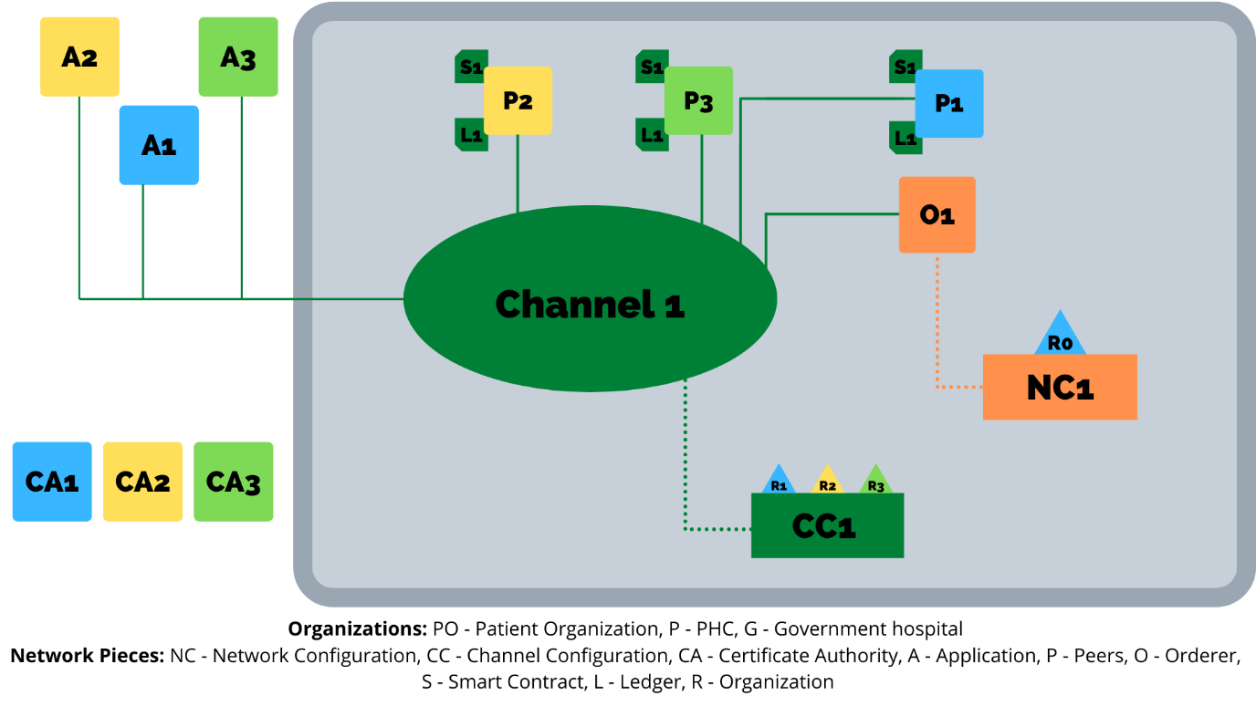
Fig. 3.2.1 System diagram for the implementation of our framework

Network Configuration (NC), which contains the information about the system channel (by default, every network consists of a system channel maintained by the orderer(s)) and several other details like the block size, ordering service and orderer information. It also defines access permissions such as who has the rights to create a channel, which is currently only given to the patient organisation. Likewise, the channel configurations comprise the details of the respective channels. Each organisation has its application interface to communicate through the use of a UI. They also have their own set of peers (one per organisation for now as per the diagram) with each peer having their own dynamically updated ledger and the respective smart contracts installed. Since we are using just one peer per organisation, for now, the peer is an anchor peer, and depending on the endorsement policy of the smart contract, it will be an endorser peer as well. Currently a fourth independent organisation owns the single orderer, but during the deployment stage, there will be a shift from the Solo ordering mechanism to another consensus mechanism to include orderers from other organisations and to increase the decentralisation.
Channel 1 is for the referral mechanism involving the writing of patient data on the blocks. The patient would initially go to the PHC (organisation 2). After their check-up, the patient medical data is written onto the blockchain. The patient may be referred to a government hospital (organisation 3), where further updates take place on the patient’s medical record on the blockchain. As a result, this channel is private. These read accesses are enabled through the use of smart contracts. An important point to be kept in mind is that the patient has complete control over who gets access to read, write or update his/her medical data, which enables privacy. We used the default settings for authentication, which involves the use of PKI and certificates, and the default consensus mechanism (Solo).
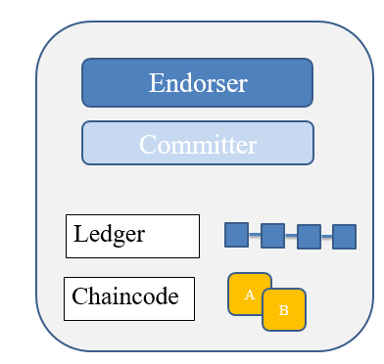
Fig 3.2.2. Diagram of a peer

Each of the peers has some of the components depicted in Fig 3.1.2. Firstly, they are an endorser peer, which endorses the transactions. There will be a copy of the ledger in each of the peers, and this ledger depends on the channel to which the peer is connected. Each peer will have chaincodes installed on them (chaincode needs to be installed on peers if they need to transact on the blockchain). In our use case, chaincode is synonymous to smart contract.

Transaction Flow: Hyperledger Fabric introduces a new architecture for transactions that they call execute-order-validate. It addresses the resiliency, flexibility, scalability, performance and confidentiality challenges faced by the order-execute model by separating the transaction flow into three steps:
- Execute a transaction and check its correctness, thereby endorsing it,
- Order transactions via a (pluggable) consensus protocol, and
- validate transactions against an application-specific endorsement policy before committing them to the ledger
This design departs radically from the order-execute paradigm used by most other platforms in that Fabric executes transactions before reaching final agreement on their order.

Expanding the transaction flow for our use case,
Step 1: A client (such as a particular patient or a nurse in a PHC) initiates a transaction. Any one of the organisations will first initiate a transaction through the use of their application SDK. An example of a would be the registration of patient details on to the blockchain. When a proposal is made, a request is made for invoking the smart contract. This chaincode says what data can be read and/or written into the ledger (i.e. write new key-value pairs for the asset – the asset being the patient details).
Step 2: Endorsing peers verify signature & execute the transaction. The endorsing peers verify that: transaction proposal is valid by checking the signatures and it also checks if the submitter is authorised to make the request. If each of this is valid, then it submits the request. During this time no updates to the ledger take place. If everything is valid, a “proposal response” which contains the signature of the endorsing peer’s is passed to the SDK.
Step 3: Obtained proposal response is inspected by comparing it with the endorsing peer’s signature to check if it is a valid response. If it is valid, the client makes the transaction. This is then broadcasted to the ordering services and other anchor nodes. Orderer receives all transactions and orders them according to the timestamp of the transaction. The orderer proposes a new block. World state gets updated. Each peer appends the new block to its a copy of the ledger.

3.3. Patient Lifecycle
The patient lifecycle identifies the journey the patient undertakes when interacting with the PHC and Government Hospital. Our use case pertains to a cyclic lifecycle, whereby the patient is introduced into the blockchain and completes a cycle after every round of treatment. There are two broad scenarios that encompass this cycle.
- A patient first registers on the blockchain by providing their personal information. She then requests for a PHC check-up. The next step would be the treatment of the patient at the PHC.
- The second scenario has the same start (registration on the blockchain and request for a check-up) but in this case, we expect a complication to arise such that the PHC issues a referral. A government hospital then accepts this referral and treats them.
After the completion of any of these two scenarios, the cycle will start again once the patient requests for another check-up. Important Note: Every patient is uniquely identified through the combination (composite key) of Patient First Name and Patient ID. For example, a patient by the name of Chris with a patient ID of 12345 would be uniquely identified by the key ‘Chris12345’. All the data for this patient is attributed to the key value pair.
There are two important concepts that concern us when dealing with a patient: states and transactions. Indeed, this is true for all blockchain use cases; there are conceptual objects of value, modeled as states, whose lifecycle transitions are described by transactions. The following diagram describes the changes in states through the use of transactions.

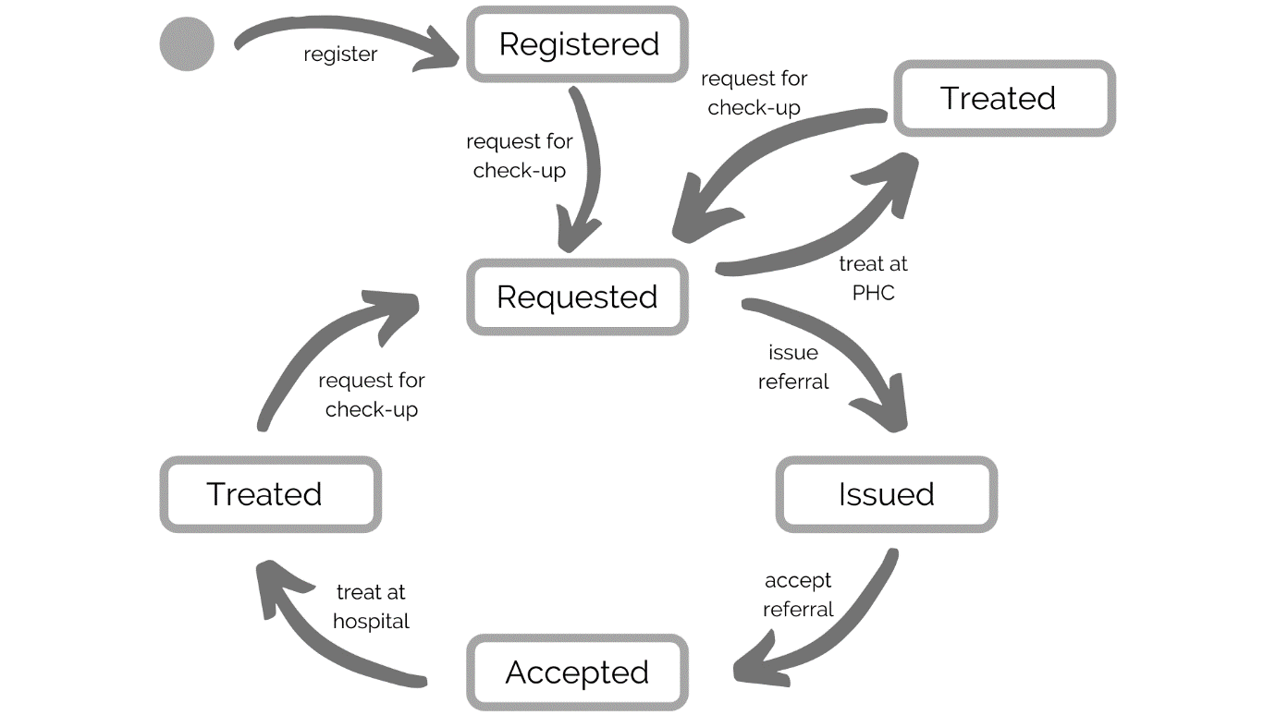
Fig. 3.3.1 The state transition diagram for a patient. The patient transitions between registered, requested, issued, accepted and treated (two types) states by means of the different transactions.

3.4. Smart Contract and Transactions
The three entities form a consortium. They have a private and secure channel in which any of them can communicate. Depending on the organization, the right access controls for reading and writing of data to the blockchain need is granted. This is done through the concept of authorization. Also, in order for the transactions to actually take place, smart contracts were designed which call Fabric class methods to interact with the data, such as querying data or writing a specific diagnosis on a patient’s EHR. There exists six transactions and one query method.
- Transaction 1, Register: This transaction registers the patient on to the blockchain. It adds the personal details specified in the application to the asset. All details pertaining to further states have been assigned a string of ‘N/A’. These will be filled with data once the patient traverses through different states. Only a patient can call this transaction. It also initializes the state variable to ‘Registered’.
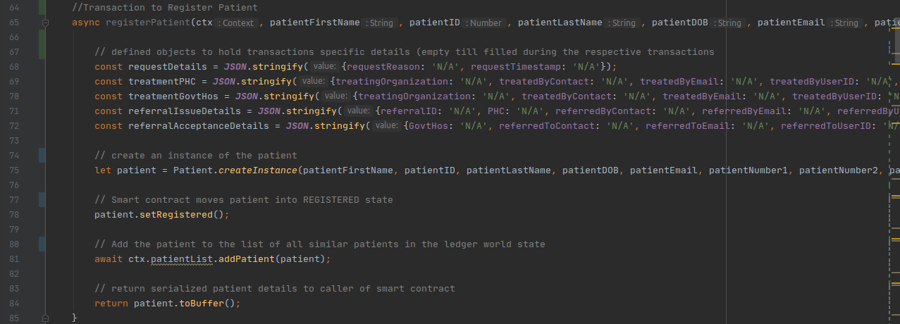
Fig 3.4.1 Transaction 1

- Transaction 2, Request for Check-up: This is for the patient to request for a check-up. Only a patient can call this transaction. Once this transaction is called, details pertaining to the request is updated on the patient’s asset. It also moves the patient’s state from ‘Registered’ to ‘Requested’.
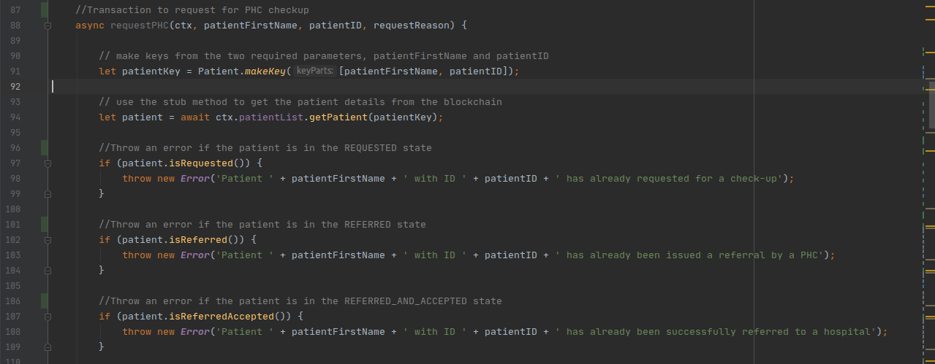
Fig. 3.4.2(a) Transaction 2

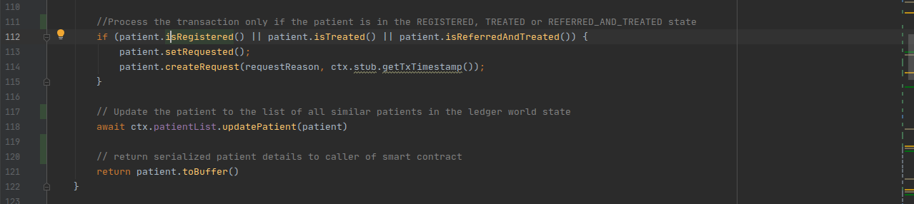
Fig. 3.4.2(b) Transaction 2

- Transaction 3, Treat at PHC: This transaction updates the data pertaining to the treatment details at the PHC. Only a PHC can call this transaction. It moves the patient from the ‘Requested’ state to the ‘Treated’ state.
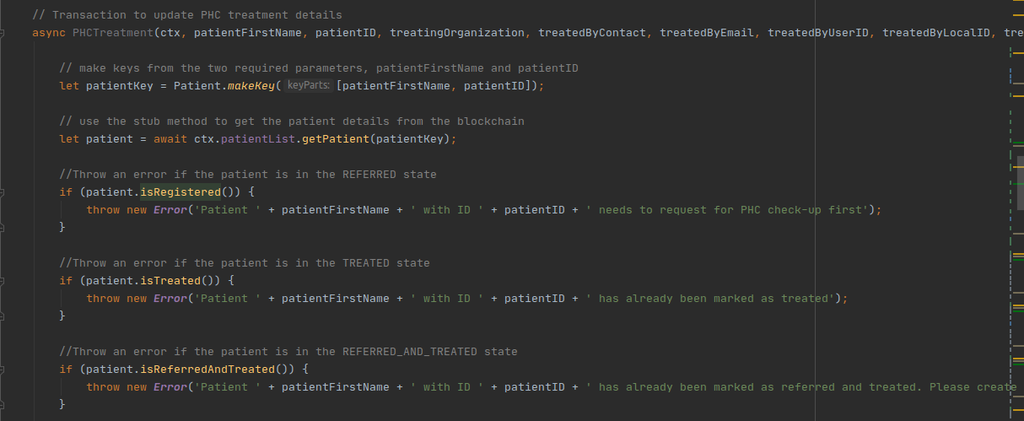
Fig. 3.4.3(a) Transaction 3

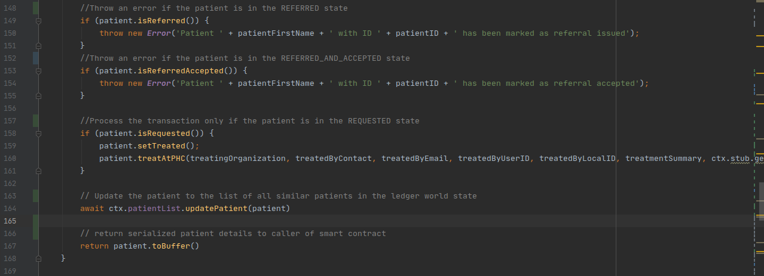
Fig. 3.4.3(b) Transaction 3

- Transaction 4, Issue Referral: This transaction issues a referral so that a government hospital can accept it. As a result, it updates the referral details, the most noteworthy of which are the details of the node/machine at the PHC which contains all the medical data that could not be put on the blockchain (off-chain data). The reason for it not being on the blockchain is due to the large size. A web service could be integrated with this blockchain platform to directly obtain the data. This transaction can only be called by a PHC. It moves the patient from the ‘Requested’ state to the ‘Issued’ state.

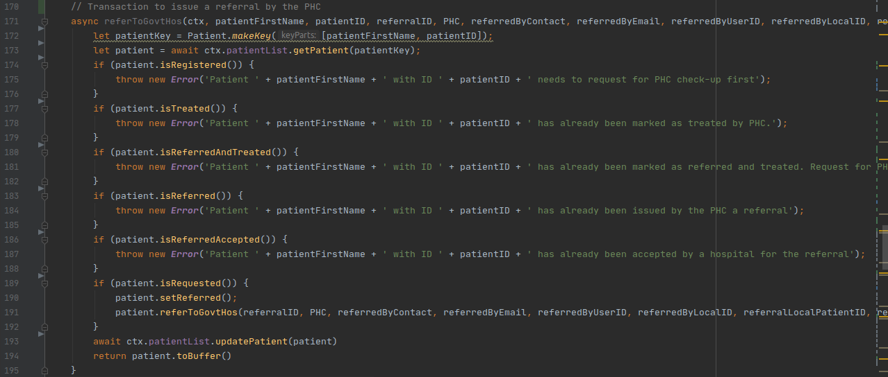
Fig. 3.4.4 Transaction 4

- Transaction 5, Accept Referral: This transaction is to be called by a government hospital when it chooses to accept a particular patient. The details pertaining to this transaction is updated on the asset. It moves the patient from the ‘Issued’ state to the ‘Accepted’ state.
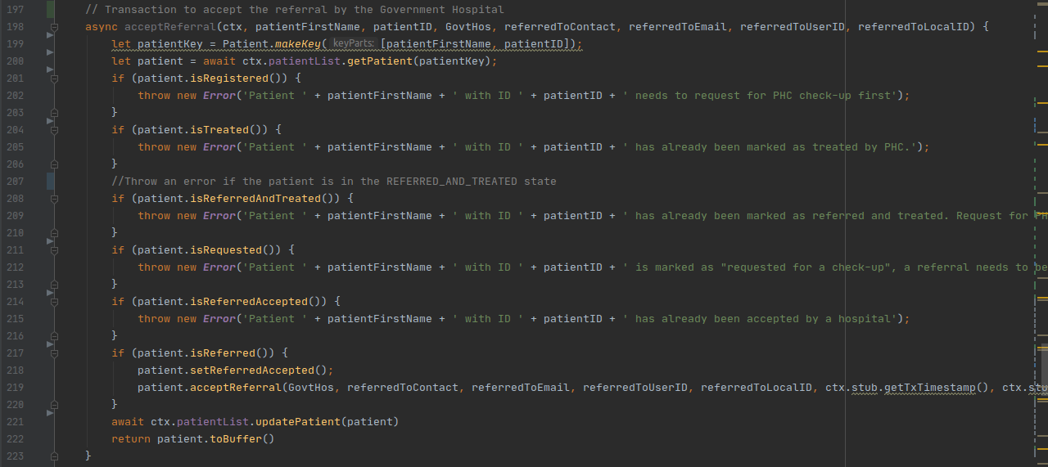
Fig. 3.4.5 Transaction 5

- Transaction 6, Treat at Hospital: This transaction updates the data pertaining to the treatment details at the Government Hospital. Only a Government Hospital can call this transaction. It moves the patient from the ‘Accepted’ state to the ‘Referred and Treated’ state.

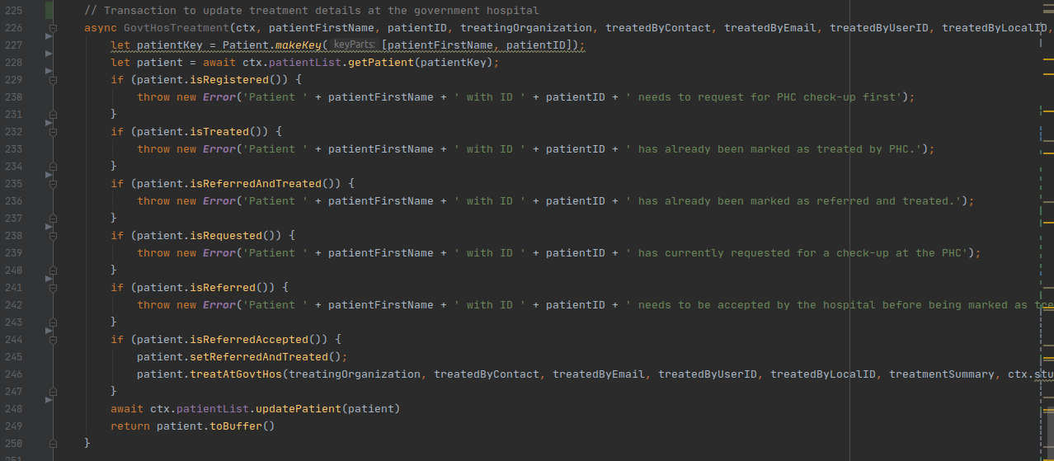
Fig. 3.4.6 Transaction 6

- Query: This method is called to print out the current latest details of the patient. It can be called by any of three organisations.
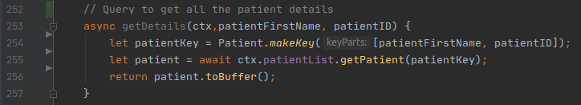
Fig. 3.4.7 Query Method

Three methods in particular seen in the screenshots above, getPatient, addPatient and updatePatient encapsulate the interactions with the blockchain.
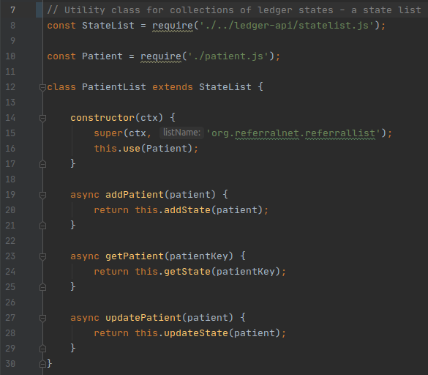
Fig. 3.4.8 PatientList.js file calling the Fabric Methods

These 3 methods in turn call getState, addState and updateState methods which use the stub APIs getState and putState to pull the data given the key or push the data given the key and the data.
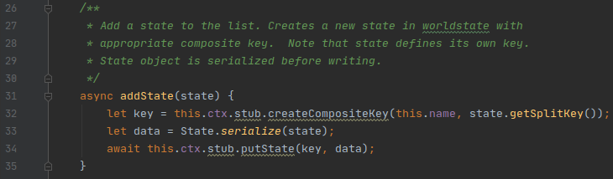
Fig. 3.4.9 addState method which uses the putState API

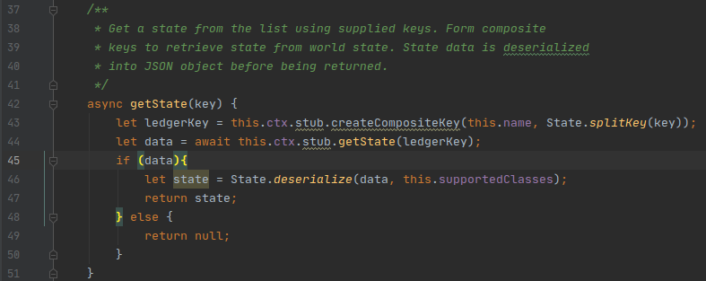
Fig. 3.4.10 getState method which uses the getState API

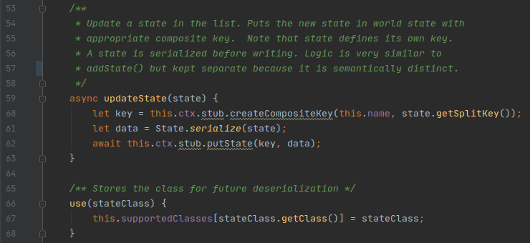
Fig. 3.4.11 updateState method which uses the putState API

3.5. Applications
An application can interact with a blockchain network by submitting transactions to a ledger or querying ledger content.
Before we can use an application, an admin and a user from a particular organization needs to first enroll themselves to obtain their wallet which holds their private key and certificate using a script that uses the Wallets and FabricCAServices classes. All the organizations must enroll an admin and at least one user. This user will then use his/her credentials to access a particular application.
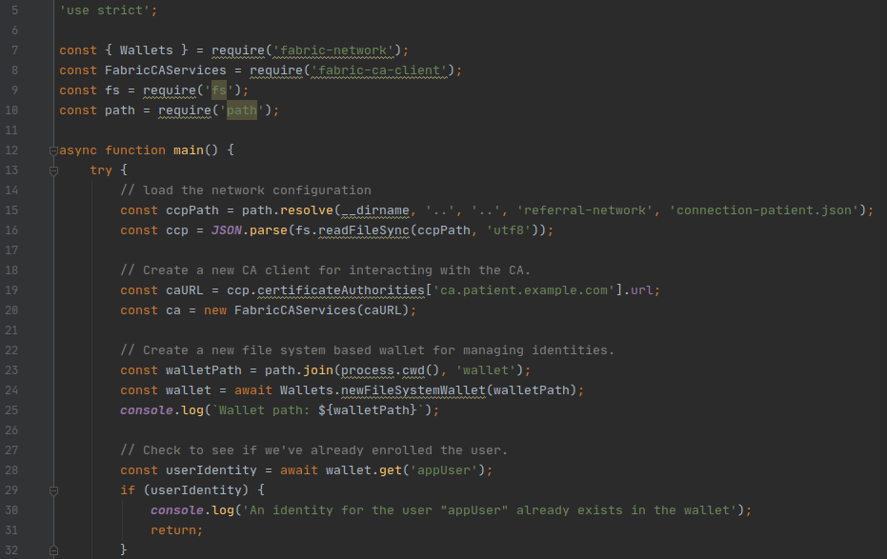
Fig. 3.5.1(a) Enrolling a user

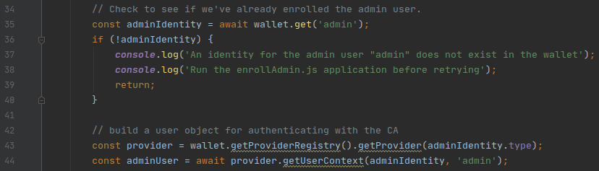
Fig. 3.5.1(b) Enrolling a user
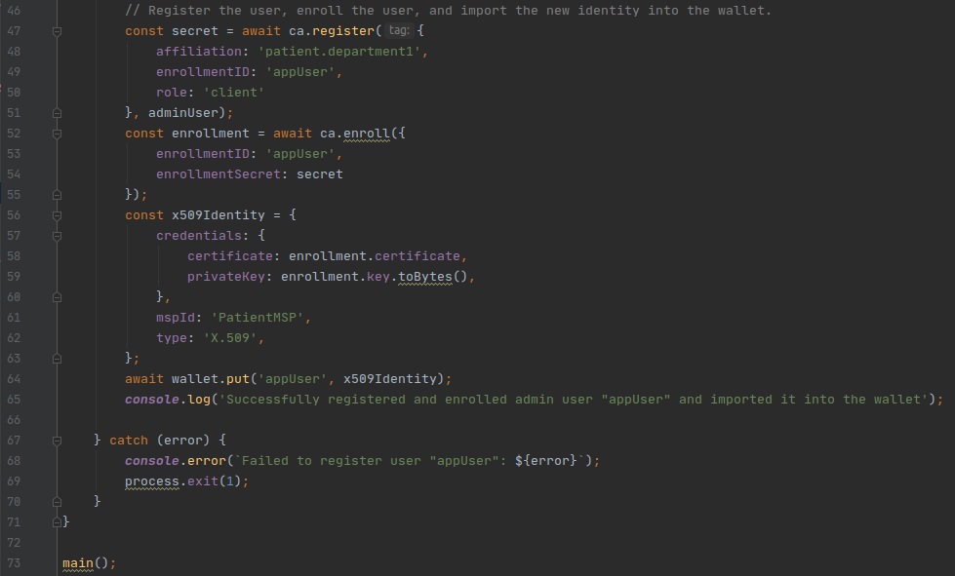
Fig. 3.5.1(c) Enrolling a user

After the enrolment is complete, the application can be called. Every application uses the Gateway API to communicate with the peer. There is one application for every transaction bringing it to six application files, and currently two query applications, one for querying only the patient personal details and one for querying all the patient latest treatment details. For the purpose of understanding the flow of logic, the following is application for the ‘Request Application’.

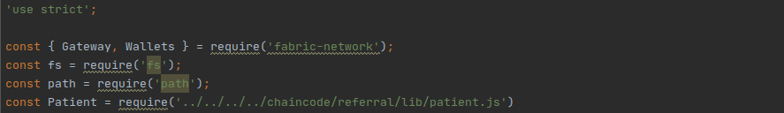
Fig. 3.5.2(a) Request Application - Import the required APIs defined by Fabric as well as the classes needed for the program

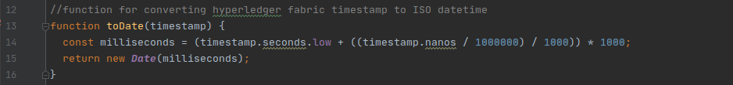
Fig. 3.5.2(b) Request Application - Defines a function to convert the Fabric timestamp into one that can be understood by a human
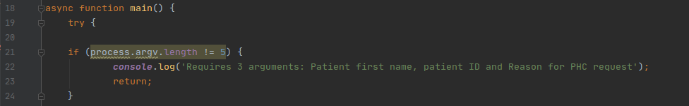
Fig. 3.5.2(c) Request Application - Main function where the first thing we need to do cross check if the number of inputs sent into the application is three. The length is five as the first two are reserved for every process as path variables

Fig. 3.5.2(d) Request Application - We take the inputs and assign it to variables

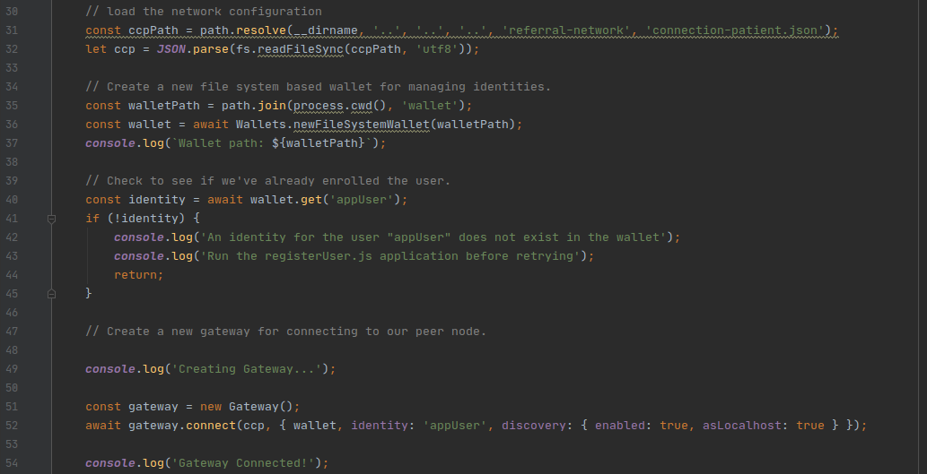
Fig. 3.5.2(e) Request Application - we pull the credentials of the user and see if it is indeed accurate. We then create a Gateway object to connect to the network

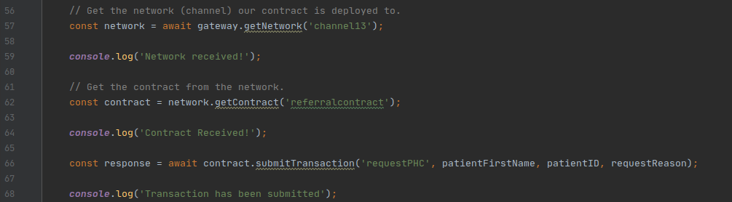
Fig. 3.5.2(f) Request Application - we first get the network and then the particular contract from the network. After successfully getting the contract, we submit a Request transaction, calling the ‘requestPHC’ method in the smart contract while providing the input arguments needed to process the transaction.

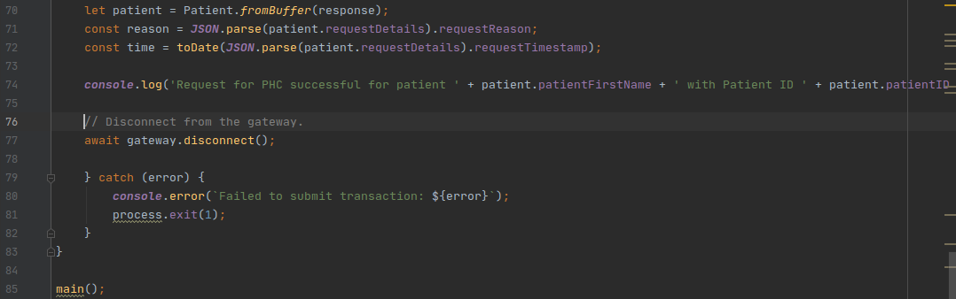
Fig. 3.5.2(g) Request Application - we deserialize (convert from binary to string) the response we obtained from submitting the transaction. We then convert the string into an object so that we can extract the variables contained in those objects. Finally, after outputting the variables, we disconnect the gateway

3.6. Identity and Data Management
Keeping in mind the two possible routes for a patient as explained in the Patient Lifecycle (Section 3.3), the following are all the variables associated with a single patient. Initially, when the first transaction is called, all the personal details are filled while all the other details are stored as ‘N/A’ which gets updated when the corresponding transactions are called. All the data is stored as key-value pairs, with the key being a composite key of Patient First Name and Patient ID and the values being all other variables. For example, a patient with Name ‘Chris’ and ID ‘12345’ is uniquely identified by the key ‘Chris12345’

Table 3.6.1 Key Variables Table
Attribute Name | Constraint
FirstName | Primary Key,  NOT NULL
PatientID | Primary Key,  NOT NULL

Table 3.6.2 Registration of Patient Table 3.6.3 Request PHC Check-Up
Attribute Name | Constraint
FirstName | Primary Key,  NOT NULL
PatientID | Primary Key,  NOT NULL
LastName | NOT NULL
Age | NOT NULL
Address | NOT NULL
ContactNo1 | NOT NULL
ContactNo2 | NOT NULL
BloodGroup | NOT NULL

Attribute Name | Constraint
FirstName | Primary Key,  NOT NULL
PatientID | Primary Key,  NOT NULL
RequestDateTime | NOT NULL
RequestReason | NOT NULL
Table 3.6.4 PHC Treatment Table 3.6.5 Govt. Hosp. Treatment
Attribute Name | Constraint
FirstName | Primary Key,  NOT NULL
PatientID | Primary Key,  NOT NULL
TreatingOrganization | NOT NULL
TreatedByContact | NOT NULL
TreatedByEmail
TreatedByUserID | NOT NULL
TreatedByLocalID | NOT NULL
TreatmentDateTime | NOT NULL
TreatmentSummary | NOT NULL
BlockchainTransactionID | NOT NULL
Attribute Name | Constraint
FirstName | Primary Key,  NOT NULL
PatientID | Primary Key,  NOT NULL
TreatingOrganization | NOT NULL
TreatedByContact | NOT NULL
TreatedByEmail
TreatedByUserID | NOT NULL
TreatedByLocalID | NOT NULL
TreatmentDateTime | NOT NULL
TreatmentSummary | NOT NULL
BlockchainTransactionID | NOT NULL

Table 3.6.6 Issue of E-referral Table 3.6.7 Acceptance of E-referral
Attribute Name | Constraint
FirstName | Primary Key,  NOT NULL
PatientID | Primary Key,  NOT NULL
ReferralAcceptanceDateTime | NOT NULL
Organization | NOT NULL
ReferredToContact | NOT NULL
ReferredToEmail
ReferredToUserID | NOT NULL
ReferredToLocalID | NOT NULL
Blockchain Transaction ID | NOT NULL
Attribute Name | Constraint
FirstName | Primary Key,  NOT NULL
PatientID | Primary Key,  NOT NULL
ReferralID | NOT NULL
ReferralIssueDateTime | NOT NULL
Organization | NOT NULL
ReferredByContact | NOT NULL
ReferredByEmail
ReferredByUserID | NOT NULL
ReferredByLocalID | NOT NULL
PatientLocalID (Patient’s ID on the node to get his/her PHC check-up details) | NOT NULL
NodeID (ID of machine in which patient record lies) | NOT NULL
ReferralReason | NOT NULL  Enumeration of 11 possible cases
ReferralNote
PriorityFlag | Two states: Emergency/ Normal (E/N)
Blockchain TransactionID | NOT NULL

Each table corresponds the variables associated with each transaction. They are taken as inputs via the application and updated on the blockchain.

3.7. Benchmarking
Once the network was built, smart contracts created and applications written, the final step is to benchmark the network and the transactions using several technical parameters. The main point of benchmarking is to figure out whether the solution is scalable and efficient in the Indian context. Benchmarks were conducted on two PCs, the second being more powerful.
Computer 1 had the following specifications:
- 2 core CPU (Intel Core i5-6200U @ 2.30GHz)
- 4 GB RAM
- 4GB Intel HD Graphics 520
- 500GB HDD
Computer 2 had the following specifications:
- 4 core CPU (Intel Core i5-9300H 9th Gen @ 2.40GHz)
- 8 GB RAM
- 4GB NVIDIA GeForce GTX 1650 GPU
- 500GB SSD

CHAPTER 4
RESULTS AND DISCUSSIONS

4.1 Running the Network
In order to run the network, we call out ‘byfn.sh’ script. The very first thing it does is to create the containers from the docker-compose files by calling the docker-compose command. It is then followed by commands to create the channel, join all peers to the channel, install the chaincode on every peer, instantiate the contract on the channel and call the ’instantiate’ method in the contract to observe if everything successfully ran.

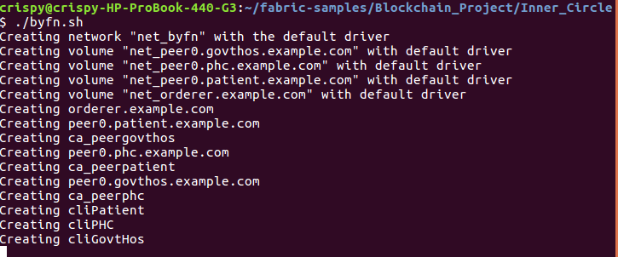
Fig 4.1.1 Running the byfn.sh script to start the network – Here, we run the byfn.sh script which results in the all the containers starting and the following network components being implemented

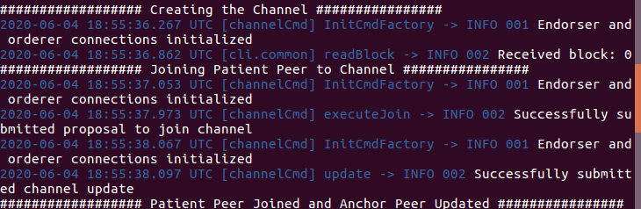
Fig 4.1.2 Channel being created and patient peer joining the channel – Here, we can see the successful channel creation and the patient peer joining the channel. Likewise, the two other peers from the other organisations join the channel as well.

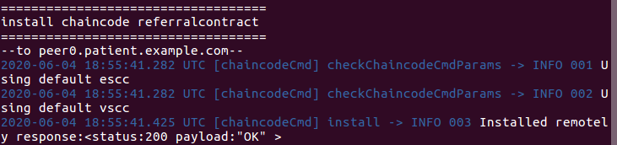
Fig 4.1.3 Chaincode installed on patient peer

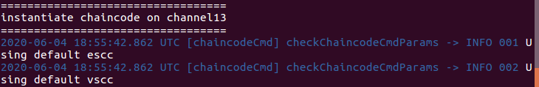
Fig 4.1.4 Chaincode instantiated on the channel

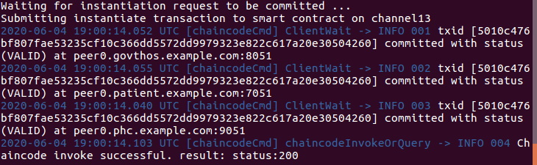
Fig 4.1.5 ‘instantiate’ function from contract being called – As can be seen, the function is successfully called showing that the smart contract is working flawlessly

4.2 Enrolling the admins and users
Once the network has been fully set up, the next step is enrol the admin and users of every organization, the code for which has been mentioned in Section 3.5. Fig. 4.2.1 shows the enrolment of admin and user for the Patient Organization.
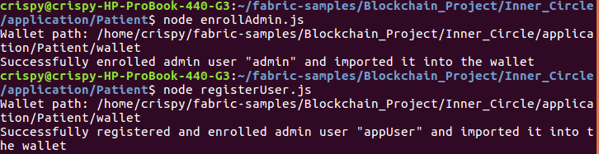
Fig 4.2.1 Enrolling and Registering admin and user for the Patient Organisation – Before running the applications, this needs to be done since only users of organisations can run the applications
4.3 Running the Applications
Once the network is setup and the enrolments are complete, the next step is to start calling each of the applications to write a patient into the blockchain and observe her transition into the different states. We will be following the second patient lifecycle as mentioned in Section 3.3. Hence, the screenshots follow the transactions: Register (Fig 4.3.1) -> Request (Fig 4.3.2) -> Issue Referral (Fig. 4.3.3) -> Accept Referral (Fig 4.3.4) -> Treatment (Fig 4.3.5). Fig 4.3.6 is the Query method to obtain all the latest details of the patient in the World State once the five transactions is complete.

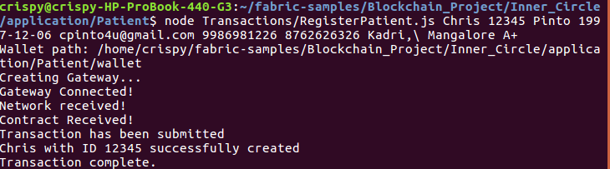
Fig 4.3.1 Running the Register Application – Here, we use the node command to run the RegisterPatient.js application file while providing all the input parameters. This results in the patient key-value pairs being written on the blockchain.

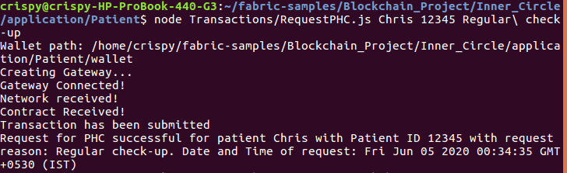
Fig 4.3.2 Running the Request Application – Here, the patient applies for a check-up at the PHC providing the reason for check-up as well

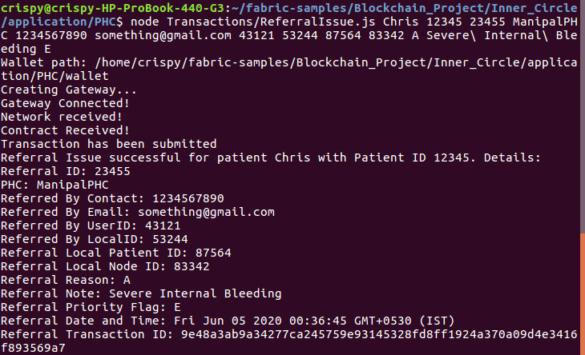
Fig 4.3.3 Running the Referral Issue Application – In this case, a complication arises, and the patient needs to be referred to a government hospital. All the details are provided, and the government hospital needs to accept this referral which happens in the next step

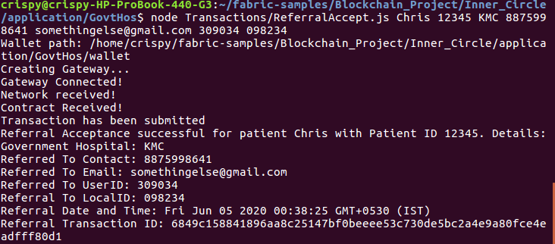
Fig 4.3.4 Running the Referral Accept Application – Here, the government hospital accepts the referral and the patient is transferred to the hospital

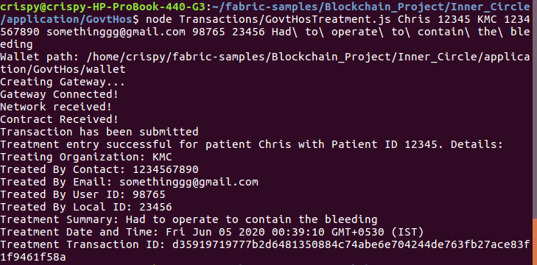
Fig 4.3.5 Running the Government Hospital Treatment Application – The government hospital successfully treats the patient and puts in the details of treatment which is updated on the blockchain

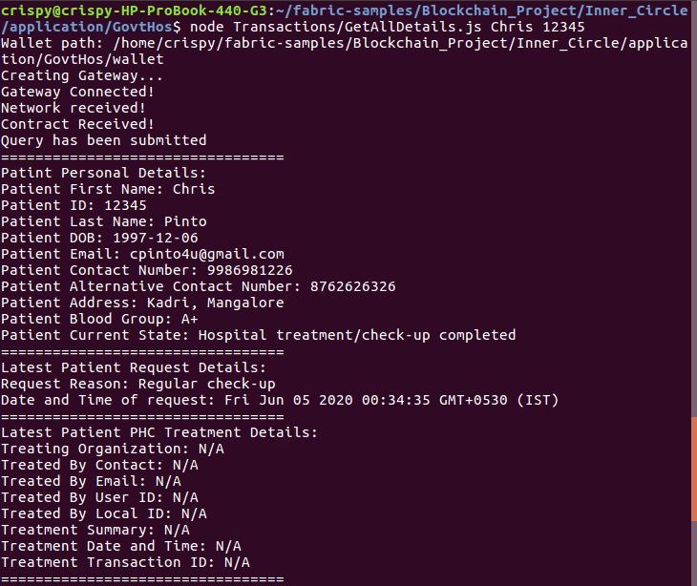
Fig 4.3.6(a) Running the Query All Details Application
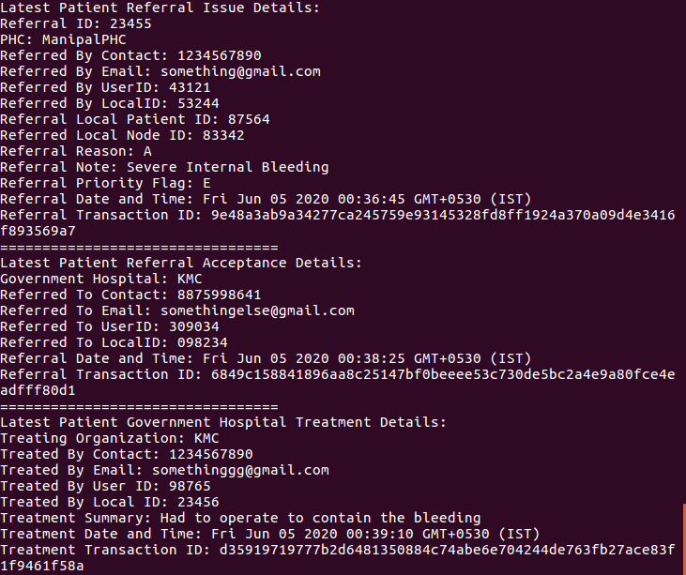
Fig 4.3.6(b) Running the Query All Details Application

4.4 Simulation Results
The final task to be done is to benchmark the network and the smart contract to capture key performance metrics. Like mentioned in Section 3.7, the first set of screenshots (Fig 4.4.1 – 4.4.4) correspond to PC 1 and the second set (Fig 4.4.5 – 4.4.8) to PC 2.

Fig 4.4.1 and 4.4.5 show the summary of all the transactions present in the smart contract whereas the other screenshots show the benchmarks for the Register transaction in particular.

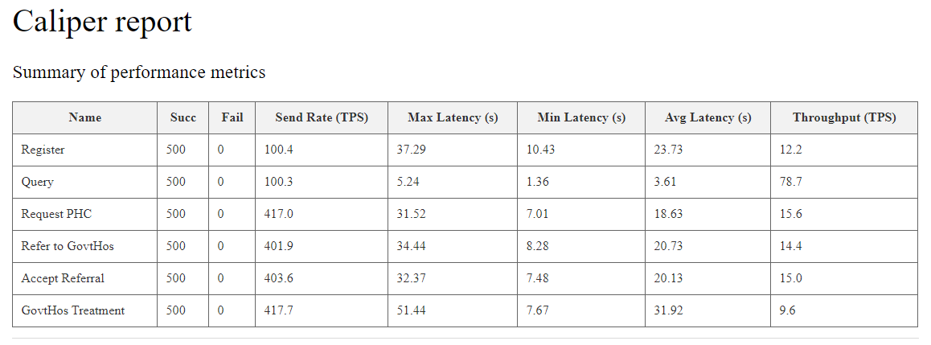
Fig 4.4.1 Summary of Transactions (PC1) – All the core metrics for all the transactions are specified

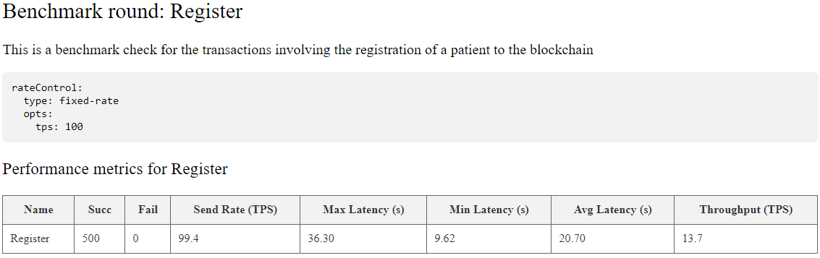
Fig 4.4.2 Register Transaction Benchmark (PC1) – Fixed rate of 100 tps was used

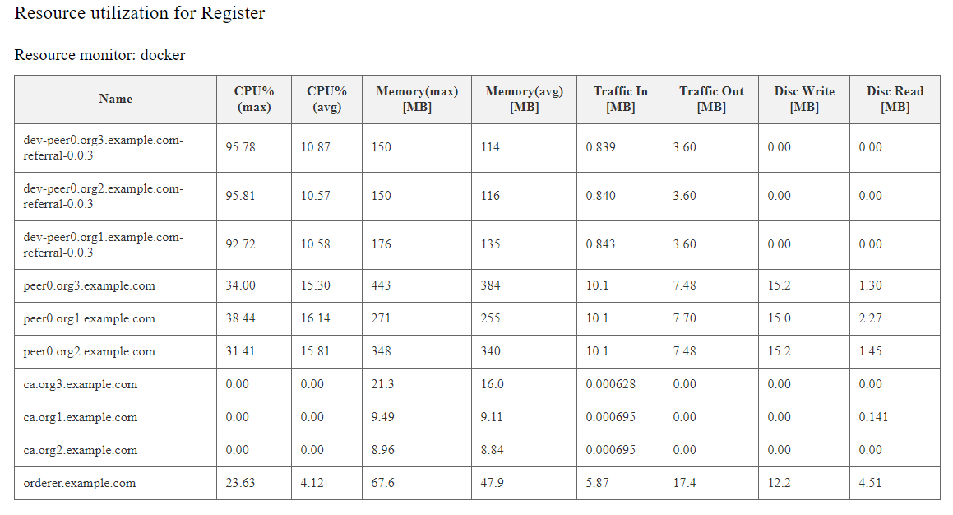
Fig 4.4.3 Register Transaction Resource Consumption (PC1) – These are all the process related benchmarks for the register transaction. Likewise, each transaction has its own Resource Utilization.

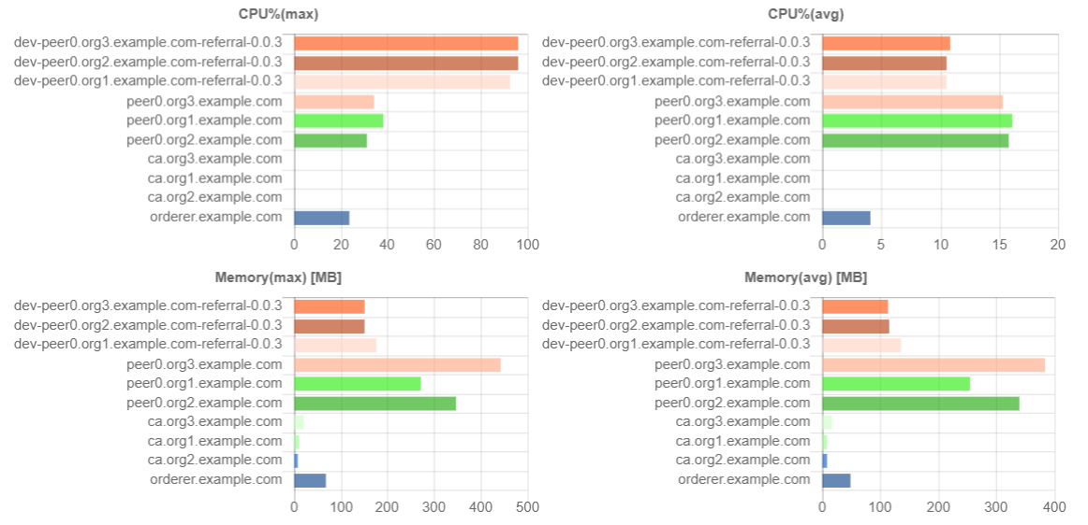

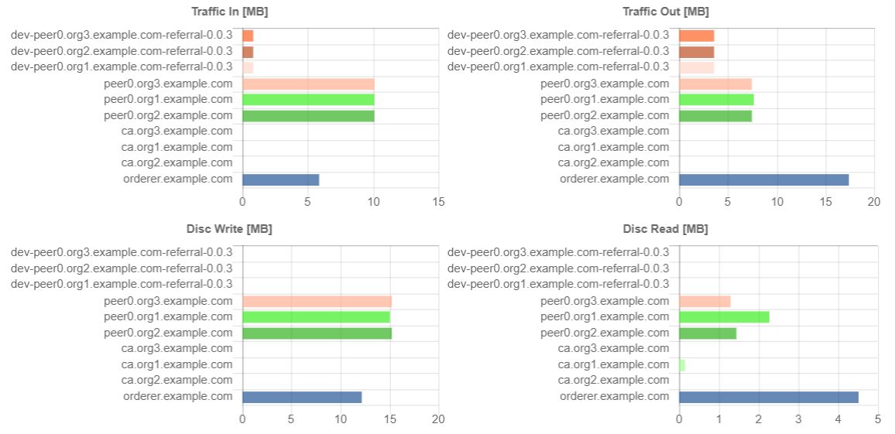
Fig 4.4.4 Register Transaction Resource Consumption Bar Plots (PC1) – These are the Resource Utilization values plotted graphically for better understanding

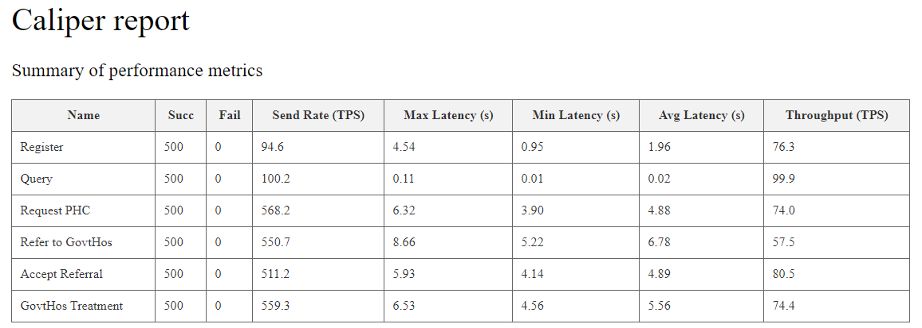
Fig 4.4.5 Summary of Transactions (PC2) - All the core metrics for all the transactions are specified

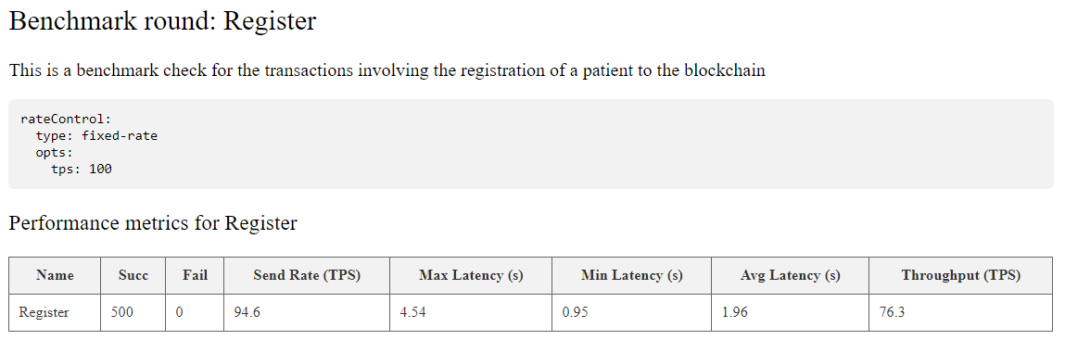
Fig 4.4.6 Register Transaction Benchmark (PC2) – Fixed rate of 100 tps was used

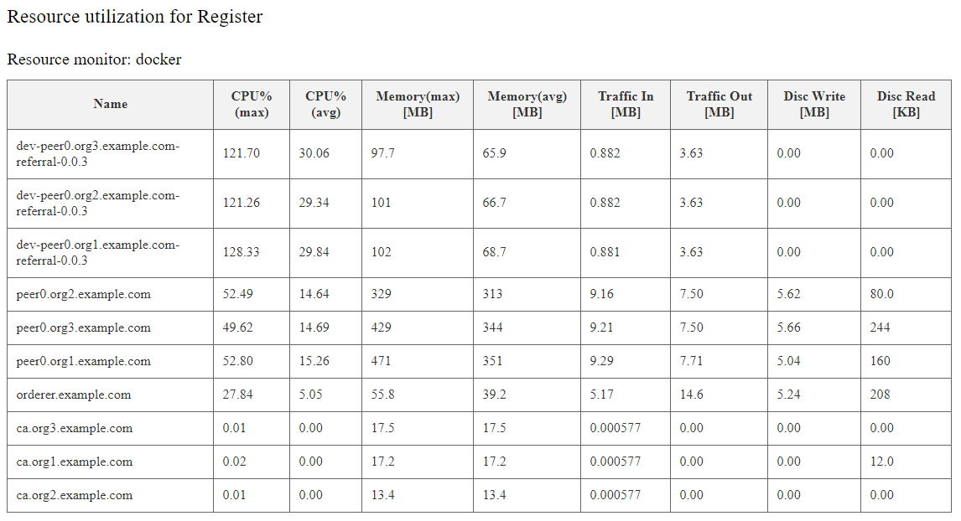
Fig 4.4.7 Register Transaction Resource Consumption (PC2) - These are all the process related benchmarks for the register transaction. Likewise, each transaction has its own Resource Utilization.

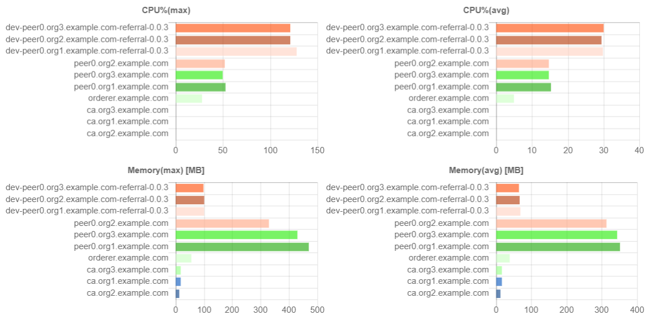
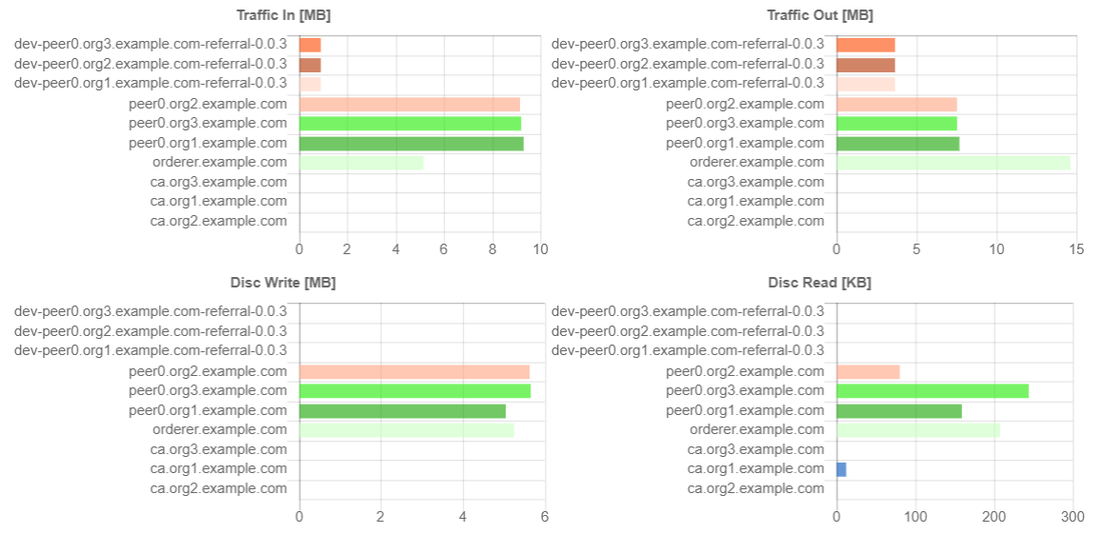
Fig 4.4.8 Register Transaction Resource Consumption Bar Plots (PC2) - – These are the Resource Utilization values plotted graphically for better understanding

4.5 Results Discussion
Section 4.1 shows the successful running of the network, with all the docker containers running, the channel being created, the peers joining the channel, the referral contract being installed on all the peers, the referral contract being instantiated on the channel and the successful status returned from the calling of the instantiate function present in the smart contract. As it stands, the instantiate function has no semantic instantiation rules, as we do not require the blockchain to be pre-loaded with data.
Section 4.2 shows the successful creation of the admin and user credentials for the Patient organisation. One admin per organisation is the default whereas users can be one or more, as specified in the docker configuration files. Likewise, it is needed to run similar commands for the PHC and Government Hospital organisations to enrol and register the admin and user. We defined each organisation to have one user for now.
In Section 4.3, we follow the Patient Lifecycle where a patient user first calls the Register transaction along with her personal details in order to write the patient details on to the blockchain. The patient then requests for a PHC check-up with a request reason. The point of view then changes to the PHC where a complication arises and the PHC issues a referral with the respective referral details. Then we once again change out point of view to the government hospital who is able to look at issuance and accept the referral. Once the referral is accepted, the patient is moved to the government hospital and treated. The government hospital then runs the Treatment transaction along with the treatment details. Finally, if any one of the Organisations queries the details of the patient, they would be able to see all the latest details of the patient, as shown in Fig 4.3.6

Benchmarks Discussion:
- Firstly, as expected, we can see that the higher specification PC inherently has the better Latency and Throughput, owing to faster processing power.
- Throughput is considered to be the most important parameter as it directly indicates how scalable the model is. For the higher end PC, we can see that the lowest throughput belongs to the issue referral transaction (57.5 tps). This is no surprise since it contains the largest amount of code. For reference, Bitcoin has a throughput of 27 tps and Ethereum has a throughput of 15 tps. Also considering our network is permissioned and much smaller than Bitcoin and Ethereum, the model is very much scalable as 57.5 transactions (the lowest) is quite high. Even for the lower end PC, a tps of 9.6 (lowest) is still extremely feasible due to the network being permissioned.
- The query function has the highest throughput and lowest latency since it does not involve committing of a transaction.

CHAPTER 5
CONCLUSION

With data surrounding every facet of our lives, it becomes crucial to ensure that third parties do not tamper or steal our personal data in order to uphold the ideology of privacy of one’s data. Although cryptographic techniques and distributed technology are not recent innovations, the need for it has risen over the years as common people become more aware of the need to protect their data. With users favouring convenience over privacy, there is still a long way to go for complete adoption of the blockchain technology. In this project, we intend to create a blockchain based solution for the read/write operations involving EHR data for a patient, keeping the patient in the centre. In the current scenario, although privacy laws state that patients own their EHR data, the data is stored in central servers owned by third party entities like hospitals or a cloud company. Through this project, we aim to shift the ownership back to the patient. Using access control, we can make all the transaction patient-centric. This project shows the capabilities of blockchain technology in the healthcare and how it will revolutionise the health sector.
As per the defined objective, smart contracts were successfully defined for each change of state. Six transactions were defined in total. Alongside the transactions, applications were also made for the respective users of each organization to call the transactions in the chaincode. Only the right participants can trigger the right transactions, so the privacy policies are inbuilt in the current network setup. The users of the PHC and Government Hospitals have the access to query patient details, and as a result, we assume that they will rightfully be the gatekeepers of that information.
In the future, this project can further be extended the use case to involve more transactions with more stakeholders, namely private hospitals, research institutes and insurance companies who would have only read permissions while incentivizing patients, such as through the payment of tokens, to share their data. This would also need to be accompanied with revised privacy policies. Data masking also is to be enabled to ensure stronger privacy norms so that patient’s personal details are kept completely private. A robust UI can be integrated with the current network and deployed into production to test actual usefulness in a real-world setting.

REFERENCES

[1] | S. T. S. T. N. K. Aparna Kumari, “Fog computing for Healthcare 4.0 environment: Opportunities and challenges,” Computers & Electrical Engineering, pp. 1-13, 2018.
[2] | K. P. R. E. Sudeep Tanwar, “Blockchain-based electronic healthcare record system for healthcare 4.0 applications,” Journal of Information Security and Applications, p. 13, 2019.
[3] | T. S. ,. T. S. ,. K. N. ,. P. R. ,. C. K.-K. .. Kumari A, “Fog data analytics: A taxonomy and process model,” Journal of Network and Computer Applications, pp. 90-104, 2019.
[4] | P. I. S. T. S. T. N. K. M. S. O. K.-F. H. Jayneel Vora, “Ensuring Privacy and Security in E- Health Records,” in 2018 International Conference on Computer, Information and Telecommunication Systems (CITS), Colmar, France, 2018.
[5] | M. C. Tzourakis, “The Healthcare Industry and Data Quality,” 14 January 2020. [Online]. Available: http://mitiq.mit.edu/iciq/Documents/IQ%20Conference%201996/Papers/TheHealthCareIndustryandDataQuality.pdf.
[6] | Globalscape , “EFT for Healthcare,” 14 January 2019. [Online]. Available: https://www.globalscape.com/healthcare.
[7] | IANS, “Hackers attack Indian healthcare website, steal 68 lakh records,” 22 August 2019. [Online]. Available: https://ciso.economictimes.indiatimes.com/news/hackers-attack-indian-healthcare-website-steal-68-lakh-records/70782910.
[8] | A. B. a. H. K. Karim Abouelmehdi, “Big healthcare data: preserving security and privacy,” Journal of Big Data, pp. 5-10, 2018.
[9] | Jess White, “Electronic health data transfer: Where hospitals stand right now,” 20 December 2018. [Online]. Available: https://www.healthcarebusinesstech.com/electronic-health-data/.
[10] | Govt of India, “ELECTRONIC HEALTH RECORD (EHR) STANDARDS FOR INDIA 2016,” January 2016. [Online]. Available: https://mohfw.gov.in/sites/default/files/EMR-EHR_Standards_for_India_as_notified_by_MOHFW_2016_0.pdf.
[11] | H. W. D. J. M. L. W. J. X Yue, “HealHealthcare data gateways: found healthcare intelligence on blockchain with novel privacy risk control,” Journal of medical systems, pp. 10-15, 2016.
[12] | X. N. ,. H. X. Zhang J, “A secure system for pervasive social network-based healthcare,” 2016.
[13] | S. E. ,. A. K. ,. G. J. ,. D. X. ,. G. M. Xia Q, “MeDShare: Trust-Less Medical Data Sharing Among Cloud Service Providers via Blockchain,” 2017.
[14] | C. J. ,. W. H. ,. Y. Y. ,. M. M. ,. H. J. Jiang S, “BlocHIE: A BLOCkchain-Based Platform for Healthcare Information Exchange,” in 2018 IEEE International Conference on Smart Computing (SMARTCOMP), Taormina, Italy, 2018.
[15] | S. A. ,. G. I. ,. B. V. Uddin MA, “Continuous Patient Monitoring With a Patient Centric Agent: A Block Architecture,” 2018.
[16] | J. M. M. M. P. B. M. Gaby G. Daghera, “Ancile: Privacy-preserving framework for access control and interoperability of electronic health records using blockchain technology,” Sustainable Cities and Society, pp. 283-297, 2018.
[17] | M. Z. A. B. A. B. S. K. Abdullah Al Omar, “Privacy-friendly platform for healthcare data in cloud based on,” Future Generation Computer Systems, pp. 511-21, 2019.
[18] | L. H. K. K. D. K. Faisal Jamil, “A novel Medical Blockchain Model for Drug Supply Chain Integrity Management in a Smart Hospital,” Electronics, pp. 505-32, 2019.
[19] | J. W. G. C. R. L. B. C. O. K.-L. T. Tien Tuan Anh Dinhz, “BLOCKBENCH: A Framework for Analyzing Private Blockchains,” p. 16, 2017.
[20] | D. J. S. P. S. S. Bhabendu Kumar Mohanta, “Blockchain technology: A survey on applications and security privacy Challenges,” Internet of Things, p. 19, 2019.
[21] | H. L. G. X. M. W. G. D. X. L. Wenbo Jiang, “PTAS: Privacy-preserving Thin-client Authentication Scheme in blockchain-based PKI,” Future Generation Computer Systems, p. 185–195, 2019.
[22] | M. J. C. X. T. K. R. Sukhwani H, “Performance Modeling of PBFT Consensus Process for Permissioned Blockchain Network (Hyperledger Fabric),” Hong Kong, China, 2017.
[23] | P. S. ] Zhang X, “Blockchain support for flexible queries with granular access control to electronic medical records (EMR),” in 2018 IEEE International Conference on Communications (ICC), Kansas City, USA, 2018.
[24] | S. H. Z. Q. Z. D. ] Guo R, “Secure attribute-based signature scheme with multiple authorities for blockchain in electronic health record system,” 2018.
[25] | X. N. H. X. ] Zhang J, “ A secure system for pervasive social network-based healthcare.,” 2016.
[26] | W. S. ,. R. Y. ,. L. H. ,. Y. Y. Fan K, “Medblock: efficient and secure medical data sharing via blockchain.,” in J Med Syst , 2018.

SUPPLEMENTARY RESOURCES

- GitHub Link and Structure
Link: https://github.com/CrispNCrispy/Blockchain_Project

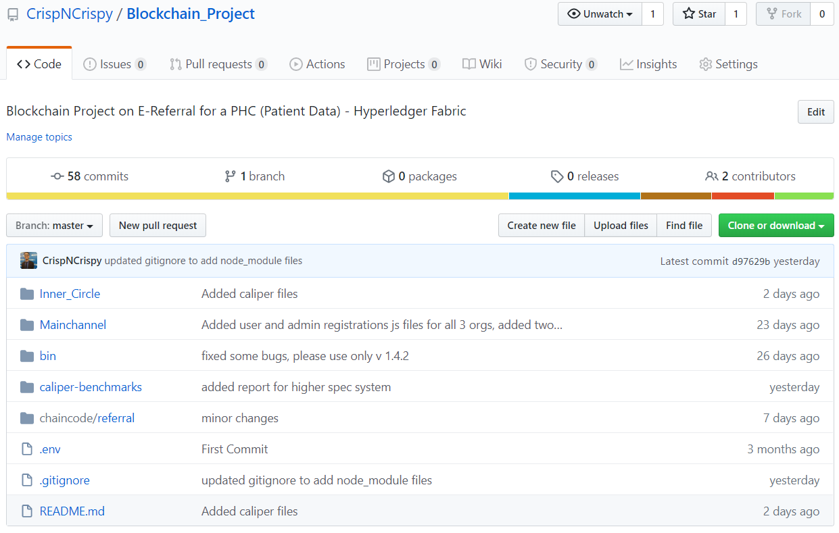
Fig 5.1 Github Structure. Screenshot taken on 11/06/2020

All the project related files are fully accessible via GitHub. Further installation instructions, guides and explanation can be obtained from the README.md file present in the repository.
The following are the contents of each of the directories.
- Inner_Circle: Contains all the network setup files and application files for the network comprising of the three main organizations. This is the core directory for all work related to the project.
- Mainchannel: This is an experimental directory for six organisations, which further includes a private hospital, research centre and insurance organisation. This can be ignored for the purpose of the project.
- bin: Contains the Docker images for Hyperledger Fabric v1.4.2 required to run the simulations.
- caliper-benchmarks: Contains all the files required for benchmarking the created network and chaincode. It also contains the reports for the same.
- chaincode: Contains the code for the smart contract. It incorporates all the APIs used in Fabric to interact with the blockchain.

PROJECT DETAILS

Student Details
Student Name | Chris Cyprian Pinto
Register Number | 160903016 | Section / Roll No | 5
Email Address | cpinto4u@gmail.com | Phone No (M) | +919986981226
Project Details
Project Title | Authorisation and Privacy Policies in a Patient-Centric Blockchain
Project Duration | 4 months | Date of reporting | January 14, 2020
Guide Details
Faculty Name | Dr. Rohini R. Rao
Designation | Assistant Professor – Senior Scale
Full contact address with pin code | Department of Computer Applications,  Manipal Institute of Technology, Manipal – 576 104  (Karnataka State), INDIA
Email address | rohini.rao@manipal.edu | Phone No | +919480503167

