# Integrating Graph and Large Language Model with AOP-Wiki for Contextual and Semantic Parsing of Adverse Outcome Pathway Information

Saurav Kumar1, Deepika Deepika1, Vikas Kumar1,2*

*1IISPV, Hospital Universitari Sant Joan de Reus, Universitat Rovira I Virgili, Reus, Spain*

*2German Federal Institute for Risk Assessment (BfR), Berlin, Germany*

## Abstract

Adverse Outcome Pathways (AOPs) provide the basis for non-animal testing, by outlining the cascade of molecular and cellular events initiated on exposure to stressors that leads to adverse effects. Currently, AOPs are considered an integral part of the New Approach Methodology (NAMs) to aid in human health risk assessment. Over the last few years, the scientific community has shown immense interest in developing AOPs with crowdsourcing, which are being archived in the AOP wiki. AOP wiki is a centralized repository coordinated by the OECD, which hosts around 512 AOPs having endorsed and developmental status. However, the AOP-wiki platform currently lacks the capability to provide a versatile querying system, that allow developers to explore and analyse the AOPs network in a flexible manner. This limitation become more challenging, when more AOPs gets add up in coming years. Therefore, the objective of this work is to leverage the full potential of the AOP wiki archive by adapting its data into a graph database. Simultaneously providing both database query and natural language query interface to gather information in network visual format. A case study was taken with three levels of use case scenarios (simple, moderate, and complex query) for evaluating the information extraction. Also, stepwise queries is implemented to collate multiple queries in single one. The design of query engine increases the potential of AOPs exploration, by reducing the time, human resources and technical needed to gather information from existing AOP during AOP development phase. With dynamic prompt generation, the query engine has the capability to get precise in query generation with more interaction. This tool is freely available on GitHub for wider community usability and further enhancement.

Keywords: Adverse outcome pathway, large language model, Graph database, Risk assessment, Artificial intelligence

## Introduction

The concept of Adverse Outcome Pathway (AOP) was laid in 2010 by Ankely et al. to streamline the idea of Next Generation Risk Assessment (NGRA)1. Ankely et al. described AOPs as an organizing framework to facilitate the representation of cascade events initiated by the sufficient stressor’s perturbation at the molecular level1. Events in AOPs are broadly categorized into three categories i.e., Molecular Initiating Event (MIE), Key Event (KE), and Adverse Outcome (AO), with their biological organization level mentioned based on their occurrence to effectively applied for risk assesment1. AOPs broadly capture the mechanistic knowledge of events in a well-connected sequential format, which helps in the strategic planning and development of new approach methodologies (NAMs) such as *in vitro* tests, targeted assays, and Integrated Approaches to Testing and Assessment (IATA). The NAMs aim to fill the gaps in decision-making in chemical risk assessment while shifting the risk assessment towards animal-free approaches.

AOP developments are backed by guidelines and principles mentioned in the AOP Developers’ Handbook2. AOP Developer’s handbook is revised regularly to reflect the most feasible principles and practices that have been acquired by the developers over the year2. As per the mentioned guidelines and principles, AOPs developed over the years are stored in AOP Knowledgebase (AOP-KB). AOP-KB stores machine-readable textual information of AOPs in XML formatted data model. On top of AOP-KB, there are two other services i.e., AOP Portal and AOP Wiki was built that acts as query interface. AOP portal enables the search of AOP and key events with keywords, it also provides information about AOP endorsement. Whereas AOP-wiki is hosted as a central repository for AOPs developed as part of the OECD AOP development Programme. AOP-Wiki provides a platform to crowd-source and organize available knowledge as well as provides read/write access to AOP-KB following the OECD EAGMST guidelines. There are various third-party tools developed to enrich and support the AOP development are also assembled in the AOP-wiki and AOP-KB platform.

The ubiquity of graphs in data representation cannot be overstated. Any form of data can be reimagined as graph data whether it is tabular, relational, or even unstructured text3. In mathematical terms graphs are represented with notation , where is the set of nodes and is the set of edges, where each edge contains a pair of nodes representing a connection between node and node 3 .Interestingly, the implicit data structure of AOPs is a graph as it represents the cascade of events in the form of nodes (KE) connected by edges (KER).

Having AOP data not being adapted into a “queryable graph”, limits its usability and ease with which users can interact and retrieve desired information.

The concept of FAIR data i.e., Findable, accessible, Interoperable, and reusable data becomes crucial if data is being shared, integrated, and utilized across multiple disciplines of scientific research. FAIR data aims to make research data more valuable and impactful.

Catia et al. work on the FAIRification in the AOPs, by rationally dividing the key event term of AOP into three sub-terms i.e., process, object, and action. The three sub-terms were assigned with respective ontologies and were given a unique identifier to each of them. Whereas Martens et al. convert AOP data into Resource Description Format (RDF), with the help of standard ontology. RDF is a modeling framework, which describes resources in a machine-readable format. It is widely used to represent data and relationships on the web. To create AOPs machine-readable, terms such as AOP, key event, and key event relationship were registered to generate persistent and resolvable identifiers, which allow interoperability with other resources. RDF data is queried using SPARQL (SPARQL Protocol and RDF Query Language), which allows searching, filtering, and extracting the desired information. RDF conversion makes AOP queryable up to a certain extent, but the complex and lengthy query of SPARQL makes it hard for the non-technical user to implement it.

Also, querying with SPARQL required remembering the exact identifier of the nodes, which is cumbersome.

The response of SPARQL queries is in tabular format in AOP-WIKI RDF which is counterintuitive as per the graph nature of AOPs. The tabular response gives a hard time to the user to understand, how different AOP elements are interconnected. In addition to that, SPARQL does not give the flexibility to implement the graph algorithms. Graph algorithms are a powerful tool that comes in handy to get deep insights into graph data such as AOP networks.

In this article, we unveil the capacity of a graph database to serve as a natural and adapted data structure for Adverse Outcome Pathways (AOP). We demonstrate how a graph database empowers the risk assessors, and modelers to capture the multifaceted relationship that underlies within AOPs, while efficiently exploiting the wealth of unstructured information associated with each AOPs. Crafting queries either in SPARQL or Cypher (graph) for data retrieval is a challenge, particularly for non-technical users. To alleviate this complexity, a pioneering step has been taken to integrate a powerful Large Language Model (LLM). The LLM model with its ability to seamlessly generate queries in response to natural language queries by users, bridges the technical gap and provides user-friendly communication to extract value insights from graph data. Beyond simplifying query composition, the interpretation of extracted data in an interactive network further eases AOPs network analysis. This work provides a unified full-stack solution that encompasses essential components i.e., data structure, query generator, and interactive interpretation for AOPs. This tool harmoniously converges to create an invaluable toolset for the AOP developer’s community.

## Materials and Methods

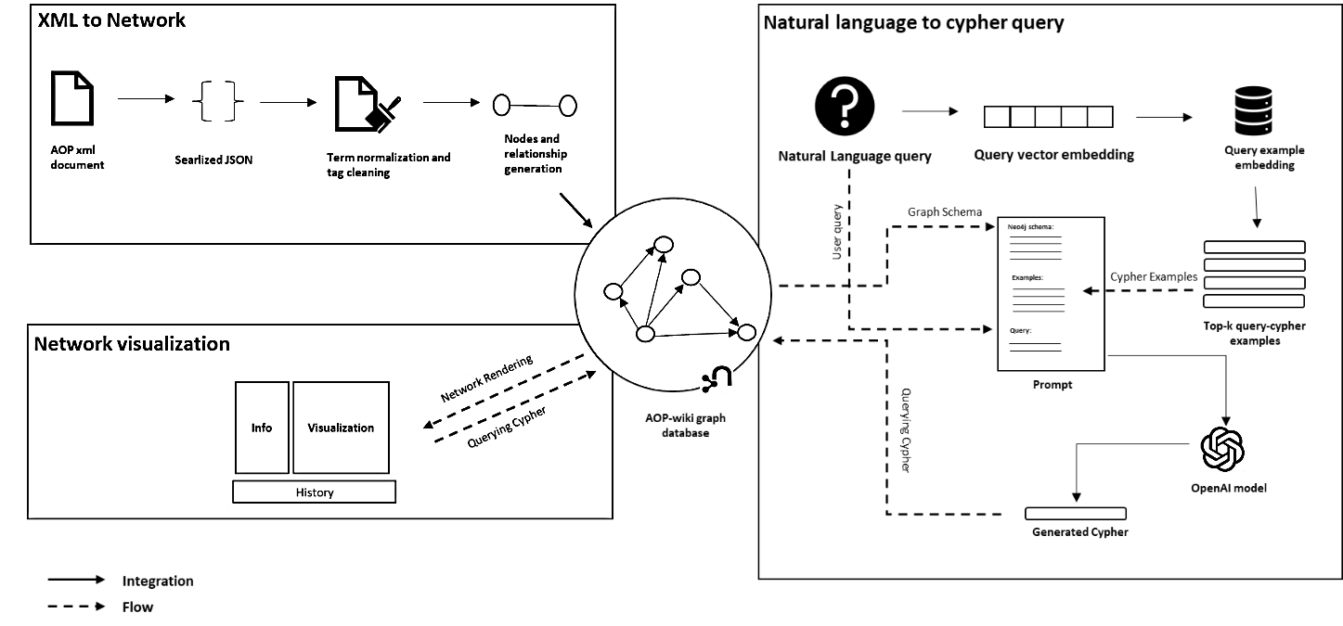

**Figure 1. Methodological workflow XML to graph model conversation.**

The method of adapting AOP wiki data in graph format is broadly divided into 3 steps i.e., 1.) XML to network conversion, 2.) Natural language to graph query and 3.) network visualization.

All three components seamlessly interconnect to build a cohesive tool. In this interconnection the schema of the generated graph database in step 1. is useful for prompt generation and finally, the visualization component, which renders the network as the graph or natural language query. In the subsequent methods section, we will delve deep into these 3 steps.

#### XML to network conversion

XML version of the latest AOP data released on April,2023 had been downloaded from <https://aopwiki.org/donwloads>. AOP data gets updated quarterly in a year. XML file is then parsed into a Python dictionary object using the xmltodict library. The converted dictionary object consists of elements, such as AOP, key-event, key-event-relationship, chemical, stressor, and taxonomy which are the building blocks of the whole AOP network. These data elements hold unique IDs, which helps in referencing and restructuring the block to develop the whole AOP from scratch. For building a query-able graph database, the Neo4j platform was used.

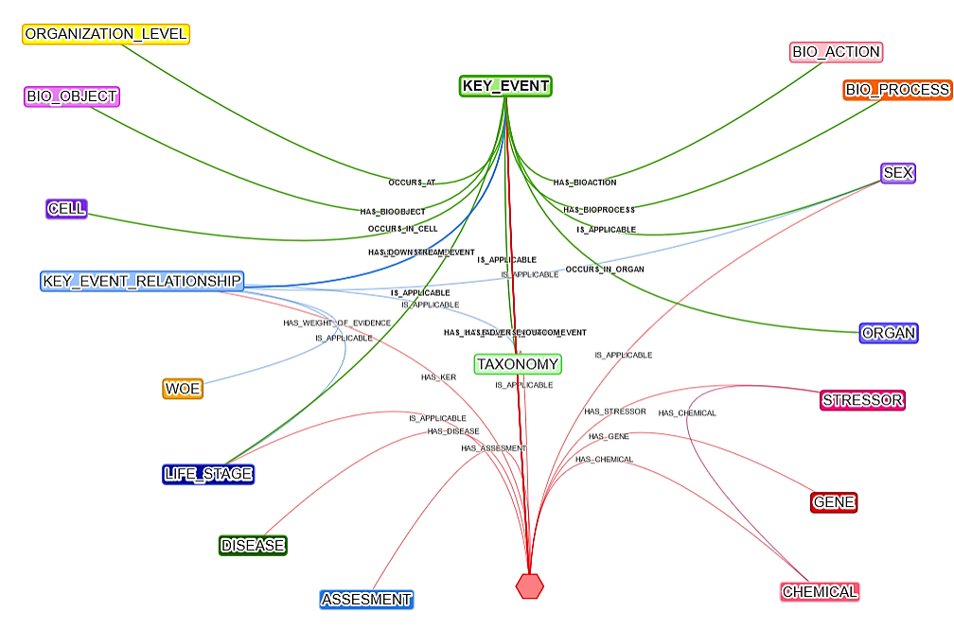

ORGANIZATION_LEVEL

BIO_PROCESS

BIO_ACTION

KEY_EVENT

BIO_OBJECT

SEX

ORGAN

STRESSOR

CELL

GENE

KEY_EVENT_RELATIONSHIP

TAXONOMY

CHEMICAL

LIFE_STAGE

CHEMICAL

ASSESMENT

WOE

Figure . Neo4j graph data model schema for AOP-wiki XML data

Neo4j is a widely used graph database management system, designed to store, manage, and query large amounts of data organized in graph structure. Neo4j relies on Cypher query language to interact with graph data. It is designed to express simple to complex queries, that can transverse and retrieve the relationship within the graph. As Neo4j, at its core uses Java to run the engine, to make it accessible programmatically Py2neo had used. Py2neo is a Python library, which acts as an interface between Python and Neo4j and makes programmatic access to neo4j with ease. With Py2neo, nodes, and relationships are built while keeping a consistent naming convention of node and edge labels and their properties. Nodes and edge labels are all in uppercase and the labels having more than one word are joined with the snake naming convention. Properties of nodes and edges are written in lowercase. The strict naming convention provides robustness to the graph data model.

## More to add about the duplication and normalization of different properties-

The schema of the graph in Figure 1. provides the abstract view of different nodes and their relationship with each other. Typically, in AOP graphical representation, there are mainly three types of nodes i.e., AOP, key event, and Key event relationship present. In this schema, it has been extended to capture information like taxonomy, sex, biological organization level, assessment methodology, and many more. Also, while populating the properties of nodes, textual information was processed using regex to clean the HTML tags to make the text human readable. The extended schema gives flexibility to the user to retrieve different aspects of AOP to put in their analysis. Some of the crucial textual information of AOP such as their assessment methodology and weight of evidence are also represented as nodes, so it will be helpful in context-based queries.

Table . Description of AOP nodes and their relations

|  |  |  |
| --- | --- | --- |
| S.NO | NODES | PROPERTIES |
| 1. | AOP | id  authors  name  short_name  abstract  potential_applications  essentiality-support  authors  references |
| 2. | KEY_EVENT | Id  name  short_name  description  measurement methodology  url  references |
| 3. | KEY_EVENT_RELATIONSHIP | name  quantitative understanding  evidence supporting taxonomic applicability  references |
| 4. | BIO_ACTION | name  source  source id |
| 5. | BIO_OBJECT | Name  Source  Source id |
| 6. | BIO_PROCESS | Name  Source  Source id |
| 7. | STRESSORS | ID  NAME  URL |
| 8. | CHEMICAL | Name  Type  Identifier |
| 9. | ORGAN | Name  Source  Source-id |
| 10. | ORGANIZATION_LEVEL | name |

In the AOP wiki portal, each AOP has brief information contained in the abstracts, description, and detailed information about KE, and kER in specific sections of that AOP. Sections containing descriptive textual information, such as abstract, description, the weight of evidence, and assessment method methodology, etc. have been combined into a single document. Over the combined document Named Entity Recognition (NER) is applied to extract the biological concepts such as gene, protein, chemical, and disease using BERN2. BERN2 is a neural biomedical named entity recognition and normalization tool developed by dmis-lab, south Korea. The extracted entities were normalized using glida grounder, to bring the entity name in grounded form using ontology assistance. Normalized entities are converted into nodes and integrated into the network.

To make the AOPs network, contextually queryable, textual embedding has been implemented. Embedding is a fundamental concept of natural language processing and machine learning. Embedding represents words and sentences as a dense vector in a continuous vector space. Vector embeddings transform high-dimensional discrete data (words and phrases) into a lower-dimensional continuous vector while preserving the meaningful relationship. Hence it allows algorithms to capture the semantic, syntactic, and contextual relation between words and sentences.

Textual information of three foundational elements of AOPs i.e. AOP, KE, and KER has been considered for embedding generation. For AOP embedding, AOP’s name, abstract, potential application, background, and short name have been taken. While merging information of AOP as mentioned above, pre-text such as “AOP with id”, “the abstract of AOP”, 2title of AOP” etc. has pre-appended to keep information descriptive. Similarly, for KE embedding generation, its name, short name, description, measurement methodology, and evidence supporting taxonomic applicability have been taken, which were merged with pre-text. For KER, its weight of evidence contains crucial information, hence the weight of the evidence node, which is connected directly to KER has also been merged with the properties of KER to generate embeddable text. The openAI most capable embedding model, “text-embedding-ada-002” is used to generate the embedded context of textual content of AOP, KE, and KER. The text-embedding model has a context input length of up to 8192 tokens and returns reduced embedding with 1536 dimensions. The embedded content is matched with a context-based query asked by the user using the Graph Data Science Library of Neo4j. The cosine similarity method is used to calculate the closeness of the query and context, based on the similarity score, the top matching component asked by the user is returned.

#### Natural Language to graph query

To bridge the technical gap and provide flexibility to query information in natural language form, an infamous OpenAI’s GPT-4 model was used. OpenAI’s GPT-4 is an advanced artificial intelligence model designed to understand and generate human-like text. The GPT-4 model is trained on an extensive and varied corpus of text derived from the internet, encompassing sources like books, articles, websites, documentation, and code repositories. The training on such a massive amount of data enables the model to learn patterns, syntax, semantics, and contextual nuances. GPT-4 model inherently does not possess specific knowledge about Cypher queries, instead, they acquire knowledge through extensive training data or prompts they are exposed to. Description and examples of cypher query provided in the prompt enable the model to generate coherent patterns. However, the response from the model is based on statistical patterns, they have learned while training, rather than a deep understanding of the Neo4j Cypher.

The quality and correctness of generated cypher queries depend on how precise the prompt is provided. The precise prompt here signifies explicit instruction, relevant context, illustrative examples of desired responses, and clear specification of the output format. To build precise prompts, in this work dynamic few shot prompt generation methodology has been adopted. In dynamic methodology, a few examples in the prompt are provided similar to the query. Similar examples make the model aware of the syntax and variables to be used for generating the cypher. The variable part in the dynamic prompt is the provided example query and query itself, whereas other components are static. Static components of prompts include graph schema, context, and output format. Graph schema holds information about how the database is structured and the properties mentioned in nodes and edges. Context provides precise instruction to the model, while output format provides schema such as JSON, or YAML to generate parse able output.

The overall compilation of prompts follows the sequence mentioned in Figure 1. First, the real-time query of the user is embedded. Based on this query embedding, similar example queries are retrieved using cosine similarity from the vector embedding database. The example is then merged with other components mentioned above and fed to the model for the final cypher query.

#### Interactive network visualization

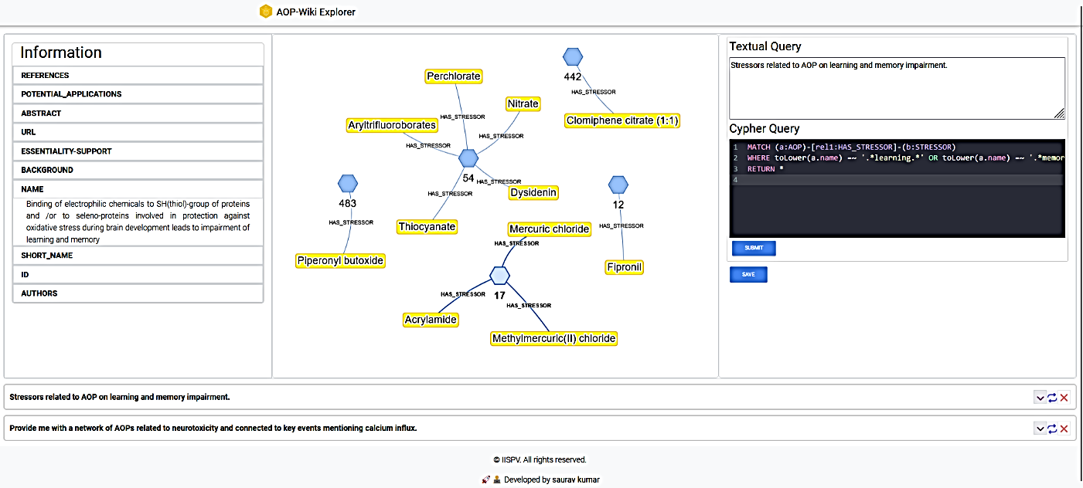

**Natural language query**

**Information area**

**Cypher query**

**History area**

**Visualization area**

Figure . AOP-Wiki Explorer user interface. The AOP Wiki Explorer user interface provides an interactive playground to get graphical insights into AOP. The user interface rationally designs into 4 components i.e. 1.) Natural Language query area, 2.) Cypher query area 3.) Visualization area 4.) Information area 5.) History area

AOP-wiki Explorer comes with an interactive user interface, The interface is thoughtfully structured into five distinct components, and each component plays a pivotal role in enhancing user interaction and understanding. These components orchestrate harmoniously and provide users with an adaptable playground to analyze and design AOPs. The components and their role are as follows:

**Natural language query:** It takes user-initiated queries in natural language form. Input to this component is mandatory as it helps to keep track of human-understandable queries. Along with this, it helps to generate cypher from natural language.

**Cypher query:** Takes direct Neo4j cypher query as input. Here users with technical knowledge can craft intricate cypher queries, and able to leverage the full potential of a graph database to extract precise insights and patterns. Syntax highlighting is supported by the cypher which provides readability to the code

**Visualization Area:** It’s a visual output component that renders the pattern given by the cypher query. Visual representation empowers the users to unravel complex relationships, dependencies, and trends within AOPs and helps developers foster informed decision-making. Visualization is powered by the Neovis library, which is a part of the Vis JavaScript library specialized in handling Neo4j queries.

**Information Area:** It provides comprehensive details stored as properties in nodes and edges. When tapped over the graph component in the interactive visualization, it shows the tabular list of properties and URLs to navigate the source of origin i.e. AOP-wiki.

**History Area:** This component allows users to retrace their steps and revisit previous interactions. This feature facilitates iterative exploration and dynamic data investigation.

The processing of raw data to the network has been done with Python3. Neo4J version _ has been used as the graph database platform. Interactive visualization has been developed with React, a JavaScript framework for UI development. Along with this other JavaScript library such as Neovis.js, codeMirror.js, etc. has been used. The backend has developed with a Flask micro server in Python.

## Result and Discussion

### Adopting AOP-wiki XML as a Graph database

This work adept AOP-Wiki XML information into a graph data structure. Transforming XML data to graphs enables the researchers to query AOPs in their more natural way. Along with this AOP wiki information has been further enriched with information about genes/proteins, chemicals, and diseases mentioned in each AOP using Named Entity Recognition. A total of unique 1138 biological entities have been identified, and out of that 439 were gene/protein, 378 chemicals, and 321 diseases. Each of the entities was attached to their respective ontology such as CHEBI is associated with chemicals, MIM is related to disease, NCBIGene for genes, and MESH is a general purpose which covers multiple domains. With ontology association, the problem of duplication of the same entity with a synonym has been resolved. The enrichment allows users to search AOPs with the very fundamental information of their work such as genes or chemicals associated with them and gives more flexibility to information retrieval. The enriched information is available as supplementary information. To make the AOP graph data free of redundant information and more FAIR, information such as life stages and taxonomy has been filtered and attached to its consistent identifier. Out of the 23 identified life stages, redundant ones like "Adults" and "Adult," as well as "Foetal" and "Fetal," have been filtered and attached to their permanent identifier. Similarly, lots of other terms like “Adult, reproductively mature”, “1 to < 3 months” and many more were carefully assigned with specific ontology and definition. FAIRified life stages are available as supplementary.

The schema of the graph database was designed to align with criteria aimed at enhancing information accessibility and interoperability, thus leading to broader applicability of the tool. Information such as life stages, sex, taxonomy, gene/protein chemical, etc. of AOPs and KE often reside deep in their textual descriptions, so rendering and filtering information on these criteria is challenging. Representing this information as separate nodes leads to fine-level granularity, reduced term redundancy, and wider accessibility of information. Additionally, representing key event relationships as edge limits the accessibility and interconnectivity with other vital details such as sex, life stages, etc. To address this concern, multiple schemas were designed and the one which meet the criteria was selected, the network visuals of all schemas are present in the supplementary.

## Finally, as discussion write about, how a graph can handle a surge number of nodes and edges

### Addressing query crafting with LLM integration

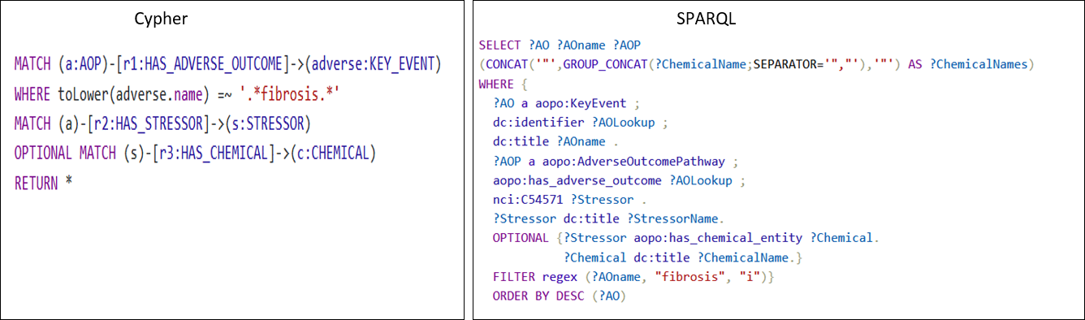Figure 4. Query complexity comparison between cypher and SPARQL. Both queries retrieve the same information about the chemicals which leads to adverse outcomes of fibrosis.

Each database comes up with its own syntax or query language to facilitate efficient information retrieval. SPARQL Protocol and RDF Query LanguageSQL (SPARQL) are used for managing and retrieval from databases mapped in RDF format. Similarly, the cypher query is used with Neo4j graph databases. In terms of complexity, the neo4j query is far less complex and more intuitive than the SPARQL query. As an example, to retrieve the chemicals which are related to “fibrosis” as an adverse outcome, the syntax mentioned in Fig 4. is used, to retrieve the same information with both the cypher and SPARQL query. The cypher query pattern resembles to graph, where the parenthesis “()” represents the node, while “-[]->” represents the edge. Filtering the nodes and relationships based on certain criteria can be done using the WHERE clause or directly imputing property as key and value in the nodes and relationship. Static clauses used in cypher and SPARQL both are comprehensible and represent the intended process.

|  |  |
| --- | --- |
| **Natural Language Query** | **Visual representation of network generated from query** |
| **Simple:** Stressors related to AOP on learning and memory impairment. |  |
| **Moderate:** Provide me with a network of AOPs related to neurotoxicity and connected to key events mentioning calcium influx. |  |
| **Complex:** key events which lie in the shortest path connecting AOPs related to neurotoxicity. |  |

Table . Different variations of query simple, moderate, and complex are shown in natural language and network format. Cypher query for each natural language query is present in the supplementary.

Querying connected information from graph databases provides significant flexibility, the flexibility entails the inherent nature of graph databases. Graph databases consider the relation between data points as first-class information in the data model, which is crucial for biological information. Mostly, the biological facts are non-linear, one fact influences other facts in multiple ways, and the same is applicable to AOPs as well. Graph transversal is one of the key properties of graph databases, it makes it efficient to navigate from one node to another and capture the intermediate relationship between them.

Depending on the research question, the complexities of database queries can range from relatively simple to highly complex. Table 2 and Figure 4 illustrate the diversity of questions and queries researchers may need to address while building or evaluating the AOP. Crafting complex queries is not an easy task for researchers from non-technical backgrounds. The advent of Large Language models (LLM) emerges as a valuable resource and offers a solution to tackle the problem of crafting queries. With a few examples of natural language and cyphers in the form of a prompt, the model adapts the pattern and syntax of cyphers being able to generate the cyphers for real-time queries asked by the user. LLM acts as a wrapper and bridges the gap of technical needs. Well-curated natural language query in accordance with the schema of a graph database is enough to generate precise cypher. Having no communication barrier between the information source and the users will increase the accessibility and usability of the tool. The growing usability of the tool results in the addition of diverse queries in the AOP context from the users leading to an increase in precision and accuracy of cypher generation. The diverse queries asked by the developers will also reflect the needs and expectations they have from the AOP wiki; hence this will be also helpful in modulating the AOP wiki as per the user’s requirement in future updates.

In this study we used OpenAI GPT-4 with 8k context size closed source LLMs, for each request to the language model charges $0.03/1k tokens. On average our prompt consists of 5k tokens, which costs us $0.15 for each natural language to cypher generation. These expenses are anticipated to reduce over time, as the database accumulates relevant examples, we expect to rely on prompt examples resembling user queries, thereby reducing the need of imputing multiple examples. Furthermore, with the rapid advancement of large language model development in the open-source community, the problem concerning cost will be addressed. The recent release of open open-source LLMA model by Facebook shows the capacity to generate code and has garnered attention. In the future fine-tuning models like LLMA on cypher queries will be a cost-effective alternative to the OpenAI model.

### Interactive and stepwise query

The interface for exploring AOP development is designed to facilitate interactive and stepwise queries, acknowledging the inherently exploratory nature of AOP development. In this section, we will explain the things with the help of an example query i.e. “What are the key events that are connecting the AOPs which is applicable to fish and rat taxonomy and has adverse outcome related to fertility or reproductive issue”. From the query, you can infer that the complex query can be broken down into multiple queries such as 1.) AOPs which are applicable to “fish” and “rat” 2.) Filter the AOPs, which mention “fertility” or “reproductive” issues in the adverse outcome 3.) Find the shortest path between the filtered AOPs which are connected by key events only. The above-mentioned queries are rationally divided into steps and queried separately, which allows users to analyze the results of the query individually and make further decisions as per requirement. In Figure 5. above mentioned natural language query is presented in cypher query and the visual representation of the query is present in supplementary.

Figure . Stepwise query of information.

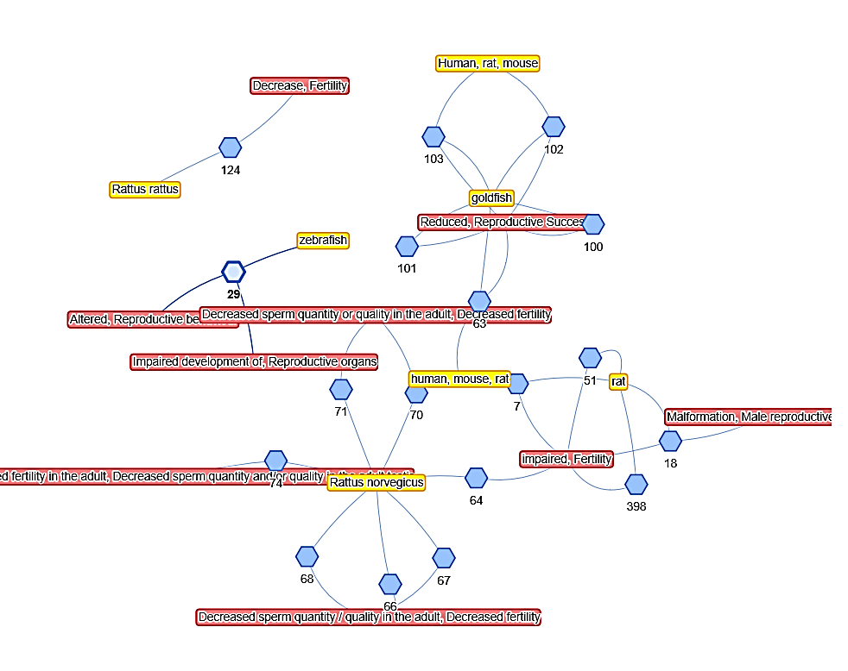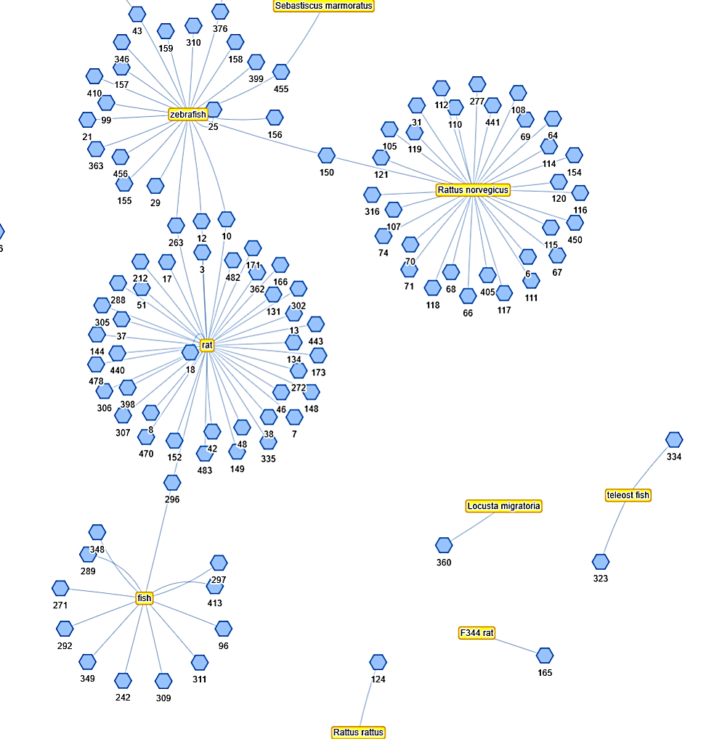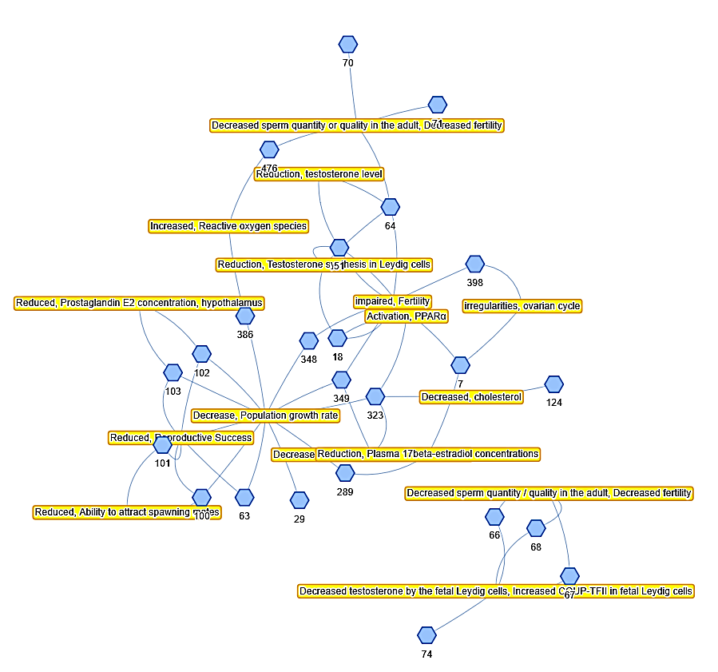

**Query 3.**

**shortest path between the filtered AOPs which are connected by key events only.**

**Query 1.**

**AOPs applicable to “fish” and “rat” taxonomy?**

**Query 2.**

**Filter the AOPs, which mention “fertility” or “reproductive” issues in the adverse outcome**

Figure 4 Network view of step wise query

## Conclusions

In this work we adept AOP-wiki data in its natural representation as a graph enabling the users to query and link information in a very flexible way. With databases comes the technical bottleneck of crafting queries to retrieve desirable information and hence it reduces the usability of the tool among domain users. In this work, we fill the technical gap and implement the large language model’s ability to generate cypher queries based on the natural language query provided in the context of a graph database schema. Having an exploratory nature to the AOP development process, we thoughtfully designed the interface which allows users to retrieve their complex research queries in multiple steps, and keep track of individual queries separately. The results of the queries will be retrieved in interactive network form. The Detailed information on AOPs, key events, and their relation is accessible in tabular form and also provides the functionality to retrace the information source.

## Now we will talk about the extension of this work, in future

# 1. Structuring whole AOP information in the form of ontology, Selection of terms in sex, life stage,

## References

1 G. T. Ankley, R. S. Bennett, R. J. Erickson, D. J. Hoff, M. W. Hornung, R. D. Johnson, D. R. Mount, J. W. Nichols, C. L. Russom, P. K. Schmieder, J. A. Serrrano, J. E. Tietge, D. L. Villeneuve, *Environ Toxicol Chem* **2010**, *29*, 730.

2 AOP developers handbook.

3 C. Vicknair, X. Nan, M. Macias, Y. Chen, Z. Zhao, D. Wilkins, *Proceedings of the Annual Southeast Conference* **2010**.

## 