# Integrating Graph and Large Language Model with AOP-Wiki for Contextual and Semantic Parsing of Adverse Outcome Pathway Information

Saurav Kumar1, Deepika Deepika1, Vikas Kumar1,2*

*1IISPV, Hospital Universitari Sant Joan de Reus, Universitat Rovira I Virgili, Reus, Spain*

*2German Federal Institute for Risk Assessment (BfR), Berlin, Germany*

# Supplementary

Table 1 Natural language and their corresponding cypher query to retrieve information from database

|  |  |
| --- | --- |
| **Natural Language Query** | **Cypher Query** |
| **Simple:** Stressors related to AOP on learning and memory impairment. | MATCH (a:AOP)-[rel1:HAS_STRESSOR]-(b:STRESSOR)  WHERE toLower(a.name) =~ '.*learning.*' OR toLower(a.name) =~ '.*memory.*'  RETURN * |
| **Moderate:** Provide me with a network of AOPs related to neurotoxicity and connected to key events mentioning calcium influx. | MATCH (a: AOP)-[rel1:HAS_KEY_EVENT]-(b:KEY_EVENT)  WHERE toLower(a.name) =~ '.*neuro.*'  WITH a  MATCH (a)-[rel2:HAS_KEY_EVENT]-(c:KEY_EVENT)  WHERE toLower(c.name) =~ '.*calcium.*'  RETURN * |
| **Complex:** key events which lie in the shortest path connecting AOPs related to neurotoxicity. | MATCH (a:AOP)-[:HAS_ADVERSE_OUTCOME]-(c:KEY_EVENT)  WHERE toLower(a.name) =~ '.*neuro.*'  WITH collect(a.id) as nodes  MATCH (aop1:AOP) WHERE aop1.id IN nodes  MATCH (aop2:AOP) WHERE aop2.id IN nodes AND aop1<>aop2  MATCH path = shortestPath((aop1)-[:HAS_KEY_EVENT*..2]-(aop2))  RETURN path |

Figure 1 Stepwise query cyphers

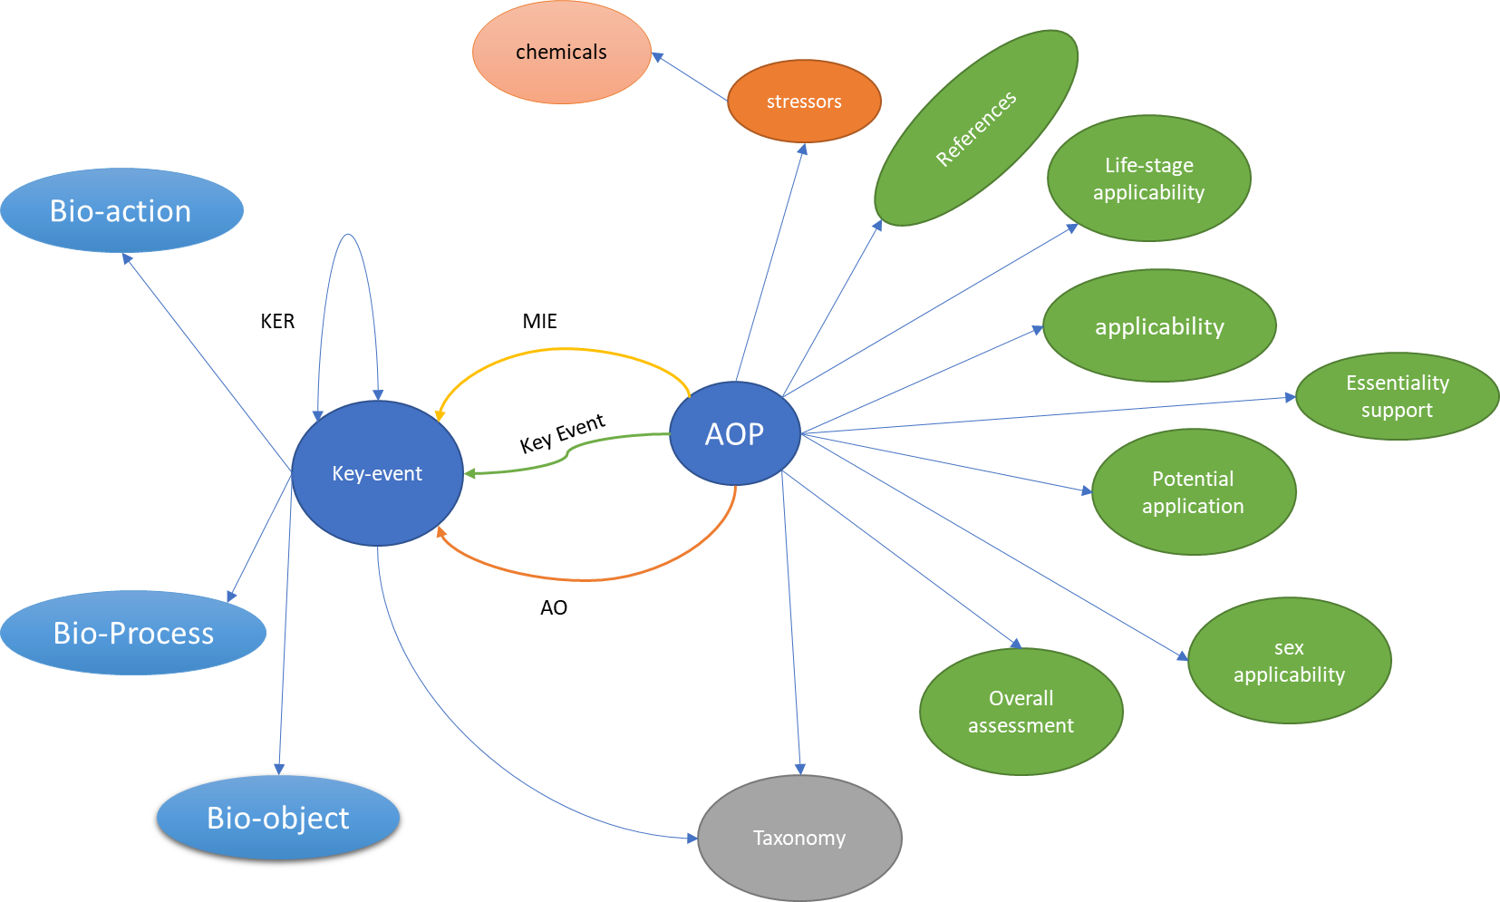

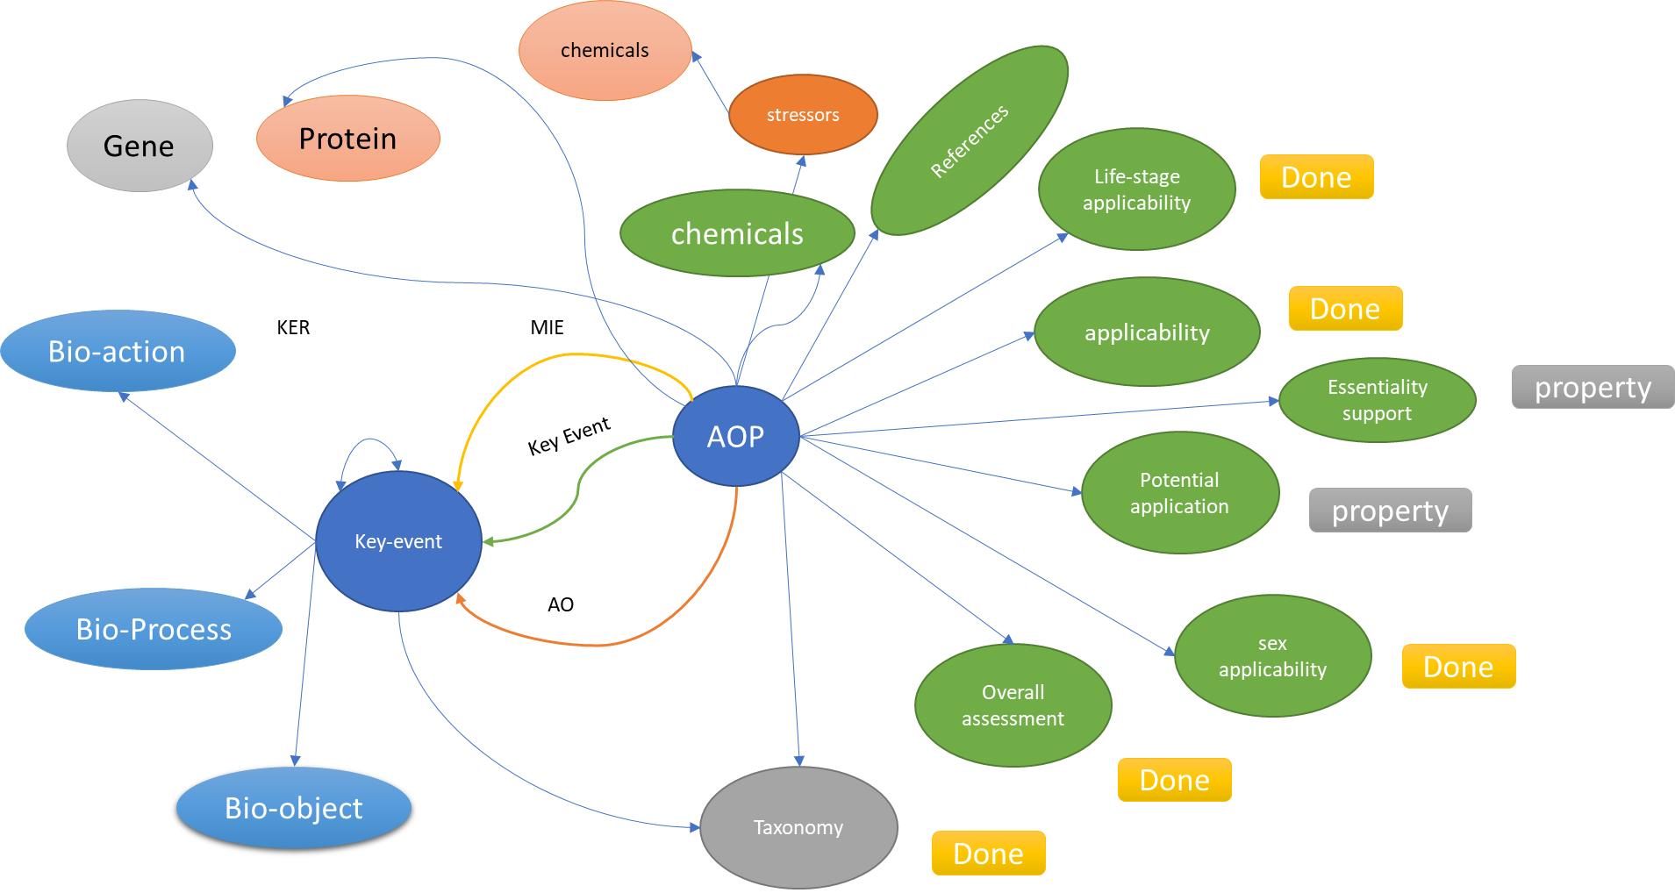

Figure 2 Different schema of AOP graph data adopted