Ministerul Educației și Cercetării al Republicii Moldova

Universitatea Tehnică a Moldovei

Facultatea Calculatoare, Informatică și Microelectronică

Departamentul Ingineria Software și Automatică

**Raport**

Disciplina: *Programarea în rețea*  
Lucrarea de laborator nr.1  
Tema: Aplicație de tip chat utilizând TCP

A efectuat: st.gr. TI-225, Rotari Cristian

A verificat: lect.univ. Ion Gatman

Chișinău 2025

Server cod:  
import socket

import threading

HOST = '127.0.0.1'

PORT = 12345

clients = []

*def* **handle_client**(client_socket, client_address):

*print*(*f*"[NEW CONNECTION] *{*client_address*}* connected.")

    clients.*append*(client_socket)

    try:

        while True:

            message = client_socket.*recv*(1024).*decode*('utf-8')

            if not message:

                break

*print*(*f*"[*{*client_address*}*] *{*message*}*")

*broadcast*(message,client_socket)

    except ConnectionResetError:

*print*(*f*"[DISCONNECTED] *{*client_address*}* left the chat.")

    finally:

        clients.*remove*(client_socket)

        client_socket.*close*()

*def* **broadcast**(message, sender_socket):

    for client in clients:

        if client != sender_socket:

            try:

                client.*send*(message.*encode*('utf-8'))

            except:

                clients.*remove*(client)

*def* **start_server**():

    server = socket.*socket*(*socket*.AF_INET, *socket*.SOCK_STREAM)

    server.*bind*((HOST,PORT))

    server.*listen*(5)

*print*(*f*"[LISTENING] Server is listening on *{*HOST*}*:*{*PORT*}*")

    while True:

        client_socket, client_address = server.*accept*()

        thread = threading.*Thread*(target=*handle_client*,args=(client_socket,client_address))

        thread.*start*()

*print*(*f*"[ACTIVE CONNECTIONS] *{threading*.*active_count*()-1*}*")

if __name__ == "__main__":

*start_server*()

Client cod:  
import socket

import threading

HOST = '127.0.0.1'

PORT = 12345

*def* **receive_messages**(client_socket):

    """Function to receive messages from the server."""

    while True:

        try:

            message = client_socket.*recv*(1024).*decode*('utf-8')

            if message:

*print*(message)

        except:

*print*("Connection to server lost.")

            client_socket.*close*()

            break

*def* **start_client**():

    """Start the chat client."""

    client = socket.*socket*(*socket*.AF_INET, *socket*.SOCK_STREAM)

    client.*connect*((HOST,PORT))

*print*("Connected to the chat server.")

    receive_thread = threading.*Thread*(target=*receive_messages*,args=(client,))

    receive_thread.*start*()

    while True:

        try:

            message = *input*()

            if message.*lower*() == 'exit':

                break

            client.*send*(message.*encode*('utf-8'))

        except:

            break

    client.*close*()

if __name__ == "__main__":

*start_client*()

Interactiunea:  
Server:  
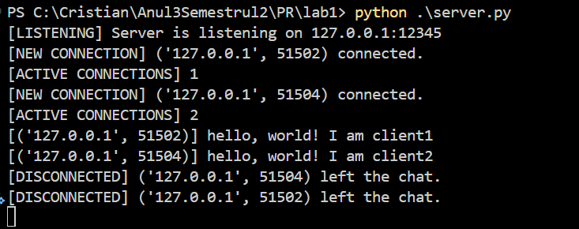

Client1:  
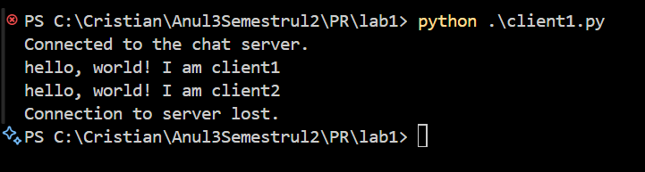

Client2:

