Ministerul Educației și Cercetării al Republicii Moldova

Universitatea Tehnică a Moldovei

Facultatea Calculatoare, Informatică și Microelectronică

Departamentul Ingineria Software și Automatică

**Raport**

Disciplina: *Programarea în rețea*  
Lucrarea de laborator nr.2  
Tema: Aplicație de tip chat utilizând UDP

A efectuat: st.gr. TI-225, Rotari Cristian

A verificat: lect.univ. Ion Gatman

Chișinău 2025

Server cod:

import socket

import threading

import queue

PORT = 5000

SERVER_IP = "127.0.0.1"

*def* **RecvData**(sock,recvPackets):

    while True:

        data,addr = sock.*recvfrom*(1024)

        recvPackets.*put*((data,addr))

*def* **RunServer**():

*print*(*f*'Server hosting on IP-> *{*SERVER_IP*}*')

    s = socket.*socket*(*socket*.AF_INET,*socket*.SOCK_DGRAM)

    s.*bind*((SERVER_IP,PORT))

    clients = *set*()

    recvPackets = queue.*Queue*()

*print*('Server Running...')

    threading.*Thread*(target=*RecvData*,args=(s,recvPackets)).*start*()

    while True:

        while not recvPackets.*empty*():

            data,addr = recvPackets.*get*()

            if addr not in clients:

                clients.*add*(addr)

                continue

            clients.*add*(addr)

            data = data.*decode*('utf-8')

            if data.*endswith*('qqq'):

                clients.*remove*(addr)

                continue

*print*(*str*(addr)+data)

            for c in clients:

                if c!=addr:

                    s.*sendto*(data.*encode*('utf-8'),c)

    s.*close*()

if __name__ == '__main__':

*RunServer*()

Client cod:

import socket

import threading

import random

import os

SERVER_IP = "127.0.0.1"

SERVER_PORT = 5000

CLIENT_IP = "127.0.0.1"

*def* **ReceiveData**(sock):

    while True:

        try:

            data, _ = sock.*recvfrom*(1024)

*print*(data.*decode*('utf-8'))

        except:

            pass

*def* **RunClient**():

    port = random.randint(6000,10000)

*print*(*f*'Client IP-> *{*CLIENT_IP*}* Port-> *{*port*}*')

    server = (SERVER_IP, SERVER_PORT)

    s = socket.*socket*(*socket*.AF_INET,*socket*.SOCK_DGRAM)

    s.*bind*((CLIENT_IP,port))

    name = *input*('Please write your name here: ')

    if name == '':

        name = 'Guest'+*str*(*random*.randint(1000,9999))

*print*('Your name is:'+name)

    s.*sendto*(name.*encode*('utf-8'),server)

    threading.*Thread*(target=*ReceiveData*,args=(s,)).*start*()

    while True:

        data = *input*()

        if data == 'qqq':

            break

        elif data=='':

            continue

        data = '['+name+']' + '->'+ data

        s.*sendto*(data.*encode*('utf-8'),server)

    s.*sendto*(data.*encode*('utf-8'),server)

    s.*close*()

    os.*_exit*(1)

if __name__ == '__main__':

*RunClient*()

Server Output:

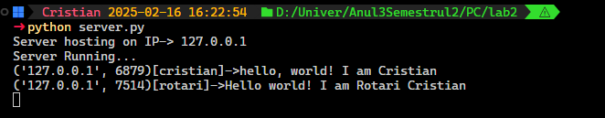

Client 1 Output:  
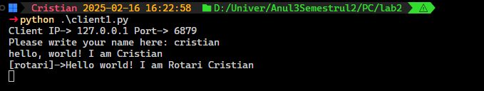

Client 2 Output:

