# Proposal for new emoji: Do-No-Evil Monkey

* **Author:** Christoph Päper
* **Mail:** christoph.paeper@crissov.de
* **Submitted:** 2017-05-29
* **Latest version:** https://crissov.github.io/unicode-proposals/fourth-monkey

## Introduction

I hereby request the addition of a **Do-No-Evil Monkey** emoji to the Unicode Standard. Rationals, glyph examples, character properties as well as discussion of inclusion and exclusion factors are included on the following pages. As per the [emoji submission guidelines](http://www.unicode.org/emoji/selection.html#submission) this document does not include the character proposal form.

The canonic Three Wise Monkeys are almost always depicted as covering their eyes (🙈 *See-No-Evil* U+1F648, Mizaru / Minai), ears (🙉 *Hear-No-Evil* U+1F649, Kikazaru / Mikazaru / Kikanai) and mouth (🙊 *Say-No-Evil* U+1F64A, Iwazaru / Mazaru / Iwanai), respectively, hence can easily be limited to show the head. There is some considerable deviation and variation for the less-canonic fourth monkey. I am specifically proposing the *Do-No-Evil Monkey* Shizaru / Shinai. Its hands are often shown crossed or tied and either above its head or in its lap. The former depiction is better compatible with existing glyphs and can also symbolize the less frequent alternative *Think-No-Evil Monkey*, while the latter hints – sometimes in a quite obvious way – at the sexual innuendo of ‘doing something evil’. Other specific activities are also sometimes depicted, e.g. *Write-No-Evil* or *Smell-No-Evil*.

[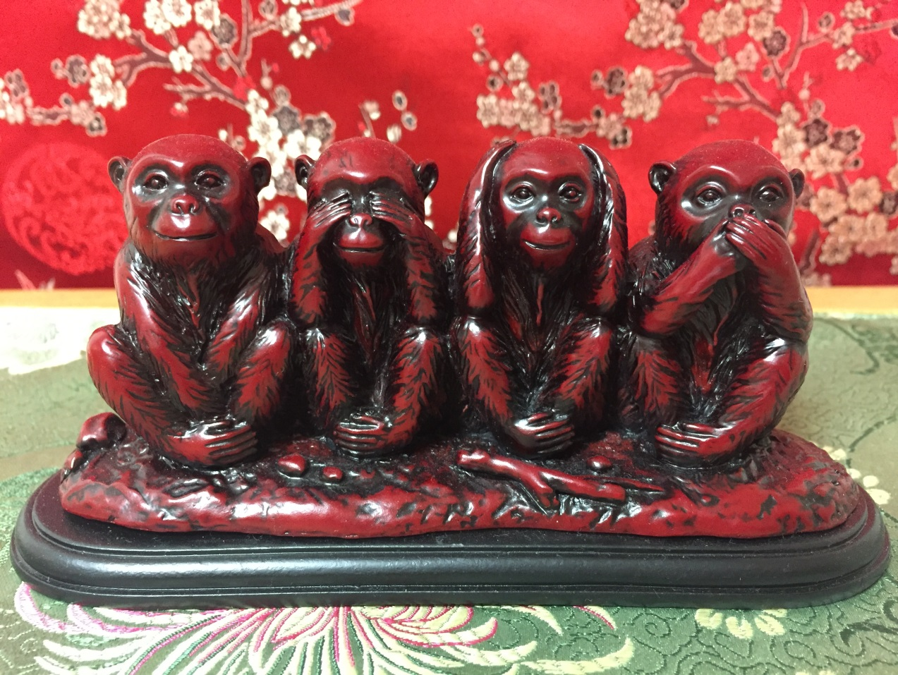](https://commons.wikimedia.org/wiki/File:Four_wise_monkeys.jpg)

## Names

The preferred CLDR short name of the character is “Do-No-Evil Monkey”.

The existing monkeys share most of their [English CLDR keywords](http://www.unicode.org/cldr/charts/latest/annotations/germanic.html). The table shows proposed additions in bold face.

|  |  |  |
| --- | --- | --- |
| Name | Common Keywords | Individual Keywords |
| see-no-evil monkey | face, monkey; evil, forbidden, gesture, no, not, prohibited | see, **watch, blind** |
| hear-no-evil monkey | face, monkey; evil, forbidden, gesture, no, not, prohibited | hear, **listen, deaf** |
| speak-no-evil monkey | face, monkey; evil, forbidden, gesture, no, not, prohibited | speak, **tell, mute, taste, eat** |
| **do-no-evil monkey** | face, monkey; evil, forbidden, gesture, no, not, prohibited | **do, act, sex, think, dumb** |
| monkey face | face, monkey |  |

## Images

Adapted Emojione 2 (or Emojitwo) graphics:   
[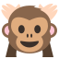](img/emojione-monkey-arms-crossed.svg) [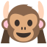](img/emojione-monkey-hands-up.svg)

## Factors for Inclusion

### A. Compatibility:

There are no known legacy character sets containing *Do-No-Evil Monkey*.

### B. Expected Usage Level:

I expect the *Do-No-Evil Monkey* emoji to be used slightly less than its three existing siblings, but these are among the highly used emojis on <http://www.emojistats.org> and <http://emojitracker.com>. Not least because they are being used to express ‘I can’t …’, ‘I won’t …’, ‘I don’t wanna …’ and ‘Please don’t …’ (hear, see, say/taste/smell something).

|  |  |  |
| --- | --- | --- |
| Emoji | Emojistats rank | Emojitracker rank |
| 🙈 *See-No-Evil* U+1F648 | 11 | 29 |
| 🙉 *Hear-No-Evil* U+1F649 | 141 | 204 |
| 🙊 *Say-No-Evil* U+1F64A | 45 | 54 |

I have *not* included charts supplied by Google Trends showing the frequency of searches for the fourth monkey in comparison to the other three monkeys. They would show, however, that the name of the fourth monkey is searched for almost as often as the others. *Mizaru* is the most frequent term, because the other two canonic monkeys are known in the West under different names:

* [Mizaru, Kikazaru, Iwazaru, Shizaru](https://trends.google.com/trends/explore?q=Mizaru,Kikazaru,Iwazaru,Shizaru)
* [Mizaru, Mikazaru, Mazaru, Shizaru](https://trends.google.com/trends/explore?q=Mizaru,Mikazaru,Mazaru,Shizaru)
* [Minai, Kikanai, Iwanai, Shinai](https://trends.google.com/trends/explore?q=Minai,Kikanai,Iwanai,Shinai)

The *-nai* diagram is not useful, because *shinai* is also the weapon used in kendo and *minai* may be a common misspelling of *Minaj* (apparently a popular singer).

* [*… no evil* phrases in Google Books](https://books.google.com/ngrams/interactive_chart?content=say+no+evil%2Cspeak+no+evil%2Chear+no+evil%2Csee+no+evil%2Cdo+no+evil%2Cthink+no+evil&case_insensitive=on&year_start=1908&year_end=2008&corpus=15&smoothing=3&share=&direct_url=t4%3B%2Csay%20no%20evil%3B%2Cc0%3B%2Cs0%3B%3Bsay%20no%20evil%3B%2Cc0%3B%3BSay%20no%20evil%3B%2Cc0%3B.t4%3B%2Cspeak%20no%20evil%3B%2Cc0%3B%2Cs0%3B%3Bspeak%20no%20evil%3B%2Cc0%3B%3BSpeak%20no%20evil%3B%2Cc0%3B%3BSpeak%20No%20Evil%3B%2Cc0%3B%3BSPEAK%20NO%20EVIL%3B%2Cc0%3B%3BSpeak%20no%20Evil%3B%2Cc0%3B.t4%3B%2Chear%20no%20evil%3B%2Cc0%3B%2Cs0%3B%3Bhear%20no%20evil%3B%2Cc0%3B%3BHear%20no%20evil%3B%2Cc0%3B%3BHear%20No%20Evil%3B%2Cc0%3B%3BHEAR%20NO%20EVIL%3B%2Cc0%3B%3BHear%20no%20Evil%3B%2Cc0%3B.t4%3B%2Csee%20no%20evil%3B%2Cc0%3B%2Cs0%3B%3Bsee%20no%20evil%3B%2Cc0%3B%3BSee%20No%20Evil%3B%2Cc0%3B%3BSee%20no%20evil%3B%2Cc0%3B%3BSEE%20NO%20EVIL%3B%2Cc0%3B%3BSee%20no%20Evil%3B%2Cc0%3B.t4%3B%2Cdo%20no%20evil%3B%2Cc0%3B%2Cs0%3B%3Bdo%20no%20evil%3B%2Cc0%3B%3BDo%20no%20evil%3B%2Cc0%3B.t4%3B%2Cthink%20no%20evil%3B%2Cc0%3B%2Cs0%3B%3Bthink%20no%20evil%3B%2Cc0%3B%3BThink%20no%20evil%3B%2Cc0%3B%3BThink%20No%20Evil%3B%2Cc0)

### C. Image distinctiveness:

If drawn badly, a monkey raising both hands – as if being arrested – could look much like the one covering its ears 🙉.

If the position and posture of its hands and arms is not unusual enough, it could also be confused with 🐵 *Monkey Face* U+1F435 or, much less likely, 🐒 *Monkey* U+1F412.

### D. Completeness:

This character is proposed to complete a frequent, though less canonic set.

### E. Frequently Requested:

I have no evidence of this character being frequently requested by name, but “it wasn’t me”, “I didn’t do nothing”, “my hands are tied” and their equivalents in other languages are frequently used phrases that would be subject to be augmented or substituted by the proposed emoji character.

## Factors for Exclusion

### F. Overly Specific:

One of the two existing generic monkey emojis – 🐵 and 🐒 – could be used in proximity to all of the three wise monkeys – 🙈 🙉 🙊 – to signify the fourth one without further explicit determination of its *verb*-No-Evil status: 🙈 🙉 🙊 🐵. This would be quite ambiguous, though, and does not work if one wants to refer to the meaning of the fourth monkey specifically.

### G. Open-ended:

There could be subsequent proposals for monkey emojis to symbolize missing senses or abilities, i.e. adding *feeling/touching*, *smelling* or *moving/walking* to existing *seeing/blind*, *hearing/deaf* and *speaking/mute* (which already doubles as *tasting* or *eating*). Glyphs for the Do-No-Evil Monkey should be able to cover anything usually done with one’s hands and either *thinking* or *copulating*.

Someone could want to propose other creature or face emojis – animal, human or other – to be used with the expressions exhibited by the monkeys, but that is pure speculation and would not depend on the existence of a fourth monkey. While the concept has been adopted to other species, the monkeys are always considered the canonic reference.

### H. Already Representable:

The intended meaning could be represented by an emoji sequence of either Monkey Face 🐵 or Monkey 🐒 and a negation symbol 🚫 next to a future activity, hand or other body part emoji, but this would not work well alongside the three existing wise monkeys which have dedicated code points assigned to them.

### I. Logos, Brands etc.

There are some logos and brands that incorporate cartoon monkeys or apes, but non is known to me that would rely on one explicitly doing nothing. There are companies, brands and products named after the Japanese designations of the monkeys. [*Don’t be evil*](https://en.wikipedia.org/wiki/Don%27t_be_evil) is the motto of Google’s original corporate code of conduct.

### J. Transient:

The English [Wikipedia](https://en.wikipedia.org/wiki/Three_wise_monkeys#Variations) article states that the four-monkey version has been around at least as the three-monkey version. It is just that the triplet is more common in contemporary Japan where emojis originated.

## Sort location

The *Do-No-Evil Monkey* emoji should be sorted after the other Three Wise Monkey emojis. It should be part of the same categories as these. It should be added to the Supplemental Symbols and Pictographs block near other facial or animal emoji, e.g. in rows U+1F90*x* or U+1F99*x*.

The character does not decompose in any way, since U+1F648–A are also not considered compositions of either U+1F435 or U+1F412. It does not make use of emoji modifiers. It has emoji presentation by default.

## Other information

### References

* [Wikipedia](https://en.wikipedia.org/wiki/Three_wise_monkeys#Variations)

### License

The sample images included in this proposal were created by me and me alone based upon Emojione 2.2 art distributed under a Creative Commons Attribution license. I hereby declare that the Unicode Consortium and its members are granted the right to use, edit and redistribute these contents in any way they want without restriction. Copies of the sample images are available at the following address: http://github.com/Crissov/unicode-proposals/