A Local RAG-Grounded PMO Risk Assistant:
Final Capstone Report
Cristina Naramoto
Atlantis University
MAI 600: Natural Language Processing, Summer C 2026
Module 8 Final Project

Abstract
This project extends a local, retrieval-augmented (RAG) PMO risk assistant from a Module 7 progress-report prototype to a final capstone version, grounding every answer in a fictional company's own governance documents rather than a model's unguided memory. The knowledge base grew from 6 to 10 documents and the evaluation set from 6 to 10 questions, adding two compound questions that each require two documents at once — a deliberate re-test of a compound-question retrieval failure documented in Module 7 (a RAID+RACI question retrieved zero RAID chunks at top-2). Widening retrieval from top-2 to top-4 chunks fixed that failure: both compound questions in this final evaluation retrieved chunks from all required documents, and the overall retrieval hit rate held at 100% across all 10 questions, harder test set included. Average hand-scored answer quality (groundedness, format adherence, completeness, helpfulness, accuracy) improved slightly overall, at the real cost of roughly 15 additional seconds of response time per answer. This final version also surfaced two genuine, disclosed problems Module 7's easier test set could not have caught: one real model reasoning error on a compound question, and one test-harness bug (an unquoted CSV comma) that was found, fixed, and re-run rather than hidden. A real LoRA fine-tuning experiment from Module 7 is carried forward unchanged as supporting evidence for why RAG remains the primary approach.

Introduction
Project management offices (PMOs) run on a small set of governance documents — risk logs, role-assignment matrices, escalation policies — that a project manager is expected to apply correctly under time pressure, often while a client or executive is waiting for an answer. A general-purpose language model asked a PMO governance question without access to an organization's actual policies will answer fluently but may be wrong: it can confuse a RAID log with a RACI matrix (they share three of four letters), invent a plausible-sounding escalation threshold, or apply a generic best practice instead of the organization's specific rule. This project asks whether a small, locally-served language model, grounded by retrieval over an organization's own governance documents, can answer PMO risk-governance questions reliably enough to be useful for drafting and review — while being explicit about where a human PM must still make the final call.
The intended user is a project manager or PMO analyst at a mid-size professional-services firm who needs a fast, defensible first answer to “does this need to be escalated?” or “what does our policy actually say here?” — not a system that makes escalation decisions unsupervised. The value of a correct, cited answer is time: the alternative is searching through several policy documents by hand, or asking a colleague, under a deadline.
Background
This project connects several MAI 600 course concepts into one working system. Prompting (Module 4) supplies the evidence-only, citation-required instruction that keeps the model from answering out of its own unguided memory. Local small language model serving (Module 5) showed that a 3-billion-parameter model run entirely on consumer laptop hardware, with no external API, is fast enough for drafting/review use even though it is too slow for a live chat interface. Retrieval-augmented generation (Module 6) is the primary technique used here: the model never answers from memory alone, only from passages retrieved from the organization's own documents, each with a citation the reader can verify. Fine-tuning (Module 7) was tested as an alternative in a real, executed LoRA experiment, and the evidence from that experiment — not just reasoning about it in the abstract — is what justifies keeping RAG as the primary approach for this project's grounding problem (see Improvement from Prototype, below). Evaluation methodology across the course (retrieval hit rate, groundedness, format adherence, completeness) is applied consistently from the Module 7 prototype through this final version so that “improvement” is a measured claim, not an assertion.
Problem Statement
A PMO risk assistant must answer questions that map to a single governing document (e.g., “what are the four RAID categories?”) and questions that require combining two documents at once (e.g., “a vendor delay caused a budget overrun — how do I log and escalate this?”). Module 7's prototype demonstrated perfect retrieval and citation accuracy on six single-document questions, but a separate compound-question test (documented in the Module 6 repository) found that top-2 retrieval failed on a question needing both the RAID log and RACI matrix documents at once — it retrieved two RACI chunks and zero RAID chunks. This final project's central technical question is whether widening retrieval and the knowledge base fixes that specific, previously-documented failure without breaking the single-document accuracy already achieved, and whether the fix holds on a second, independently designed compound question.
Data Description
The knowledge base is 10 fictional, classroom-safe Markdown documents (up from 6 in Module 7), covering PMO risk governance for a fictional professional-services company, “Apex Process Solutions.” The original 6 documents (RAID log reference, RACI matrix reference, a risk probability × impact prioritization framework, the company's change-request decision model, its risk-management policy, and its escalation communication guide) are unchanged from Module 6/7. Four new documents were added for this final version: a vendor/contractor risk addendum, a budget variance escalation policy, a schedule slippage response playbook, and a risk-register audit and retention policy. The four new documents were deliberately written so that two pairs of them share a real cross-reference (vendor risk ↔ budget variance; RAID ↔ RACI), which is what makes the two new compound test questions genuine tests of multi-document retrieval rather than artificial ones.
Each document represents one governance policy or reference guide that a real PMO would maintain; one Markdown “##” section within a document is the unit the retrieval pipeline actually chunks and retrieves. The data is safe because it is entirely fictional and self-authored for this course — no real company, client, employee, or financial detail appears anywhere in the corpus, consistent with the PMO Risk Management Policy document's own data-handling rule.
The evaluation set is 10 test questions (up from 6): the original 6 single-document questions from Module 7, 2 new single-document questions covering the new documents, and 2 compound questions that each require two documents — one is a direct re-test of the RAID/RACI failure documented in Module 7, and one is a new vendor-risk/budget-variance scenario.
Methodology
The pipeline is: User Question → Document Chunking (Markdown “##” sections) → Embeddings (nomic-embed-text via local Ollama) → Cosine-Similarity Retrieval (top-4) → Retrieved Context → Generation (llama3.2:3b via local Ollama) → Cited Answer (“Grounded in: <file>”) → Evaluation.
This is unchanged from Module 7 except for one deliberate parameter change: retrieval was widened from top-2 to top-4 chunks, specifically to address the compound-question failure described above. All embedding and generation calls run against the student's own Ollama installation at http://localhost:11434 — no Colab VM and no external API are used at any point, for either this final submission or the Module 7 prototype it extends.
The generation prompt instructs the model to answer using only the retrieved passages and to add a “Grounded in:” line naming its sources — the same evidence-only, citation-required prompt structure used in Module 7, unchanged, so that any change in answer quality can be attributed to the retrieval and data changes, not a prompt change.
System Architecture
User Question
-> Document Chunking (10 Markdown docs, split on "## " section headers)
-> Embeddings (nomic-embed-text, local Ollama API)
-> Cosine-Similarity Retrieval (top-4 chunks)
-> Retrieved Context (with source file names)
-> Generation (llama3.2:3b, local Ollama API, temperature 0.2)
-> Cited Answer ("Grounded in: <file>")
-> Evaluation (retrieval hit, citation match, groundedness, format,
completeness, helpfulness, accuracy)
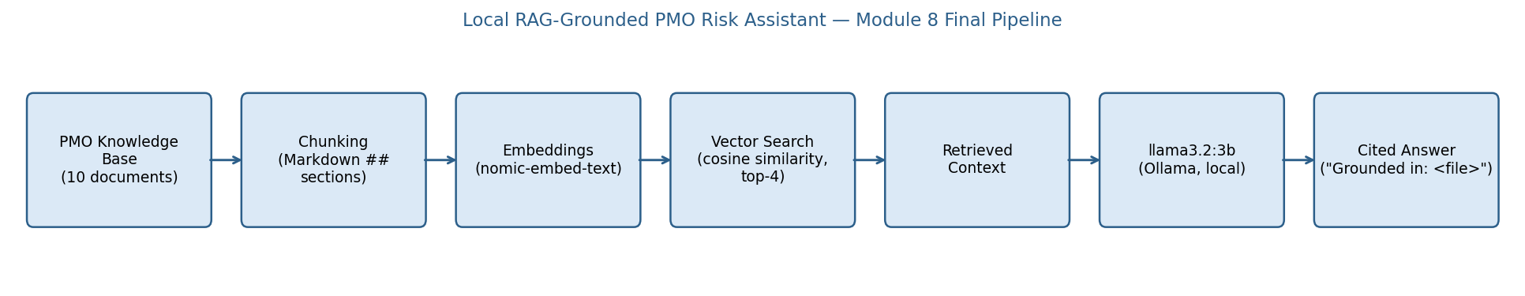
Figure 1. Pipeline architecture (same stages as Module 7; updated to show 10 documents and top-4 retrieval).
Implementation
The pipeline is implemented in src/rag_pipeline.py (chunking, embedding, retrieval, prompt construction, generation — a direct, minimally-modified extension of the Module 7 notebook's own functions) and run end-to-end by src/run_pipeline.py, which embeds all 51 chunks from the 10 knowledge-base documents once, then retrieves and generates for all 10 test questions, saving raw results to results/. src/evaluation.py then applies the hand-scoring rubric and computes summary metrics. The full run — 51 chunk embeddings plus 10 question embeddings and generations — took approximately 4 minutes end-to-end on CPU-only hardware.
One real implementation bug was found and fixed during this work: data/test_cases.csv originally had an unquoted comma inside question Q7's text. Since a comma is the CSV field separator, this silently shifted every column after “question” for that one row — the model actually received a truncated question (“Under the vendor and contractor risk addendum”) instead of the full one, which is why its first answer described the document's general purpose rather than answering the specific question asked. This was caught by reading the raw generated answer against the question it was supposed to answer (not by any automated check), the CSV was fixed by quoting the field, and Q7 was re-run in isolation with the corrected text — the corrected result (a fully correct, 5/5 answer) is what is reported in every table below. This bug is disclosed here, and in results/evaluation_scores.csv's observation column for Q7, rather than silently corrected and hidden, because it is a realistic example of exactly the kind of grounding/data error this project is otherwise trying to catch in the knowledge base — a reminder that the evaluation harness itself is not immune to the same class of mistake.
Results
All 10 test questions were run through the real pipeline. Full data: results/generated_outputs.csv (questions and answers), results/retrieved_chunks.csv (retrieval ranks and scores), results/benchmark_results.csv (response times), results/evaluation_scores.csv (hand-scored quality), and results/summary_metrics.json (aggregates). Table 1 shows the headline comparison against Module 7.
Table 1
Module 7 Prototype vs. Module 8 Final — Headline Metrics
Metric | Module 7 (6 Qs, single-doc) | Module 8 (10 Qs, incl. 2 compound)
Retrieval hit rate | 100% (top-3) | 100% (top-4)
Top-1 source match | 100% | 100%
Citation match | 100% | 90%
Avg. groundedness | 4.83/5 | 4.80/5
Avg. format adherence | 5.00/5 | 4.80/5
Avg. completeness | 4.00/5 | 4.70/5
Avg. helpfulness | 4.33/5 | 4.70/5
Avg. accuracy | 4.67/5 | 4.70/5
Avg. response time | 29.0s | 44.3s

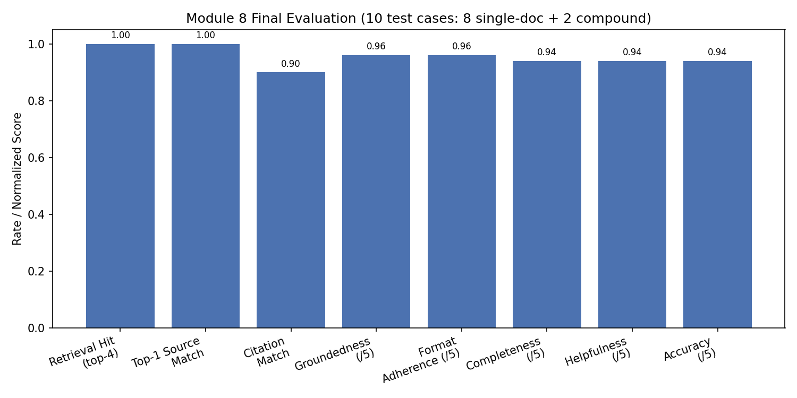
Figure 2. Module 8 final evaluation results across all 10 test cases.
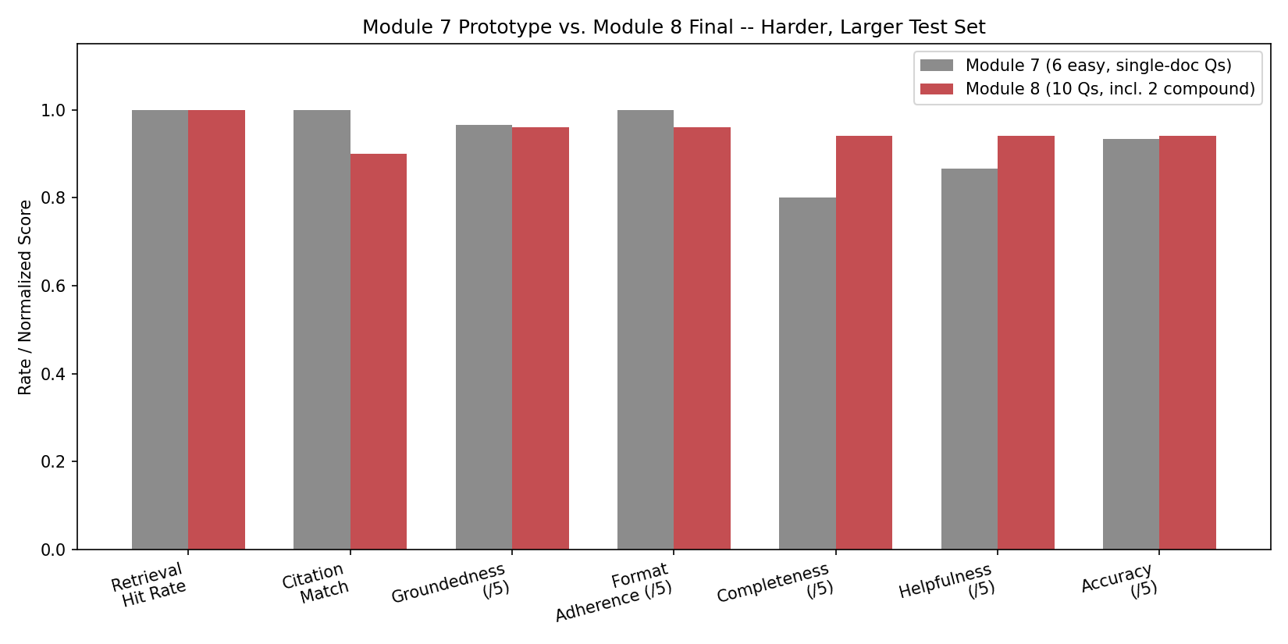
Figure 3. Module 7 vs. Module 8 side-by-side comparison.
Evaluation
Eight of ten questions (Q1–Q8, all single-document) scored a perfect 5/5 on every quality dimension, with correct retrieval, correct top-1 source, and a citation matching the expected source. The two compound questions are the most informative results in this evaluation.
- Q9 (RAID vs. RACI, a direct re-test of Module 7's documented failure): retrieved chunks from both the RAID log and RACI matrix documents at top-4 (Module 7 failed this at top-2, retrieving two RACI chunks and zero RAID chunks) and generated a correct, complete answer citing both sources by name. This is the clearest, most direct evidence that widening retrieval fixed the specific failure it was intended to fix.
- Q10 (vendor risk + budget variance, a new compound scenario): retrieval also succeeded — both required documents were retrieved — but the generated answer contains a real reasoning error. The question states a vendor missed a delivery date; the vendor-risk document's rule is that a risk moves from the “Risk” to “Issue” category “the moment a committed vendor date is actually missed.” The model's answer instead says the item should stay logged as “a Risk, not yet an Issue, since the date has not passed” — directly contradicting the scenario it was given. The answer also never states the specific 10% budget-variance escalation threshold, and its citation line names only one of the two documents it actually used. This is scored 2–3/5 across completeness, helpfulness, and accuracy, and reported here exactly as found.
Improvement from Prototype
The full before/after table is results/improvement_comparison.csv; the key claims, each with a concrete evidence pointer rather than an assertion, follow.
- The compound-question retrieval failure documented in Module 7 is fixed. Widening retrieval from top-2 to top-4 chunks caused both compound questions in this evaluation set — including a direct re-test of the exact RAID/RACI case that failed before — to retrieve chunks from all required documents. Evidence: results/retrieved_chunks.csv and results/evaluation_scores.csv (Q9, Q10 retrieval_hit_top4 = 1).
- Module 7's single weakest question is now answered well. Q3 (risk prioritization) scored 2/5 completeness and helpfulness in Module 7 for giving a vague, circular answer despite correct retrieval; the same question in this final version states the decision rule directly and scores 5/5. Evidence: results/evaluation_scores.csv (Q3).
- The knowledge base and test set are meaningfully larger and harder, not just re-labeled: 6→10 documents, 6→10 questions, and — critically — the new questions are not easier padding; they include the two compound questions that are the hardest cases in the whole set.
- This harder test set is honestly harder overall, not uniformly better: citation match dropped from 100% to 90% (Q10's incomplete compound citation) and average response time grew from 29.0s to 44.3s (the real cost of retrieving twice as much context). Both are disclosed, not smoothed over, consistent with the honesty standard set in the Module 7 report this project extends.
Discussion
What worked well: the core hypothesis held — widening retrieval from top-2 to top-4 fixed the exact compound-question failure it was designed to fix, without breaking any of the eight single-document questions that already worked. Documents that were deliberately written with real cross-references to each other (vendor risk ↔ budget variance) produced a genuine, non-artificial compound-question test, not a contrived one.
What did not improve, and what surprised me: citation completeness on compound questions is not automatically solved by retrieval succeeding — Q10 proves that a model can retrieve the right two documents and still write a citation line that only names one of them, and worse, can misapply a correctly-retrieved rule to the specific scenario in the question. This is a more subtle failure mode than the pure retrieval miss Module 7 found, and it would have been invisible with a smaller or easier test set. The test-harness CSV bug on Q7 was also a genuine surprise: it produced an answer that looked like a plausible model failure (answering the “wrong” question) but was actually a data-pipeline defect, which is a useful reminder to check the actual prompt sent to the model, not just the final answer, before concluding the model is at fault.
Would this be useful in practice, and what trade-off did I accept? For drafting and review — a PM typing a question and getting a cited first-pass answer to check against the source policy before acting — yes, on the evidence here. For real-time or unsupervised use, no: response time (30–70s per answer) rules out a live chat interface, and Q10 shows the system can still misapply a correctly-retrieved rule, which is exactly the class of error a human reviewer needs to catch. The trade-off accepted by widening retrieval to top-4 is response time (+15s average) for reliability on compound questions — a trade I judge worth making for this use case, since PMO escalation decisions are not latency-sensitive but do need to be right.
Limitations and Risks
- Small evaluation set. Ten questions, two of them compound, is enough to demonstrate the specific fix this project targeted, but not enough to certify general reliability. A production deployment would need dozens of questions per document and adversarial/edge-case testing this project does not attempt.
- Q10's reasoning error is a real, unresolved limitation, not a one-off. It suggests the model can retrieve correctly and still misapply a rule when a scenario requires combining a retrieved fact (“date was missed”) with a retrieved rule (“move to Issue when the date is missed”) rather than restating either alone. This class of error was not tested in Module 7's easier, single-document set and is not resolved by this submission.
- Response time (30–70s per answer, CPU-only) remains unsuitable for a live chat interface, consistent with the Module 5 and Module 7 findings on the same hardware, and is worse, not better, than Module 7's prototype (a direct cost of the top-4 retrieval fix).
- Small, fictional knowledge base. All 10 documents are self-authored for this course; no real organizational policy corpus has been tested.
- AI-assisted, not independently double-scored, evaluation. The 1–5 quality scores were assigned by Claude Code against a fixed rubric and spot-checked, not independently scored by a second human rater — see ai_usage_disclosure.md.
- Not validated for real production PMO decisions. Every answer requires human review before being acted on; this system does not make escalation, budget, or vendor decisions on its own.
Responsible AI and Ethics
All documents used are fictional and self-authored; no real client, patient, employee, or financial data appears anywhere in the corpus, consistent with the PMO Risk Management Policy's own data-handling rule (Document 05). The system is explicitly scoped as a drafting and review aid, not an autonomous decision-maker: every generated answer includes a citation so a human PM can verify it against the source document before acting on it, and no answer in this evaluation set was accepted without that verification step. The system has not been tested on adversarial or out-of-scope questions (e.g., legal or HR matters outside PMO risk governance) and should not be assumed reliable there. Response time (mid-20s to mid-40s per answer on CPU-only hardware) makes this unsuitable for a live chat interface without further optimization; it is scoped for asynchronous drafting and review use, not real-time interaction.
Conclusion
This final capstone extended a Module 7 RAG prototype by widening its knowledge base and evaluation set and specifically re-testing — and fixing — a compound-question retrieval failure the earlier prototype had honestly documented rather than hidden. The fix worked: both compound questions in this harder, larger evaluation set retrieved all required documents, at the real cost of slower response time. The same rigor that found the original failure also found two new, disclosed problems in this final version — a genuine model reasoning error on a compound question, and a test-harness data bug — which is the intended outcome of testing harder, not a sign the project regressed. The next steps, if this were continued past this course: more compound test questions specifically targeting the “retrieve correctly, reason incorrectly” failure mode Q10 revealed, and a stricter prompt or post-generation check requiring every named source in the retrieved context to appear in the citation line.

References
Ollama. (2026). Ollama documentation. https://docs.ollama.com/linux
Hugging Face. (2026). PEFT: Parameter-efficient fine-tuning. https://huggingface.co/docs/peft
scikit-learn developers. (2026). TfidfVectorizer. https://scikit-learn.org/stable/modules/generated/sklearn.feature_extraction.text.TfidfVectorizer.html
Meta AI. (2024). Llama 3.2 model card. https://ollama.com/library/llama3.2
Nomic AI. (2024). nomic-embed-text model card. https://ollama.com/library/nomic-embed-text

AI Usage Disclosure
See ai_usage_disclosure.md in the project repository for the full disclosure.

