MP1-PYTHON

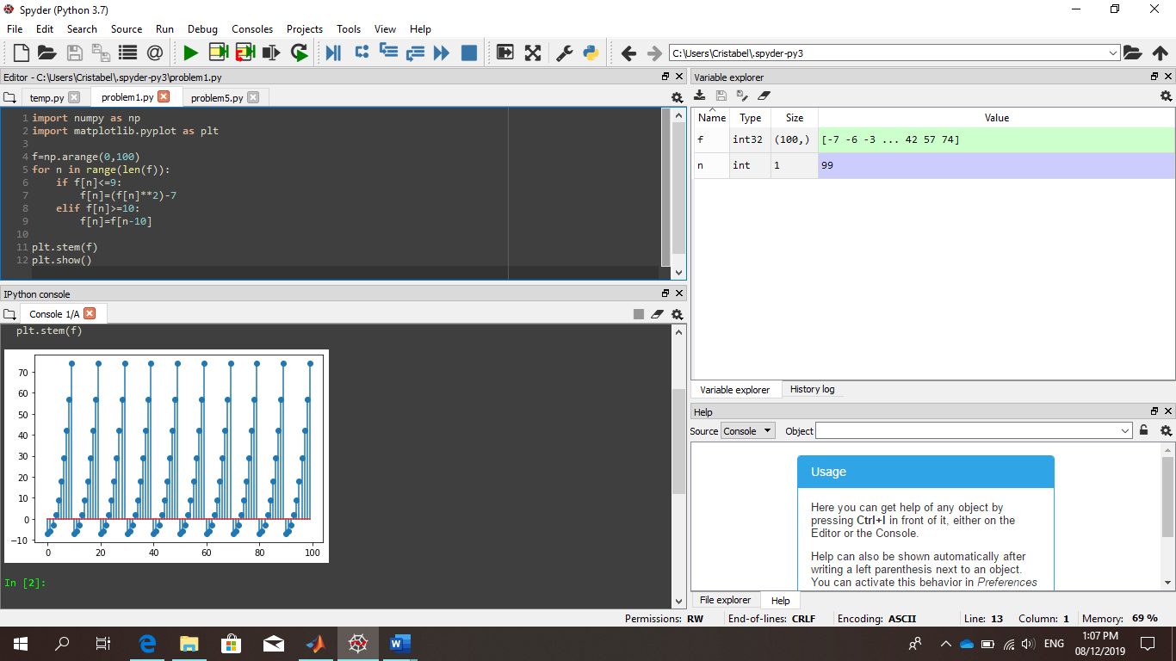

Since the graph is done using stem(), the output only plots one variable ‘f(n)’ and didn’t join the coordinates of ‘f(n)’ and ‘n’. It only plots a discrete function and shows the set of data points solved by the program. It is a plot that consist of lines and set of points.