MP3-MATLAB

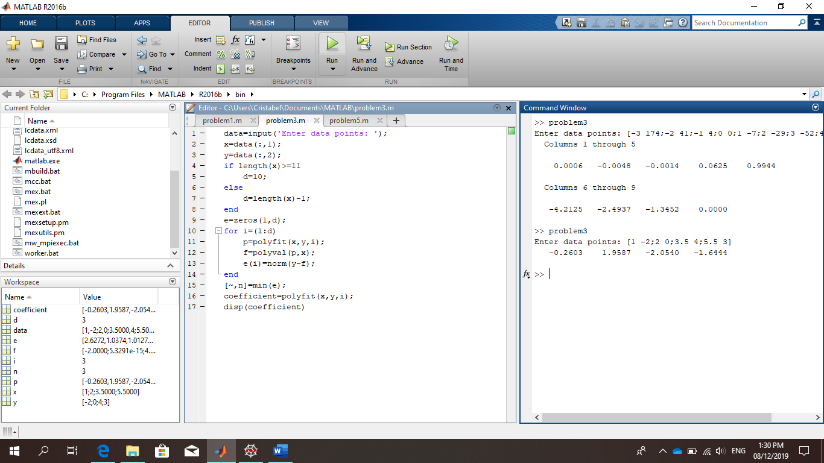

We used data points from the manual (and probset ni Sir Lao)