# AISC2013 - Deployment of AI Solutions

# FINAL EXAM SPECIFICATIONS

**Assignment Guidelines:** Application Development with Version Control and Docker

Cristeena Joseph – 500223331

**Python Application:**

* **Upload Data**

Upload data using flask app UI,

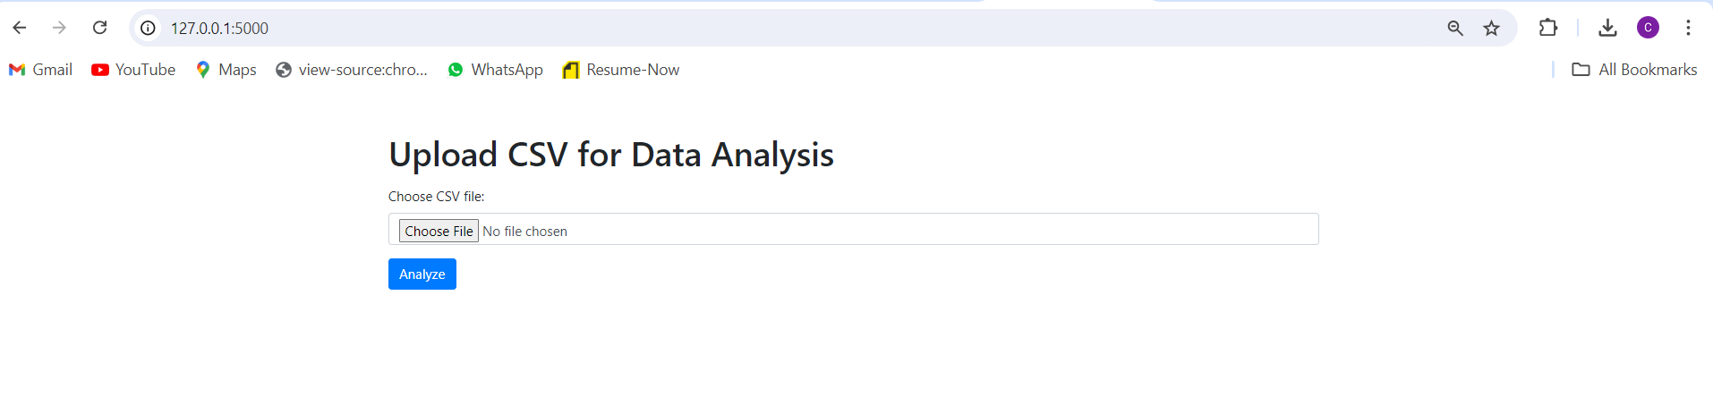

* Flask render the html page to GET the file upload

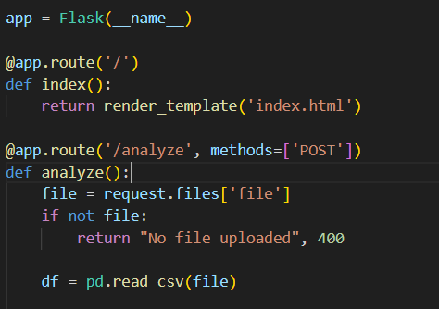

* Analysis of the data uploaded

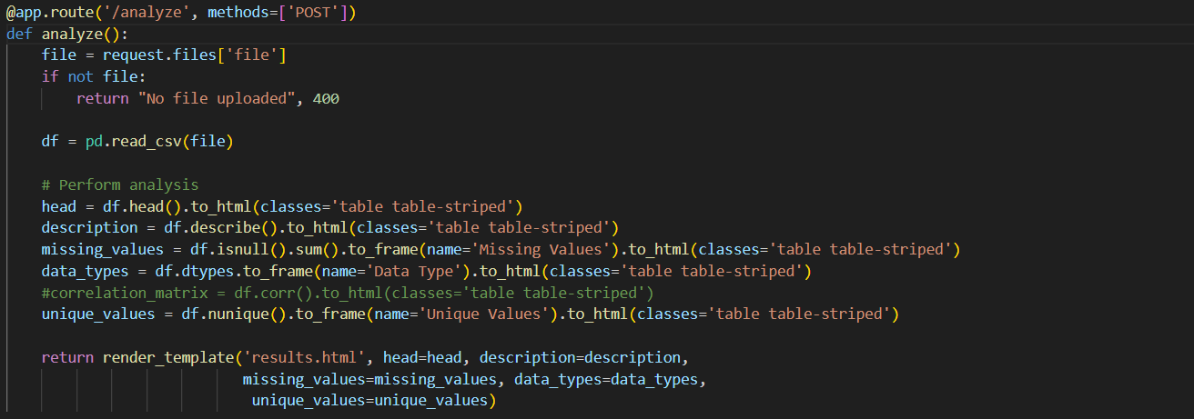

* Results return in Application

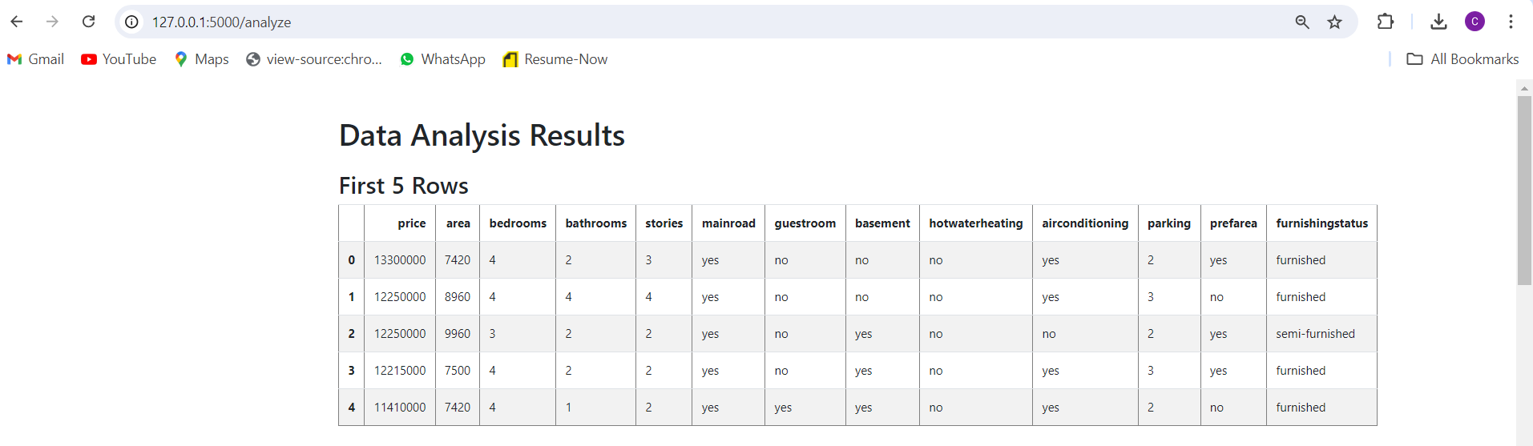

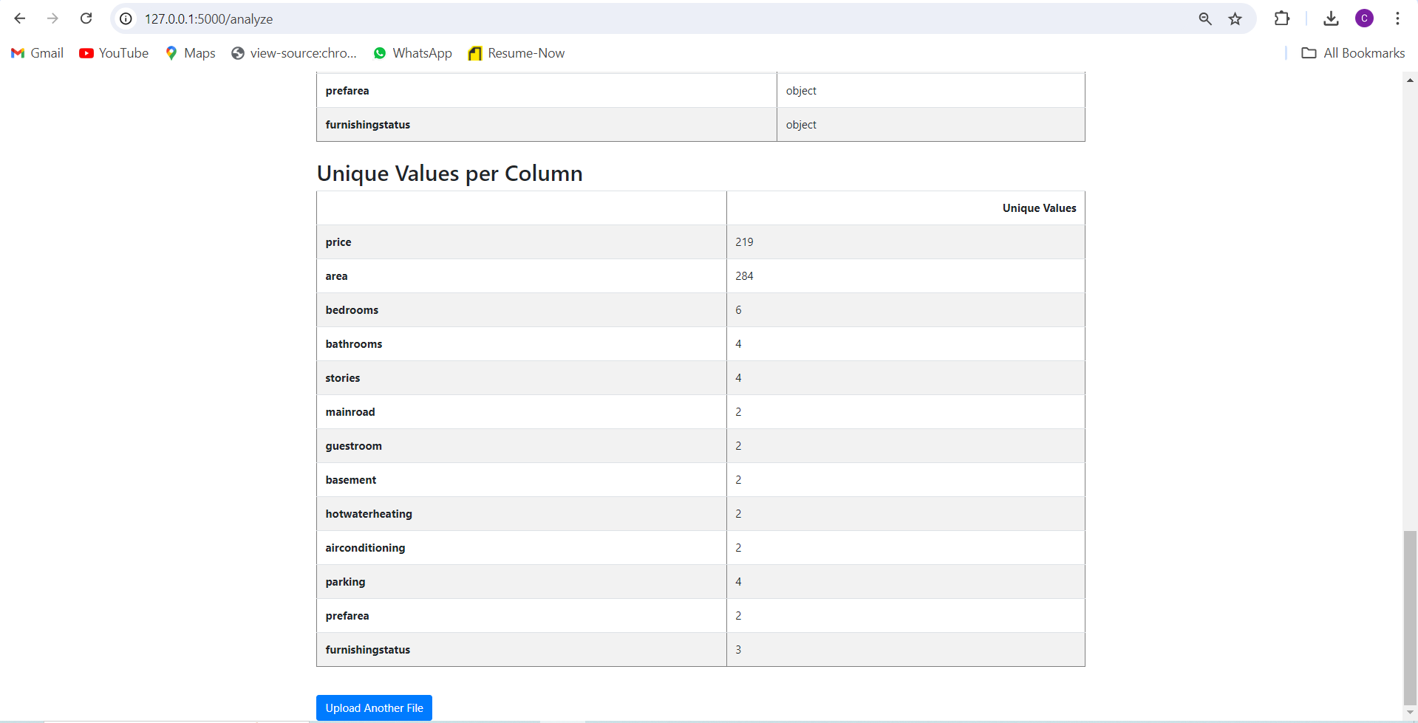

**Version Control**

* Create a Repo

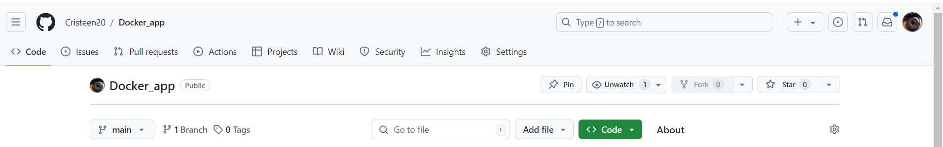

* Clone the repository

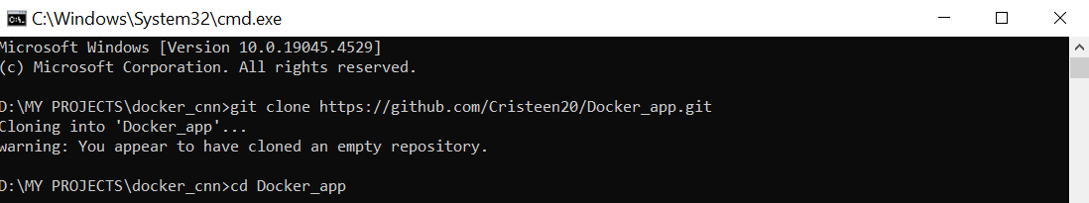

* Add the Application files into the repo folder
  + **Git status**

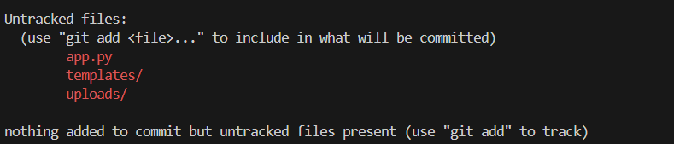

The files in red are the files which is not present in the remote repo.

* + Create git branch

**Git checkout -b dev**

* + **Git add .**



* + **Git commit -m “commit message”**

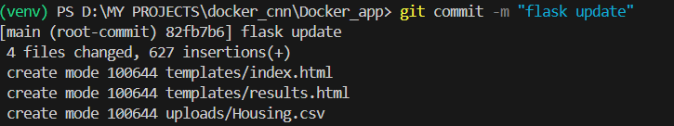

* + **Git push**

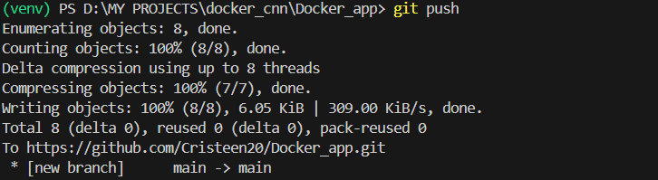

* **Upon any change in files -**  the files changed will appear red

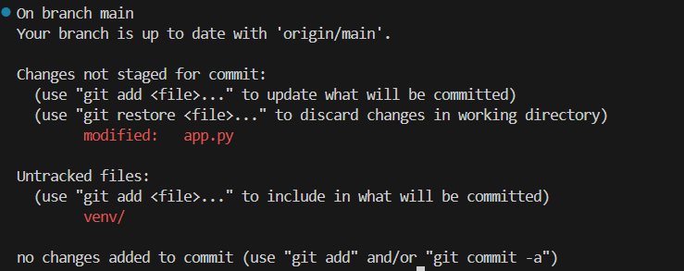

* Performing the same steps allows saving of the new change in a new commit.
* Each files will have the commit messages with which those were changed.

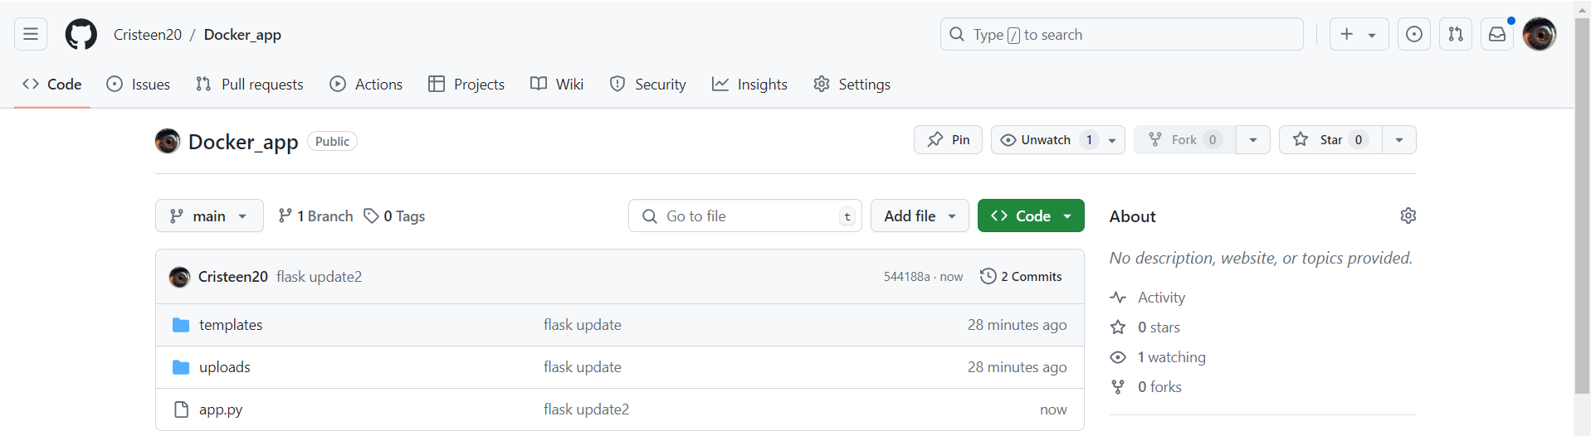

**Docker Containerization**

* Docker Container
  + Create **Dockerfile** for the project

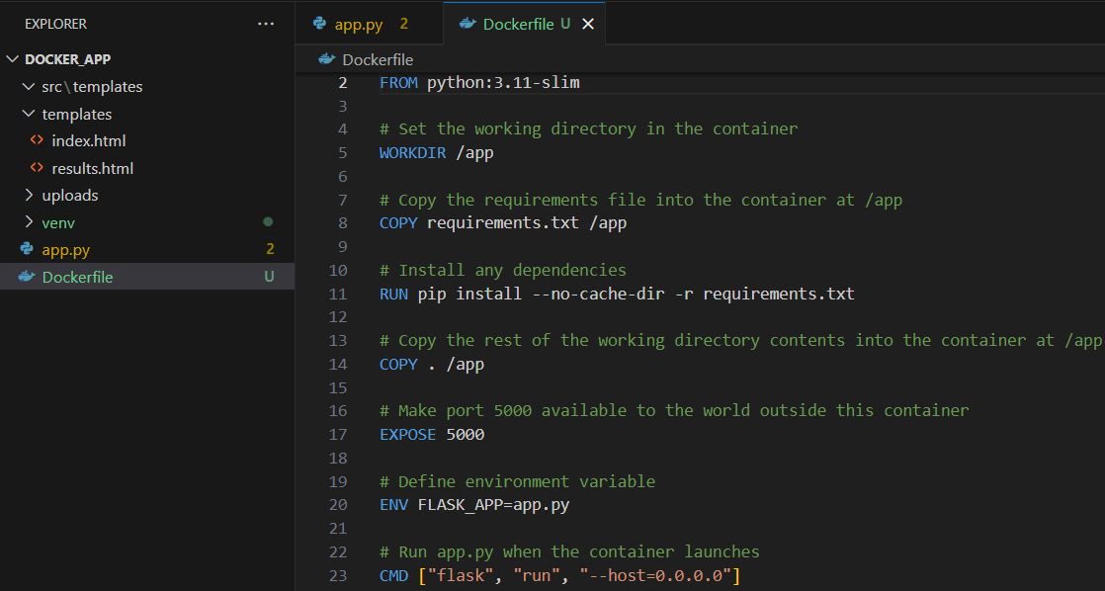

* + Create requirements.txt from the virtual environment
    - pip freeze > requirements.txt



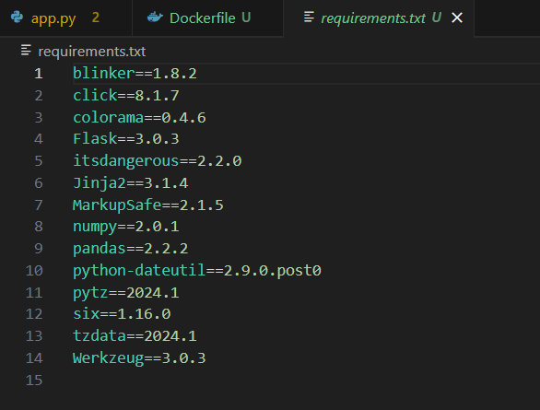

* + Build **docker image**
    - docker build -t my-flask-app .