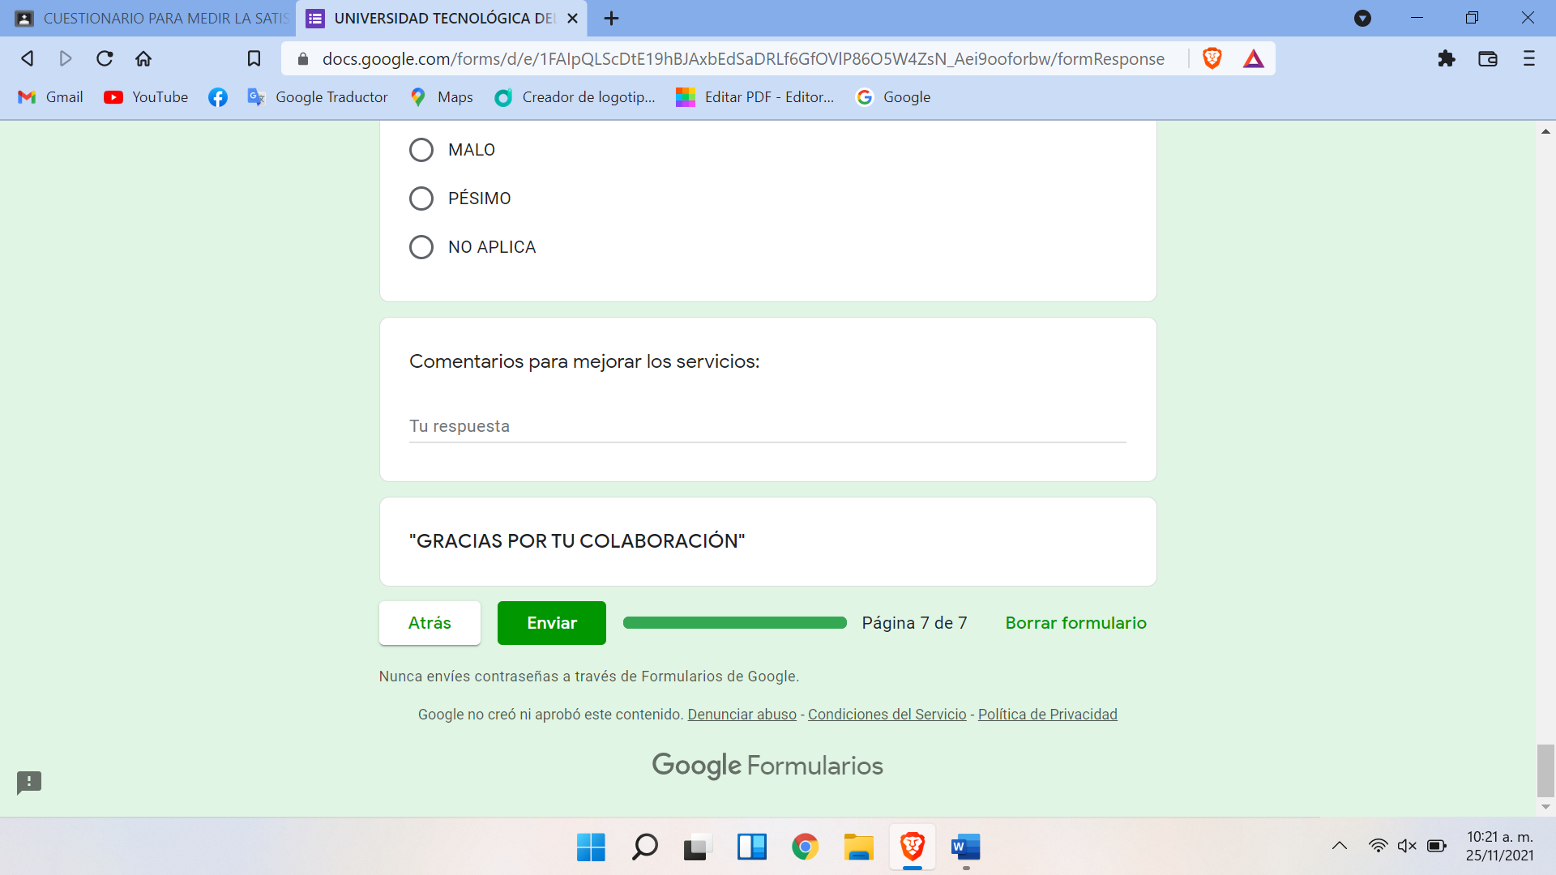https://docs.google.com/forms/d/e/1FAIpQLScDtE19hBJAxbEdSaDRLf6GfOVlP86O5W4ZsN_Aei9ooforbw/viewform?usp=pp_url&entry.1000005=ING+DESARROLLO+Y+GESTI%C3%93N+DE+SOFTWARE&entry.1000004=D%C3%A9cimo&entry.1000006=NO+APLICA&entry.1000007=NO+APLICA&entry.1000008=NO+APLICA&entry.1000009=NO+APLICA&entry.1000010=BIEN&entry.1000011=BIEN&entry.1000012=BIEN&entry.1000013=BIEN&entry.1000014=BIEN&entry.1000015=BIEN&entry.1000016=BIEN&entry.1000017=BIEN&entry.1000018=BIEN&entry.1000019=MALO&entry.222303391=REGULAR&entry.1000021=BIEN&entry.1000022=BIEN&entry.1000023=BIEN&entry.1000024=BIEN&entry.1000025=BIEN&entry.1000026=BIEN&entry.1000027=BIEN&entry.1000028=BIEN&entry.1000029=BIEN&entry.1000030=BIEN&entry.1000031=BIEN&entry.1000032=BIEN&entry.1000033=BIEN&entry.1000034=BIEN&entry.1000035=BIEN&entry.1000036=BIEN&entry.1000037=BIEN&entry.1000038=BIEN&entry.1000039=BIEN&entry.1000040=BIEN&entry.1000041=BIEN&entry.1000042=BIEN&entry.1000043=BIEN&entry.1000044=BIEN&entry.1000045=BIEN&entry.1000046=BIEN&entry.1000047=BIEN&entry.1000048=BIEN&entry.1000049=BIEN&entry.1000050=BIEN&entry.1000051=BIEN&entry.1000052=BIEN&entry.1000053=BIEN&entry.1000056=BIEN&entry.1000055=REGULAR&entry.1000057=REGULAR&entry.1000058=REGULAR&entry.1000059=REGULAR&entry.1000060=BIEN&entry.1000061=BIEN&entry.1000062=BIEN&entry.1000063=BIEN&entry.1000064=REGULAR&entry.1000065=REGULAR&entry.1000066=BIEN&entry.1000067=BIEN&entry.1000068=BIEN&entry.1000069=BIEN&entry.1000070=BIEN&entry.1000071=MUY+BIEN&entry.1000072=MUY+BIEN&entry.1000073=MUY+BIEN&entry.1000074=MUY+BIEN&entry.1000075=MUY+BIEN&entry.1000076=MUY+BIEN&entry.1000077=BIEN&entry.1000078=BIEN&entry.1000079=BIEN