Web Chat Application

Analysis and Design Document

Student: Pop Cristian Constantin

**Group: 30235**

Revision History

|  |  |  |  |
| --- | --- | --- | --- |
| **Date** | **Version** | **Description** | **Author** |
| <07/Apr/17> | <x.x> | <details> | Pop Cristian |
|  |  |  |  |
|  |  |  |  |
|  |  |  |  |

Table of Contents

I. Project Specification 4

II. Elaboration – Iteration 1.1 4

1. Domain Model 4

2. Architectural Design 4

2.1 Conceptual Architecture 4

2.2 Package Design 4

2.3 Component and Deployment Diagrams 4

III. Elaboration – Iteration 1.2 4

1. Design Model 4

1.1 Dynamic Behavior 4

1.2 Class Design 4

2. Data Model 4

3. Unit Testing 4

IV. Elaboration – Iteration 2 4

1. Architectural Design Refinement 4

2. Design Model Refinement 4

V. Construction and Transition 5

1. System Testing 5

2. Future improvements 5

VI. Bibliography 5

# Project Specification

The purpose of this project is to design and implement a chat application that can be accessed by the users by using a web browser. The application should allow sending multiple types of messages including text messages, messages containing images and file attachments. The application will allow users to belong to multiple conversations, each conversation containing multiple users. When a user sends a message to a conversation every user associated with that conversation should see it.

The application should use a database that will be used for two purposes:

* Storing information about users and the credentials that the user should use for logging in
* Storing messages sent by the users

# 

# Elaboration – Iteration 1.1

# Domain Model

Below is a conceptual class diagram that describes the following:

* There will be multiple kind of messages and each type will be handled differently
* A conversation will contain multiple messages. These messages will be considered owned by that conversation
* 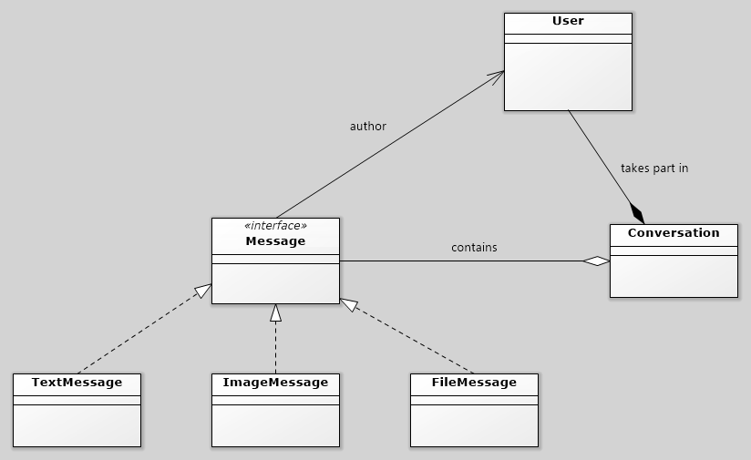A conversation has multiple users that take part in it. New users can be added or existing ones removed

# Architectural Design

## Conceptual Architecture

The system will use a client-server model with the Client running inside the user’s web browser and the server being on a separate machine responding to the client’s requests.

The architectural pattern used will be the Layers pattern. This will split the application into multiple isolated layers that contain different parts of the application. The main layers of this system will be:

* Data Access Layer – contains the logic used to access the database and provides data for other layers
* Business Layer – contains the logic of the application that describes how transactions should be performed and how objects should be handled
* Presentation Layer – contains the logic used to communicate with the client. It takes inputs from the user and processes them by calling services from the Business Layer and then returns a reply for the user with the result of their actions

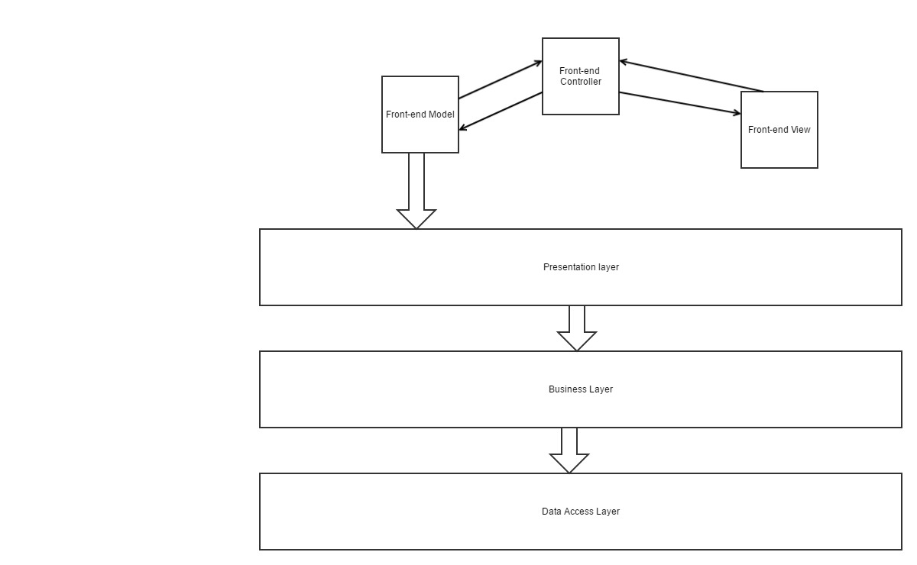The application will also have some components that might span across different layers. Examples of such components are the ones responsible for security, logging and exception handling.

## Package Design

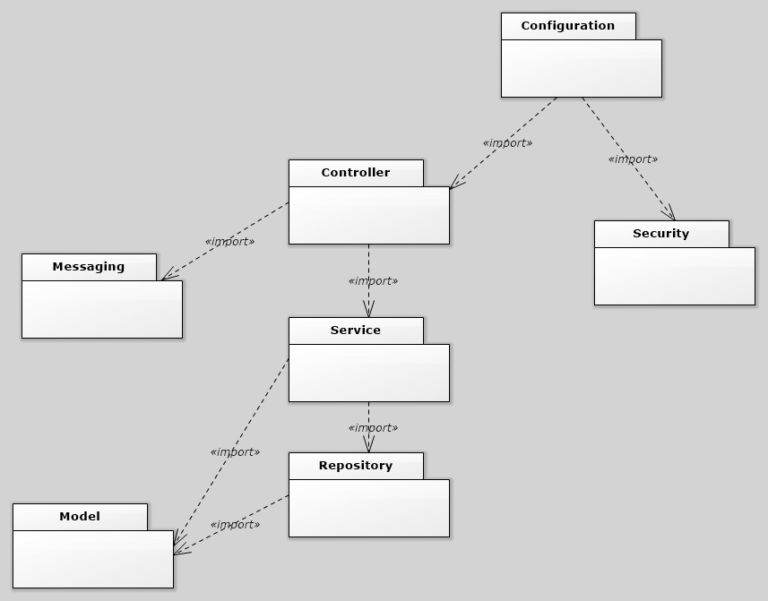

## Component and Deployment Diagrams

# 

# Elaboration – Iteration 1.2

# Design Model

## Dynamic Behavior

*[Create the interaction diagrams (1 sequence, 1 communication diagrams) for 2 relevant scenarios]*

## Class Design

*[Create the UML class diagram; apply GoF patterns and motivate your choice]*

# Data Model

*[Create the data model for the system.]*

# Unit Testing

*[Present the used testing methods and the associated test case scenarios.]*

# Elaboration – Iteration 2

# Architectural Design Refinement

*[Refine the architectural design: conceptual architecture, package design (consider package design principles), component and deployment diagrams. Motivate the changes that have been made.]*

# Design Model Refinement

## *[Refine the UML class diagram by applying class design principles and GRASP; motivate your choices. Deliver the updated class diagrams.]*

# Construction and Transition

# System Testing

*[Describe how you applied integration testing and present the associated test case scenarios.]*

# Future improvements

*[Present future improvements for the system]*

# Bibliography